Lab 13: Implementing Least Recently Used (LRU) Page Replacement Algorithm in C

Write a c program to implement LRU Page Replacement algorithm. If we use the recent past as an approximation of the near future, then we will replace the page that has not been used for the longest period of time. Least Recently Used (LRU) page replacement algorithm basically works on the concept that the pages that are heavily used in previous instructions are likely to be used heavily in next instructions. The page that are used very less are likely to be used less in future.

The output of program is as shown below:

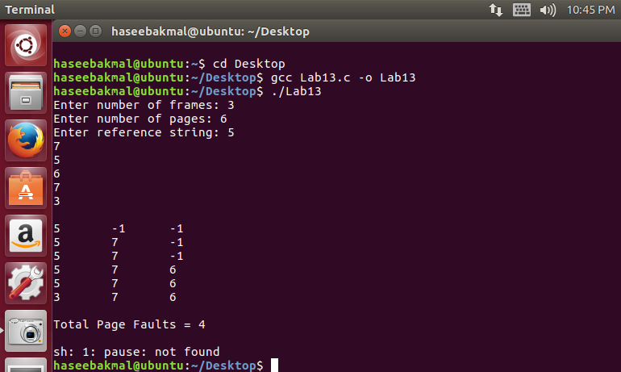

#include<stdio.h>
#include<stdlib.h>
int findLRU(int time[], int n){
int i, minimum = time[0], pos = 0;
for(i = 1; i < n; ++i){
if(time[i] < minimum){
minimum = time[i];
pos = i;
}
}
return pos;
}
int main() {
int no_of_frames, no_of_pages, frames[10], pages[30], counter = 0, time[10], flag1, flag2, i, j, pos, faults = 0;
printf("Enter number of frames: ");
scanf("%d", &no_of_frames);

printf("Enter number of pages: ");
scanf("%d", &no_of_pages);

printf("Enter reference string: ");
for(i = 0; i < no_of_pages; ++i){
scanf("%d", &pages[i]);
}

for(i = 0; i < no_of_frames; ++i){
frames[i] = -1;
}

for(i = 0; i < no_of_pages; ++i){
flag1 = flag2 = 0;

for(j = 0; j < no_of_frames; ++j){
if(frames[j] == pages[i]){
counter++;
time[j] = counter;
flag1 = flag2 = 1;
break;
}
}

if(flag1 == 0){
for(j = 0; j < no_of_frames; ++j){
if(frames[j] == -1){
counter++;
faults++;
frames[j] = pages[i];
time[j] = counter;
flag2 = 1;
break;
}
}
}

if(flag2 == 0){
pos = findLRU(time, no_of_frames);
counter++;
faults++;
frames[pos] = pages[i];
time[pos] = counter;
}
printf("\n");

for(j = 0; j < no_of_frames; ++j){
printf("%d\t", frames[j]);
}
}

printf("\n\nTotal Page Faults = %d", faults);

system("pause");
}

