March 1 at 9:09pm
Bio202 11am
3 functions of cAMP.
• Acts as second
messenger in the cell
• It has role in
glycogen metabolism
• ↑cAMP,
↑glycogenolysis
• ↑cAMP ↑TAG
metabolism
• ↑cAMP ↑ lipolysis marks
2.how banaspati ghee is produced from oil. 2 marks
3. hydrogenation of fats. 3 marks
4.interactions in DNA. 5 marks
The purine and
pyrimidine bases are
hydrophobic and
relatively insoluble in
water at the nearneutral
pH of the cell.
• Hydrophobic stacking
interactions in which
bases are positioned
with the planes of
their rings parallel
• Hydrophobic
stacking are an
important interaction
between bases in
nucleic acids.
• The stacking also
involves a
combination of van
der Waals and
dipole-dipole
interactions between
the bases • Hydrophobic
stacking are an
important interaction
between bases in
nucleic acids.
• The stacking also
involves a
combination of van
der Waals and
dipole-dipole
interactions between
the bases
The most important
functional groups of
pyrimidines and
purines are
• ring nitrogens,
• carbonyl groups, and
• exocyclic amino
groups.
• The most important
hydrogen-bonding
patterns are those
defined by James D.
Watson and Francis
Crick, in which
• A bonds specifically
to T (or U) and
• G bonds to
• These two types of
base pairs
predominate in
double-stranded
DNA and RNA.
5.sponification and its end products. 3 marks
6. waxes its types and properties. 10 marks
Esters of
fatty acids with higher
molecular weight
monohydric alcohols.
(having one OH group)
A second group of
neutral lipids that are
of physiological
importance
• Properties of waxes
• Waxes are insoluble
in water, but
• soluble in fat
solvents and are
• negative for acrolein
test.
• very resistant to
Rancidity
• Waxes are not easily
hydrolyzed as the
fats
• and are indigestible
by lipases (enzymes
responsible for fat
digestion in body)
• Thus they are of no
nutritional value
• Waxes are of two
types:
• True waxes
• Other Waxes or
Non true waxes or
Wax-like compounds
Lipid s • 2.Other Waxes or
Non true waxes
• include esters of:
• Cholesterol
• Vitamin A
• Vitamin D
• 1.True Waxes
• Bees-wax is
secreted by the
honeybees that use
it to form the co Li
• 2.Spermaceti
• is a wax that is most
often found in the
head cavities of
the sperm whale. id
Lipid
7.enzymes and its classification. 10 marks

•International Union of Biochemists (IUB) developed an unambiguous system of enzyme nomenclature in which each enzyme has a
•unique nameand
•codenumber

•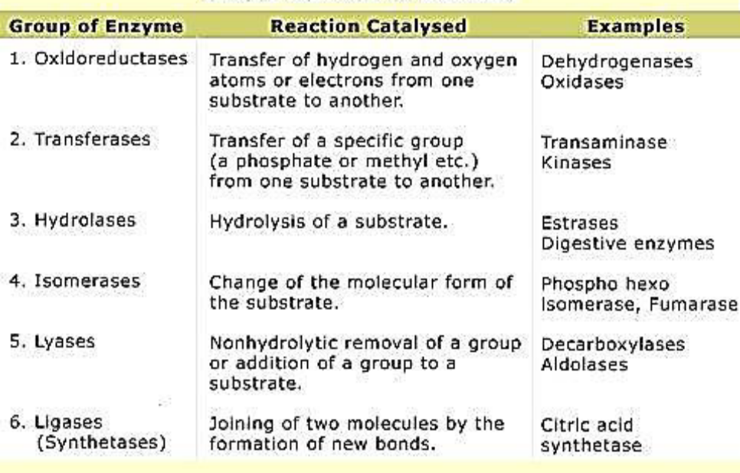s
8. 2 examples of unnatural pyrimidine bases. 2 marks.
MCQs come from CSS exams :-P mujhy nhi aty thy mostly

.
1.Role of nucleotide in regulatory functions.. 5
2. Natural sources of waxes. 3
• Waxes are widely
distributed in nature
such as the secretion
of certain insects as;
• Bees-wax,
• Spermaceti of the
sperm whale
Waxes also form
protective coatings of
the skins and furs of
animals and
• leaves and fruits of
Plants
Cholesterol
esters: Lanolin (or
wool fat)
3. Types and properties of waxes. 10
4. Types of cyclic nucleotides. 2
5. Enzymes and their classes. 10
6. Properties of nitrogenous bases. 5
Nitrogenous Bases
• Aromatic: The
Nitrogen containing
bases are aromatic i.e.
they have alternate
double bonds
Heterocyclic:
• They are heterocyclic
i.e. structures that
contain other atoms in
addition to carbon,
such as nitrogen in the
ring structure
The six-atom rings of
purines and pyrimidines
are numbered in
opposite directions…
Weak Bases: Purines
or pyrimidines with an –
NH2 group are weak
Bases

Functional Groups:
c
Hydrophobicity:
• The purine and
pyrimidine bases are
hydrophobic and
relatively insoluble in
water at the nearneutral
cell pH
• Stacking Interaction:
Hydrophobic stacking
interactions in which
two or more bases are
positioned with the
planes of their rings
parallel (like a stack of
coins) are one of two
important modes of
interaction between
bases in nucleic acids
• Base stacking helps to
minimize contact of the
bases with water, and
these interactions are
very important in
stabilizing the threedimensional
structure
of nucleic acids.
• UV light absorbance:
The conjugated double
bonds of purine and
pyrimidine derivatives
absorb ultraviolet lights
• The atoms in the
rings of the bases
are numbered
• 1 to 6 in
pyrimidines &
• 1 to 9 in purines
Phosphodiester Bond
• When two or more
nucleotides combine
together a
phosphodiester bond
is formed
7. Numbering of carbons of pentose sugar in nucleotides and nucleosides. 2
• In the pentoses of
nucleotides and
nucleosides the
carbon numbers are
given a prime (' )
designation to
distinguish them
from the numbered
atoms of the
nitrogenous
The carbons in the
pentose are
numbered 1' to 5 '.
• Numerals with a
prime (e.g., 2' or 3')
distinguish atoms of
the sugar from those
of the heterocycle
Thus, when the 5'-
carbon of a
nucleoside (or
nucleotide) is
referred to, a carbon
atom in the pentose,
rather than an atom
in the base, is being
specifiss
8..
BIO202 11am 1 marchs
1.PK1 of lysine is...
Lysine | 2.18
2. Simplest amino acid.
• A simple amino acid
e.g. glycine is a
diprotic acid when
fully protonated
• This means that it
has two groups, the
COOH and the NH3
+
group that can yield
protons
3. Carbohydrates and lipids formed..
4. Pyrimidins are.
tc
5. Guanine bonds with.. G3=C
6. Tripple bond found in..
1.Enzyme catalyze joining two molecules... Ligase
2. Optimum pH of pepsin...7
Pepsin | 1.5 - 1.6
3. Hsp70 b ans tha ik ka. PROTEIN IN NETWORKING
4. RNA is working copy of DN
bile salt is secreted by______and stored in________.. (liver, gallblader)
1.Waxes and its type and ts characteristic
2.enzymes and its classfication
3.name the pentagon sugers in nucleic acid and its characteristic.
4.Role of nucleutide energy currency in cell
5.Simple lipide and types
1. Simple lipids:
Esters of fatty acids with
various alcohols
These contain:
a. Fats (and Oils) and
b. Waxes.
s a. Fats: Esters of fatty
acids with glycerol (Oils
are fats in the liquid
state)
b. Waxes: Esters of
fatty acids with higher
molecular weight
monohydric alcohols.
(having one OH group)
6. three functions of primidines and purines.
7.differentatiate between adenini and guanine
• Both DNA and RNA
contain the same
purine bases:
• Adenine (A)
• Guanine (G)
• Adenine when
combines with pentose
the structure is known
as Adenosine or
deoxyadenosine
• Guanine when
combines with pentose
the structure is known
as Guanosine or
deoxyguanosine
• Adenine is 6-
aminopurine
• Guanine is 2-amino,6-
hydroxypurine
.
vBio202
What are enzymes ? Classification? 10 marks
Wax ?? It's type and properties ?
Name 2 unnatural pyrimidines ?
Neucleotide regulation ?
How can make bnaspati ghe
2 long 10 marks
what is wax ? describe in detail
what is enzyme ? also describe its functional groups
5 marks
what is primary DNA
3 marks
what is rancidity ? and what is hydroxyl and oxidize rancitity
baki bhul gay
2 long 10 marks
what is wax ? describe in detail
what is enzyme ? also describe its functional groups
5 marks
what is primary DNA
3 marks
what is rancidity ? and what is hydroxyl and oxidize rancitity
baki bhul gay
vBio202 at 4:30 pm
1)What is ranicidity?what are the factors that effect the rancidity of fats?5 marks
2)Primary structure of DNA?5marks
3)What are sterols?give 1 example of sterol present in animal tissue?3 marks
4)Differentiate b/w the structure of thymine and uracil?2marks
5)Write 3 functional group or purine and pyrimidine?3 marks
Functional Groups:
The most important
functional groups of
pyrimidines and purines
are
• ring nitrogens
• carbonyl groups
• exocyclic amino groups
6)What are waxes?give their properties and also explain its types?10 marks
7)What are enzymes?explain the types of enzymes?10 marks
8) Difference b/w nucleotide and nucleoside?2 marks
Nd mcqs were mostly from.mid term tpcs and also from end tpcs
Keratin kis main presrnt hy (hoof hair nails)
Palmitic acid main carbons kitny hty hyn
15 16 18
Polysachride ki type puchi thi
Fructse sucrose lactose cellulose
At 25°C kw value kia hti hy
1×10^14 or 1×10^-7
Bile k tpc se b ta k kahan se niklta hy or kahan store hta hy
Rhinocerous k horn kis sw bny hty hyn
Enzyme kinetics py konsa factor effect krta hy
Michelus mentn eq kis liye hti hy
Cmptetetive non competitive inhibitor
Flhl itny he yaad aye hyn...or jo yaad aye wo share kar dungi...

io202 (biochemstry)
1: Describe the role of nucleotide as a energy currency of the cell??
2: What are simple lipid? give two types of simple lipid??
3: Name three functional group of purines and pyrimidines??
4: Two example of unnatural pyrimidine bases??
5: Diff between nucleotide and nucleoside??
6: What is waxes?? explain in detail?
7: what is enzyme explain in detail?

5 Comments
1515

Dowwnloooood
Bio202 at 4:30 pm

1: Describe the role of nucleotide as a energy currency of the cell??
2: What are simple lipid? give two types of simple lipid??
A simple lipid is a fatty acid ester of different alcohols and carries no other substance. These lipids belong to a heterogeneous class of predominantly nonpolar compounds, mostly insoluble in water, but soluble in nonpolar organic solvents such as chloroform and benzene.
example: fats and oils.
3: Name three functional group of purines and pyrimidines??
nitro group
Exocyclic amino group
Or 3rd ha carbonyl group

4: Two example of unnatural pyrimidine bases??
fluorouracil or Azc
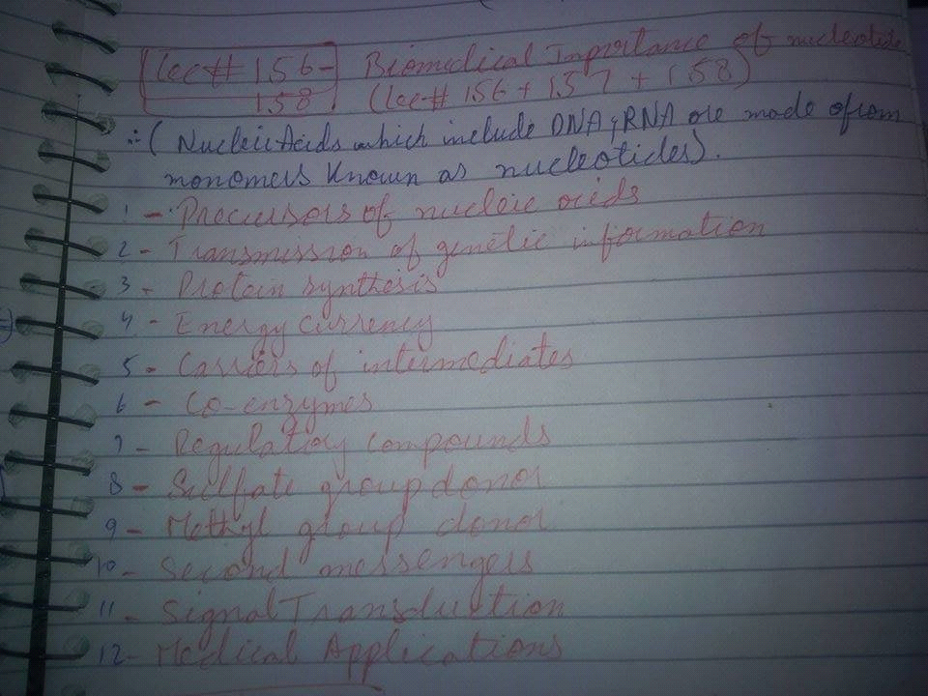

6: What is waxes?? explain in detail?
Waxes are a diverse class of organic compounds that are
hydrophobic,
malleable solids
near ambient temperatures
. They include higher alkanes and lipids,
typically with melting points above about 40 °C (104 °F),
melting to give low viscosity liquids.
Waxes are insoluble in water but soluble in organic, nonpolar solvents.
Natural waxes of different types are produced by plants and animals and occur in petroleum.
Animal waxes[edit]
The most commonly known animal wax is beeswax,
but other insects secrete (release) waxes,
A major component of the beeswax used in constructing honeycombs is the
ester myricyl palmitate which is an ester of triacontanol and palmitic acid.
Its melting point is 62-65 °C.
Spermaceti occurs in large amounts in the head oil of the sperm whale.
One of its main constituents is cetyl palmitate, another ester of a fatty acid and a fatty alcohol.
Lanolin is a wax obtained from wool, consisting of esters of sterols

Quizzzzzzzzzzzzzzzzzzzzzzzzzzzzzzz
BIO202 Quiz 2 with Answers
Fatty acids produce alkyl alcohols by __________ of carboxylic group.
Esterification
Oxidation
Reduction
None
#Reduction
Poly unsaturated fatty acids (like alpha-linolenic acid) with a double bond between C-3 and C-4 are called ________ fatty acids
omega-4
omega-3
omega-3,4
None of given
#Omega3
Hydrogenation of fatty acids leads to hardening of natural oils and formation of margarine because:Hydrogenation of fatty acids leads to hardening of natural oils and formation
(Missed)
Fatty acids are carboxylic acids in which length of ___________ chains range from 4 to 36 carbons.
Hydrocarbon
Polycarbon
Monosaccharide
Disaccharides
#Monosaccharide
1. 18-carbon oleic acid, with one double bond is abbreviated as__________
18:0
18-0
18-1
18:1
#18:1
The first fatty acid produced during fatty acid synthesis in the body and the precursor to longer fatty acids is ____________.
Linoleic acid
Arachidonic acid
Oleic acid
Palmitic acid
#Arachidonic_acid
Physical and Chemical Properties of Fatty Acids are due to their__________ .
length of hydrocarbon chain and degree of saturation
length of polypeptide chain and hydrocarbon atoms
name of fatty acid
side chain attached to all hydrogen atoms
None
#length_of_hydrocarbon_chain_and_degree_of_saturation
Amphipathic means that:
one end of the molecule is negative, the other is positive
one end of the molecule is hydrophobic, the other hydrophilic
one end of the molecule is carbohydrate, the other is protein
All
#All
In Poly unsaturated fatty acids, the carbon of the methyl group is known as___ carbon.
Alpha
Omega
Mu
Bravo
#Omega
Fats are the ___________ of fatty acids and glycerol.
Esters'
Ether
Isomer
Tautomer
Bakiii picssss
Total questions 48
MCQs:40
1.Explain numbring of carbon atoms in nitroginus bases. 2 marks
2.Two properties of glycerol trinitrate. 2 marks
3.name of Three pyrimidine bases.3 marks.
4.explain bees wax and spermaceti.3 marks
5.write five Properties of nitrogenous bases.5 marks
6.what is Rancidity?name and factors 5 marks
7. What is waxes?write detail Classfication with examples.10 marks
8. what is enzymes? detail note on diifrent types of enzymes with exampls. 10 marks
Like · Reply · 2 · February 25 at 8:33pm

Maria Chouhdry Bio202 at 4:30 pm
1)What is ranicidity?what are the factors that effect the rancidity of fats?5 marks
2)Primary structure of DNA?5marks
3)What are sterols?give 1 example of sterol present in animal tissue?3 marks
4)Differentiate b/w the structure of thymine and uracil?2mark
5)Write 3 functional group or purine and pyrimidine?3 s marks
6)What are waxes?give their properties and also explain its types?10 marks
7)What are enzymes?explain the types of enzymes?10 marks
8) Difference b/w nucleotide and nucleoside?2 marks
Nd mcqs were mostly from.mid term tpcs and also from end tpcs
Keratin kis main presrnt hy (hoof hair nails)
Palmitic acid main carbons kitny hty hyn
15 16 18
Polysachride ki type puchi thi
Fructse sucrose lactose cellulose
At 25°C kw value kia hti hy
1×10^14 or 1×10^-7
Bile k tpc se b ta k kahan se niklta hy or kahan store hta hy
Rhinocerous k horn kis sw bny hty hyn
Enzyme kinetics py konsa factor effect krta hy
Michelus mentn eq kis liye hti hy
Cmptetetive non competitive inhibitor
Flhl itny he yaad aye hyn...or jo yaad aye wo share kar dungi...
Like · Reply · February 25 at 11:07pm
s
Emma Scarlet 😐
Like · Reply · February 26 at 6:42am
Maria Chouhdry MCQs:40
1.Explain numbring of carbon atoms in nitroginus bases. 2 marks
2.Two properties of glycerol trinitrate. 2 marks
3.name of Three pyrimidine bases.3 marks.
4.explain bees wax and spermaceti.3 marks
5.write five Properties of nitrogenous bases.5 marks
6.what is Rancidity?name and factors 5 marks
7. What is waxes?write detail Classfication with examples.10 marks
8. what is enzymes? detail note on diifrent types of enzymes with exampls. 10 marks
Like · Reply · 1 · February 26 at 8:04

