Solution by Riz mughal
- THE INTEGRATING FACTOR FOR THE FIRST ORDER LINEAR DIFFERENTIAL EQUATION: DY/DX+Y COT X =SIN²X IS
SIN X
- THE INTEGRATING FACTOR FOR THE FIRST ORDER LINEAR DIFFERENTIAL EQUATION: 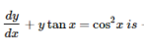
SECX
- IF THE NON-EXACT DIFFERENTAIL EQUATION M(x,y)DX+N(x,y)DY=0 IS OF THE FORM YF(xy)dx+xg(xy)dy=0, then the integrating factor is----------
1/xM-yN,xM-yN!=0
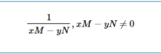
- IF THE NON-EXACT DIFFERENTAIL EQUATION M(x,y)DX+N(x,y)DY=0 IS homogeneous and Xm(X,Y)+YN
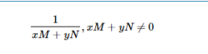
- Separable form f(y)dy=g(x)dx, of the differential equation: y-xdy/dx=a(y²+dy/dx)is-------
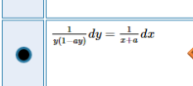
- Which of following will satisfy the differential equation: 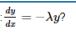
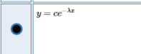
- Ydx-y(sinx)dy=0, is an example of ---- differential equation.
Non-exact
- Which of the following substitution will transform the differential equation: 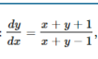 in to separate
Z=x+y
- Which of the following substitution will transform the differential equation: 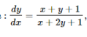IN TO A SEPARATE
X=X+h,y=Y+k
- If the differential equation: M(x,y)dx+N(x,y)dy= 0 is not exact, then after ------------an appropriate function u(x,y), we can from it to be exact.
Multiplying by
- The integrating factor for the first order linear differential equation: dy/dx+ytanx =cos²x is--------
Sec x
- Which of the following is an implicit solution of the differential equation: dy/dx=-x/y
X²+y²-4=0
- The differential equation(sin2x-tany) dx-xsec²ydy=0 is exact because---------
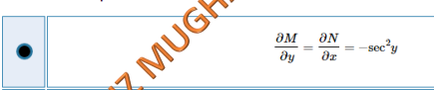
- A differential equation M(x,y)dx+N(x,y)dy=0 is exact if and only if----------
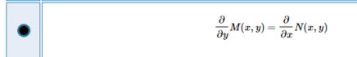
- Which of the following substitution will transform the differential equation: 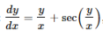into
Y=vx
- Which of the following is first order linear equation in unknown variable y?
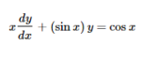
- For the non-exact differential equation 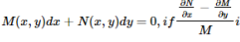is a function of y, then the
Function of y
- For the non-exact differential equation 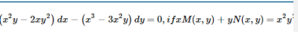
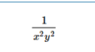
- For the non-exact differential equation 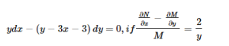
Y²

- The differential equation: 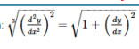has……………..
Order 2 and degree 4
- 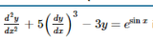is an example of ----------------differential equation.
Ordinary non-linear
- The differential equation 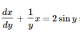is first order linear in unknown……….
Variable x
- Separable form of the differential equation: is -------------,where $v=y-1,$

- If fx²y³dx+x³y²dy=0 has the equivalent form as 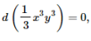then its solution is ---------
X³y³=c
- Which of the following function would satisfy: 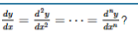
Y=Ae^{x}
- Which of the following is first order linear equation in unknown variable x?
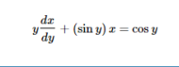
- Separable form f(y)dy+g(x)dx=0, of the differential equation:x sin ydx+(x²+1) cos ydy=0 is--------
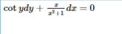
- 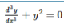IS A ------------differential equation of degree-----
Non-linear.1
- General solution of the separable differential equation: 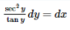is -------
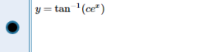
By helping hand
- The homogeneous linear differential equations always possess the --------------solution.
Trivial
- The auxiliary equation of the differential equation 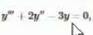is---
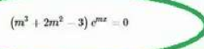
- The differential equation 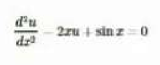is
Non-linear and homogenous
- Let 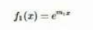and 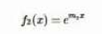are linearly independent because
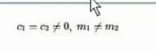
- The logistic equation, 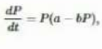can be identified as a nonlinear equation that is ---------------
Separable
- Wronskian of 1 and x²,W(1,x²)=----------
2x
- In the logistic equation 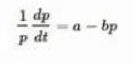the term 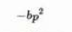can be interpreted as
Inhibition term
- Orthogonal trajectories occur naturally in the area(s) of-------------
(iv)all(i)(ii)and (iii)
- The leading coefficient in the differential equation 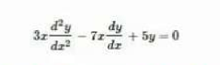
3

- Which one of the following will be used to draw an ogive?
A cumulative frequency distribution
- Which one is the formula of mid range.
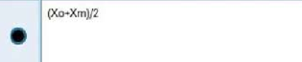
- Data arrangement in order of magnitude is called
Arrayed data
- From the following table what is lower class boundry when mode is calculated?
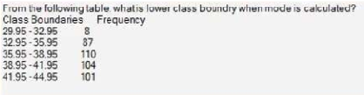
29.95
- The solutions y1=c1,y2=c2 cosx , y3=c3 sinx of a differential equation are
Linearly independent
- Wronskian of the functions y1(x)=1,y2(x)cosx,y3(x)=sinx is
1
- The value of amplitude in the solution X=7sin(3t+2.45) is
7
- The order of the differential equation 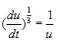is
1
- The solution of the differential equation 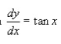is
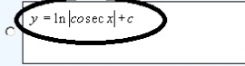
- A differential equation 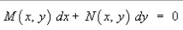is said to be an exact if--------------
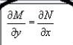
- The differential equation is a/an---------differential equation
Non-exact
- For a 1st order linear differential equation 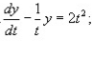the integarating factor will be--------
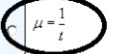
- A differential equation 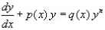for ,1 is called a/an------------
Bernoulli equation
- In order to change the Bernoulli equation 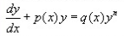into linear differential equation, we choose----
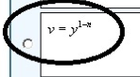
- The auxiliary equation of the differential equation 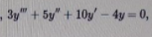is
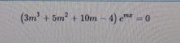
- Two function f(x)=x and 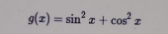are……..
Linearly independent
- A modification of the nonlinear logistic differential equation 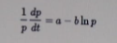has been used in the study of…….
All of these
- If we substitute 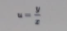in differential equation 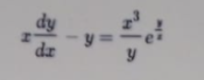then the given differential equation can be simplified to
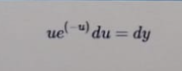
If 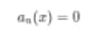in the differential equation 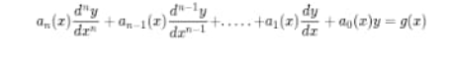for some xEI
Exist and unique
A function satisifying the differential equation on the some interval I, containing a and b, whose graph passes through two points (a,yo)and (b,y1)is called solution of the -------------value problem
Initial

