Zoo307

Complete Handouts 2023

Muhammad Zaman 👆😍 

0304-4756496

Subscribe to our YouTube Channel
https://www.youtube.com/channel/UCU9pcfHIAq8FgR7JFwpipdQ?sub_confirmation=1
Join our WhatsApp Group

Introduction
Lesson No. 1
Environmental Biology
Environmental science/Biology is the dynamic, interdisciplinary study of the interaction of living and non-living parts of the environment, with special focus on the impact of humans on the environment. The study of environmental science includes circumstances, objects, or conditions by which an organism or community is surrounded and the complex ways in which they interact. Environmental biology examines the ways organisms, species, and communities influence, and are impacted by, natural and humanaltered ecosystems. How the addition of a particular parasite will influence the plant and other animals of the particular area is an example of environmental biology. Like other natural sciences, environmental science is a science that gathers knowledge about the natural world. The methods of science include careful observation, record keeping, logical and mathematical reasoning, experimentation, and submitting conclusions to the scrutiny of others. Science also requires considerable imagination and creativity; a well-designed experiment is commonly described as elegant or beautiful. Science has considerable practical implications and some science is dedicated to practical applications, such as the prevention of disease. Other science proceeds largely motivated by curiosity. Whatever its goal, there is no doubt that science has transformed human existence and will continue to do so.
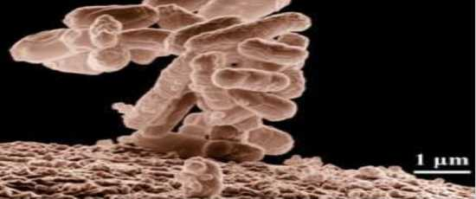
Biologists may choose to study Escherichia coli (E. coli), a bacterium that is a normal resident of our digestive tracts but which is also sometimes responsible for disease outbreaks. In this micrograph, the bacterium is visualized using a scanning electron microscope and digital colorization.

Need of Environmental Science:
The need for equitable, ethical, and sustainable use of Earth’s resources by a global population that nears the carrying capacity of the planet requires; How human behaviors affect the environment? scientific principles that govern interactions between the living and non-living. Our future depends on our ability to understand and evaluate evidence-based arguments about the environmental consequences of human actions and technologies, and to make informed decisions based on those arguments. Environment studies is all about learning the way we should live and how we can develop sustainable strategies to protect the environment. It helps individuals to develop an understanding of living and physical environment and how to resolve challenging environmental issues affecting nature. In addition to studying the physical aspects of the environment, it also emphasizes the need to conserve biodiversity and adopt a more sustainable lifestyle and utilize resources in a responsible way. Let us discuss the dire need and importance to include environmental studies in the course curriculum;
Environmental Biology is important to;
  - Learn how to use resources sustainably
  - Create awareness about preserving the environment
  - Participate in the mass movement to protect nature
  - Foster a healthy learning environment
  - Pursue a full-time career in environment studies
Lesson No. 2
Importance of Environmental Biology
1.Learn how to use resources sustainably
With natural resources such as air, water, oil, minerals are getting depleted rapidly, the environmental studies course can help students understand the importance of these resources and how we can improve the situation by taking appropriate actions in our regular lives to preserve these resources.
2.Create awareness about preserving the environment
Whether it is spreading awareness against plastic use or air pollution, universities can conduct various beyond-the-classroom activities as a part of this course to make students understand the significance of protecting the environment. Activities such as conducting awareness programs and rallies can prevent the degradation of the environment.
3.Participate in the mass movement to protect nature
While pursuing a course in environmental studies, students can be a part of mass public awareness movements and encourage their fellow batchmates to participate. Whether it is taking an initiative by planting trees in the campus, conducting workshops on various pressing issues or joining an NGO that supports environmental conservation, students can learn about various ways of protecting and conserving the environment.
4.Foster a healthy learning environment
Such important study empowers students to take a lead in creating a healthier, greener and sustainable learning environment where students understand the importance of saving the environment and take necessary steps to conserve the natural resources. Environment studies also help them develop the knowledge and skills required to address challenging environmental issues.
5.Pursue a full-time career in environment studies
Career opportunities in environmental studies are thriving with multiple options in the energy industry, animal conservation and more. You can prepare yourself for a fulfilling career that will include everything from conducting research, protecting the environment, crunching statistics, analyzing data, working in the field, interviewing people about disaster management and drafting policies with lawmakers to conserve the planet.
6.Helps in generating Creativity skills
Environmental science promotes the study and understanding of natural and human-caused processes in our natural environment. By researching and investigating complex environmental issues, students develop and enhance essential skills such as critical thinking, problem-solving, and creative thinking.
7.Saves the World from Destruction
An understanding of the relationship between humans and their environment is important to establish a sustainable feature. Humans have been abusing and exploiting the environment for years and have cause environmental degradation around the world. In the absence of a thorough understanding of environmental science, there is a considerable risk that what we know as a home may be lost to extinction. Environmental Biology is important because of the growing presence of calamities in our world. Examples of these calamities include flash floods, hurricanes, droughts, and many others. The growing presence of these calamities means that there is a great danger that our planet earth may lead to complete extinction.
8.Safeguards Future Generations
The discoveries made through the study of this field have led to a better understanding of our natural environment. These discoveries have been implemented into everyday life, and with continued improvement and following nature-related rules and regulations, we are directly saving resources for our next generations. The field of environmental sciences is a growing area of study which is enlarging due to the increasing number of challenges that the earth is facing. Apart from saving the planet, it has several career opportunities and opportunities for people who are associated with it. Environmental science is a growing field with increased opportunities due to our planet’s health.
Lesson No. 3
Scientific Method
What is Science? Environmental Biology is a science, but what exactly is science? What does the study of Environmental biology share with other scientific disciplines? Science (from the Latin scientia, meaning “knowledge”) can be defined as a process of gaining knowledge about the natural worldscience is a very specific way of learning about the world. The history of the past 500 years demonstrates that science is a very powerful way of gaining knowledge about the world; it is largely responsible for the technological revolutions that have taken place during this time. There are areas of knowledge, . the methods of science cannot be applied to. These include such things as morality, aesthetics, o spirituality. Science cannot investigate these areas because they are outside the realm of material phenomena, the phenomena of matter and energy, and cannot be observed and measured.
The scientific method is a method of research with defined steps that include experiments and careful observation
- The whole Scientific Method consists of following steps;
  - Make an Observation
  - Ask a Question
  - Do Background Research
  - Form a Hypothesis
  - Conduct an Experiment
  - Analyze Results and Draw a Conclusion
  - Report Your Results
The scientific method is a series of defined steps that include experiments and careful observation. If a hypothesis is not supported by data, a new hypothesis can be proposed.
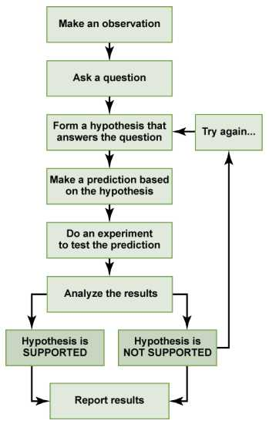
1.Make an Observation
You can’t study what you don’t know is there. This is why scientists are so curious—they’re always looking for patterns, trends, questions, and problems that we don’t understand. Once a scientist finds a really interesting pattern that they want to know more about, they move onto the next step. For example, let’s say that you notice a lot of people are drinking alkaline water because they think it’s healthier for them, but you’re not sure if it actually is or not. 
2. Ask a Question
Once a scientist finds an interesting thing to study, they need to ask a question that hopefully they can answer. A question that you could ask about alkaline water might be, “Does alkaline water actually make people healthier?”


3. Do Background Research
To find out the answer to your question, you need to know what potential answers are. That’s where background research comes in, remembering that not everything you read online is true. Use reliable sources, like Google Scholar…and untamedscience.com! In our alkaline water example, you could search online for articles or published scientific papers showing how people change when they drink alkaline water. You could look at overall health, or specific thinks like lung function, blood pH, etc.…


Lesson No. 4
Scientific Method
4. Form a Hypothesis
Two methods of logical thinking are used to form a hypothesis: inductive reasoning and deductive reasoning;
Inductive reasoning is a form of logical thinking that uses related observations to arrive at a general conclusion. his type of reasoning is common in descriptive science.
Deductive reasoning or deduction is the type of logic used in hypothesis-based science. In deductive reasoning, the pattern of thinking moves in the opposite direction as compared to inductive reasoning.
A hypothesis is a statement of what you think the answer to your question is. It’s different from the question you formed because it’s answering the question you developed with a specific prediction that you’ll go on to test. A good hypothesis should be falsifiable, meaning that it’s possible to prove it wrong.
Both types of logical thinking are related to the two main pathways of scientific study: descriptive science and hypothesis-based science. Descriptive (or discovery) science aims to observe, explore, and discover, while hypothesis-based science begins with a specific question or problem and a potential answer or solution that can be tested. The boundary between these two forms of study is often blurred, because most scientific endeavors combine both approaches. Observations lead to questions, questions lead to forming a hypothesis as a possible answer to those questions, and then the hypothesis is tested. Thus, descriptive science and hypothesis-based science are in continuous dialogue. Let’s say that your background research showed there wasn’t much of an effect on overall health. A hypothesis for this might be: “Drinking alkaline water has no effect on how well people feel.”
5. Conduct an Experiment
How do you find an answer to your hypothesis? You conduct an experiment to test it. Depending on what a scientist is studying, an experiment can be very quick or take years—some experiments have even been going on for hundreds of years. Designing a good experiment is a whole industry that some scientists spend their whole careers working on. But any good science experiment must always serve its one main function: to prove or disprove a hypothesis. To develop an experiment for the alkaline water example, you’d need a creative way to get people to drink normal and alkaline water, and ask them to rank how well they feel after drinking each.
6. Analyze Results and Draw a Conclusion
This is what we’ve all been waiting for—what is the answer to the question? In this step, scientists take a step back, look at the data, and decide whether to accept or reject the hypothesis. Sometimes the conclusion is pretty straightforward, but scientists always do statistical tests just to make sure they’re reading the results correctly. Now that you’ve collected your data from the alkaline water experiment, let’s say that there is no real difference in how well people feel based on what type of water they drink. In this case, you’d accept (or, fail to reject) your original hypothesis. Alkaline water would just be a scam that didn’t really affect how well people feel.
7. Report Your Results
You’ve just tested an important piece of information. It’s something that nobody else in the world knows. What good is that knowledge if you keep it to yourself? The final step of the scientific process is to report your results. Scientists generally report their results in scientific journals, where each report has been checked over and verified by other scientists in a process called peer review. If your alkaline water study were real, then you’d need to find a relevant journal and submit your article to them for publication.
Basic and Applied Science
Basic science or “pure” science seeks to expand knowledge regardless of the short-term application of that knowledge. It is not focused on developing a product or a service of immediate public or commercial value. The immediate goal of basic science is knowledge for knowledge’s sake, though this does not mean that in the end it may not result in an application. In contrast, applied science aims to use science to solve real-world problems, such as improving crop yield, find a cure for a particular disease, or save animals threatened by a natural disaster. In applied science, the problem is usually defined for the researcher.
Lesson No. 5
Concepts in Environmental Science
Ecological Footprint (EF)
The Ecological Footprint (EF), developed by Canadian ecologist and planner William Rees, is basically an accounting tool that uses land as the unit of measurement to assess per capita consumption, production, and discharge needs. It starts from the assumption that every category of energy and material consumption and waste discharge requires the productive or absorptive capacity of a finite area of land or water. If we (add up) all the land requirements for all categories of consumption and waste discharge by a defined population, the total area represents the Ecological Footprint of that population on Earth whether or not this area coincides with the population’s home region.
Environmental Sustainability
The sociopolitical, scientific, and cultural challenges of living within the means of the earth without significantly impairing its function is known as sustainability.
Precautionary Principle
The precautionary principle is an important concept in environmental sustainability. A 1998 consensus statement characterized the precautionary principle this way: “when an activity raises threats of harm to human health or the environment, precautionary measures should be taken even if some cause-and-effect relationships are not fully established scientifically”. For example, if a new pesticide chemical is created, the precautionary principle would dictate that we presume, for the sake of safety, that the chemical may have potential negative consequences for the environment and/or human health, even if such consequences have not been proven yet. In other words, it is best to proceed cautiously in the face of incomplete knowledge about something’s potential harm.
Indicators of Global Environmental Stress
Forests: Deforestation remains a main issue. The largest losses of forest area are taking place in the tropical moist deciduous forests, the zone best suited to human settlement and agriculture.
Soil: As much as 10% of the earth’s vegetated surface is now at least moderately degraded. Trends in soil quality and management of irrigated land raise serious questions about longer-term sustainability.
Freshwater: Some 20% of the world’s population lacks access to safe water and 50% lacks access to safe sanitation.
Marine Fisheries: 25% of the world’s marine fisheries are being fished at their maximum level of productivity and 35% are overfished (yields are declining).
Biodiversity: Biodiversity is increasingly coming under threat from development, which destroys or degrades natural habitats, and from pollution from a variety of sources.
Atmosphere: The Intergovernmental Panel on Climate Change has established that human activities are having a discernible influence on global climate. CO2 emissions in most industrialized countries have risen during the past few years and countries generally failed to stabilize their greenhouse gas emissions.
Indicators of Global Environmental Stress
Toxic Chemicals: About 100,000 chemicals are now in commercial use and their potential impacts on human health and ecological function represent largely unknown risks. Persistent organic pollutants are now so widely distributed by air and ocean currents that they are found in the tissues of people and wildlife everywhere; they are of particular concern because of their high levels of toxicity and persistence in the environment.
Hazardous Waste: Pollution from heavy metals, especially from their use in industry and mining, is also creating serious health consequences in many parts of the world. Domestic and industrial waste production continues to increase in both absolute and per capita terms, worldwide.
The Tragedy of the Commons
In his essay, The Tragedy of the Commons, Garrett Hardin (1968) looked at what happens when humans do not limit their actions by including the land as part of their ethic. The tragedy of the commons develops in the following way: Imagine a pasture open to all (the ‘commons’). It is to be expected that each herdsman will try to keep as many cattle as possible on the commons. As rational beings, each herdsman seeks to maximize their gain. Adding more cattle increases their profit, and they do not suffer any immediate negative consequence because the commons are shared by all. However, this same conclusion is reached by each and every rational herdsman sharing the commons. Therein lies the tragedy: each person is locked into a system that compels them to increase their herd, without limit, in a world that is limited. Eventually this leads to the ruination of the commons. In a society that believes in the freedom of the commons, freedom brings ruin to all because each person acts selfishly. Environmental Justice
Environmental Justice is defined as the fair treatment and meaningful involvement of all people regardless of race, color, national origin, or income with respect to the development, implementation, and enforcement of environmental laws, regulations, and policies. It will be achieved when everyone enjoys the same degree of protection from environmental and health hazards and equal access to the decision-making process to have a healthy environment in which to live, learn, and work.
Lesson No. 6
Environmental Ethics
Environmental ethics is a branch of applied philosophy that studies the conceptual foundations of environmental values as well as more concrete issues surrounding societal attitudes, actions, and policies to protect and sustain biodiversity and ecological systems.
These includes;
      - Frontier Ethic
      - Sustainable Ethic
      - Land Ethic
Frontier Ethic
A frontier ethic assumes that the earth has an unlimited supply of resources. If resources run out in one area, more can be found elsewhere or alternatively human ingenuity will find substitutes. This attitude sees humans as masters who manage the planet. The frontier ethic is completely anthropocentric (human-centered), for only the needs of humans are considered.
Sustainable Ethic
A sustainable ethic is an environmental ethic by which people treat the earth as if its resources are limited. This ethic assumes that the earth’s resources are not unlimited and that humans must use and conserve resources in a manner that allows their continued use in the future. A sustainable ethic also assumes that humans are a part of the natural environment and that we suffer when the health of a natural ecosystem is impaired
A sustainable ethic includes the following tenets:
  - The earth has a limited supply of resources.
  - Humans must conserve resources.
  - Humans share the earth’s resources with other living things.
  - Growth is not sustainable.
  - Humans are a part of nature.
  - Humans are affected by natural laws.
  - Humans succeed best when they maintain the integrity of natural processes sand cooperate with nature.
Land Ethic
Aldo Leopold, an American wildlife natural historian and philosopher suggested that humans had always considered land as property, just as ancient Greeks considered slaves as property. He believed that mistreatment of land (or of slaves) makes little economic or moral sense, much as today the concept of slavery is considered immoral. All humans are merely one component of an ethical framework. Leopold suggested that land be included in an ethical framework, calling this the land ethic. The land ethic simply enlarges the boundary of the community to include soils, waters, plants and animals; or collectively, the land. In short, a land ethic changes the role of Homo sapiens from conqueror of the land-community to plain member and citizen of it. It implies respect for his fellow members, and also respect for the community as such.
Lesson No. 7
Matter
Atoms, Molecules and Compounds
Life is made of matter. Matter is something that occupies space and has mass. All matter is composed of Elements, substances that cannot be broken down or transformed chemically into other substances. Each element is made of atoms, each with a constant number of protons and unique properties. A total of 118 elements have been defined; however, only 92 occur naturally and fewer than 30 are found in living cells. The remaining 26 elements are unstable and therefore do not exist for very long or are theoretical and have yet to be detected. Each element is designated by its chemical symbol (such as H, N, O, C, and Na), and possesses unique properties. These unique properties allow elements to combine and to bond with each other in specific ways. An Atom is the smallest component of an element that retains all of the chemical properties of that element. For example, one hydrogen atom has all of the properties of the element hydrogen, such as it exists as a gas at room temperature and it bonds with oxygen to create a water molecule. Hydrogen atoms cannot be broken down into anything smaller while still retaining the properties of hydrogen. If a hydrogen atom were broken down into subatomic particles, it would no longer have the properties of hydrogen.
Atoms combine to form Molecules. Molecule are chemicals made from two or more atoms bonded together.
Some molecules are very simple, like O2, which is comprised of just two oxygen atoms.
Some molecules used by organisms, such as DNA, are made of many millions of atoms.
Sub-Atomic Particles
- All atoms contain three sub atomic particles names as;
  - Protons
  - Electrons
  - neutrons.
The only exception is hydrogen (H), which is made of one proton and one electron. A proton is a positively charged particle that resides in the nucleus (the core of the atom) of an atom and has a mass of 1 and a charge of +1. An electron is a negatively charged particle that travels in the space around the nucleus. In other words, it resides outside of the nucleus. It has a negligible mass and has a charge of –1. Neutrons, like protons, reside in the nucleus of an atom. They have a mass of 1 and no charge. The positive (protons) and negative (electrons) charges balance each other in a neutral atom, which has a net zero charge

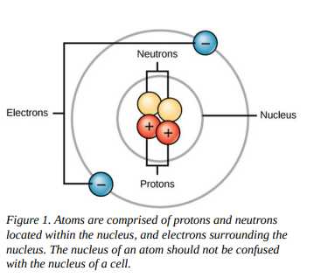
Each element contains a different number of protons and neutrons, giving it its own atomic number and mass number. The atomic number of an element is equal to the number of protons that element contains. The mass number is the number of protons plus the number of neutrons of that element. Therefore, it is possible to determine the number of neutrons by subtracting the atomic number from the mass number.
Isotope
Isotopes are different forms of the same element that have the same number of protons, but a different number of neutrons.
There are three isotopes of the element hydrogen:
  - Hydrogen
  - deuterium
  - Tritium
Lesson No. 8
Carbon Dating
Carbon-14 (14C) is a naturally occurring radioisotope that is created in the atmosphere by cosmic rays. This is a continuous process, so more 14C is always being created. As a living organism develops, the relative level of 14C in its body is equal to the concentration of 14C in the atmosphere. When an organism dies, it is no longer ingesting 14C, so the ratio will decline. 14C decays to 14N by a process called beta decay; it gives off energy in this slow process. After approximately 5,730 years, only one-half of the starting concentration of 14C will have been converted to 14N.The time it takes for half of the original concentration of an isotope to decay to its more stable form is called its half-life. Because the half-life of 14C is long, it is used to age formerly living objects, such as fossils. Using the ratio of the 14C concentration found in an object to the amount of 14C detected in the atmosphere, the amount of the isotope that has not yet decayed can be determined. Based on this amount, the age of the fossil can be calculated to about 50,000 years (Shown in figure below).

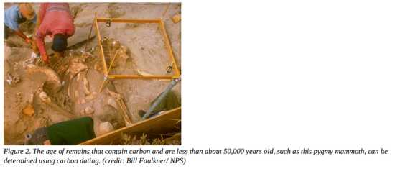
Isotopes with longer half-lives, such as potassium-40, are used to calculate the ages of older fossils. Through the use of carbon dating, scientists can reconstruct the ecology and biogeography of organisms living within the past 50,000 years.

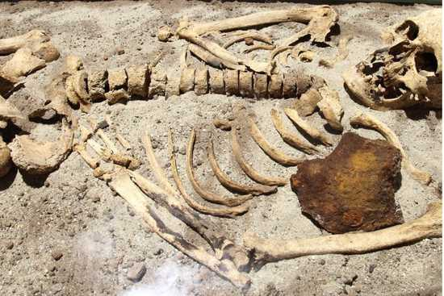
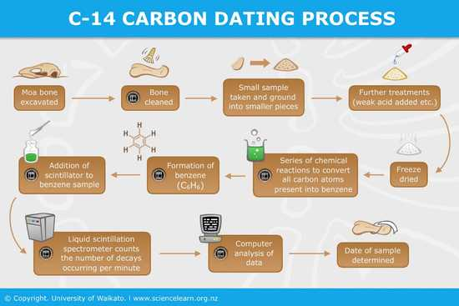
Lesson No. 9
Chemical Bonds
Ions
How elements interact with one another depends on the number of electrons and how they are arranged. When an atom does not contain equal numbers of protons and electrons it is called an ion. Because the number of electrons does not equal the number of protons, each ion has a net charge. For example, if sodium loses an electron, it now has 11 protons and only 10 electrons, leaving it with an overall charge of +1.
Cation and Anion
Positive ions are formed by losing electrons and are called cations. Negative ions are formed by gaining electrons and are called anions. Elemental anionic names are changed to end in -ide. As an example, when chlorine becomes an ion it is referred to as chloride

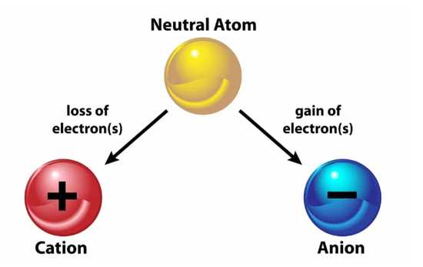
Chemical Bonds
Ionic and covalent bonds are strong bonds formed between two atoms. These bonds hold atoms together in a relatively stable state.
Ionic bonds are formed between two oppositely charged ions (an anion and a cation). Because positive and negative charges attract, these ions are held together much like two oppositely charged magnets would stick together.
Covalent bonds form when electrons are shared between two atoms. Each atom shares one of their electrons, which then orbits the nuclei of both Environmental Biology 37 Figure 3. Hydrogen bonds form between slightly positive (δ+) and slightly negative (δ–) charges of polar covalent molecules, such as water. atoms, holding the two atoms together. Covalent bonds are the strongest and most common form of chemical bond in organisms. Unlike most ionic bonds, covalent bonds do not dissociate in water.
- Covalent bonds come in two varieties:
  - Polar
  - Non-polar.
A non-polar covalent bond occurs when electrons are shared equally between the two atoms. Polar covalent bonds form when the electrons are shared unequally.
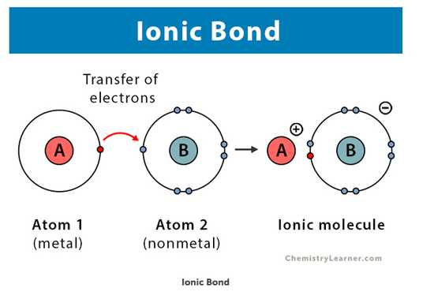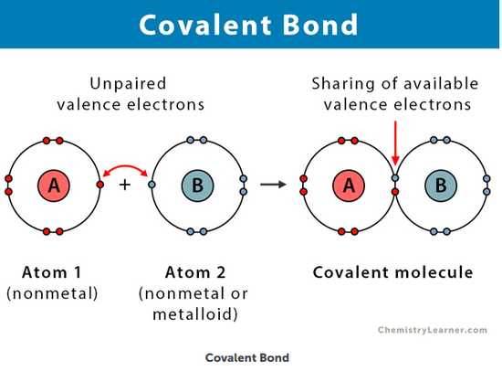
Electronegativity:
A measure of their affinity for electrons. Some elements, such as oxygen, are very electronegative because they strongly attract electrons from other atoms. Hydrogen, meanwhile, has low electronegativity and thus weakly attracts electrons, in comparison. Polar covalent bonds form when the two atoms involved have significantly different electronegativities. In biological systems, this occurs when oxygen bonds with hydrogen and when nitrogen (also quite electronegative) bonds with hydrogen.
Hydrogen Bonds
Hydrogen Bonding is a special type of dipole-dipole attraction between molecules, not a covalent bond to a hydrogen atom. It results from the attractive force between a hydrogen atom covalently bonded to a very electronegative atom such as a N, O, or F atom and another very electronegative atom.
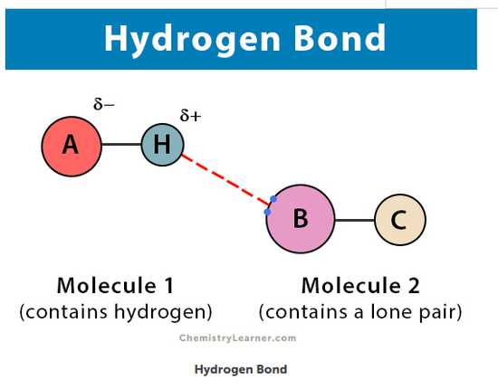
Lesson No. 10
Importance of Water
Water is essential to life; even minute traces of it on another planet can indicate that life could or did exist on that planet. Water is one of the more abundant molecules in living cells and the one most critical to life as we know it. Approximately 60–70 percent of your body is made up of water. Without it, life simply would not exist.

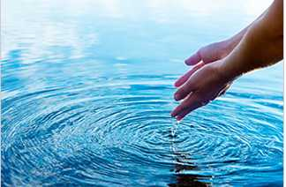

Importance of water can be described by following parameters;
  - Water is Polar
  - Water stabilizes temperature
  - Water is an excellent solvent
  - Water is cohesive
Water is Polar
- Water is polar because of its shape. The hydrogen ends of the molecule are positive and the oxygen end is negative. This causes water molecules to attract each other and other polar molecules. Water is a "polar" molecule, meaning that there is an uneven distribution of electron density. Water has a partial negative charge (Delta-) near the oxygen atom due the unshared pairs of electrons, and partial positive charges (Delta-) near the hydrogen atoms. Each water molecule attracts other water molecules because of the positive and negative charges in the different parts of the molecule. Water also attracts other polar molecules (such as sugars) that can dissolve in water and are referred to as hydrophilic (“water-loving”).
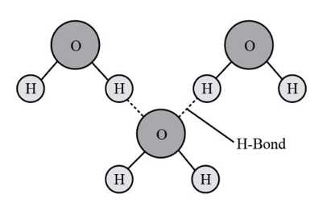
Water Stabilizes Temperature:
The hydrogen bonds in water allow it to absorb and release heat energy more slowly than many other substances. Temperature is a measure of the motion (kinetic energy) of molecules. As the motion increases, energy is higher and thus temperature is higher. Water absorbs a great deal of energy before its temperature rises. Increased energy disrupts the hydrogen bonds between water molecules. Because these bonds can be created and disrupted rapidly, water absorbs an increase in energy and temperature changes only minimally. This means that water moderates temperature changes within organisms and in their environments.
Water is an Excellent Solvent
Because water is polar, with slight positive and negative charges, ionic compounds and polar molecules can readily dissolve in it. Water is, therefore, what is referred to as a solvent—a substance capable of dissolving another substance. The charged particles will form hydrogen bonds with a surrounding layer of water molecules.
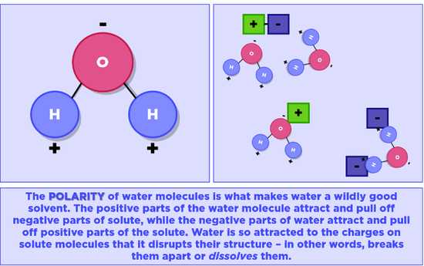
Water is Cohesive:
In cohesion, water molecules are attracted to each other (because of hydrogen bonding), keeping the molecules together at the liquid-air (gas) interface. Cohesion gives rise to surface tension, the capacity of a substance to withstand rupture when placed under tension or stress. Cohesion and surface tension keep the water molecules intact and the item floating on the top. It is even possible to “float” a steel needle on top of a glass of water if you place it gently, without breaking the surface tension.
Lesson No. 11
Buffers, pH, Acids, and Bases
pH
The pH of a solution is a measure of its acidity or alkalinity. The pH scale ranges from 0 to 14. A change of one unit on the pH scale represents a change in the concentration of hydrogen ions by a factor of 10, a change in two units represents a change in the concentration of hydrogen ions by a factor of 100.Thus, small changes in pH represent large changes in the concentrations of hydrogen ions.
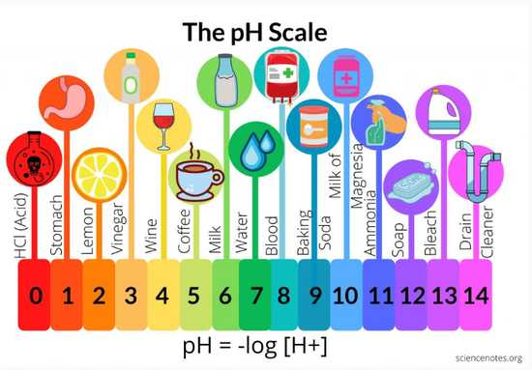
Acids and Bases
Acids are substances that provide hydrogen ions (H+) and lower pH, whereas bases provide hydroxide ions (OH–) and raise pH. The stronger the acid, the more readily it donates H+.For example, hydrochloric acid and lemon juice are very acidic and readily give up H+ when added to water. Conversely, bases are those substances that readily donate OH–. The OH– ions combine with H+ to produce water, which raises a substance’s pH. Sodium hydroxide and many household cleaners are very alkaline and give up OH– rapidly when placed in water, thereby raising the pH.
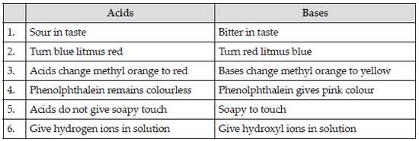Buffers readily absorb excess H+ or OH–, keeping the pH of the body carefully maintained in the aforementioned narrow range. Carbon dioxide is part of a prominent buffer system in the human body; it keeps the pH within the proper range. This buffer system involves carbonic acid (H2CO3) and bicarbonate (HCO3–) anion. If too much H+ enters the body, bicarbonate will combine with the H+ to create carbonic acid and limit the decrease in pH. Likewise, if too much OH– is introduced into the system, carbonic acid will combine with it to create bicarbonate and limit the increase in pH.
Lesson No. 12
Biological Molecules
Molecules from which living organisms are made. These
are categorized as organic and inorganic biomolecules.
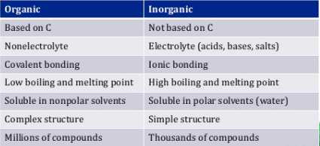
Organic molecules are those that contain carbon covalently bonded to hydrogen. In addition, they may contain oxygen, nitrogen, phosphorus, sulfur, and additional elements. There are four major classes of organic molecules: carbohydrates, lipids, proteins, and nucleic acids. Each is an important component of the cell and performs a wide array of functions.
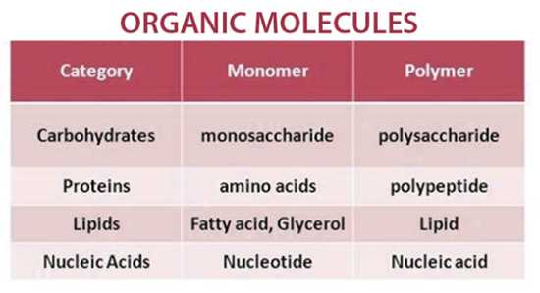
Carbohydrates
Carbohydrates include what are commonly referred to as simple sugars, like glucose, and complex carbohydrates such as starch. While many types of carbohydrates are used for energy, some are used for structure by most organisms, including plants and animals. For example, cellulose is a complex carbohydrate that adds rigidity and strength to the cell walls of plants. The suffix “-ose” denotes a carbohydrate, but note that not all carbohydrates were given that suffix when names (e.g., starch).
Lipids
Lipids include a diverse group of compounds that are united by a common feature. Lipids are hydrophobic (“water-fearing”), or insoluble in water, because they are non-polar molecules (molecules that contain non-polar covalent bonds) .
Lipids perform many different functions in a cell;
Cells store energy for long-term use in the form of lipids called fats. Lipids are most important components of cellular membranes. Lipids also provide insulation from the environment for plants and animals. For example, they help keep aquatic birds and mammals dry because of their water repelling nature. Lipids are also the building blocks of many hormones and are an important constituent of cellular membranes. Lipids include fats, oils, waxes, phospholipids, and steroids.
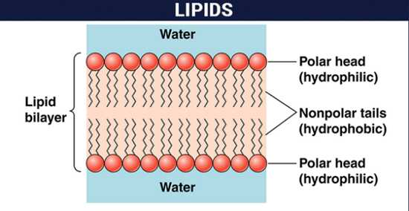
Proteins
Proteins are one of the most abundant organic molecules in living systems and have the most diverse range of functions of all macromolecules. They are all polymers of amino acids. The functions of proteins are very diverse because there are 20 different chemically distinct amino acids that form long chains, and the amino acids can be in any order. Proteins can function as enzymes, hormones, contractile fibers, cytoskeleton rods, and much more. Enzymes are vital to life because they act as catalyst in biochemical reactions (like digestion). Each enzyme is specific for the substrate (a reactant that binds to an enzyme) upon which it acts. Enzymes can function to break molecular bonds, to rearrange bonds, or to form new bonds.

Nucleic Acid
Nucleic acids are very large molecules that are important to the continuity of life. They carry the genetic blueprint of a cell and thus the instructions for its functionality. The two main types of nucleic acids are deoxyribonucleic acid (DNA) and ribonucleic acid (RNA). DNA is the genetic material found in all organisms, ranging from single-celled bacteria to multicellular mammals. The other type of nucleic acid, RNA, is mostly involved in protein synthesis. The DNA molecules never leave the nucleus, but instead use an RNA intermediary to communicate with the rest of the cell. Other types of RNA are also involved in protein synthesis and its regulation. DNA and RNA are made up of small building blocks known as nucleotides. The nucleotides combine with each other to form a polynucleotide: DNA or RNA. Each nucleotide is made up of three components: a nitrogenous base, a pentose (five-carbon) sugar, and a phosphate. DNA has a beautiful double-helical structure
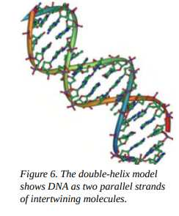
Lesson No. 13
Energy
The strength and vitality required for sustained physical or mental activity. Nutrients and other molecules are imported into the cell to meet these energy demands. For example, energy is required for the synthesis and breakdown of molecules, as well as the transport of molecules into and out of cells. Scientists use the term Bioenergetics to describe the concept of energy flow through living systems, such as cells. Cellular processes such as the building and breaking down of complex molecules occur through step-wise chemical reactions.
Metabolism and its Types
All of the chemical reactions that take place inside cells, including those that consume or generate energy, are referred to as the cell’s Metabolism.
- Metabolism is categorized in to two categories;
  - Anabolism
  - Catabolism
Anabolism refers to the process which builds molecules the body needs; it usually requires energy for completion. Catabolism refers to the process that breaks down complex molecules into smaller molecules; it usually releases energy for the organism to use.
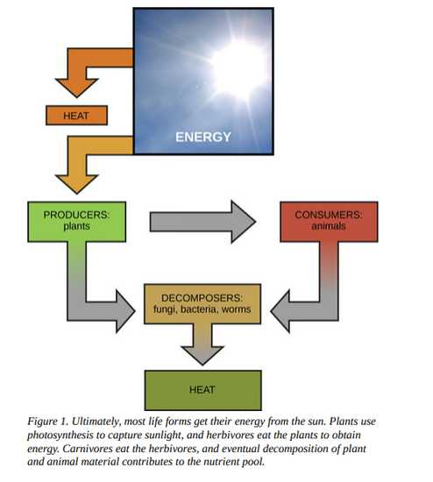
Thermodynamics, System and Surrounding
Thermodynamics refers to the study of energy and energy transfer involving physical matter. The matter relevant to a particular case of energy transfer is called a system Everything outside of that matter is called the surroundings. For instance, when heating a pot of water on the stove, the system includes the stove, the pot, and the water.
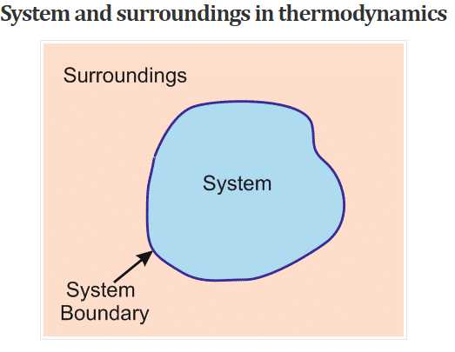
Open System and Closed System
There are two types of systems: open and closed. In an open system, energy can be exchanged with its surroundings. The stovetop system is open because heat can be lost to the air. A closed system cannot exchange energy with its surroundings.
Lesson No. 14
Laws of Thermodynamics
First Law of Thermodynamics
The first law of thermodynamics states that the total amount of energy in the universe is constant and conserved. In other words, there has always been, and always will be, exactly the same amount of energy in the universe.
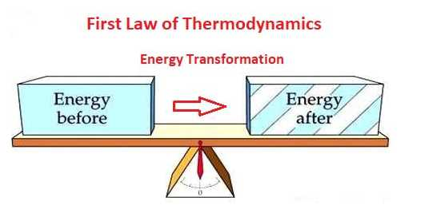
Energy exists in many different forms. According to the first law of thermodynamics, energy may be transferred from place to place or transformed into different forms, but it cannot be created or destroyed. For example plants perform one of the most biologically useful energy transformations on earth: that of converting the energy of sunlight to chemical energy stored within organic molecules In this figure, shown are some examples of energy transferred and transformed from one system to another and from one form to another. The food we consume provides our cells with the energy required to carry out bodily functions, just as light energy provides plants with the means to create the chemical energy they need. 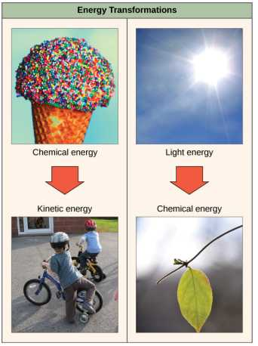
Second Law of Thermodynamics This law explains that all energy transfers and transformations are never completely efficient. In every energy transfer, some amount of energy is lost in a form that is unusable in most cases, this form is heat energy. Thermodynamically, heat energy is defined as the energy transferred from one system to another that is not work. For example, when a light bulb is turned on, some of the energy being converted from electrical energy into light energy is lost as heat energy. Likewise, some energy is lost as heat energy during cellular metabolic reactions.
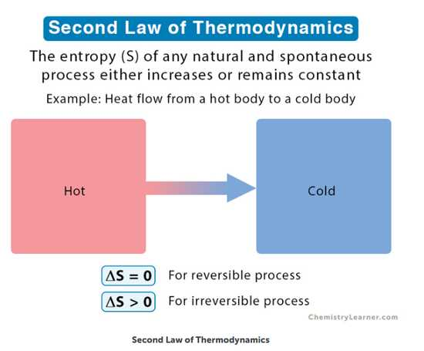
Kinetic Energy and Potential Energy:
Energy associated with objects in motion is called Kinetic Energy. A speeding bullet, a walking person, and the rapid movement of molecules in the air all have kinetic energy. The energy possessed by a body by virtue of its position relative to others, stresses within itself, electric charge, and other factors is called Potential Energy. A rock sitting on the edge of a cliff. If the rock falls, the potential energy will be converted to kinetic energy, as the rock will be moving. A stretched elastic string in a longbow.
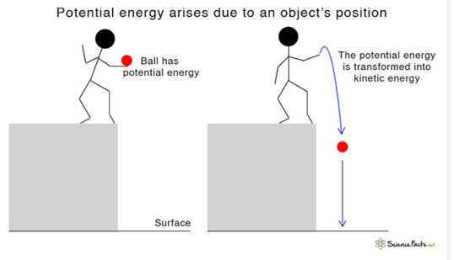
Lesson No. 15
Biological Organization
Living things are highly organized and structured, following a hierarchy of scale from small to large. All the levels of biological organizations are as following;
  - Sub-atomic and atomic level
  - Molecular Level
  - Cell and organelles level
  - Tissue Level
  - Organ and Organ system level
  - Individual
  - Population
  - Community
  - Ecosystem
  - Biome/Biosphere
Levels of Biological Organization
The atom is the smallest and most fundamental unit of matter. It consists of a nucleus surrounded by electrons. Atoms combine to form molecules, which are chemical structures consisting of at least two atoms held together by a chemical bond. In plants, animals, and many other types of organisms, molecules come together in specific ways to create structures called organelles. Organelles are small structures that exist within cells and perform specialized functions. In most multicellular organisms, cells combine to make tissues, which are groups of similar cells carrying out the same function. Organs are collections of tissues grouped together based on a common function. Organs are present not only in animals but also in plants. An organ system is a higher level of organization that consists of functionally related organs. For example vertebrate animals have many organ systems, such as the circulatory system that transports blood throughout the body and to and from the lungs; it includes organs such as the heart and blood vessels. Organisms are individual living entities. For example, each tree in a forest is an organism. All the individuals of a species living within a specific area are collectively called a population. A community is the set of different populations inhabiting a common area. For instance, all of the trees, flowers, insects, and other populations in a forest form the forest’s community. The forest itself is an ecosystem. An ecosystem consists of all the living things in a particular area together with the abiotic, or non-living, parts of that environment such as nitrogen in the soil or rainwater. At the highest level of organization, the biosphere is the collection of all ecosystems, and it represents the zones of life on Earth. It includes land, water, and portions of the atmosphere.
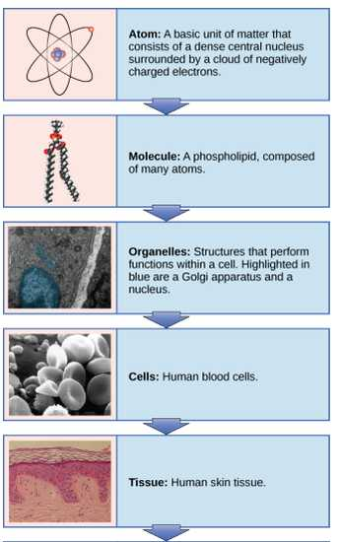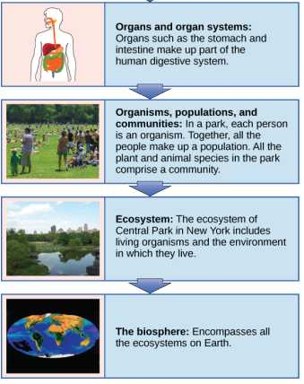
Lesson No. 16
Photosynthesis
Entrance of Energy into an Ecosystem
Photosynthesis is the process by which plants use sunlight, water, and carbon dioxide to create oxygen and energy in the form of sugar.
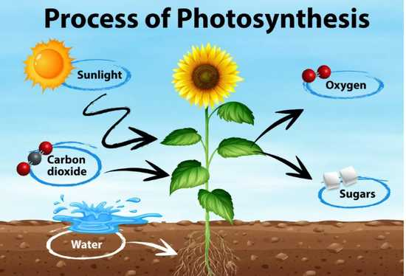
Through photosynthesis, certain organisms convert solar energy (sunlight) into chemical energy, which is then used to build carbohydrate molecules. The energy stored in the bonds to hold these molecules together is released when an organism breaks down food. Cells then use this energy to perform work, such as movement. The energy that is harnessed from photosynthesis enters the ecosystems of our planet continuously and is transferred from one organism to another. Therefore, directly or indirectly, the process of photosynthesis provides most of the energy required by living things on Earth.
Photosynthesis also results in the release of oxygen into the atmosphere. In short, to eat and breathe humans depend almost entirely on the organisms that carry out photosynthesis.
Autotrophs
An autotroph is an organism that can produce its own food. The Greek roots of the word autotroph mean “self” (auto) “feeder” (troph). Plants are the best-known autotrophs, but others exist, including certain types of bacteria and algae.
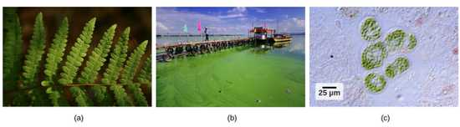
(a) Plants, (b) algae, and (c) certain bacteria, called cyanobacteria, are photoautotrophs that can carry out photosynthesis. Algae can grow over enormous areas in water, at times completely covering the surface.
Oceanic algae contribute enormous quantities of food and oxygen to global food chains. More specifically, plants are photoautotrophs, a type of autotroph that uses sunlight and carbon from carbon dioxide to synthesize chemical energy in the form of carbohydrates. All organisms carrying out photosynthesis require sunlight.
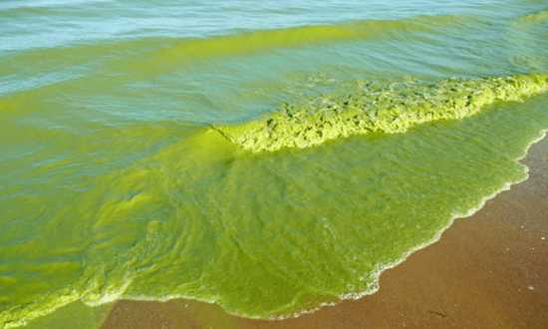
Heterotrophs
Heterotrophs are organism’s incapable of photosynthesis that must therefore obtain energy and carbon from food by consuming other organisms. The Greek roots of the word heterotroph mean “other” (hetero) “feeder” (troth), meaning that their food comes from other organisms. Even if the organism being consumed is another animal, it traces its stored energy back to autotrophs and the process of photosynthesis. Humans are heterotrophs, as are all animals and fungi. Heterotrophs depend on autotrophs, either directly or indirectly. For example, a deer obtains energy by eating plants. A wolf eating a deer obtains energy that originally came from the plants eaten by that deer. Using this reasoning, all food eaten by humans can be traced back to autotrophs that carry out photosynthesis.
Summary of Photosynthesis
Photosynthesis requires sunlight, carbon dioxide, and water as starting reactants. After the process is complete, photosynthesis releases oxygen and produces carbohydrate molecules, most commonly glucose. These sugar molecules contain the energy that living things need to survive. The complex reactions of photosynthesis can be summarized by the chemical equation shown in Figure.
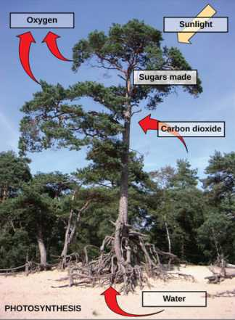

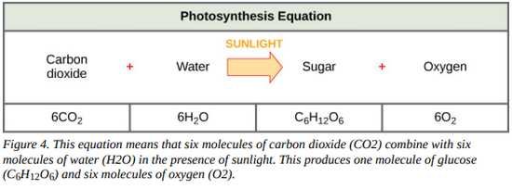Although the equation looks simple, the many steps that take place during photosynthesis are actually quite complex. In plants, photosynthesis takes place primarily in the chloroplasts of leaves. Chloroplasts have a double (inner and outer) membrane. Within the chloroplast is a third membrane that forms stacked, disc-shaped structures called thylakoids. Embedded in the thylakoid membrane are molecules of chlorophyll, a pigment (a molecule that absorbs light) through which the entire process of photosynthesis begins.
Two Parts of Photosynthesis
Photosynthesis takes place in two stages:
  - Light-dependent reactions
  - Calvin cycle
In the light dependent reaction’s chlorophyll absorbs energy from sunlight and then converts it into chemical energy with the aid of water. The light-dependent reactions release oxygen as a byproduct from the splitting of water. In the Calvin cycle, the chemical energy derived from the light-dependent reactions drives both the capture of carbon in carbon dioxide molecules and the subsequent assembly of sugar molecules.
Lesson No. 17
The Global Significance of Photosynthesis
Theme of global significance of photosynthesis consists of following main points;
  - Creation of Oxygen
  - Production of Energy
  - Carbon Fixation
Creation of Oxygen (O2)
It creates O2, which is important for two reasons.
The molecular oxygen in Earth’s atmosphere was created by photosynthetic organisms; without photosynthesis there would be no O2 to support cellular respiration needed by complex, multicellular life. Photosynthetic bacteria were likely the first organisms to perform photosynthesis, dating back 2-3 billion years ago. Thanks to their activity, and a diversity of present-day photosynthesizing organisms, Earth’s atmosphere is currently about 21% O2. Also, this O2 is vital for the creation of the ozone layer, which protects life from harmful ultraviolet radiation emitted by the sun. Ozone (O3) is created from the breakdown and reassembly of O2.
Production of Energy
It provides energy for nearly all ecosystems. By transforming light energy into chemical energy, photosynthesis provides the energy used by organisms, whether those organisms are plants, grasshoppers, wolves, or fungi. The only exceptions are found in very rare and isolated ecosystems, such as near deep sea hydrothermal vents where organisms get energy that originally came from minerals, not the sun.
Carbon Fixation
It provides the carbon needed for organic molecules. Organisms are primarily made of two things: water and organic molecules, the latter being carbon based. Through the process of carbon fixation, photosynthesis takes carbon from CO2 and converts it into sugars (which are organic). Carbon in these sugars can be re-purposed to create the other types of organic molecules that organisms need, such as lipids, proteins, and nucleic acids. For example, the carbon used to make your DNA was once CO2 used by photosynthetic organisms
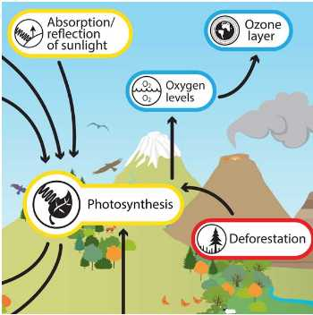
Lesson No. 18
Introduction to Ecosystem
Ecosystem
An ecosystem is a community of organisms and their abiotic (non-living) environment. Ecosystems can be small, such as the tide pools found near the rocky shores of many oceans, or large, such as those found in the tropical rainforest of the Amazon in Brazil as shown in figures
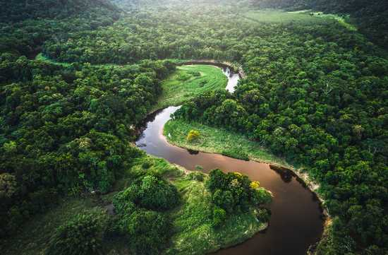

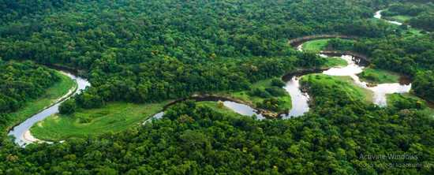

Components of Ecosystem
Every ecosystem has two components, namely, biotic components and abiotic components. Biotic components refer to all living organisms in an ecosystem. Abiotic refers to the non-living things. These biotic and abiotic interactions maintain the equilibrium in the environment
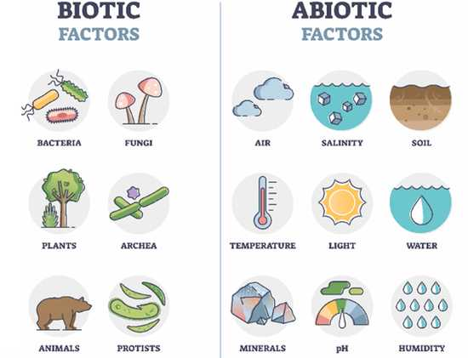
Categories of ecosystems
There are three broad categories of ecosystems based on their general environment:
  - Freshwater Ecosystems
  - Marine Ecosystems
  - Terrestrial Ecosystems
Within these three categories are individual ecosystem types based on the environmental habitat and organisms present.
Freshwater Ecosystems
Freshwater ecosystems are the least common, occurring on only 1.8 percent of Earth’s surface. These systems comprise lakes, rivers, streams, and springs; they are quite diverse and support a variety of animals, plants, fungi, protists and prokaryotes.
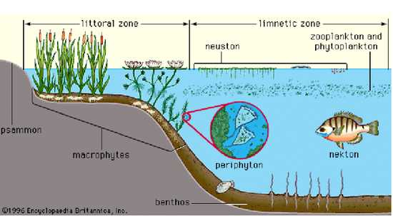
Marine Ecosystem
Marine ecosystems are the most common, comprising 75 percent of Earth’s surface and consisting of three basic types: shallow ocean, deep ocean water, and deep ocean bottom. Shallow ocean ecosystems include extremely biodiverse coral reef ecosystems. Small photosynthetic organisms suspended in ocean waters, collectively known as phytoplankton, perform 40 percent of all photosynthesis on Earth. Deep ocean bottom ecosystems contain a wide variety of marine organisms. These ecosystems are so deep that light is unable to reach them.
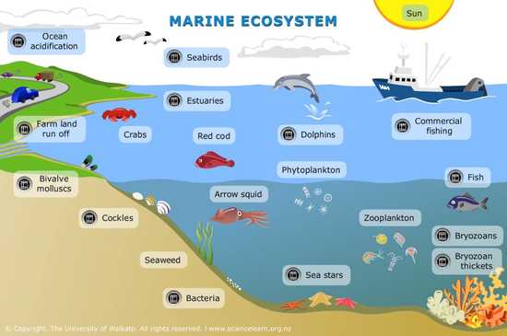
Terrestrial Ecosystems
Terrestrial ecosystems, also known for their diversity, are grouped into large categories called biomes. A biome is a large-scale community of organisms, primarily defined on land by the dominant plant types that exist in geographic regions of the planet with similar climatic conditions. Examples of biomes include tropical rainforests, savannas, deserts, grasslands, temperate forests, and tundra’s
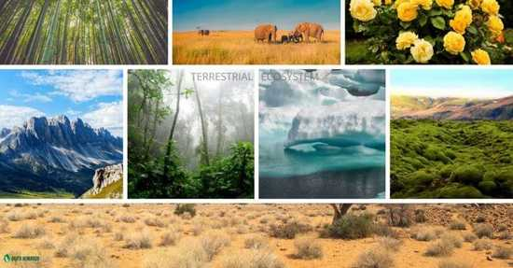.

Lesson No. 19
Freshwater Ecosystem
Freshwater ecosystems are a subset of Earth's aquatic ecosystems. They include lakes, ponds, rivers, streams, springs, bogs, and wetlands.

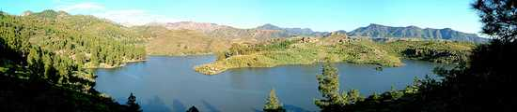
Freshwater habitats can be classified by different factors, including temperature, light penetration, nutrients, and vegetation. Contrasted with marine ecosystems, which have a larger salt content.
There are three basic types of freshwater ecosystems:
Lentic (slow moving water, including pools, ponds, and lakes) Lotic (faster moving water, for example streams and rivers) Wetlands (areas where the soil is saturated or inundated for at least part of the time). Freshwater habitats can be classified by different factors, including temperature, light penetration, nutrients, and vegetation. Contrasted with marine ecosystems, which have a larger salt content. There are three basic types of freshwater ecosystems: Lentic (slow moving water, including pools, ponds, and lakes) Lotic (faster moving water, for example streams and rivers) Wetlands (areas where the soil is saturated or inundated for at least part of the time).
Five broad threats to freshwater biodiversity include;
  - Overexploitation
  - Water pollution

  - Flow modification
  - Destruction or degradation of habitat
  - Invasion by exotic species
Freshwater biodiversity faces many threats. The World Wide Fund for Nature's Living Planet Index noted an 83% decline in the populations of freshwater vertebrates between 1970 and 2014.These declines continue to outpace contemporaneous declines in marine or terrestrial systems. The causes of these declines are related to:A rapidly changing climate
Online wildlife trade and invasive species
  - Infectious disease
  - Toxic algae blooms
  - Hydropower damming and fragmenting of half the world's rive
  - Emerging contaminants, such as hormones
  - Engineered nanomaterials
  - Microplastic pollution
  - Light and noise interference
  - Saltier coastal freshwaters due to sea level rise
  - Calcium concentrations falling below the needs of some freshwater organisms
  - The additive—and possibly synergistic—effects of these threats
Extinction of Freshwater Fauna
Over 123 freshwater fauna species have gone extinct in North America since 1900.Of North American freshwater species, an estimated 48.5% of mussels, 22.8% of gastropods, 32.7% of crayfishes, 25.9% of amphibians, and 21.2% of fish are either endangered or threatened. Projected extinction rates for freshwater animals are around five times greater than for land animals, and are comparable to the rates for rainforest communities. Given the dire state of freshwater biodiversity, a team of scientists and practitioners from around the globe recently drafted an Emergency Action plan to try and restore freshwater biodiversity
Lesson No. 20
Types of Freshwater Ecosystem
Lentic Freshwater Ecosystem
This section is an excerpt from Lake ecosystem. A lake ecosystem or lacustrine ecosystem includes biotic (living) plants, animals and micro-organisms, as well as abiotic (non-living) physical and chemical interactions. Lake ecosystems are a prime example of lentic ecosystems (lentic refers to stationary or relatively still freshwater from the Latin lentus, which means "sluggish"), which include ponds and lakes . Lentic ecosystems can be compared with lotic ecosystems, which involve flowing terrestrial waters such as rivers and streams. Together, these two ecosystems are examples of freshwater ecosystems.
Lotic ecosystems
This section is an excerpt from River ecosystem.River ecosystems are flowing waters that drain the landscape, and include the biotic (living) interactions amongst plants, animals and micro-organisms, as well as abiotic (nonliving) physical and chemical interactions of its many parts.River ecosystems are part of larger watershed networks or catchments, where smaller headwater streams drain into mid-size streams, which progressively drain into larger river networks.
Lentic Freshwater Ecosystem
The major zones in river ecosystems are determined by the river bed's gradient or by the velocity of the current. Faster moving turbulent water typically contains greater concentrations of dissolved oxygen, which supports greater biodiversity than the slow-moving water of pools. These distinctions form the basis for the division of rivers into upland and lowland rivers. Upland habitats are cold, clear and rocky whose rivers are fast-flowing in mountainous area. Lowland habitats are warm with slow-flowing rivers found in relatively flat lowland areas, with water that is frequently colored by sediment and organic matter.
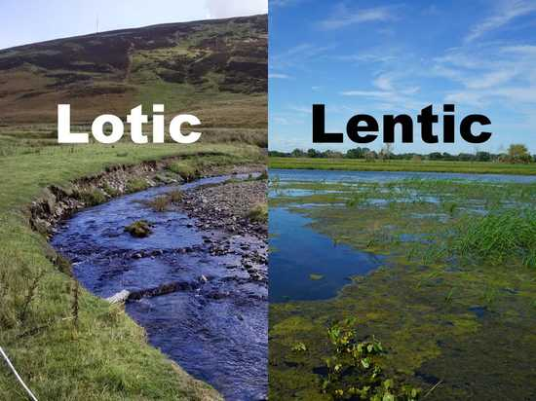
Wetlands
This section is an excerpt from Wetland. A wetland is a distinct ecosystem that is flooded or saturated by water, either permanently (for years or decades) or seasonally (for weeks or months). Flooding results in oxygen-free (anoxic) processes prevailing, especially in the soils. The primary factor that distinguishes wetlands from terrestrial land forms or water bodies is the characteristic vegetation of aquatic plants, adapted to the unique anoxic hydric soils. Wetlands are considered among the most biologically diverse of all ecosystems, serving as home to a wide range of plant and animal species. Methods for assessing wetland functions, wetland ecological health, and general wetland condition have been developed for many regions of the world. The water in wetlands is either freshwater, brackish or saltwater. Wetlands contribute a number of functions that benefit people. These are called ecosystem services and include water purification, groundwater replenishment, stabilization of shorelines and storm protection, water storage and flood control, processing of carbon (carbon fixation, decomposition and sequestration), other nutrients and pollutants, and support of plants and animals.
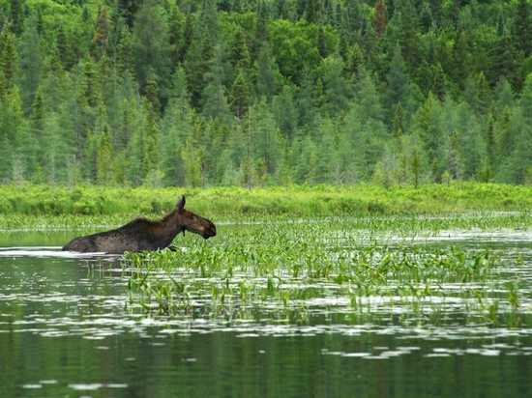
Lesson No. 21
Marine Ecosystem
Marine ecosystems are the largest of Earth’s aquatic ecosystems and exist in waters that have a high salt content. These systems contrast with freshwater ecosystems, which have a lower salt content. Marine waters cover more than 70% of the surface of the Earth and account for more than 97% of Earth's water supply and 90% of habitable space on Earth.
Marine Ecosystem Zone
Seawater has an average salinity of 35 parts per thousand of water. Actual salinity varies among different marine ecosystems. Marine ecosystems can be divided into many zones depending upon water depth and shoreline features.
  - The oceanic zone is the vast open part of the ocean where animals such as whales, sharks, and tuna live.
  - The benthic zone consists of substrates below water where many invertebrates live.
  - The intertidal zone is the area between high and low tides. Other near-shore (neritic) zones can include;
  - Mudflats
  - Seagrass meadows
  - Mangroves
  - Rocky intertidal systems
  - Salt marshes
  - Coral reefs
  - Lagoons
In the deep water, hydrothermal vents may occur where chemosynthetic sulfur bacteria form the base of the food web.

Biodiversity
Marine ecosystems are characterized by the biological community of organisms that they are associated with and their physical environment.
- Classes of organisms found in marine ecosystems include;
  - Brown algae
  - Dinoflagellates
  - Corals
  - Cephalopods
  - Echinoderms
  - and sharks.
Threats to Marine Ecosystem
Human uses of marine ecosystems and pollution in marine ecosystems are significantly threats to the stability of these ecosystems.
Environmental problems concerning marine ecosystems include;
  - Unsustainable exploitation of marine resources (for example overfishing of certain species)
  - Marine pollution
  - Climate change
  - Building on coastal areas.
Moreover, much of the carbon dioxide causing global warming and heat captured by global warming are absorbed by the ocean, ocean chemistry is changing through processes like ocean acidification which in turn threatens marine ecosystems.
Lesson No. 22
Marine Coastal Ecosystems
A marine coastal ecosystem is a marine ecosystem which occurs where the land meets the ocean.
- Marine coastal ecosystems include many different types of marine habitats such as;
  - Estuaries and Lagoons
  - Salt marshes and Mangrove forests
  - Seagrass meadows and Coral reefs
  - Kelp forests and Backwaters
Importance
Directly and indirectly, these provide a vast range of ecosystem services for humans, such as;
    - Sequestering carbon
    - Cycling nutrients and elements
    - Providing nurseries and fishing grounds for commercial fisheries
    - Preventing coastal erosion and moderating extreme events
    - Providing recreational services and supporting tourism.

Coastal Habitats
- There are following coastal habitats;
- Intertidal Zone
Estuaries
Lagoons
Reefs
Vegetated
Intertidal Zone
The intertidal zone, also known as the foreshore, is the area above water level at low tide and underwater at high tide. This area can include several types of habitats with various species of life, such as sea stars, sea urchins, and many species of coral with regional differences in biodiversity.
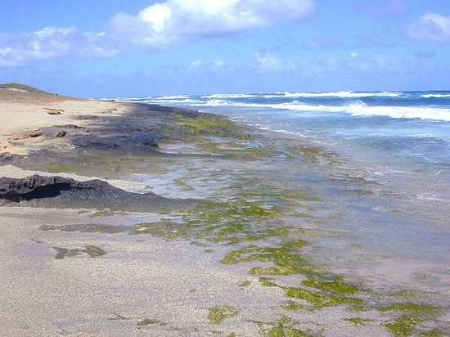
Estuaries
An estuary is a partially enclosed coastal body of brackish water with one or more rivers or streams flowing into it, and with a free connection to the open sea. Estuaries form a transition zone between river environments and maritime environments and are an example of an ecotone.
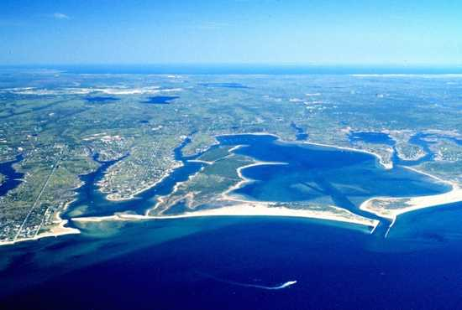
Lagoons
A lagoon is a shallow body of water separated from a larger body of water by a narrow landform, such as reefs, barrier islands, barrier peninsulas, or isthmuses.

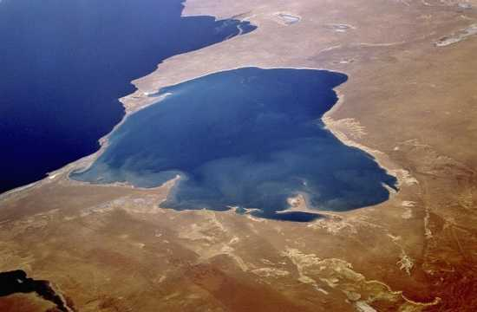
Reefs
A ridge of jagged rock, coral, or sand just above or below the surface of the sea is called reef.
- It is of two types;
    - Coral Reefs
    - Bivalve Reefs
Coral Reefs
A coral reef is an underwater ecosystem characterized by reef-building corals. Reefs are formed of colonies of coral polyps held together by calcium carbonate. Most coral reefs are built from stony corals, whose polyps cluster in groups.
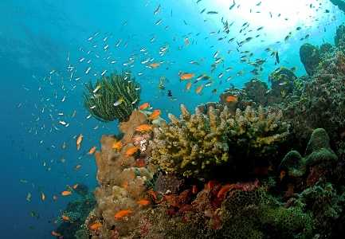
Bivalve Reefs
Bivalve reefs provide coastal protection through erosion control and shoreline stabilization, and modify the physical landscape by ecosystem engineering, thereby providing habitat for species by facilitative interactions with other habitats such as tidal flat benthic communities, seagrasses and marshes.
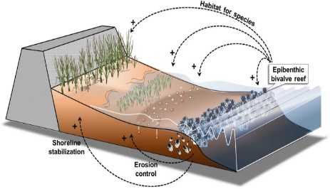
Lesson No. 23
Vegetated Marine Coastal Ecosystems
Vegetated coastal ecosystems occur throughout the world, as illustrated in the diagram below.
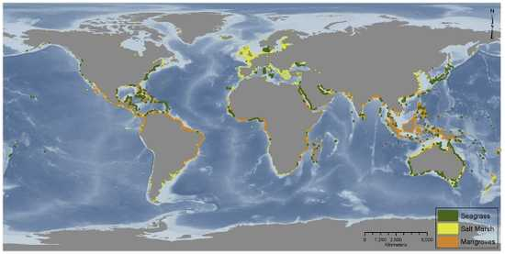
Vegetated coastal ecosystems include;
Mangrove Forests
Salt Marshes
Seagrass Meadows
Kelp Forests
Mangrove Forests
Mangroves are trees or shrubs that grow in low-oxygen soil near coastlines in tropical or subtropical latitudes. Mangroves consist of species that are not necessarily related to each other and are often grouped for the characteristics they share rather than genetic similarity Mangroves can often be recognized by their dense tangle of roots that act to protect the coast by reducing erosion from storm surges, currents, wave, and tides.
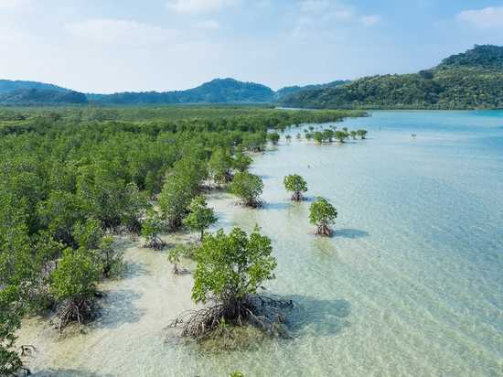
Salt Marshes
Salt marshes are a transition from the ocean to the land, where fresh and saltwater mix. the soil in these marshes is often made up of mud and a layer of organic material called peat. Peat is characterized as waterlogged and root-filled decomposing plant matter that often causes low oxygen levels (hypoxia).
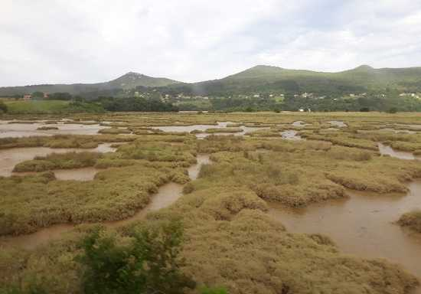

Seagrass Meadows
Seagrasses are the only flowering plants which grow in marine environments. A meadow is an open habitat, or field, vegetated by grasses, herbs and non-woody plants. Seagrasses form dense underwater meadows which are among the most productive ecosystems in the world. They provide habitats and food for a diversity of marine life comparable to coral reefs
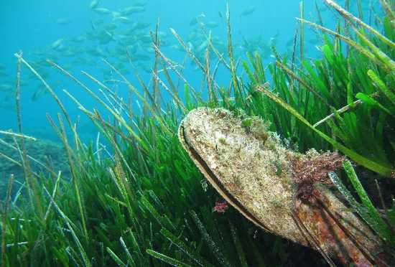
Kelp Forests
Kelp forests occur worldwide throughout temperate and polar coastal oceans. Physically formed by brown macroalgae, kelp forests provide a unique habitat for marine organisms and are a source for understanding many ecological processes. 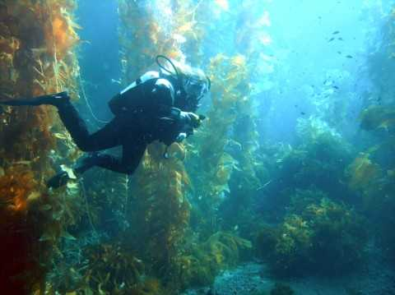
Lesson No. 24
Terrestrial Ecosystem
Terrestrial ecosystems are ecosystems which are found on land.
- These ecosystems include:
                - Tundra
                - Taiga
                - Temperate deciduous forest
                - Tropical rain forest
                - Grassland
                - Deserts
Terrestrial ecosystems differ from aquatic ecosystems by the predominant presence of soil rather than water at the surface and by the extension of plants above this soil/water surface in terrestrial ecosystems. There is a wide range of water availability among terrestrial ecosystems (including water scarcity in some cases), whereas water is seldom a limiting factor to organisms in aquatic ecosystems. Because water buffers temperature fluctuations, terrestrial ecosystems usually experience greater diurnal and seasonal temperature fluctuations than do aquatic ecosystems in similar climates.
Organisms and processes
Organisms in terrestrial ecosystems have adaptations that allow them to obtain;
        - Water when the entire body is no longer bathed in that fluid
        - Means of transporting the water from limited sites of acquisition to the rest of the body
        - Means of preventing the evaporation of water from body surfaces.
They also have traits that provide body support in the atmosphere, a much less buoyant medium than water, and other traits that render them capable of withstanding the extremes of temperature, wind, and humidity that characterize terrestrial ecosystems. Finally, the organisms in terrestrial ecosystems have evolved many methods of transporting gametes in environments where fluid flow is much less effective as a transport medium.
Types of Terrestrial Ecosystems
There are different types of terrestrial ecosystems but mainly includes;
                - Forests
                - Grassland
                - Tundra
                - Deserts
Lesson No. 25
Forests
The word forest broadly describes an area that has a large number of trees.
There are three general types of forest that exist:
      - Temperate
      - Tropical
      - Boreal/Taiga
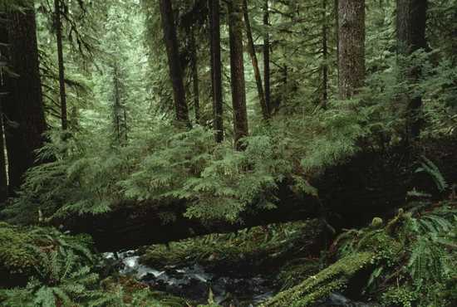
Temperate Forests
A temperate forest is a forest found between the tropical and boreal regions, located in the temperate zone.It is the second largest biome on our planet, covering 25% of the world's forest area, only behind the boreal forest, which covers about 33%.
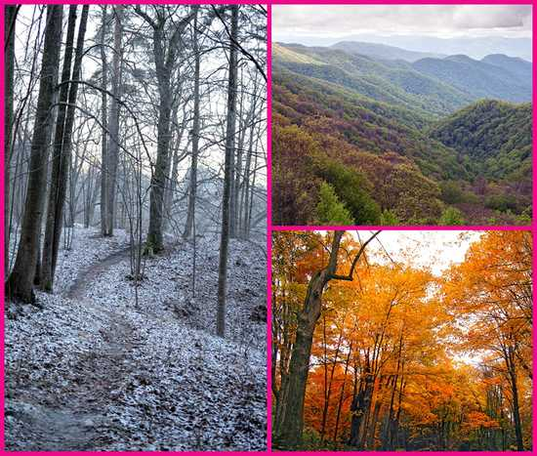
Climate
The climate of a temperate forest is highly variable depending on the location of the forest. For example, Los Angeles and Vancouver, Canada are both considered to be located in a temperate zone, however, Vancouver is located in a temperate rainforest, while Los Angeles is more subtropical. Temperate forests typically have winters that often reach below freezing, however even this is not always true. The East Coast forests retain their deciduous nature largely due to the excessive freezing days each winter, as the leaves often freeze over and are only designed to live for one season. Milder areas such as the southern coast of British Columbia where the average winter lows are above freezing often have evergreen rainforests.
Types of Temperate Forests
There is major four types of temperate forests as follows;
                - Deciduous
                - Coniferous
                - Mixed
                - Temperate Rainforest
Temperate Deciduous Forests
They are found in Europe, East Asia, North America, and in some parts of South America. Deciduous forests are composed mainly of broadleaf trees, such as maple and oak, that shed all their leaves during one season.They are typically found in three middle-latitude regions with temperate climates characterized by a winter season and year-round precipitation: eastern North America, western Eurasia and northeastern Asia
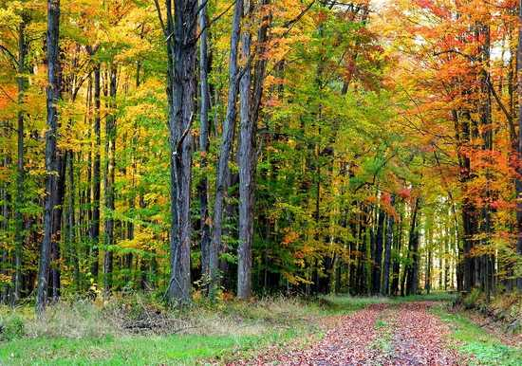
Lesson No. 26
Forests
Temperate Rainforest
Temperate rainforests are the wettest of all the types, and are found only in very wet coastal areas.Trees here are all evergreens, and are typically covered with thick moss and underbrush. Adding to its rarity is that most of the temperate rainforests outside protected areas have been cut down and no longer exist.Currently, complete temperate rainforests can only be found in select areas of the Pacific Northwest, parts of Chile and New Zealand. Small stands can be found in Great Britain and southern Australia.
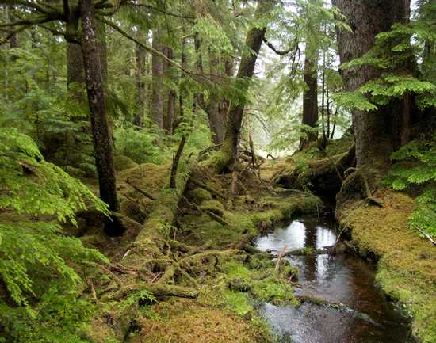

Tropical Forests
Tropical forests are forested landscapes in tropical regions: land areas approximately bounded by the tropic of Cancer and Capricorn, but possibly affected by other factors such as prevailing winds. He original tropical rainforests, which covered the planet's land surface, were the type of flora that covered Earth.
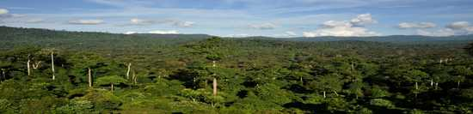
Boreal Forests/Taiga
Taiga generally referred to in North America as a boreal forest or snow forest, is a biome characterized by coniferous forests consisting mostly of pines, spruces, and larches. Taiga or boreal forest has been called the world's largest land biome.

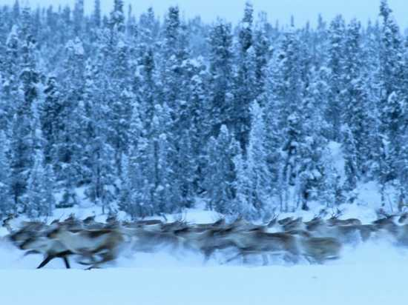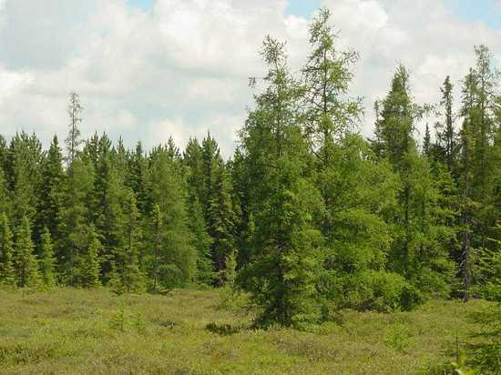
Temperate Coniferous Forests
Coniferous forests are composed of needle-leaved evergreen trees, such as pine or fir. Evergreen forests are typically found in regions with moderate climates. Boreal forests, however, are an exception as they are found in subarctic regions.Coniferous trees often have an advantage over broadleaf trees in harsher environments. Their leaves are typically hardier and longer lived but require more energy to grow.
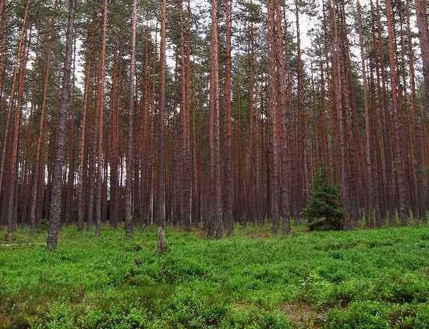
Temperate Mixed Forests
As the name implies, conifers and broadleaf trees grow in the same area. The main trees found in these forests in North America and Eurasia include fir, oak, ash, maple, birch, beech, poplar, elm and pine. Other plant species may include magnolia, prunus, holly, and rhododendron. In South America, conifer and oak species predominate. In Australia, eucalypts are the predominant trees. Hardwood evergreen trees which are widely spaced and are found in the Mediterranean region are olive, cork, oak and stone pine.
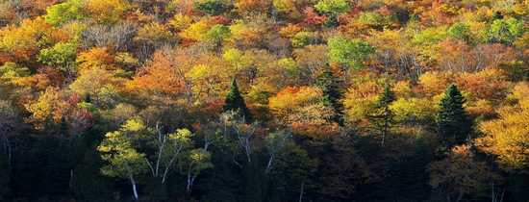
Lesson No. 27
Forests
Part -III
Taiga
The main tree species, the length of the growing season and summer temperatures vary across the world. The taiga of North America is mostly spruce, Scandinavian and Finnish taiga consists of a mix of spruce, pines and birch, Russian taiga has spruces, pines and larches depending on the region, while the Eastern Siberian taiga is a vast larch forest.Climate change is a threat to taiga, and how the carbon dioxide absorbed or emitted should be treated by carbon accounting is controversial.
Temperature
After the permanent ice caps and tundra, taiga is the terrestrial biome with the lowest annual average temperatures, with mean annual temperature generally varying from −5 to 5 °C (23 to 41 °F). Extreme winter minimums in the northern taiga are typically lower than those of the tundra. There are taiga areas of eastern Siberia and interior Alaska-Yukon where the mean annual reaches down to −10 °C (14 °F)
Growing Season
The growing season, when the vegetation in the taiga comes alive, is usually slightly longer than the climatic definition of summer as the plants of the boreal biome have a lower temperature threshold to trigger growth than other plants. Some sources claim 130 days growing season.High latitudes mean that the sun does not rise far above the horizon, and less solar energy is received than further south. But the high latitude also ensures very long summer days, as the sun stays above the horizon nearly 20 hours each day, or up to 24 hours, with only around 6 hours of daylight, or none, occurring in the dark winters, depending on latitude. The areas of the taiga inside the Arctic Circle have midnight sun in mid-summer and polar night in mid-winter.n as typical for the taiga.
Precipitation
The taiga experiences relatively low precipitation throughout the year (generally 200–750 mm (7.9–29.5 in) annually, 1,000 mm (39 in) in some areas), primarily as rain during the summer months, but also as snow or fog. Snow may remain on the ground for as long as nine months in the northernmost extensions of the taiga biome. The fog, especially predominant in low-lying areas during and after the thawing of frozen Arctic seas, stops sunshine from getting through to plants even during the long summer days. As evaporation is consequently low for most of the year, annual precipitation exceeds evaporation, and is sufficient to sustain the dense vegetation growth including large trees. This explains the striking difference in biomass per square meter between the Taiga and the Steppe biomes, (in warmer climates), where evapotranspiration exceeds precipitation, restricting vegetation to mostly grasses.
Soils
Taiga soil tends to be young and poor in nutrients, lacking the deep, organically enriched profile present in temperate deciduous forests.[30] The colder climate hinders development of soil, and the ease with which plants can use its nutrients. The relative lack of deciduous trees, which drop huge volumes of leaves annually, and grazing animals, which contribute significant manure, are also factors. The diversity of soil organisms in the boreal forest is high, comparable to the tropical rainforest. Fallen leaves and moss can remain on the forest floor for a long time in the cool, moist climate, which limits their organic contribution to the soil. Acids from evergreen needles further leach the soil, creating spodosol, also known as podzol and the acidic forest floor often has only lichens and some mosses growing on it. In clearings in the forest and in areas with more boreal deciduous trees, there are more herbs and berries growing, and soils are consequently deeper.
Flora
The forests of the taiga are largely coniferous, dominated by larch, spruce, fir and pine. The woodland mix varies according to geography and climate so for example the Eastern Canadian forests ecoregion of the higher elevations of the Laurentian Mountains and the northern Appalachian Mountains in Canada is dominated by balsam fir Abies balsamea, while further north the Eastern Canadian Shield taiga of northern Quebec and Labrador is notably black spruce Picea mariana and tamarack larch Larix laricina.
Fauna
The taiga is home to a number of large herbivorous mammals, such as moose and reindeer/caribou. Some areas of the more southern closed boreal forest also have populations of other deer species such as the elk (wapiti) and roe deer.The largest animal in the taiga is the wood bison, found in northern Canada, Alaska and has been newly introduced into the Russian far-east.Small mammals of the Taiga biome include rodent species including beaver, squirrel, North American porcupine and vole, as well as a small number of lagomorph species such as snowshoe hare and mountain hare. These species have adapted to survive the harsh winters in their native ranges.
Lesson No. 28
Grassland Ecosystem
Grasslands are areas where the vegetation is dominated by grasses.
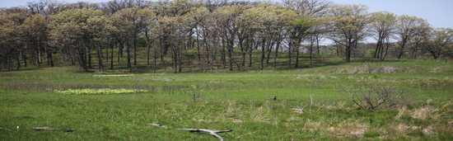
Grasslands occur naturally on all continents except Antarctica and are found in most ecoregions of the Earth. Grasslands are one of the largest biomes on earth and dominate the landscape worldwide.
- There are different types of grasslands:
  - Natural grassland
  - Semi-natural grasslands
  - Agricultural grasslands
They cover 31–69% of the Earth's land area
They can also be described as the following:
“Semi-natural grasslands are one of the world's most biodiverse habitats on a small spatial scales’’
“Semi-natural grasslands belong to the most species rich ecosystems in the world’’“They have been formed over the course of centuries through extensive grazing and mowing without the use of pesticides or fertilisers in modern time’’
Biodiversity
Grasslands dominated by unsown wild-plant communities ("unimproved grasslands") can be called either natural or "semi-natural" habitat. He semi-natural grasslands contain many species of wild plants, including grasses, sedges, rushes, and herbs; 25 plant-species per 100 square centimeters can be found. Associated with the wild-plant diversity of the "unimproved" grasslands is usually a rich invertebrate fauna; there are also many species of birds that are grassland "specialists", such as the snipe and the little bustard. The original wild-plant communities having been replaced by sown monocultures of cultivated varieties of grasses and clovers, such as perennial ryegrass and white clover. In many parts of the world, "unimproved" grasslands are one of the most threatened types of habitat, and a target for acquisition by wildlife conservation groups or for special grants to landowners who are encouraged to manage them appropriately.
Lesson No. 29
Grassland Ecosystem
Vegetation/Flora
Woody plants, shrubs or trees may occur on some grasslands—forming savannas, scrubby grassland or semi-wooded grassland, such as the African savannas or the Iberian deheza.Dominant trees for the semi-natural grassland are Quercus robur, Betula pendula, Corylus avellana, Crataegus and many kinds of herbs.
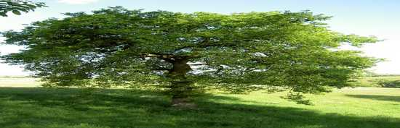
Fauna
Grasslands support the greatest aggregations of large animals on earth, including jaguars, African wild dogs, pronghorn, black-footed ferret, plains bison, mountain plover, African elephant, Sunda tiger, black rhino, white rhino, savanna elephant, greater one-horned rhino, Indian elephant and swift fox. Grazing animals, herd animals, and predators in grasslands, like lions and cheetahs live in the grasslands of the African savanna.
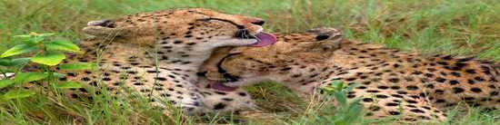

Grassland in all its form supports a vast variety of mammals, reptiles, birds, and insects. Typical large mammals include the blue wildebeest, American bison, giant anteater, and Przewalski's horse.
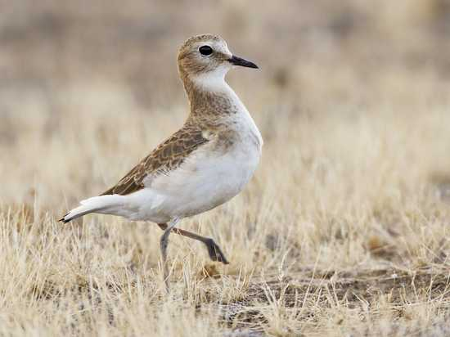
Carbon sequestration
Grasslands hold about 20 percent of global soil carbon stocks.Herbaceous (non-wooded) vegetation dominates grasslands and, unlike forests, carbon is stored in the roots and soil underground.grassland species have an extensive fibrous root system, with grasses often accounting for 60-80% of the biomass carbon in this ecosystem.For this reason, soil carbon accounts for about 81% of the total ecosystem carbon in grasslands. Grasslands have suffered large losses of organic carbon due to soil disturbances, vegetation degradation, fires, erosion, nutrient deficiencies, and water shortages.The type, frequency and intensity of the disturbance can play a key role in the soil organic carbon (SOC) balance of grasslands. Bedrock, irrigation practices, soil acidification, liming, and pasture management can all have potential impacts on grassland organic carbon stocks.
General Classification
Generally Grassland ecosystems are classified into:
          - Tropical and subtropical
          - Temperate
          - Flooded
          - Montane
          - Tundra grasslands
          - Desert and xeric
Lesson No. 30
Tundra
The Arctic tundra lies north of the subarctic boreal forests and is located throughout the Arctic regions of the Northern Hemisphere. Tundra also exists at elevations above the tree line on mountains. The average winter temperature is –34°C (–29.2°F) and the average summer temperature is 3°C–12°C (37°F –52°F).

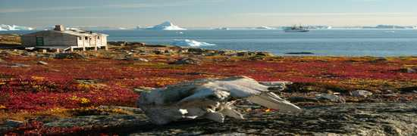

Plants in the Arctic tundra have a short growing season of approximately 50–60 days. However, during this time, there are almost 24 hours of daylight and plant growth is rapid. The annual precipitation of the Arctic tundra is low (15–25 cm or 6–10 in) with little annual variation in precipitation. And, as in the boreal forests, there is little evaporation because of the cold temperatures. Plants in the Arctic tundra are generally low to the ground and include low shrubs, grasses, lichens, and small flowering plants. There is little species diversity, low net primary productivity, and low above-ground biomass. The soils of the Arctic tundra may remain in a perennially frozen state referred to as permafrost. he permafrost makes it impossible for roots to penetrate far into the soil and slows the decay of organic matter, which inhibits the release of nutrients from organic matter. The melting of the permafrost in the brief summer provides water for a burst of productivity while temperatures and long days permit it. During the growing season, the ground of the Arctic tundra can be completely covered with plants or lichens.
Lesson No. 31
Desert Ecosystem
A desert is a barren area of landscape where little precipitation occurs and, consequently, living conditions are hostile for plant and animal life. The lack of vegetation exposes the unprotected surface of the ground to denudation. About one-third of the land surface of the Earth is arid or semi-arid.
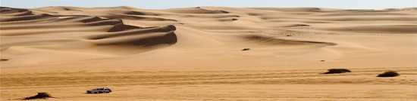
This includes much of the polar regions, where little precipitation occurs, and which are sometimes called polar deserts or "cold deserts".
Deserts can be classified by the:
      - Amount of precipitation that falls
      - Temperature that prevails
      - Causes of desertification
      - Their geographical location.
Deserts are formed by weathering processes as large variations in temperature between day and night put strains on the rocks, which consequently break in pieces. Although rain seldom occurs in deserts, there are occasional downpours that can result in flash floods. Rain falling on hot rocks can cause them to shatter, and the resulting fragments and rubble strewn over the desert floor are further eroded by the wind. This picks up particles of sand and dust, which can remain airborne for extended periods – sometimes causing the formation of sand storms or dust storms.
Adaptations of Biodiversity
Plants and animals living in the desert need special adaptations to survive in the harsh environment. Plants tend to be tough and wiry with small or no leaves, water-resistant cuticles, and often spines to deter herbivory. Some annual plants germinate, bloom and die in the course of a few weeks after rainfall, while other long-lived plants survive for years and have deep root systems able to tap underground moisture.

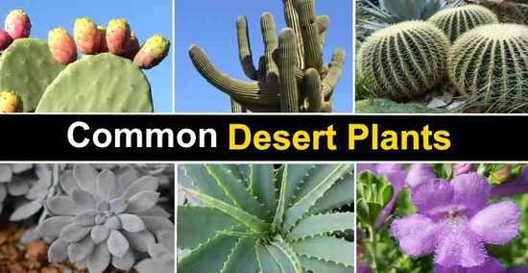
Animals need to keep cool and find enough food and water to survive. Many are nocturnal, and stay in the shade or underground during the heat of the day. They tend to be efficient at conserving water, extracting most of their needs from their food and concentrating their urine. Some animals remain in a state of dormancy for long periods, ready to become active again during the rare rainfall. They then reproduce rapidly while conditions are favorable before returning to dormancy.
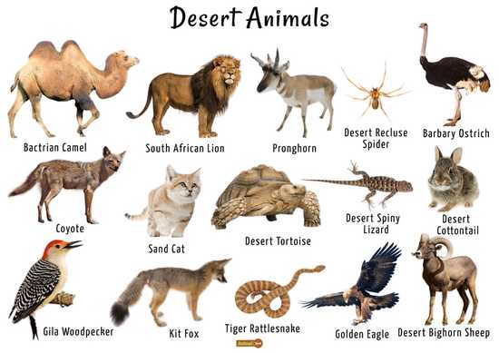
Flora
Plants face severe challenges in arid environments. Problems they need to solve include how to obtain enough water, how to avoid being eaten and how to reproduce. Photosynthesis is the key to plant growth. It can only take place during the day as energy from the sun is required, but during the day, many deserts become very hot. Opening stomata to allow in the carbon dioxide necessary for the process causes evapotranspiration, and conservation of water is a top priority for desert vegetation. Some plants have resolved this problem by adopting crassulacean acid metabolism, allowing them to open their stomata during the night to allow CO2 to enter, and close them during the day, or by using C4 carbon fixation.
Some dominant plants are as follows;
                - Prickly Pear Cacti.
                - Tumbleweed.
                - Saguaro Cactus.
                - Mexican Poppies.
                - Weathered Trees.
                - Wildflowers.
                - Orange Trees.
                - Ficus.
Fauna
Animals adapted to live in deserts are called xerocoles. A xerocole, is a general term referring to any animal that is adapted to live in a desert. Many desert animals (and plants) show especially clear evolutionary adaptations for water conservation or heat tolerance and so are often studied in comparative physiology, ecophysiology, and evolutionary physiology.One well-studied example is the specializations of mammalian kidneys shown by desert-inhabiting species. Some dominant Animalsare as follows;Lizards, geckos, toads, jackrabbits, camels, snakes, spiders and meerkats.
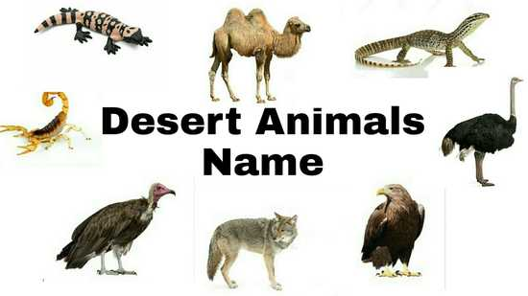

Lesson No. 32
Food Chain and Food Web
A food chain is a linear sequence of organisms through which nutrients and energy pass as one organism eats another.
The levels in the food chain are;
    - Producers
    - Primary consumers
    - Higher level consumers (Secondary and Tertiary)
    - Decomposers

Producers, Consumers and Decomposers
In many ecosystems, the base, or foundation, of the food chain consists of photosynthetic organisms (plants or phytoplankton), which are called producers. The organisms that consume the producers are herbivores called primary consumers. Secondary consumers are usually carnivores that eat the primary consumers. Tertiary consumers are carnivores that eat other carnivores. Higher-level consumers feed on the next lower trophic levels, and so on, up to the organisms at the top of the food chain.

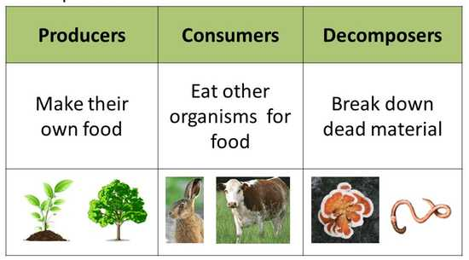
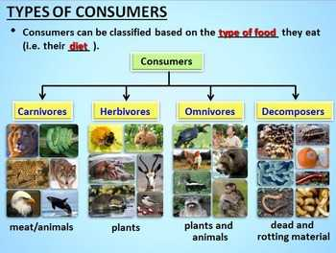
Food Chain and Food Web
These levels are used to describe ecosystem structure and dynamics. There is a single path through a food chain. Each organism in a food chain occupies a specific trophic level (energy level), its position in the food chain or food web.
Food Web
A food web is a concept that accounts for the multiple trophic (feeding) interactions between each species.

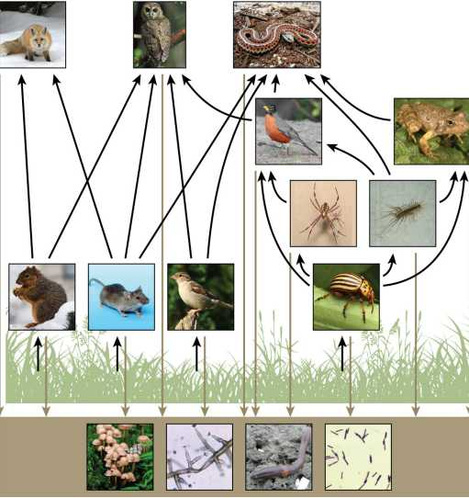

Lesson No. 33
Food Chain and Food Web
Food Web and Energy
All living things require energy in one form or another. At the cellular level, energy is used in most metabolic pathways (usually in the form of ATP), especially those responsible for building large molecules from smaller compounds. Living organisms would not be able to assemble complex organic molecules (proteins, lipids, nucleic acids, and carbohydrates) without a constant energy input.
Energy Flow in a Food Web
Food-web diagrams illustrate how energy flows directionally through ecosystems. They can also indicate how efficiently organisms acquire energy, use it, and how much remains for use by other organisms of the food web. Energy is acquired by living things in two ways: autotrophs harness light or chemical energy and heterotrophs acquire energy through the consumption and digestion of other living or previously living organisms.
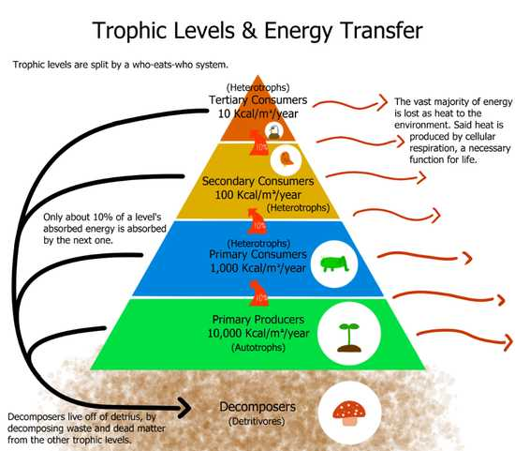
Autotrophs
Organisms capable of synthesizing their own food (more specifically, capable of using inorganic carbon as a carbon source are Known as Autotrophs.
Autotrophs are of two kinds;
  - Photoautotrophs (use sunlight as an energy source)
  - Chemoautotrophs (use inorganic molecules as an energy source.)
Gross and Net Primary Productivity
The rate at which photosynthetic producers incorporate energy from the Sun is called gross primary productivity. The energy that remains in the producers after accounting for these organisms’ metabolism and heat loss is called net primary productivity The net productivity is then available to the primary consumers at the next trophic level.
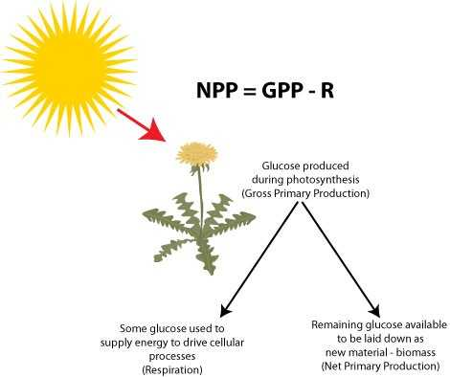
Biomagnification
Biomagnification is the increasing concentration of persistent, toxic substances in organisms at each successive trophic level. These are substances that are lipid soluble and are stored in the fat reserves of each organism. Many substances have been shown to biomagnify, including classical studies with the pesticide dichlorodiphenyltrichloroethane (DDT), which were described in the 1960s bestseller Silent Spring by Rachel Carson. DDT was a commonly used pesticide before its dangers to apex consumers, such as the bald eagle, became known. DDT and other toxins are taken in by producers and passed on to successive levels of consumers at increasingly higher rates.
Lesson No. 34
Biogeochemical Cycle
The recycling of inorganic matter between living organisms and their nonliving environment are called biogeochemical cycles. Geologic processes, such as weathering, erosion, water drainage, and the subduction of the continental plates, all play a role in the cycling of elements on Earth
- In this course we will discuss following biogeochemical cycles;
              - Water Cycle
              - Carbon Cycle
              - Nitrogen Cycle
              - Phosphorus Cycle
              - Sulphur Cycle
Water Cycle
The hydrosphere is the area of Earth where water movement and storage occurs: as liquid water on the surface (rivers, lakes, oceans) and beneath the surface (groundwater) or ice, (polar ice caps and glaciers), and as water vapor in the atmosphere.The hydrosphere is the area of Earth where water movement and storage occurs: as liquid water on the surface (rivers, lakes, oceans) and beneath the surface (groundwater) or ice, (polar ice caps and glaciers), and as water vapor in the atmosphere.
Whole process involves following steps;
The water cycle is driven by the Sun’s energy as it warms the oceans and other surface waters. This leads to evaporation (liquid water to water vapor) of liquid surface water and sublimation (ice to water vapor) of frozen water, thus moving large amounts of water into the atmosphere as water vapor.These water vapor condenses into clouds as liquid or frozen droplets and eventually leads to precipitation (rain, snow, hail), which returns water to Earth’s surface.Rain reaching Earth’s surface may evaporate again, flow over the surface, or percolate into the ground.Most easily observed is surface runoff: the flow of freshwater over land either from rain or melting ice. Runoff can make its way through streams and lakes to the oceans. A significant percentage of water evaporates immediately from the surfaces of plants. What is left reaches the soil and begins to move down.The plant will use some of this water for its own metabolism and some of that will find its way into animals that eat the plants, but much of it will be lost back to the atmosphere through a process known as transpiration: water enters the vascular system of plants through the roots and evaporates, or transpires, through the stomata (small microscope openings) of the leaves. Ecologists combine transpiration and evaporation into a single term that describes water returned to the atmosphere: evapotranspiration. Water in the soil that is not taken up by a plant and that does not evaporate is able to percolate into the subsoil and bedrock where it forms groundwater. Groundwater is a significant, subsurface reservoir of fresh water. It exists in the pores between particles in dirt, sand, and gravel or in the fissures in rocks. Groundwater can flow slowly through these pores and fissures and eventually finds its way to a stream or lake where it becomes part of the surface water again.Ecologists combine transpiration and evaporation into a single term that describes water returned to the atmosphere: evapotranspiration. Water in the soil that is not taken up by a plant and that does not evaporate is able to percolate into the subsoil and bedrock where it forms groundwater.Groundwater is a significant, subsurface reservoir of fresh water. It exists in the pores between particles in dirt, sand, and gravel or in the fissures in rocks. Groundwater can flow slowly through these pores and fissures and eventually finds its way to a stream or lake where it becomes part of the surface water again.
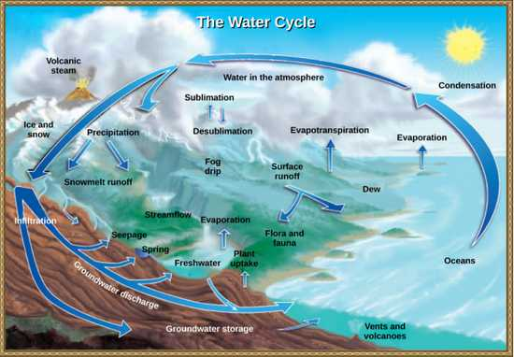
Lesson No. 35
Carbon Cycle
Carbon is the second most abundant element in organisms, by mass. Carbon is present in all organic molecules (and some molecules that are not organic such as CO2), and its role in the structure of biomolecules is of primary importance. Carbon compounds contain energy, and many of these compounds from dead plants and algae have fossilized over millions of years and are known as fossil fuels. Since the beginning of the Industrial Revolution the demand for Earth’s limited fossil fuel supplies has risen, causing the amount of carbon dioxide in our atmosphere to drastically increase. increase in carbon dioxide is associated with climate change and is a major environmental concern worldwide.Carbon is the second most abundant element in organisms, by mass. Carbon is present in all organic molecules (and some molecules that are not organic such as CO2), and its role in the structure of biomolecules is of primary importance. Carbon compounds contain energy, and many of these compounds from dead plants and algae have fossilized over millions of years and are known as fossil fuels. Since the beginning of the Industrial Revolution the demand for Earth’s limited fossil fuel supplies has risen, causing the amount of carbon dioxide in our atmosphere to drastically increase. This increase in carbon dioxide is associated with climate change and is a major environmental concern worldwide.
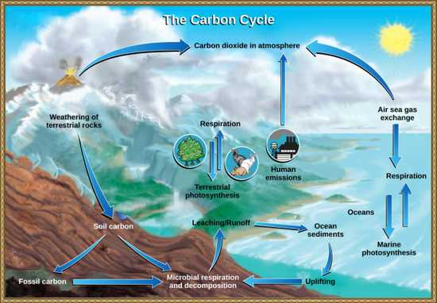
The Biological Carbon Cycle
Organisms are connected in many ways, even among different ecosystems. A good example of this connection is the exchange of carbon between heterotrophs and autotrophs by way of atmospheric carbon dioxide.Carbon dioxide (CO2) is the basic building block that autotrophs use to build high energy compounds such as glucose. The energy harnessed from the Sun is used by these organisms to form the covalent bonds that link carbon atoms together. These chemical bonds store this energy for later use in the process of respiration. Most terrestrial autotrophs obtain their carbon dioxide directly from the atmosphere, while marine autotrophs acquire it in the dissolved form (bicarbonate, HCO3 – ).Carbon is passed from producers to higher trophic levels through consumption. For example, when a cow (primary consumer) eats grass (producer), it obtains some of the organic molecules originally made by the plant’s photosynthesis. Those organic compounds can then be passed to higher trophic levels, such as humans, when we eat the cow. At each level, however, organisms are performing respiration, a process in which organic molecules are broken down to release energy.As these organic molecules are broken down, carbon is removed from food molecules to form CO2, a gas that enters the atmosphere. Thus, CO2 is a byproduct of respiration. Recall that CO2 is consumed by producers during photosynthesis to make organic molecules. As these molecules are broken down during respiration, the carbon once again enters the atmosphere as CO2.Carbon exchange like this potentially connects all organisms on Earth. Think about this: the carbon in your DNA was once part of plant; millions of years ago perhaps it was part of dinosaur.
Lesson No. 36
Carbon Cycle
The Biogeochemical Carbon Cycle
The movement of carbon through land, water, and air is complex, and, in many cases, it occurs much more slowly than the movement between organisms. Carbon is stored for long periods in what are known as carbon reservoirs, which include the atmosphere, bodies of liquid water (mostly oceans), ocean sediment, soil, rocks (including fossil fuels), and Earth’s interior. The level of carbon dioxide in the atmosphere is greatly influenced by the reservoir of carbon in the oceans. The exchange of carbon between the atmosphere and Carbon dioxide (CO2) from the atmosphere dissolves in water and reacts with water molecules to form ionic compounds. Some of these ions combine with calcium ions in the seawater to form calcium carbonate (CaCO3), a major component of the shells of marine organisms. These organisms eventually die and their shells form sediments on the ocean floor. Over geologic time, the calcium carbonate forms limestone, which comprises the largest carbon reservoir on Earth. d water reservoirs influences how much carbon is found in each. On land, carbon is stored in soil as organic carbon as a result of the decomposition of organisms or from weathering of terrestrial rock and minerals (the world’s soils hold significantly more carbon than the atmosphere, for comparison). Deeper underground are fossil fuels, the anaerobically decomposed remains of plants and algae that lived millions of years ago. Fossil fuels are considered a nonrenewable resource because their use far exceeds their rate of formation A non-renewable resource is either regenerated very slowly or not at all. Another way for carbon to enter the atmosphere is from land (including land beneath the surface of the ocean) by the eruption of volcanoes and other geothermal systems. Carbon sediments from the ocean floor are taken deep within Earth by the process of subduction: the movement of one tectonic plate beneath another. Carbon is released as carbon dioxide when a volcano erupts or from volcanic hydrothermal vents.
Lesson No. 37
Nitrogen Cycle
Getting nitrogen into living organisms is difficult. Plants and phytoplankton are not equipped to incorporate nitrogen from the atmosphere (where it exists as tightly bonded, triple covalent N2) even though this molecule comprises approximately 78 percent of the atmosphere. Nitrogen enters the living world through free-living and symbiotic bacteria, which incorporate nitrogen into their organic molecules through specialized biochemical processes. Certain species of bacteria are able to perform nitrogen fixation, the process of converting nitrogen gas into ammonia (NH3), which spontaneously becomes ammonium (NH4 + ). Ammonium is converted by bacteria into nitrites (NO2 − ) and then nitrates (NO3 − ). At this point, the nitrogen-containing molecules are used by plants and other producers to make organic molecules such as DNA and proteins. This nitrogen is now available to consumers.Certain species of bacteria are able to perform nitrogen fixation, the process of converting nitrogen gas into ammonia (NH3), which spontaneously becomes ammonium (NH4 + ). Ammonium is converted by bacteria into nitrites (NO2 − ) and then nitrates (NO3 − ). At this point, the nitrogen-containing molecules are used by plants and other producers to make organic molecules such as DNA and proteins. This nitrogen is now available to consumers.
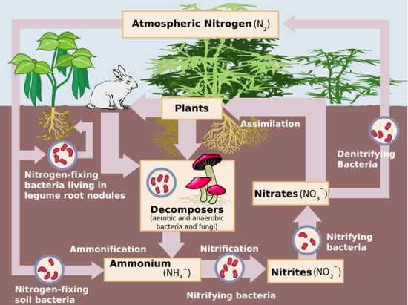
Lesson No. 38
Phosphorus Cycle
Phosphorus is an essential nutrient for living processes. It is a major component of nucleic acids and phospholipids, and, as calcium phosphate, it makes up the supportive components of our bones. Phosphorus is often the limiting nutrient (necessary for growth) in aquatic, particularly freshwater, ecosystems. Phosphorus occurs in nature as the phosphate ion (PO4 3-). In addition to phosphate runoff as a result of human activity, natural surface runoff occurs when it is leached from phosphate-containing rock by weathering, thus sending phosphates into rivers, lakes, and the ocean. This rock has its origins in the ocean. Phosphate-containing ocean sediments form primarily from the bodies of ocean organisms and from their excretions. However, volcanic ash, aerosols, and mineral dust may also be significant phosphate sources. This sediment then is moved to land over geologic time by the uplifting of Earth’s surface. (Figure on next slide) Phosphorus is also reciprocally exchanged between phosphate dissolved in the ocean and marine organisms. The movement of phosphate from the ocean to the land and through the soil is extremely slow, with the average phosphate ion having an oceanic residence time between 20,000 and 100,000 years.

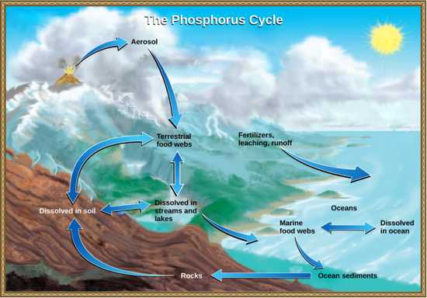
Phosphorus Cycle
Excess phosphorus and nitrogen that enter these ecosystems from fertilizer runoff and from sewage cause excessive growth of algae. The subsequent death and decay of these organisms depletes dissolved oxygen, which leads to the death of aquatic organisms such as shellfish and fish. This process is responsible for dead zones in lakes and at the mouths of many major rivers and for massive fish kills, which often occur during the summer months. A dead zone is an area in lakes and oceans near the mouths of rivers where large areas are periodically depleted of their normal flora and fauna. These zones are caused by eutrophication coupled with other factors including oil spills, dumping toxic chemicals, and other human activities. The number of dead zones has increased for several years, and more than 400 of these zones were present as of 2008.
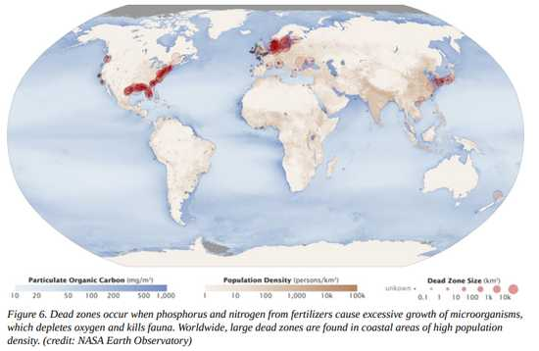
Lesson No. 39
Sulphur Cycle
Sulfur is an essential element for the molecules of living things. As part of the amino acid cysteine, it is involved in the formation of proteins. As shown in Figure on next slide, sulfur cycles between the oceans, land, and atmosphere. Atmospheric sulfur is found in the form of sulfur dioxide (SO2), which enters the atmosphere in three ways:
  - First, from the decomposition of organic molecules;
  - Second, from volcanic activity and geothermal vents; and,
  - Third, from the burning of fossil fuels by humans.
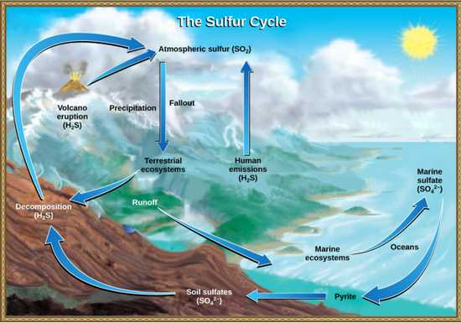
Sulphur Cycle
On land, sulfur is deposited in four major ways: precipitation, direct fallout from the atmosphere, rock weathering, and geothermal vents. Atmospheric sulfur is found in the form of sulfur dioxide (SO2), and as rain falls through the atmosphere, sulfur is dissolved in the form of weak sulfuric acid (H2SO4). Sulfur can also fall directly from the atmosphere in a process called fallout. Also, as sulfur-containing rocks weather, sulfur is released into the soil. On land, sulfur is deposited in four major ways: precipitation, direct fallout from the atmosphere, rock weathering, and geothermal vents. Atmospheric sulfur is found in the form of sulfur dioxide (SO2), and as rain falls through the atmosphere, sulfur is dissolved in the form of weak sulfuric acid (H2SO4). Sulfur can also fall directly from the atmosphere in a process called fallout. Also, as sulfur-containing rocks weather, sulfur is released into the soil. Sulfur enters the ocean in runoff from land, from atmospheric fallout, and from underwater geothermal vents. Some ecosystems rely on chemoautotrophs using sulfur as a biological energy source. This sulfur then supports marine ecosystems in the form of sulfates.
Human Activity on Sulphur Cycle
Human activities have played a major role in altering the balance of the global sulfur cycle. The burning of large quantities of fossil fuels, especially from coal, releases larger amounts of hydrogen sulfide gas into the atmosphere. As rain falls through this gas, it creates the phenomenon known as acid rain, which damages the natural environment by lowering the pH of lakes, thus killing many of the resident plants and animals. Acid rain is corrosive rain caused by rainwater falling to the ground through sulfur dioxide gas, turning it into weak sulfuric acid, which causes damage to aquatic ecosystems. Acid rain also affects the man-made environment through the chemical degradation of buildings. For example, Environmental Biology 81 many marble monuments, such as the Lincoln Memorial in Washington, DC, have suffered significant damage from acid rain over the years. These examples show the wide-ranging effects of human activities on our environment and the challenges that remain for our future.
Lesson No. 40
Introduction to Biodiversity
Biodiversity is all the different kinds of life you'll find in one area—the variety of animals, plants, fungi, and even microorganisms like bacteria that make up our natural world. Each of these species and organisms work together in ecosystems, like an intricate web, to maintain balance and support life.
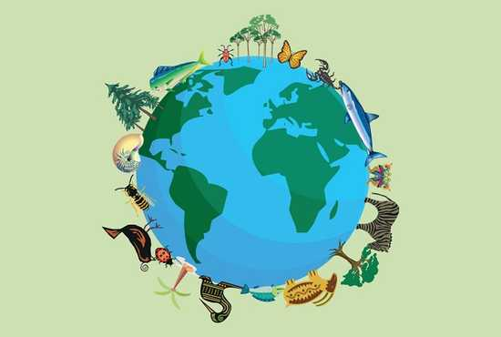
Taxonomy and other Terms
Biologists name, group, and classify organisms based on similarities in genetics and morphology. This branch of biological science is known as taxonomy. Taxonomists group organisms into categories that range from very broad to very specific. The broadest category is called domain and the most specific is species.
- Currently, taxonomists recognize three domains:
  - Bacteria
  - Archaea
  - Eukarya.
All life forms are classified within these three domains.
Taxonomic Hierarchy
“Taxonomic hierarchy is the process of arranging various organisms into successive levels of the biological classification either in a decreasing or an increasing order from kingdom to species and vice versa”
Taxon/Taxa
Taxon, plural Taxa, any unit used in the science of biological classification, or taxonomy. Taxa are arranged in a hierarchy from kingdom to subspecies, a given taxon ordinarily including several taxa of lower rank.
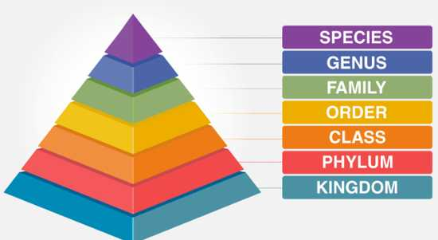
- Kingdom
The kingdom is the highest level of classification, which is divided into subgroups at various levels. There are 5 kingdoms in which the living organisms are classified, namely, Animalia, Plantae, Fungi, Protista, and Monera.
- Phylum
This is the next level of classification and is more specific than the kingdom. There are 35 phyla in kingdom Animalia. For Example – Porifera, Chordata, Arthropoda, etc.
- Class
Class was the most general rank in the taxonomic hierarchy until phyla were not introduced. Kingdom Animalia includes 108 classes including class mammalia, reptilia, aves, etc. However, the classes used today are different from those proposed by Linnaeus and are not used frequently.
- Order
Order is a more specific rank than class. The order constitutes one or more than one similar families. There are around 26 orders in class mammalia such as primates, carnivora, etc.
- Family
This category of taxonomic hierarchy includes various genera that share a few similarities e.g., the families in the order Carnivora include Canidae, Felidae, Ursidae, etc.
- Genus
A group of similar species forms a genus. Some genera have only one species and is known as monotypic, whereas, some have more than one species and is known as polytypic. For eg., lion and tiger are placed under the genus Panthera.
- Species
It is the lowest level of taxonomic hierarchy. There are about 8.7 million different species on earth. It refers to a group of organisms that are similar in shape, form, reproductive features. Species can be further divided into sub-species.
Taxonomic Hierarchy | Examples
Kingdom | Animalia
Phylum | Chordata
Class | Mammalia
Order | Primates
Family | Hominidae
Genus | Homo
Species | sapiens
Lesson No. 41
Domains of Life
There are three domains of life;
    - Bacteria
    - Archaea
    - Eukarya
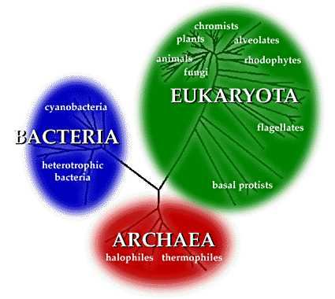
Domain Bacteria includes prokaryotic, unicellular organisms. They are incredibly abundant and found in nearly every imaginable type of habitat, including your body. Bacteria are well-known for their metabolic diversity. Many species of bacteria are autotrophs, meaning they can create their own food source without having to eat other organisms well-known and ecologically-important group of photosynthetic bacteria is cyanobacteria. Cyanobacteria play important roles in food webs of aquatic systems, such as lakes. Other species of bacteria are heterotrophs, meaning that they need to acquire their food by eating other organisms. This classification includes the bacteria that cause disease in humans (during an infection, the bacteria is eating you). However, most heterotrophic bacteria are harmless to humans. In fact, you have hundreds of species of bacteria living on your skin and in your large intestine that do you no harm. Beyond your body, heterotrophic bacteria play vital roles in ecosystems, especially soil dwelling bacteria that decompose living matter and make nutrients available to plants.
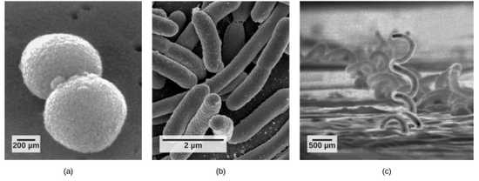
Many prokaryotes fall into three basic categories based on their shape: (a) cocci, or spherical; (b) bacilli, or rod-shaped; and (c) spirilla, or spiral-shaped.
Domain Archaea
Like bacteria, organisms in domain Archaea are prokaryotic and unicellular. Archaea, (domain Archaea), any of a group of single-celled prokaryotic organisms (that is, organisms whose cells lack a defined nucleus) that have distinct molecular characteristics separating them from bacteria (the other, more prominent group of prokaryotes) as well as from eukaryotes (organisms, including plants and animals, whose cells contain a defined nucleus). Archaea is derived from the Greek word archaios, meaning “ancient” or “primitive,” and indeed some archaea exhibit characteristics worthy of that name.
- Members of the archaea include:
Pyrolobus fumarii, which holds the upper temperature limit for life at 113 °C (235 °F) and was found living in hydrothermal vents; Species of Picrophilus, which were isolated from acidic soils in Japan and are the most acid-tolerant organisms known—capable of growth at around pH 0; The methanogens, which produce methane gas as a metabolic by-product and are found in anaerobic environments, such as in marshes, hot springs, and the guts of animals, including humans.
Extremophiles
Many archaean species are found in some of the most inhospitable environments, areas of immense pressure (bottom of the ocean), salinity (such as the Great Salt Lake), or heat (geothermal springs). Organisms that can tolerate and even thrive in such conditions are known as extremophiles. (It should be noted that many bacteria are also extremophiles).
Lesson No. 42
Domains of Life
Domains Eukarya
This domain is most familiar to use because it includes humans and other animals, along with plants, fungi, and a lesser-known group, the Protostomia Eukarya contains multicellular organisms, in addition to unicellular species. The domain is characterized by the presence of eukaryotic cells
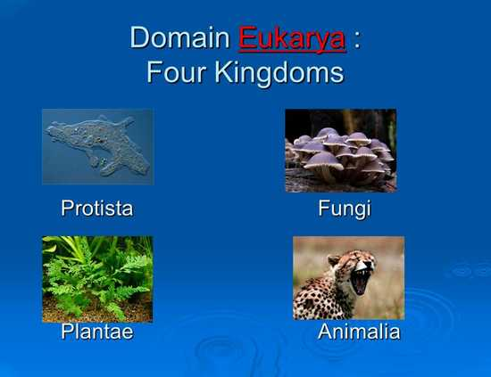

Kingdom Animalia
Kingdom Animalia is comprised of multicellular, heterotrophic organisms.This kingdom includes humans and other primates, insects, fish, reptiles, and many other types of animals.
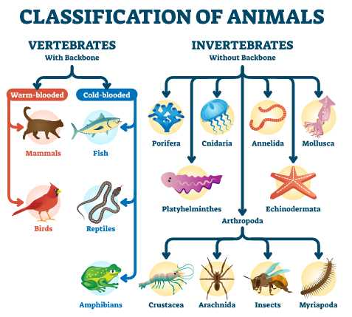
Kingdom Plantae
Kingdom Plantae includes multicellular, autotrophic organisms. Except for a few species that are parasites, plants use photosynthesis to meet their energy demands.
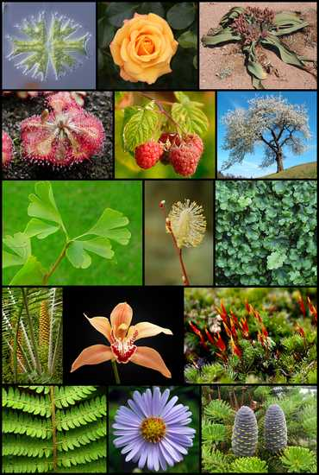
Kingdom Fungi
Kingdom Fungi includes multicellular and unicellular, heterotrophic fungi. For example mushrooms and yeast etc.
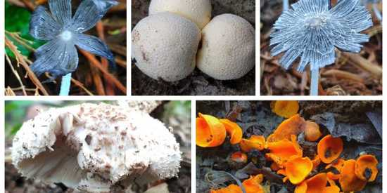

Kingdom Protista
Protists refer to a highly disparate group that was formerly its own kingdom until recent genetic analysis indicated that it should be split in to many kingdoms. As a group, protists are very diverse and include unicellular, multicellular, heterotrophic, and autotrophic organisms.
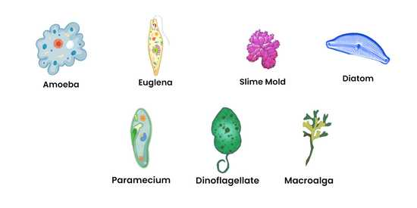

Lesson No. 43
Origin of Biodiversity
All species —from the bacteria on our skin to the birds outside—evolved at some point from a different species. Evolution is the process through which the characteristics of a species change over time, which can ultimately cause new species to arise. The theory of evolution is the unifying theory of biology, meaning it is the framework within which biologists ask questions about the living world. Its power is that it provides direction for predictions about living things that are borne out in experiment after experiment.
Discovering How Populations Change
The theory of evolution by natural selection describes a mechanism for how species can change over time. In the eighteenth century, ideas about the evolution of animals were reintroduced by the various naturalists. At the same time, James Hutton, the Scottish naturalist, proposed that geological change occurred gradually by the accumulation of small changes from processes (over long periods of time) just like those happening today.
Discovering How Populations Change
Hutton’s view was later popularized by the geologist Charles Lyell in the nineteenth century. Lyell became a friend to Darwin and his ideas were very influential on Darwin’s thinking. Lyell argued that the greater age of Earth gave more time for gradual change in species, and the process provided an analogy for gradual change in species.
Charles Darwin and Natural Selection
Natural selection as a mechanism for evolution was independently conceived of and described by two naturalists, Charles Darwin and Alfred Russell Wallace, in the mid-nineteenth century.Darwin traveled around the world on H.M.S. Beagle, visiting South America, Australia, and the southern tip of Africa. Wallace traveled to Brazil to collect insects in the Amazon rainforest from 1848 to 1852 and to the Malay Archipelago from 1854 to 1862. Darwin observed species of organisms on different islands that were clearly similar, yet had distinct differences.For example, the ground finches inhabiting the Galápagos Islands comprised several species that each had a unique beak shape 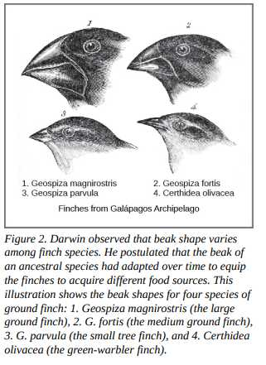
Lesson No. 44
Theory of Natural Selection
Developing the Theory of Evolution
Darwin noticed that the different islands all seemed to have their own, slightly different varieties of animals.
Somewhat similar species that suited their particular environment.

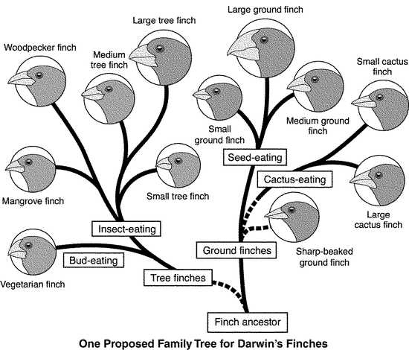

Origin of Species: Darwin’s Book
In 1859 On the Origin of Species presented evidence and proposed a mechanism for evolution that he called natural selection.
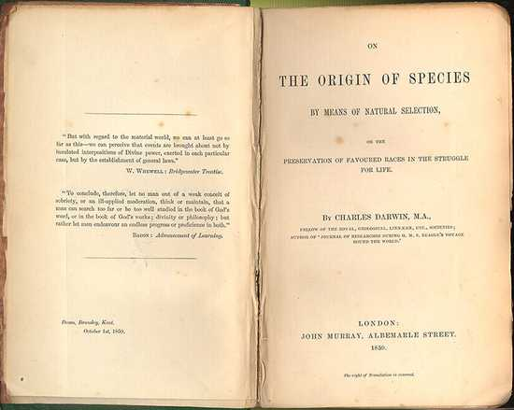
Natural Selection
Natural selection is a process of elimination.Organisms that have traits that are best adapted for the current environment are the ones that survive to breed and pass on their genes to the next generation, causing a change in the overall population.Organisms not possessing the beneficial traits either die or don’t have as many offspring.Natural selection is survival of the fittest Biological fitness- ability of an organism to survive AND reproduce (pass on its genes)
Main Points of Natural Selection
Genetic Variation is present in the population and it is inherited (passed to offspring)
    - Mutations: Changes in the DNA
    - Meiosis: crossing over
    - Random mate selection & fertilization
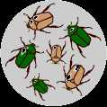

2. Living Things Overproduce Offspring (not all survive)
3. Competition for Limited Resources
4. Survival of the “Fittest”
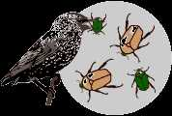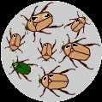
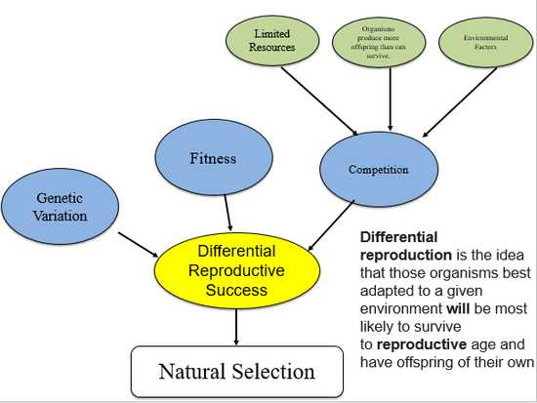
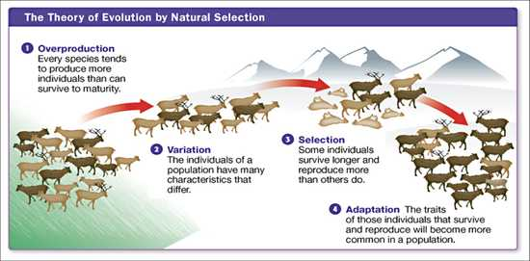
Adaptations
It is a change or the process of change by which an organism or species becomes better suited to its environment 3 Types of adaptations Camouflage is a suite of morphological adaptations that allow an organism to blend into its environment. Mimicry is a type of morphological adaptation where a species evolves to resemble another species. Antibiotic resistance develops in some bacteria,making them able to survive antibiotic treatments
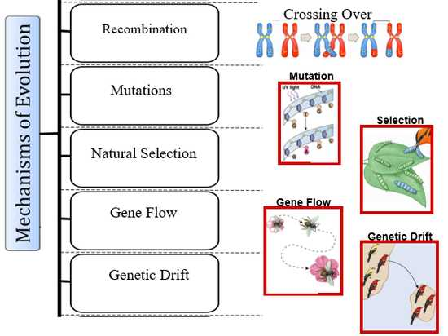

Lesson No. 46
Importance of Biodiversity
Loss of biodiversity may have reverberating consequences on ecosystems because of the complex interrelations among species. For example, the extinction of one species may cause the extinction of another. Biodiversity is important to the survival and welfare of human populations because it has impacts on our health and our ability to feed ourselves through agriculture and harvesting populations of wild animals.
Values are Subjective: Perspectives and Scales
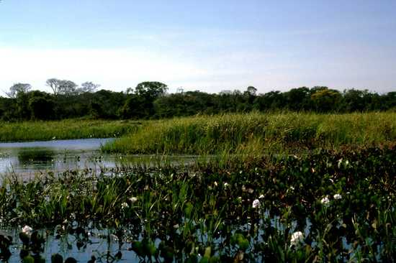
The Value of Biodiversity
- Intrinsic/inherent value
- Extrinsic/utilitarian/
instrumental value
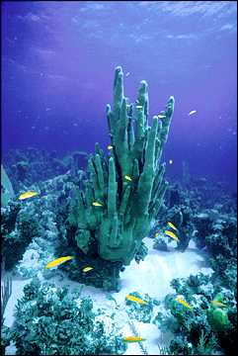
Intrinsic/inherent value
The value of something independent of its value to anyone or anything else
A philosophical concept


Direct Use Value: Goods
- Food
- Building Materials
- Fuel
- Paper Products
- Fiber (clothing, textiles)
- Industrial products (waxes, rubber, oils)
- Medicine
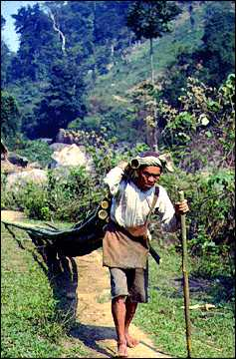
Food
Today, most people rely on ~20 types of plants, and only 3 to 4 are staple crops. Diversity is critical for developing new strains and breeds, i.e. that suit a particular environment or are resistant to pests or disease and as a source of new crops
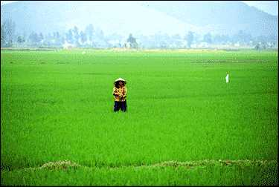
Importance/Sources
- Building Materials
- Paper Products
- Fuel
- Fiber
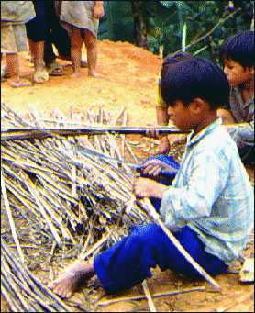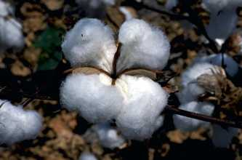
Medicine
About 80% of the people in developing countries use plants as a primary source of medicine.57% of the 150 most-prescribed drugs have their origins in biodiversity
Lesson No. 47
Importance of Biodiversity
Indirect Use Values: Services
- Regulating global processes, such as atmosphere and climate
- Soil and water conservation
- Nutrient cycling
- Pollination and seed dispersal
- Control of agricultural pests
- Genetic library
- Inspiration and information
- Scientific and educational
- Tourism and recreation
- Cultural, spiritual, and aesthetic
- Community Resilience
- Strategic
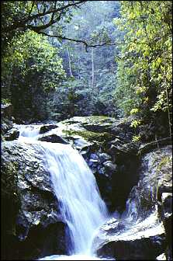
Global Processes: Atmospheric Regulation
Photosynthetic biodiversity created an oxygenated atmosphere, and also has the potential to moderate the rising amounts of atmospheric carbon dioxide linked to global climate change
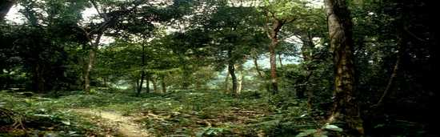
Global Processes: Climate Regulation
Forests and other vegetation modify climate: by affecting sun reflectance, water vapor release, wind patterns and moisture loss. Forests help maintain a humid environment, for example, half of all rainfall in Amazon basin is produced locally from forest-atmosphere cycle
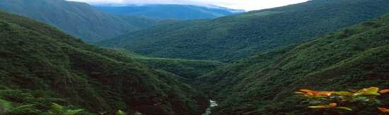
Soil and Water Conservation
Example: Coastal wetlands and mangroves
Filters excess nutrients and traps sediments that would otherwise impact neighboring marine and aquatic areas
Other services:
  - Minimizes damage from waves and floods
  - Serves as a nursery for juvenile commercial fish
  - Provides habitat for many birds, fish, and shellfish
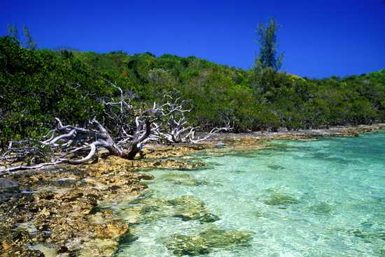
Nutrient Cycling
Biodiversity is critical to nutrient cycling and soil renewal. Decomposers such as algae, fungi, and bacteria
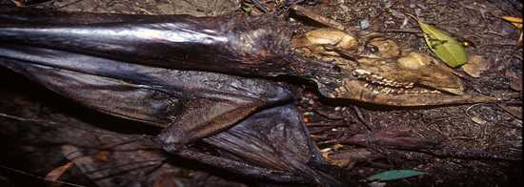
Pollination and Seed Dispersal
Many flowering plants depend on animals for pollination to produce food.30% of human crops depend on free services of pollinators; replacement value estimated billions of dollars/year in US alone
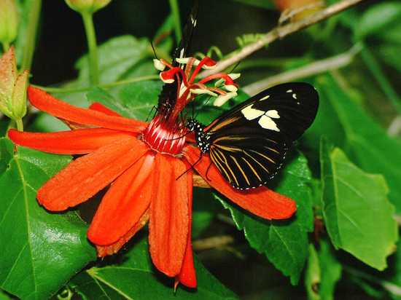
Source of Inspiration or Information
- Biomimicry
- Applied Biology
- Medical Models
- Education and Scientific Research
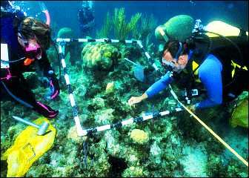
Medical Models
Hibernating bears may improve the treatment of:
  - trauma patients
  - kidney disease
  - osteoporosis
4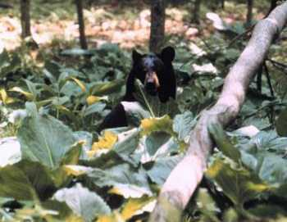
Spiritual and Cultural Values
The survival of natural areas and species are important to different cultures around the world.Thousands of cultural groups in the world, each have distinct traditions and knowledge for relating to natural world
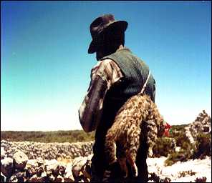
Lesson No. 46
Threats to Biodiversity
The core threat to biodiversity on the planet, and therefore a threat to human welfare, is the combination of human population growth and the resources used by that population.
- The three greatest proximate threats to biodiversity are
      - Habitat loss
      - Overharvesting
      - Introduction of exotic species
The first two of these are a direct result of human population growth and resource use. The third results from increased mobility and trade A fourth major cause of extinction, anthropogenic (human caused) climate change, has not yet had a large impact, but it is predicted to become significant during this century. Global climate change is also a consequence of human population needs for energy and the use of fossil fuels to meet those needs shown in figure below.

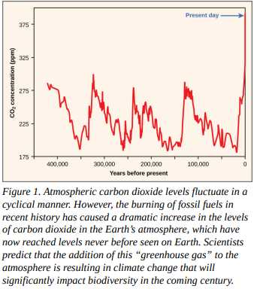
Habitat Losses
Elimination of their habitat—whether it is a forest, coral reef, grassland, or flowing river—will kill the individuals in the species. Remove the entire habitat and the species will become extinct, unless they are among the few species that do well in human-built environments. Human destruction of habitats (habitat generally refers to the part of the ecosystem required by a particular species) accelerated in the latter half of the twentieth century.
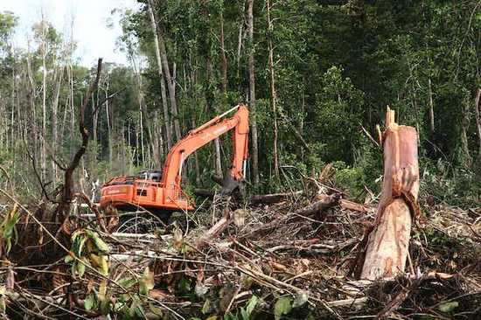
Lesson No. 49
Threats to Biodiversity
Invasive Species
Exotic species are species that have been intentionally or unintentionally introduced by humans into an ecosystem in which they did not evolve. Human transportation of people and goods, including the intentional transport of organisms for trade, has dramatically increased the introduction of species into new ecosystems.These new introductions are sometimes at distances that are well beyond the capacity of the species to ever travel itself and outside the range of the species’ natural predators.Most exotic species introductions probably fail because of the low number of individuals introduced or poor adaptation to the ecosystem they enter. Some species, however, have characteristics that can make them especially successful in a new ecosystem. These exotic species often undergo dramatic population increases in their new habitat and reset the ecological conditions in the new environment, threatening the species that exist there.When this happens, the exotic species also becomes an invasive species. Invasive species can threaten other species through competition for resources, predation, or disease.Most exotic species introductions probably fail because of the low number of individuals introduced or poor adaptation to the ecosystem they enter. Some species, however, have characteristics that can make them especially successful in a new ecosystem. These exotic species often undergo dramatic population increases in their new habitat and reset the ecological conditions in the new environment, threatening the species that exist there. When this happens, the exotic species also becomes an invasive species. Invasive species can threaten other species through competition for resources, predation, or disease.Invading exotic species can also be disease organisms. It now appears that the global decline in amphibian species recognized in the 1990s is, in some part, caused by the fungus Batrachochytrium dendrobatidis, which causes the disease chytridiomycosis
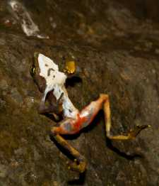
This Limosa harlequin frog (Atelopus limosus), an endangered species from Panama, died from a fungal disease called chytridiomycosis. The red lesions are symptomatic of the disease.
Climate Change
Climate change, and specifically the anthropogenic warming trend presently underway, is recognized as a major extinction threat, particularly when combined with other threats such as habitat loss.Anthropogenic warming of the planet has been observed and is due to past and continuing emission of greenhouse gases, primarily carbon dioxide and methane, into the atmosphere caused by the burning of fossil fuels and deforestation.
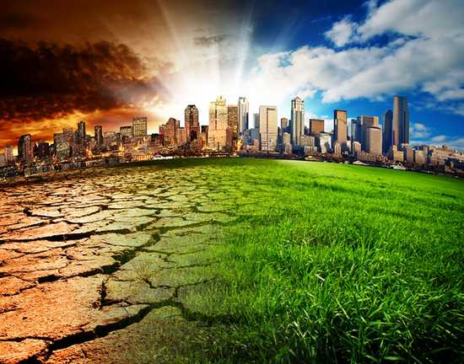

Climate gradients will also move up mountains, eventually crowding species higher in altitude and eliminating the habitat for those species adapted to the highest elevations. Some climates will completely disappear. The rate of warming appears to be accelerated in the arctic, which is recognized as a serious threat to polar bear populations that require sea ice to hunt seals during the winter months.
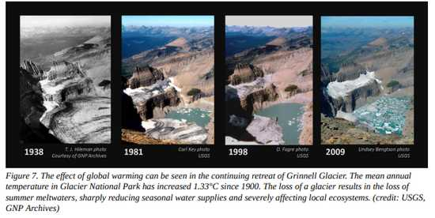
Lesson No. 50
Conservation of Biodiversity
The threats to biodiversity have been recognized for some time. Today, the main efforts to preserve biodiversity involve legislative approaches to:
  - Regulate human and corporate behavior
  - Setting aside protected areas
  - Habitat restoration
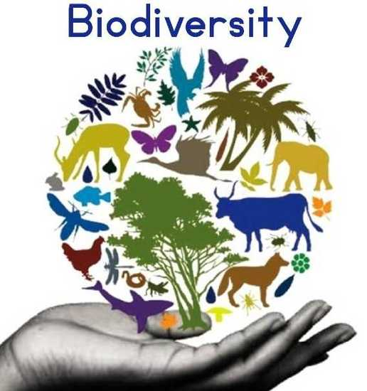
Changing Human Behavior
Legislation has been enacted to protect species throughout the world. The legislation includes international treaties as well as national and state laws. The Convention on International Trade in Endangered Species of Wild Fauna and Flora (CITES) treaty came into force in 1975. The treaty, and the national legislation that supports it, provides a legal framework for preventing “listed” species from being transported across nations’ borders, thus protecting them from being caught or killed when the purpose involves international trade. Within many countries there are laws that protect endangered species and that regulate hunting and fishing. In the United States, the Endangered Species Act (ESA) was enacted in 1973.

Migratory Bird Treaty Act
The Migratory Bird Treaty Act (MBTA) is an agreement between the United States and Canada that was signed into law in 1916 in response to declines in North American bird species caused by hunting. The Act now lists over 800 protected species. It makes it illegal to disturb or kill the protected species or distribute their parts (much of the hunting of birds in the past was for their feathers).
Kyoto Protocol
The Kyoto Protocol, an international agreement that came out of the United Nations Framework Convention on Climate Change that committed countries to reducing greenhouse gas emissions by 2012, was ratified by some countries, but spurned by others. Two countries that were especially important in terms of their potential impact that did not ratify the Kyoto protocol were the United States and China. S
Paris Agreement
A renegotiated 2016 treaty, called the Paris Agreement, once again brought nations together to take meaningful action on climate change. But like before, some nations are reluctant to participate. The elected President Trump has indicated that he will withdraw the United States’ support of the agreement.
Lesson No. 51
Conservation of Biodiversity
Establishment of wildlife and ecosystem preserves is one of the key tools in conservation efforts. A preserve is an area of land set aside with varying degrees of protection for the organisms that exist within the boundaries of the preserve.
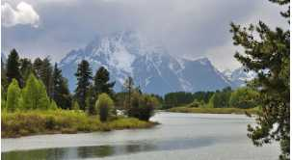

National parks, such as Grand Teton National Park in Wyoming, help conserve biodiversity.
Biodiversity hotspot
A biodiversity hotspot is a conservation concept developed by Norman Myers in 1988. Hotspots are geographical areas that contain high numbers of endemic species. The purpose of the concept was to identify important locations on the planet for conservation efforts, a kind of conservation triage. By protecting hotspots, governments are able to protect a larger number of species.
Habitat Restoration
Habitat restoration is the process of bringing an area back to its natural state, before it was impacted through destructive human activities. It holds considerable promise as a mechanism for maintaining or restoring biodiversity. Reintroducing wolves, a top predator, to Yellowstone National Park in 1995 led to dramatic changes in the ecosystem that increased biodiversity.
Keystone Species
Keystone Species, meaning a species that is instrumental in maintaining diversity within an ecosystem. Removing a keystone species from an ecological community causes a collapse in diversity. The results from the Yellowstone experiment suggest that restoring a keystone species effectively can have the effect of restoring biodiversity in the community.Ecologists have argued for the identification of keystone species where possible and for focusing protection efforts on these species. It makes sense to return the keystone species to the ecosystems where they have been removed.
Lesson No. 52
Population Ecology
Population ecology is a sub-field of ecology that deals with the dynamics of species populations and how these populations interact with the environment, such as birth and death rates, and by immigration and emigration.
Population Density
Population density is a measurement of population per unit land area. It is mostly applied to humans, but sometimes to other living organisms. It is a key geographical term. In simple terms, population density refers to the number of people living in an area per square kilometer, or other unit of land area.
Population Density Types
- Crude density- the number of populations per unit of total space
- Ecological density- number of populations per unit of habitat space (actual area where population colonize
Factors affecting the Population density
Birth rate-Birth rate is the number of individuals born in a population in a given amount of time. Human birth rate is stated as the number of individuals born per year per 1000 in the population. For example, if 35 births occur per year per 1000 individuals, the birth rate is 35.
Factors affecting the Population density
- Death Rate-A measure of the number of deaths in a particular population, scaled to the size of that population, per unit of time.
- Dispersal- refers to both the movement of individuals from their birth site to their breeding site, as well as the movement from one breeding site to another.
Lesson No. 53
Methods for estimating Population density
Lincoln or Petersen index Method
- Relies on capturing and marking some fraction of the total population and using this fraction to estimate the total population density
- Lincoln index Equation
Minimum known alive Method
Another method of mark –recaptured method to estimate population densities over an extended period of time. Also called calendar-of-catches method.MNA is defined as the number of individuals caught in a capture session, plus those that were not caught at that time but were caught both previously and subsequently
Total Count Method
A total count aims to count all the animals in a specific area. This area is called the census unit. Because of under-counting (it's unlikely all the wildlife will be seen) total counts can only provide a minimum estimate of the total population size. completely fenced, which means that no animals can enter or leave.
Quadrate or transect sampling
Counting of organisms of a single species in plots or samples area.Line transect sampling is a distance sampling method for estimating the abundance of wild animal populations.
Removal sampling
No. of organisms removed from an area in successive samples is plotted on y-axis and total number previously removed is plotted on x-axis. Removal (or depletion) sampling is a commonly used method to estimate abundance of animal populations . Removal models have been used to estimate population size, not only for many species including birds, mammals, and fish, but also for epidemiological applications
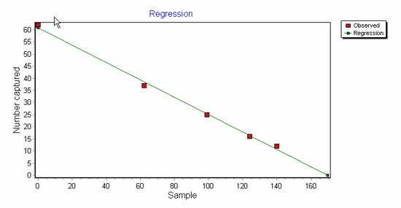
Lesson No. 54
Population Natality and Population Mortality
Population Natality
- Natality- ability of population to increase by reproduction-birth rate
- Maximum natality- (absolute or physiological)-theoretical maximum production of new individuals under ideal conditions and constant of any population (no ecological limiting factors)
Ecological or realized Natality
Population increase under actual or specific environmental conditions e.g: 400 births/year among 10,000 couples Crude birth rate is 400/year while realized natality is 4 per 100
Population Mortality
- Mortality- death rate of individuals in the population.
- Minimum Mortality- constant for a population- represents the minimum loss under ideal or non-limiting conditions
Ecological or realized mortality
The loss of individuals under a given environmental conditions.It is the actual loss of individuals under a given environmental condition. It refers to the death of individuals of a population under existing environmental conditions. Since it varies with environmental conditions, it is never constant.
Survivorship curve
Curves plotted from life table data, no surviving at beginning of age out of 1000 on vertical axis and time interval at x-axis, resulting curve is called survivorship curve
Types of survivorship curve
          - Type 1 survivorship curve
          - Type 2 survivorship curve
          - Type 3 survivorship curve
Type 1 survivorship curve
A Type 1 survivorship curve is a graph that visually represents a population that survives to adulthood without a significant decrease in population size. The population declines later. Humans are an example of a Type 1 species.
Type 2 survivorship curve
Many bird species have a Type II survivorship curve. In a Type II curve, organisms die more or less equally at each age interval. Organisms with this type of survivorship curve may also have relatively few offspring and provide significant parental care.
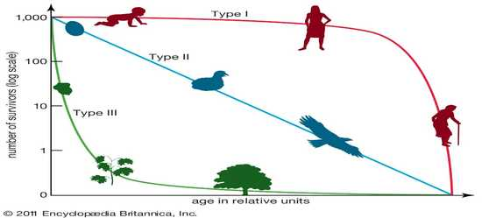

Lesson No. 55
Community Ecology
Definitions
An ecological community
consists of all the populations of all the different species that live together in a particular area
Community Ecology
consists of all species that interact in a certain area
Properties of Community or community structure
Species Richness (number of different types of species, more in areas close to equator)
Species evenness (abundance of each species)
Species- Area Effect (large areas contain more species)
Community ecology seeks to understand how species interact by studying many different kinds of relationships between organisms.
For example:
            - Animal-animal interactions
            - Animal-plant interactions
            - plant-plant interactions
Theme of Species Interaction
Each species interactions are analyzed by using three key themes;Species interactions can affect the distribution and abundance of a particular species e.g: the effect of disease-carrying tsetse flies on the distribution of cattle in Africa Species act as agents of natural selection when they interact. The outcome of interactions among species is dynamic and conditional
Types of Interactions
There are two types of interactions;
- Intraspecific Interactions
- Interspecific Interactions
Intraspecific Interactions
Interactions between same species in a community are called intraspecific —intra- means “same.“ Helps nature to keep the population under control Results in the survival of the fittest
Interspecific Interactions
Interactions between different species in a community are called interspecific interactions—inter- means "between.“interspecific competition between lions and leopards that vie for similar prey and interspecific competition between rice paddies with weeds growing in the field
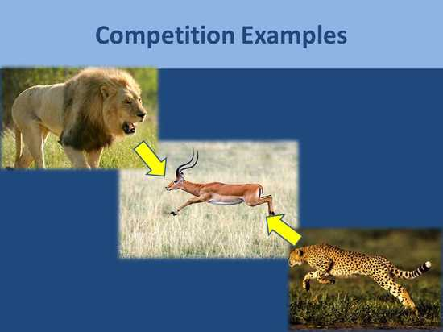
Types of Interspecific Interactions
- The main types of interspecific interactions include
              - Competition (-/-),
              - Predation (+/-),
              - Mutualism, (+/+),
              - Commensalism (+/0)
              - Parasitism(+/-).
Lesson No. 56
Competition
Competition is a (-/- interaction), where one or both inhibit the population of the other.Competition is most typically considered the interaction of individuals that vie for a common resource that is in limited supply, but more generally can be defined as the direct or indirect interaction of organisms that leads to a change in fitness when the organisms share the same resource.
Types of Competitions
There are two types of competition;
- Direct Competition for same recourse
- Interference competition
Direct Competition for same recourse
Competition negatively affects both species e.g: competition between birds for limited seeds for food, Woodpeckers and squirrels compete for nesting in the same holes and spaces in trees
Interference competition
It occurs when an individual of one species directly interferes with an individual of another species. e.g: a plant releasing allelopathic chemicals to impede the growth of a competing species.
How competition can be minimized?
Competition can be minimized if two species with overlapping niches evolve by natural selection to utilize less similar resources, resulting in resource partitioning. e.g: five species of warblers that all used the same caterpillar prey spruce tree.
Lesson No. 57
Predation, Herbivory & Commensalism
Predation
Predation is a (+ −) interaction in which one Wins, One Loses predator-prey interaction, in which one species kills and consumes another e.g: Lion is predator and deer is prey Predation shows cyclical patterns of predator/prey population sizes; predators increase in numbers when prey species are plentiful.
Carnivorous plants
Not all predators are animals. Carnivorous plants, such as the Venus fly trap and the pitcher plant, consume insects. Pitcher plants catch their prey in a pool of water containing digestive enzymes, whereas the Venus fly trap captures an insect between the two lobes of a leaf and seals the insect inside with digestive enzymes.

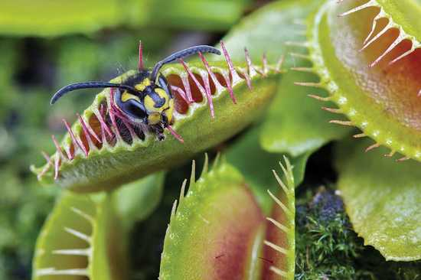

(B) Venus Fly Trap
Carnivorous plants
These plants absorb nutrients from the insects as they become available during digestion. On a microscopic scale, protozoa and bacteria also consume prey organisms. They play an important role in maintaining population sizes in microbial communities, which promotes the diversity of microorganisms and contributes to a stable community structure.
Herbivory
Herbivory is a (+ −) interaction When Predation involves involve an animal or insect consuming part of a plant, known as herbivory.Animals that feed on plants by cropping portions of the plant, but usually not killing the plant, are herbivoresPlants have spines and toxins-defensive To maximize nutrient intake, many herbivores have evolved adaptations that allow them to determine which plants contain fewer defensive compounds and more high-quality nutrients. Some insects, such as butterflies, have chemical sensors on their feet that allow them to taste the plant before they consume any part of it. Mammalian herbivores often use their keen sense of smell to detect bitter compounds, and they preferentially eat younger leaves that contain fewer chemicals.
Commensalism
- (+/0 interaction) Two species have a long-term interaction that is beneficial to one and has no positive or negative effect on the other
Example
Sucker fish, often attaches to a shark by means of its sucker which is present on the top of its head. This helps remora get protection, a free ride as well as a meal from the left over of the shark’s meal
Example- grazing cattle and cattle egrets. As the cattle graze in the grass, they stir up the insects living there, allowing the cattle egret a tasty meal. The cattle egrets get a meal, but the cattle receive nothing in return from the long-necked birds, nor are they harmed by the relationship
Lesson No. 58
Symbiosis and Parasitism
Symbiosis
Interspecific interactions in which two species live together in a long-term, intimate association Symbiotic relationships keep a delicate balance can help individual species to evolve or change and even thrive
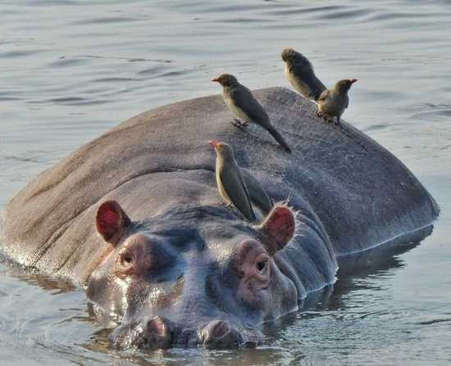

- Mutualistic association between termite and their intestinal flagellates.
Termites can eat wood but have no enzymes to digest it. However, their intestine contains certain flagellate protists (protozoans) that have the necessary enzymes to digest the cellulose of the wood eaten by termites and convert it into sugar.Both termite and flagellates cannot survive without each other Symbiosis can be; Obligatory which means that one or more of the symbionts depend on each other for survival Facultative which means that one or more of the symbionts depend on each other for survival
Importance
Provide people with food, populate the planet with trees and plants, and keep animal and plant populations in balance .Without symbiotic relationships, no coral reefs, trees might not proliferate as far and wide, aided by birds and insects that transport seeds a far.
Parasitism
- Parasitism: (+/- interaction)
Two species have a close, lasting interaction that is beneficial to one, the parasite, and harmful to the other, the host .Most of the time, the parasite feeds on the host's body but does not kill the host
Types of Parasites
There are two types of parasites;
Ecto-parasites: Present outside the body.Ticks- blood-sucking insects that thrive on the blood of its victims
- Also transfer infectious diseases to healthy organisms
Endo-parasites: Present inside the body.
- tapeworm in human intestine
Types of hosts
Two types of hosts
Definitive host (A definitive host provides a home to an adult parasite or sexual stages of parasite)
Intermediate host (host unknowingly offers a home to a juvenile parasite or asexual stage of parasite)
Parasitism examples
Plant parasite: Dodder (Cuscuta) plant is a parasitic.weed that obtains moisture and nourishment by attaching to a green, living plant.Animal parasite: Ascaris or round worms are internal parasites found in the human intestine
Lesson No. 59
The Impacts of Environmental Conditions
Our industrialized society dumps huge amounts of pollutants and toxic wastes into the earth’s biosphere without fully considering the consequences. Such actions seriously degrade the health of the earth’s ecosystems, and this degradation ultimately affects the health and well-being of human populations.
Biological Agents
Biological agents were the most significant factor in health.These included pathogenic (disease causing) organisms such as;
    - Bacteria
    - Viruses
    - Protozoa
    - Internal parasites
In modern times, cardiovascular diseases, cancer, and accidents are the leading killers in most parts of the world. However, infectious diseases still cause about 22 million deaths a year, mostly in undeveloped countries. These diseases include: tuberculosis, malaria, pneumonia, influenza, whooping cough, dysentery and Acquired Immune Deficiency Syndrome (AIDS).

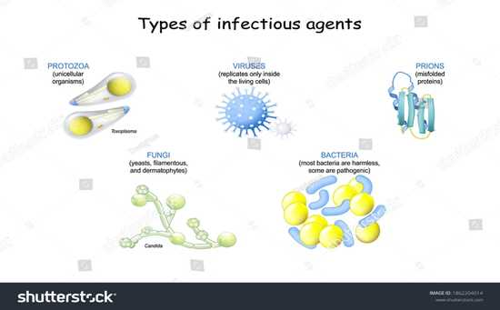
Chemical Agents
Chemical agents also have significant effects on human health. Toxic heavy metals, dioxins, pesticides, and endocrine disrupters are examples of these chemical agents. Heavy metals (e.g., mercury, lead, & cadmium) are typically produced as by-products of mining and manufacturing processes.
ENVIRONMENTAL PERSISTENCE OF DDT
The pesticide DDT was widely used for decades. It was seen as an ideal pesticide because it is inexpensive and breaks down slowly in the environment. Unfortunately, the latter characteristic allows this chemical agent to biomagnify through the food chain. Populations of bird species at the top of the food chain, e.g., eagles and pelicans, are greatly affected by DDT in the environment. When these birds have sufficient levels of DDT, the shells of their eggs are so thin that they break, making reproduction impossible. After DDT was banned in the United States in 1972, affected bird populations made noticeable recoveries, including the iconic bald eagle.
Lesson No. 60
Environmental Health Risks and Causes
Environmental Health
Environmental health is concerned with preventing disease, death and disability by reducing exposure to adverse environmental conditions and promoting behavioral change. It focuses on the direct and indirect causes of diseases and injuries, and taps resources inside and outside the health care system to help improve health outcomes.

Environmental health risks
Environmental health risks can be grouped into two broad categories;
            - Traditional Hazards
            - Modern Hazards
Traditional Hazards
Traditional hazards are related to poverty and the lack of development and mostly affect developing countries and poor people.Their impact exceeds that of modern health hazards by 10 times in Africa, 5 times in Asian countries (except for China), and 2.5 times in Latin America and Middle East
Modern Hazards
Modern hazards, caused by technological development, prevail in industrialized countries where exposure to traditional hazards is low. Poor people increasingly experience a “double burden” of traditional and modern environmental health risks. Their total burden of illness and death from all causes per million people is about twice that in rich countries, and the disease burden from environmental risks is 10 times greater.
Environmental Health Problems
- Worldwide, the top killers of children under five are:
Acute respiratory infections (from indoor air pollution) Diarrheal diseases (mostly from poor water, sanitation, and hygiene); Infectious diseases such as malaria. Malnutrition (the condition that occurs when body does not get enough nutrients) is an important contributor to child mortality—malnutrition and environmental infections are inextricably linked.
Lesson No. 61
Environmental Health Risks and Causes
Poor Water and Sanitation Access
With 1.1 billion people lacking access to safe drinking water and 2.6 billion without adequate sanitation, the magnitude of the water and sanitation problem remains significant.Intestinal worms, which thrive in poor sanitary conditions, infect close to 90 percent of children in the developing world and, depending on the severity of the infection may lead to malnutrition, anemia, or stunted growth.
Indoor Air Pollution
Indoor air pollution—a much less publicized source of poor health—is responsible for more than 1.6 million deaths per year and for 2.7% of global burden of disease.Cooking and heating with such solid fuels on open fires or stoves without chimneys lead to indoor air pollution and subsequently, respiratory infections.
Malaria
Malaria is an infectious disease spread by mosquitoes but caused by a single-celled parasite called Plasmodium. Every year, more than 200 million people become infected with malaria and about 430,000 die, with most cases and deaths found in Sub-Saharan Africa.
Emerging Diseases
Emerging and re-emerging diseases have been defined as infectious diseases of humans whose occurrence during the past two decades has substantially increased or threatens to increase in the near future relative to populations affected, geographic distribution, or magnitude of impacts.Examples include Ebola virus, West Nile virus, Zika virus, sudden acute respiratory syndrome (SARS), H1N1 influenza; swine and avian influenza (swine, bird flu), HIV, and a variety of other viral, bacterial, and protozoal diseases.
Antibiotic Resistance
Antibiotics and similar drugs, together called antimicrobial agents, have been used for the last 70 years to treat patients who have infectious diseases.Drugs have been used so widely and for so long that the infectious organisms the antibiotics are designed to kill have adapted to them, making the drugs less effective. Antibiotics and similar drugs, together called antimicrobial agents, have been used for the last 70 years to treat patients who have infectious diseases.Drugs have been used so widely and for so long that the infectious organisms the antibiotics are designed to kill have adapted to them, making the drugs less effective.
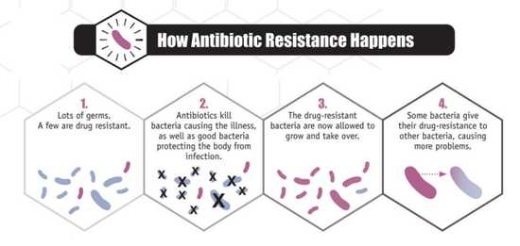
Lesson No. 62
Environmental Toxicology
Environmental toxicology is the scientific study of the health effects associated with exposure to toxic chemicals occurring in the natural, work, and living environments. The term also describes the management of environmental toxins and toxicity, and the development of protections for humans and the environment.
Ranking | Chemical Name
1 | ARSENIC
2 | LEAD
3 | MERCURY
4 | VINYL CHLORIDE
5 | POLYCHLORINATED BIPHENYLS
6 | BENZENE
7 | CADMIUM
8 | BENZO (A) PYRENE
9 | POLYCYCLIC AROMATIC HYDROCARBONS
10 | BENZO(B)FLUORANTHENE
Routes of Exposure to Chemicals
In order to cause health problems, chemicals must enter your body. There are three main “routes of exposure,” or ways a chemical can get into your body. Breathing (inhalation): Breathing in chemical gases, mists, or dusts that are in the air. Skin or eye contact: Getting chemicals on the skin, or in the eyes. They can damage the skin, or be absorbed through the skin into the bloodstream. Swallowing (ingestion): This can happen when chemicals have spilled or settled onto food, beverages, cigarettes, beards, or hands.
What Health Effects Can Chemicals Cause?
There are two types of health impacts due to these chemical toxins:
  - Acute Effect
  - Chronic Effect
Acute Effect
An acute effect of a contaminant (The term “contaminant” means hazardous substances, pollutants, pollution, and chemicals) is one that occurs rapidly after exposure to a large amount of that substance.


Chronic Effect
A chronic effect of a contaminant results from exposure to small amounts of a substance over a long period of time. In such a case, the effect may not be immediately obvious. Chronic effect are difficult to measure, as the effects may not be seen for years. Long-term exposure to cigarette smoking, low level radiation exposure, and moderate alcohol use are all thought to produce chronic effects
Lesson No. 63
Environmental Contaminants
Contaminants are often chemicals found in the environment in amounts higher than what would be there naturally. We can be exposed to these contaminants from a variety of residential, commercial, and industrial sources. Sometimes harmful environmental contaminants occur biologically, such as mold or a toxic algae bloom.
- Environmental contaminants include;
  - Carcinogen
  - Teratogen
  - Mutagen
  - Neurotoxicant
  - Endocrine disruptor
Carcinogen
An agent which may produce cancer (uncontrolled cell growth), either by itself or in conjunction with another substance. Examples include formaldehyde, asbestos, radon, vinyl chloride, and tobacco.
Teratogen
A substance which can cause physical defects in a developing embryo.Examples include alcohol and cigarette smoke.
Mutagen
A material that induces genetic changes (mutations) in the DNA.Examples include radioactive substances, x-rays and ultraviolet radiation.
Neurotoxicant
A substance that can cause an adverse effect on the chemistry, structure or function of the nervous system.Examples include lead and mercury.
Endocrine disruptor
A chemical that may interfere with the body’s endocrine (hormonal) system and produce adverse developmental, reproductive, neurological, and immune effects in both humans and wildlife. A wide range of substances, both natural and man-made, are thought to cause endocrine disruption, including:
  - Pharmaceuticals
  - Dioxin and dioxin-like compounds
  - Arsenic
  - Polychlorinated biphenyls (PCBs)
  - DDT and other pesticides
  - Plasticizers such as bisphenol A (BPA).


Lesson No. 64
Bioremediation
Bioremediation is a waste management technique that involves the use of organisms such as plants, bacteria, and fungi to remove or neutralize pollutants from a contaminated site. According to the United States EPA, bioremediation is a “treatment that uses naturally occurring organisms to break down hazardous substances into less toxic or non toxic substances”.
Types of bioremediation
There are two types of bioremediation:
  - In situ Bioremediation
  - Ex situ Bioremediation
In situ Bioremediation
When the detoxification of waste is done at the original site of the contamination is called In situ Bioremediation. It is mainly used to treat contaminations in soil and ground water.
Dependency
The process of In situ bioremediation depends on the various factors which are given below:
  - Typology of contamination
  - Characteristics of site
  - Distribution and concentration of contaminants
  - Identification of microbial community at the site
  - Temperature
  - pH value of the site
  - Identification of Moisture content
  - Nutrient supply
Ex situ Bioremediation
When the detoxification of waste is done away from the original site of the contamination is called Ex situ Bioremediation. In this process, the contaminants are unearthed from the original site and then treated in the controlled environment. For Example: composting, soil bio-piles etc.

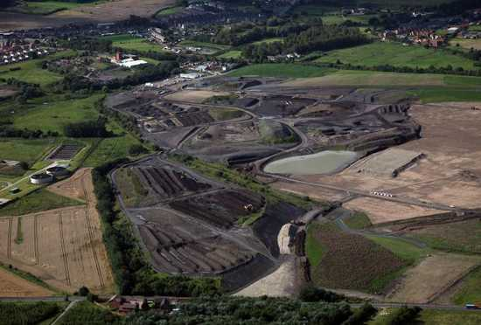

Advantages of Bioremediation
It is natural process and it requires acceptable waste treatment process for contaminated substance such as soil. It is useful for the complete removal of contaminants.It is less expensive than the other mechanism or technologies that are used for the removal of hazardous waste.
Disadvantages of Bioremediation
It is limited to those compounds that are biodegradable.It is difficult to generalise from bench and pilot-scale studies to full-scale field operations.It takes longer than other treatment options, such as excavation and removal of soil or incineration.
Lesson No. 65
Water reserves and resources
Water Reserves
Water is the only common substance that occurs naturally on earth in three forms: solid, liquid and gas. It is distributed in various locations, called water reservoirs.The oceans are by far the largest of the reservoirs with about 97% of all water but that water is too saline for most human uses Ice caps and glaciers are the largest reservoirs of fresh water but this water is inconveniently located, mostly in Antarctica and Greenland. Shallow groundwater is the largest reservoir of usable fresh water. Although rivers and lakes are the most heavily used water resources, they represent only a tiny amount of the world’s water.
Primary Fresh Water Resources
- Primary Fresh Water Resources
  - Precipitation
  - Underground Water Resources
  - Surface Water Resources;
  - Rivers, Lakes & Glaciers
Precipitation
Precipitation levels are unevenly distributed around the globe, affecting fresh water availability. More precipitation falls near the equator, whereas less precipitation tends to fall near 30 degrees north and south latitude, where the world’s largest deserts are located. These rainfall and climate patterns are related to global wind circulation cells. The intense sunlight at the equator heats air, causing it to rise and cool, which decreases the ability of the air mass to hold water vapor and results in frequent rainstorms.

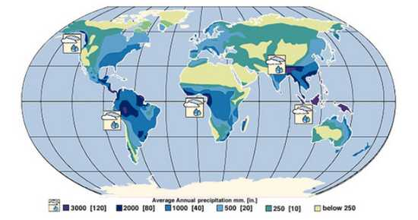 World Rainfall Map. The false-color map above shows the amount of rain that falls around the world. Areas of high rainfall include Central and South America, western Africa, and Southeast Asia. Since these areas receive so much rainfall, they are where most of the world’s rainforests grow. Areas with very little rainfall usually turn into deserts. The desert areas include North Africa, the Middle East, western North America, and Central Asia. Source: United States Geological Survey Earth Forum, Houston Museum Natural Science
Lesson No. 66
Water reserves and resources
Surface Water Resources: Rivers, Lakes, Glaciers
Flowing water from rain and melted snow on land enters river channels by surface runoff and groundwater seepage. River discharge describes the volume of water moving through a river channel over time
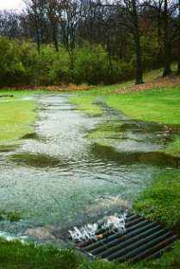
Rivers
The geographic area drained by a river and its tributaries is called a drainage basin or watershed.Rivers are an important water resource for irrigation of cropland and drinking water for many cities around the world.
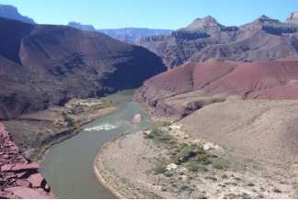
Lakes
Lakes can also be an excellent source of freshwater for human use. They usually receive water from surface runoff and groundwater discharge. They tend to be short-lived on a geological time-scale because they are constantly filling in with sediment supplied by rivers. Lakes form in a variety of ways including glaciation, recent tectonic uplift (e.g., Lake Tanganyika, Africa), and volcanic eruptions (e.g., Crater Lake, Oregon). People also create artificial lakes (reservoirs) by damming rivers. Large changes in climate can result in major changes in a lake’s size.
Glaciers
Glaciers represent the largest reservoir of fresh water, they generally are not used as a water source because they are located too far from most people.Melting glaciers do provide a natural source of river water and groundwater. During the last Ice Age there was as much as 50% more water in glaciers than there is today, which caused sea level to be about 100 m lower.
Underground Water Resources
Groundwater is a particularly important resource in arid climates, where surface water may be scarce. Groundwater is water located in small spaces, called pore space, between mineral grains and fractures in subsurface earth materials (rock or sediment). Most groundwater originates from rain or snowmelt, which infiltrates the ground and moves downward until it reaches the saturated zone (where groundwater completely fills pore spaces in earth materials).
Recharge Areas
Recharge areas are locations where surface water infiltrates the ground rather than running into rivers or evaporating.Wetlands, for example, are excellent recharge areas. A large area of sub-surface, porous rock that holds water is an aquifer. Aquifers are commonly drilled, and wells installed, to provide water for agriculture and personal use.
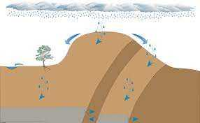
Lesson No. 67
Water supply crisis and sustainable solutions
Water Supply Problems
Groundwater is pumped from water wells, there usually is a localized drop in the water table around the well called a cone of depression. When there are a large number of wells that have been pumping water for a long time, the regional water table can drop significantly. This is called groundwater mining, which can force the drilling of deeper, more expensive wells that commonly encounter more saline groundwater. Rivers, lakes, and artificial lakes (reservoirs) can also be depleted due to overuse. Water resource problem associated with groundwater mining is saltwater intrusion, where overpumping of fresh water aquifers near ocean coastlines causes saltwater to enter fresh water zones. The drop of the water table around a cone of depression in an unconfined aquifer can change the direction of regional groundwater flow, which could send nearby pollution toward the pumping well instead of away from it. Finally, problems of subsidence (gradual sinking of the land surface over a large area) and sinkholes (rapid sinking of the land surface over a small area) can develop due to a drop in the water table.
Water Supply Crisis
The water crisis refers to a global situation where people in many areas lack access to sufficient water, clean water, or both. This section describes the global situation involving water shortages, also called water stress. In general, water stress is greatest in areas with very low precipitation (major deserts), large population density (e.g., India), or both. Future global warming could worsen the water crisis by shifting precipitation patterns away from humid areas and by melting mountain glaciers that recharge rivers downstream. Melting glaciers will also contribute to rising sea level, which will worsen saltwater intrusion in aquifers near ocean coastlines.

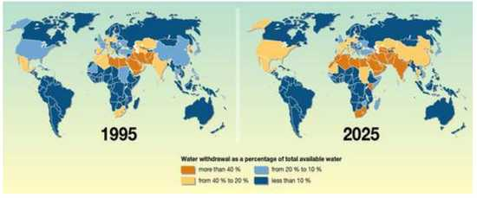

Sustainable Solutions to the Water Supply Crisis
There are following Sustainable Solutions to the Water Supply Crisis;
Reservoirs that form behind dams in rivers can collect water during wet times and store it for use during dry spells.They also can be used for urban water supplies. Other benefits of dams and reservoirs are hydroelectricity, flood control, and recreation
Lesson No. 68
Water supply crisis and sustainable solutions
Sustainable Solutions to the Water Supply Crisis
Aqueducts can move water from where it is plentiful to where it is needed. Aqueducts can be controversial and politically difficult especially if the water transfer distances are large. One drawback is the water diversion can cause drought in the area from where the water is drawn. For example, Owens Lake and Mono Lake in central California began to disappear after their river flow was diverted to the Los Angeles aqueduct. Conservation means using less water and using it more efficiently. Around the home, conservation can involve both engineered features, such as high efficiency clothes washers and low-flow showers and toilets, as well as behavioral decisions, such as growing native vegetation that require little irrigation in desert climates, turning off the water while you brush your teeth, and fixing leaky faucets. Rainwater harvesting involves catching and storing rainwater for reuse before it reaches the ground. Another important technique is efficient irrigation, which is extremely important because irrigation accounts for a much larger water demand than public water supply. Water conservation strategies in agriculture include growing crops in areas where the natural rainfall can support them, more efficient irrigation systems such as drip systems that minimize losses due to evaporation, no-till farming that reduces evaporative losses by covering the soil, and reusing treated wastewater from sewage treatment plants. Recycled wastewater has also been used to recharge aquifers.
Lesson No. 69
Water Pollution
Water pollution is the contamination of water bodies, usually as a result of human activities, so that it negatively affects its uses. Water bodies include lakes, rivers, oceans, aquifers, reservoirs and groundwater. Water pollution results when contaminants are introduced into these water bodies.
Major Categories of Water Pollutants
Infectious Agents
  - Bacteria, Viruses, Protozoa, Parasitic Worms
  - Source: Human and animal waste
Oxygen-Demanding Waste
  - Organic debris & waste + aerobic bacteria
  - Source: Sewage, feedlots, paper-mills, food processing
Inorganic Chemicals
  - Acids, Metals, Salts
  - Sources: Surface runoff, Industrial effluent, household cleansers
Major Categories of Water Pollutants
Radioactive Materials
  - Iodine, radon, uranium, cesium, thorium
  - Source: Coal & Nuclear Power plants, mining, weapons production, natural
Plant Nutrients
  - Nitrates, Phosphates,
  - Source: Sewage, manure, agricultural and landscaping runoff

Organic Chemicals
  - Oil, Gasoline, Plastics, Pesticides, Solvents, detergents
  - Sources: Industrial effluent, Household cleansers, runoff from farms and yards
Eroded Sediment
  - Soil, Silt
Heat/Thermal Pollution
  - Source: Power plants, Industrial
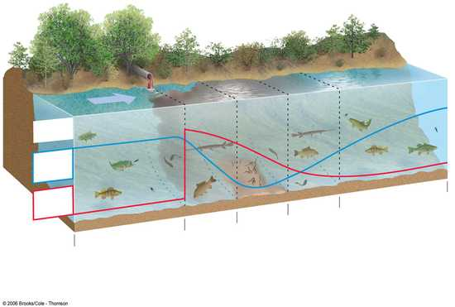
Clean Zone
Decomposition
Zone
Septic Zone
Recovery Zone
Clean Zone
Normal clean water organisms
(trout, perch, bass,
mayfly, stonefly)
Trash fish
(carp, gar,
leeches)
Fish absent, fungi,
sludge worms,
bacteria
(anaerobic)
Trash fish
(carp, gar,
leeches)
Normal clean water organisms
ayfly, stonefl)
8 ppm
Dissolved oxygen (ppm)
Biological oxygen
demand
8 m
Types of
organisms

Lesson No. 71
Water Pollution
Effects of Oil on Ocean Life
- Crude and refined petroleum
- Tanker accidents and blowouts
- Exxon Valdez
- Volatile hydrocarbons kill larvae
- Tar-like globs coat birds and marine mammals
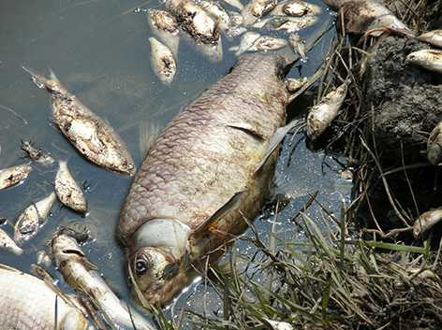
- Oil destroys insulation and buoyancy
- Heavy oil sinks and kills bottom organisms
- Coral reefs die
- Slow recovery
- Oil slicks ruin beaches
- Limited effectiveness of clean up methods
Preventing Nonpoint Source Pollution
Mostly agricultural wastesUse vegetation to reduce soil erosion.Reduce fertilizer useUse plant buffer zones around fieldsIntegrated pest management: Only use pesticides when necessary.Use plant buffers around animal feedlots.Keep feedlots away from slopes, surface water and flood zones
Laws for Reducing Point Source Pollution
Clean Water Act: The CWA is the principle law governing pollution control and water quality of the Nation's waterways. The object of the CWA is to restore and maintain the chemical, physical and biological integrity of the Nation's waters .Water Quality Act: The Clean Water Act (CWA) establishes the basic structure for regulating discharges of pollutants into the waters of the United States and regulating quality standards for surface waters.
Sewage Treatment Systems
Sewage treatment in rural and suburban areas,Septic tanks,Primary (physical) sewage treatment,Secondary (biological) sewage treatment,Urban sewage treatment (Clean Water Act),Sewage treatment facilities in many cities fail to meet federal standards,Bleaching and disinfection,Disinfectants: chlorine, ozone, and ultraviolet radiation
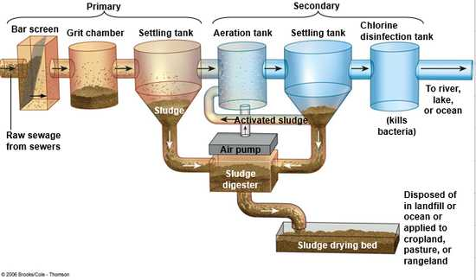
Primary and Secondary Sewage Treatment
Prevent groundwater contamination. Greatly reduce nonpoint runoff. Reuse treated wastewater for irrigation. Find substitutes for toxic pollutants. Work with nature to treat sewage. Practice four R's of resource use (refuse, reduce, recycle, reuse) Reduce resource waste Reduce air pollution Reduce poverty Reduce birth rates Fertilize your garden and yard plants with manure or compost instead of commercial inorganic fertilizer. Minimize your use of pesticides.
Never apply fertilizer or pesticides near a body of water. Grow or buy organic foods. Compost your food wastes. Do not use water fresheners in toilets. Do not flush unwanted medicines down the toilet. Do not pour pesticides, paints, solvents, oil, antifreeze, or other products containing harmful chemicals down the drain or onto the ground.
Lesson No. 72
Soil
Introduction
Soil, also commonly referred to as earth or dirt, is a mixture of organic matter, minerals, gases, liquids, and organisms that together support life
Importance of Soil
Soil plays a role in nearly all biogeochemical cycles on the Earth’s surface. Global cycling of key elements such as carbon (C), nitrogen (N), sulfur (S), and phosphorous (P) all pass through soil. In the hydrologic cycle, soil helps to mediate the flow of precipitation from the surface into the groundwater. Microorganisms living in soil can also be important components of biogeochemical cycles through the action of decomposition and other processes such as nitrogen fixation.
Soil Forming Factors
The fundamental factors that affect soil genesis can be categorized into five elements:
      - Climate
      - Organisms
      - Relief
      - Parent material
      - Time
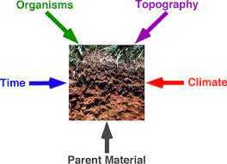
Climate
The role of climate in soil development includes aspects of temperature and precipitation. Soils in very cold areas with permafrost conditions tend to be shallow and weakly developed due to the short growing season. Organic rich surface horizons are common in low-lying areas due to limited decomposition. In warm, tropical soils, soils tend to be thicker, with extensive leaching and mineral alteration. In such climates, organic matter decomposition and chemical weathering occur at an accelerated rate.
Organisms
Animals, plants, and microorganisms all have important roles in soil development processes, in providing a supply of organic matter, and/or in nutrient cycling. Worms, nematodes, termites, ants, gophers, moles, etc. all cause considerable mixing of soil and help to blend soil, aerate and lighten the soil by creating pores (which help store water and air).
Lesson No. 73
Soil Formation Factors
Relief (Topography and Drainage
The local topography (relief) can have important microclimatic effects as well as affecting rates of soil erosion. In comparison to flat regions, areas with steep slopes overall have more soil erosion, more runoff of rainwater, and less water infiltration, all of which lead to more limited soil development in very hilly or mountainous areas. The local topography (relief) can have important microclimatic effects as well as affecting rates of soil erosion.In comparison to flat regions, areas with steep slopes overall have more soil erosion, more runoff of rainwater, and less water infiltration, all of which lead to more limited soil development in very hilly or mountainous areas.
Parent Material
The parent material of a soil is the material from which the soil has developed, whether it be river sands, shoreline deposits, glacial deposits, or various types of bedrock. In youthful soils, the parent material has a clear connection to the soil type and has significant influence.
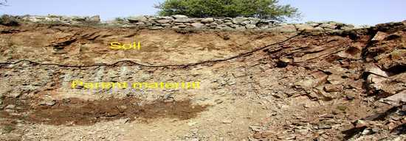

Time
In general, soil profiles tend to become thicker (deeper), more developed, and more altered over time.
However, the rate of change is greater for soils in youthful stages of development. The degree of soil alteration and deepening slows with time and at some point, after tens or hundreds of thousands of years, may approach an equilibrium condition where erosion and deepening (removals and additions) become balanced.
Young soils (< 10,000 years old) are strongly influenced by parent material and typically develop horizons and character rapidly.
Moderate age soils (roughly 10,000 to 500,000 years old) are slowing in profile development and deepening, and may begin to approach equilibrium conditions.
Old soils (>500,000 years old) have generally reached their limit as far as soil horizonation and physical structure, but may continue to alter chemically or mineralogically.
Lesson No. 74
Soil Profile and soil Uses
Soil Profile
The soil profile is a vertical section of the soil that depicts all of its horizons. The soil profile extends from the soil surface to the parent rock material. The regolith includes all of the weathered material within the profile. The regolith has two components: the solum and the saprolite.

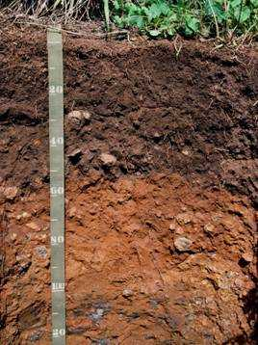
Master Horizons
There are 5 master horizons in the soil profile. Not all soil profiles contain all 5 horizons; and so, soil profiles differ from one location to another. The 5 master horizons are represented by the letters: O, A, E, B, and C.
O: The O horizon is a surface horizon that is comprised of organic material at various stages of decomposition. It is most prominent in forested areas where there is the accumulation of debris fallen from trees.
A: The A horizon is a surface horizon that largely consists of minerals (sand, silt, and clay) and with appreciable amounts of organic matter. This horizon is predominantly the surface layer of many soils in grasslands and agricultural lands.
E: The E horizon is a subsurface horizon that has been heavily leached. Leaching is the process in which soluble nutrients are lost from the soil due to precipitation or irrigation. The horizon is typically light in color. It is generally found beneath the O horizon.
B: The B horizon is a subsurface horizon that has accumulated from the layer(s) above. It is a site of deposition of certain minerals that have leached from the layer(s) above.
C: The C horizon is a subsurface horizon. It is the least weathered horizon. Also known as the saprolite, it is unconsolidated, loose parent material.
Uses of Soil
Soil is used in agriculture, where it serves as the anchor and primary nutrient base for plants. Soil material is also a critical component in mining, construction and landscape development industries. Soil serves as a foundation for most construction projects. Soil resources are critical to the environment, as well as to food and fiber production, producing 98.8% of food consumed by humans. Soil is used in agriculture, where it serves as the anchor and primary nutrient base for plants. Soil material is also a critical component in mining, construction and landscape development industries. Soil serves as a foundation for most construction projects. Soil resources are critical to the environment, as well as to food and fiber production, producing 98.8% of food consumed by humans. The biological component of soil is an extremely important carbon sink since about 57% of the biotic content is carbon. Even in deserts, cyanobacteria, lichens and mosses form biological soil crusts which capture and sequester a significant amount of carbon by photosynthesis. Soils filter and purify water and affect its chemistry. Rain water and pooled water from ponds, lakes and rivers percolate through the soil horizons and the upper rock strata, thus becoming groundwater. Pests (viruses) and pollutants, such as persistent organic pollutants (chlorinated pesticides, polychlorinated biphenyls), oils (hydrocarbons), heavy metals (lead, zinc, cadmium), and excess nutrients (nitrates, sulfates, phosphates) are filtered out by the soil. Soil organisms metabolize them or immobilize them in their biomass and necro mass thereby incorporating them into stable humus. The physical integrity of soil is also a prerequisite for avoiding landslides in rugged landscapes.
Lesson No. 75
Atmospheric Pollution
Definition
Air pollution occurs in many forms but can generally be thought of as gaseous and particulate contaminants that are present in the earth’s atmosphere.
Primary and Secondary Pollutants
Chemicals discharged into the air that have a direct impact on the environment are called primary pollutants. These primary pollutants sometimes react with other chemicals in the air to produce secondary pollutants.
Sources of Air Pollution
There are following sources of air pollution;
    - Stationary source
    - Mobile source
    - Agricultural sources
    - Natural sources
Stationary source
stationary source of air pollution refers to an emission source that does not move, also known as a point source. Stationary sources include factories, power plants, and dry cleaners
Mobile Sources
A mobile source of air pollution refers to a source that is capable of moving under its own power. In general, mobile sources imply “on-road” transportation, which includes vehicles such as cars, sport utility vehicles, and buses. Agricultural sources arise from operations that raise animals and grow crops, which can generate emissions of gases and particulate matter. For example, animals confined to a barn or restricted area produce large amounts of manure.
Natural sources
Air pollution caused by natural sources is not caused by people or their activities but occurs due to natural phenomenon. An erupting volcano emits particulate matter and gases, forest and prairie fires can emit large quantities of “pollutants”, dust storms can create large amounts of particulate matter, and plants and trees naturally emit volatile organic compounds which can form aerosols that can cause a natural blue haze.
Lesson No. 76
Common Air Pollutants
- There are six common Air Pollutants including:
    - Ground Level Ozone
    - Particulate Matter
    - Carbon Monoxide
    - Nitrogen Dioxide
    - Sulphur Dioxide
    - Lead
Ground Level Ozone
Ground-level ozone is not emitted directly into the air, but is created by chemical reactions between oxides of nitrogen (NOx) and volatile organic compounds (VOC) in the presence of sunlight. Emissions from industrial facilities and electric utilities, motor vehicle exhaust, gasoline vapors, and chemical solvents are some of the major sources of NOx and VOC.
Particulate Matter
Particulate matter, also known as particle pollution, is a complex mixture of extremely small particles and liquid droplets. Particle pollution is made up of a number of components, including acids (such as nitrates and sulfates), organic chemicals, metals, and soil or dust particles
Carbon Monoxide
Carbon monoxide (CO) is a colorless, odorless gas emitted from combustion processes. Nationally and, particularly in urban areas, the majority of CO emissions to ambient air come from mobile sources.
Nitrogen Dioxide
Nitrogen dioxide (NO2) is one of a group of highly reactive gasses known as “oxides of nitrogen,” or nitrogen oxides (NOx). EPA’s National Ambient Air Quality Standard uses NO2 as the indicator for the larger group of nitrogen oxides. NO2 forms quickly from emissions from cars, trucks and buses, power plants, and off-road equipment.

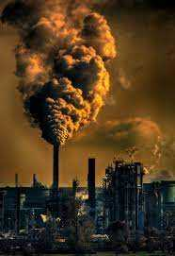
Sulphur Dioxide
Sulfur dioxide (SO2) is one of a group of highly reactive gasses known as “oxides of sulfur.” The largest sources of SO2 emissions are from fossil fuel combustion at power plants (73%) and other industrial facilities (20%). Smaller sources of SO2 emissions include industrial processes such as extracting metal from ore, and the burning of high sulfur containing fuels by locomotives, large ships, and non-road equipment.

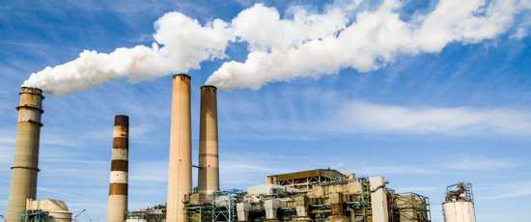
Lead
Lead is a metal found naturally in the environment as well as in manufactured products. The major sources of lead emissions have historically been from fuels in on-road motor vehicles (such as cars and trucks) and industrial sources.
Lesson No. 77
Ozone Depletion
Ozone Layer
Ozone (O3) is a gaseous molecule that occurs in different parts of the atmosphere. It is very reactive chemically and is dangerous to plant and animal life when present in the lower portions of the atmosphere. This type of ozone, called ground-level ozone, is a significant hazard to human health and is associated with pollution from vehicle exhaust and other anthropogenic emissions . Ozone that occurs in the upper atmosphere is naturally occurring and beneficial to life due to its role in blocking harmful radiation from the sun. This type of ozone is called stratospheric ozone. Ozone in the stratosphere forms when the two oxygen atoms in an O2 molecule are broken apart by the energy of sunlight. Each lone oxygen atom can then combine with a different O2 molecule to form O3, ozone.
Importance of Ozone
Sun emits UV (Ultraviolet radiations) that could be very harmful to human health. Ozone molecules absorb ultraviolet (UV) light, which is advantageous for life on Earth because UV light can break down important biomolecules such as DNA, which can lead to cell death and mutations.
Ozone Depletion
The ozone layer that protects life on Earth from harmful UV light has been depleted due to human activities.The ozone depletion process begins when CFCs (chlorofluorocarbons) and other extremely stable chemically and do not dissolve in rain, and thus can linger for long periods. After several years, ODS molecules eventually reach the ozone layer in the stratosphere, which starts at about 10 kilometers above the Earth’s surface. Once in the stratosphere, CFCs and other ODS destroy ozone molecules.In the case of CFCs, UV light in the stratosphere knocks loose a chlorine atom from the molecule, which can then destroy numerous ozone molecules, as shown in figure.
Lesson No. 78
Policies to Reduce Ozone Destruction
Tackling the issue of ozone layer destruction is an example of global cooperation that produced meaningful action on a large-scale environmental problem. In 1973, scientists first calculated that CFCs could reach the stratosphere and destroy ozone. Based only on their calculations, the United States and most Scandinavian countries banned CFCs in spray cans in 1978. In 1985, members of the British Antarctic Survey reported that a 50% reduction in the ozone layer had been found over Antarctica in the previous three springs, a very important finding.
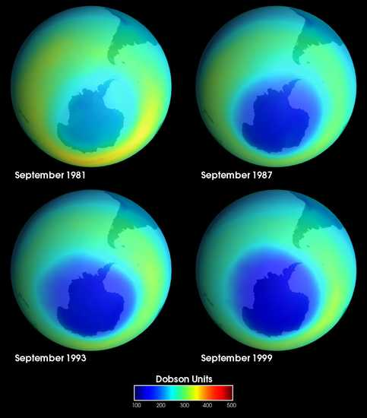

Two years after that seminal British Antarctic Survey report, an agreement titled the “Montreal Protocol on Substances that Deplete the Ozone Layer” was ratified by nations all over the world. The Montreal Protocol, as it is commonly called, controls the production and emission of 96 chemicals that damage the ozone layer.Constant vigilance and monitoring are needed, however, as illegal production and emission of CFCs and other ODS threaten recovery efforts.In 2018, scientists from the US National Oceanic and Atmospheric Administration reported that emissions of a particular type of CFC had increased 25% since 2012. Follow-up studies have since approximated the emissions as originating in particular regions of eastern Asia.
Health and Environmental Effects of Ozone Layer Depletion
There are three types of UV light, each distinguished by their wavelengths: UV-A, UV-B, and UV-C.
Stratospheric ozone molecules absorb all of the sun’s UV-C light and most of its UV-B light-B is harmful to cells because it can interact with biomolecules like DNA and damage it. This can lead to mutations and cell death. Laboratory and epidemiological studies demonstrate that UV-B causes certain types of skin cancers in humans and plays a major role in development of malignant melanoma (a particularly dangerous form of skin cancer). In addition, UV-B causes cataracts, a clouding of the lens in the eye that can lead to poor vision or even blindness.
Lesson No. 79
Acid Rain
Wet and dry deposition of acidic substances from the atmosphere.Rain, snow, cloud water droplets or solid particles
  - Sulfur Dioxide
  - Nitrogen Dioxide
Where do SO₂ and NO₂ Particles Come From?
Sulfur dioxide and nitrogen dioxide particles are emitted from utility plants, especially coal-fed electric plants Automobiles also emit acid rain causing pollution
Effects of Acid Rain
Acid rain causes acidification of lakes and streams and contributes to the damage of trees at high elevations (for example, red spruce trees above 2,000 feet) and many sensitive forest soils. acid rain accelerates the decay of building materials and paints, including irreplaceable buildings, statues, and sculptures that are part of our nation’s cultural heritage. Prior to falling to the earth, sulfur dioxide (SO2) and nitrogen oxide (NOx) gases and their particulate matter derivatives—sulfates and nitrates—contribute to visibility degradation and harm public health.
How to reduce Acid Rain
Students can Use Less Energy….
    - Turn off lights at home and classroom
    - Turn of computers
    - Ride bikes when possible
    - Use less paper
    - Use less water (conserve energy used to heat)
    - Recycle

Lesson No. 80
Green House Effect
The greenhouse effect is a process that occurs when gases in Earth's atmosphere trap the Sun's heat. This process makes Earth much warmer than it would be without an atmosphere. The greenhouse effect is one of the things that makes Earth a comfortable place to live.

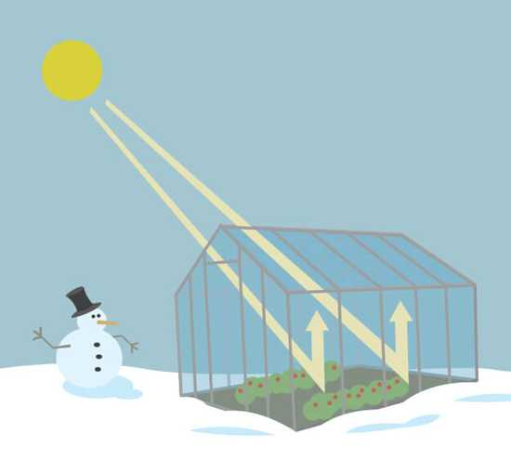

Causes of Greenhouse Effect
Human Activity Is the Cause of Increased Greenhouse Gas Concentrations. Over the last century, burning of fossil fuels like coal and oil has increased the concentration of atmospheric carbon dioxide (CO₂). This increase happens because the coal or oil burning process combines carbon with oxygen in the air to make CO₂.This CO₂ act as glass sheet and prevent to escape heat to outside.

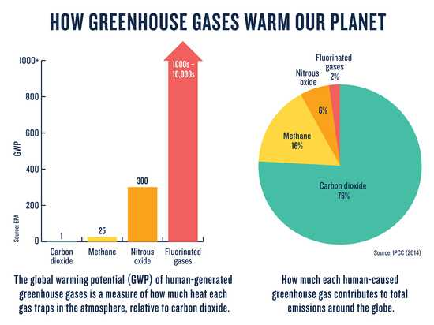
Global Warming
As a result of greenhouse effect temperature of earth is increasing, this is called global warming. This causes melting of glaciers bringing irregular floods. Global Warming causes change in wind pattern resulting change in rain pattern.
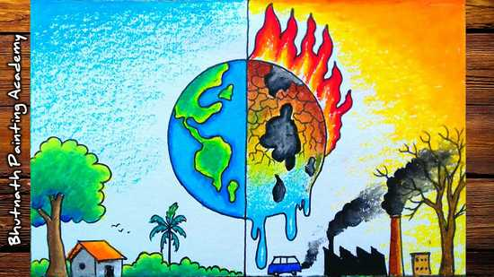
What reduces the greenhouse effect on Earth?
We can reduce emissions by shifting to alternative technologies that either don't need gasoline (like bicycles and electric cars) or don't need as much (like hybrid cars). Using public transportation, carpooling, biking, and walking leads to fewer vehicles on the road and less greenhouse gases in the atmosphere.
Lesson No. 81
Energy Resources
Biofuels
The term biofuels usually apply to liquid fuels and blending components produced from biomass materials called feedstocks. Most biofuels are used as transportation fuels, but they may also be used for heating and electricity generation.
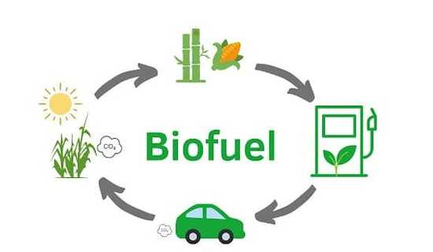
Plants, algae, and cyanobacteria utilize solar energy to grow and create biomass that can be burned and used for biofuels, such as wood, biodiesel, bioethanol. Over the course of millions of years, biomass from photosynthetic organisms can create energy-rich fossil fuels through the geologic process of burial and transformation through heat and pressure.
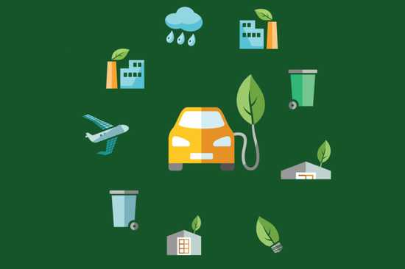
Renewable Energy Resources
Renewable energy is energy derived from natural sources that are replenished at a higher rate than they are consumed.
For example sunlight and wind.
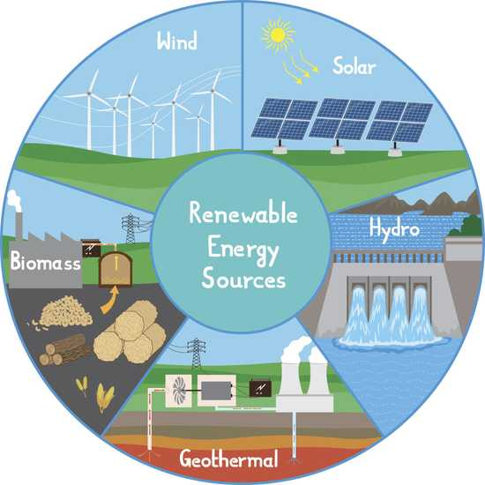

Non-Renewable Energy Resources
Nonrenewable energy resources include coal, natural gas, oil, and nuclear energy. Once these resources are used up, they cannot be replaced
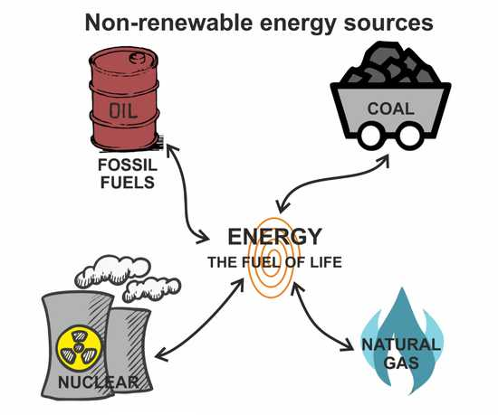

Environmental and Health Challenges of Energy Use
The environmental impacts of energy use on humans and the planet can happen anywhere during the life cycle of the energy source. The impacts begin with the extraction of the resource. They continue with the processing, purification or manufacture of the source; its transportation to place of energy generation, and ends with the disposal of waste generated during use.
Geopolitical Challenges of Fossil Fuels
Our modern technologies and services, such as transportation and plastics depend in many ways on fossil fuels. If supplies become limited or extremely costly, our economies are vulnerable. If countries do not have fossil fuel reserves of their own, they incur even more risk.
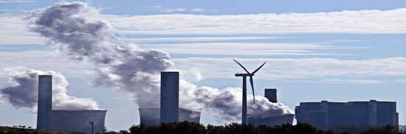
Sources of United States Net Petroleum Imports, 2009 Figure illustrates that the United States imported over half of the crude oil and refined petroleum products that it consumed during 2009.
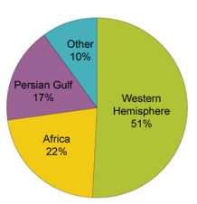
Lesson No. 82
Non-Renewable Energy Resources
Fossil Fuels
Fossil fuels comes from the organic matter of plants, algae, and cyanobacteria that was buried, heated, and compressed under high pressure over millions of years. The process transformed the biomass of those organisms into the three types of fossil fuels:
  - Oil
  - Coal
  - Natural gas

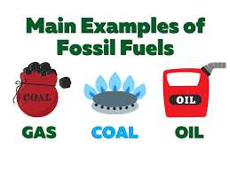
Oil
Thirty seven percent of the world’s energy consumption and 43% of the United States energy consumption comes from oil. Oil is usually found one to two miles (1.6 – 3.2 km) below the Earth’s surface, whether that is on land or ocean.
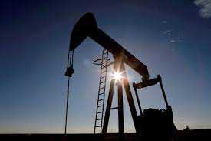
Oil Refining (Source of Pollution)
Oil refining is one of top sources of air pollution in the United States for volatile organic hydrocarbons and toxic emissions, and the single largest source of carcinogenic benzene.
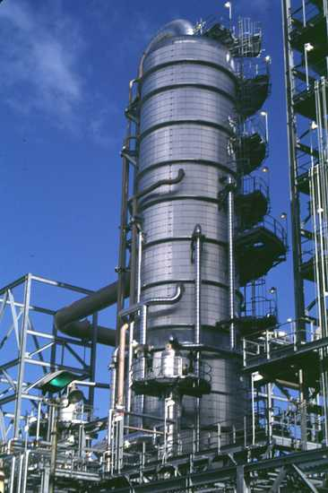
Oil Consumption (Source of Pollution)
When petroleum is burned as gasoline or diesel, or to make electricity or to power boilers for heat, it produces a number of emissions that have a detrimental effect on the environment and human health: Carbon dioxide (CO2) is a greenhouse gas and a source of climate change. Sulfur dioxide (SO2) causes acid rain, which damages plants and animals that live in water, and it increases or causes respiratory illnesses and heart diseases, particularly in vulnerable populations like children and the elderly. Nitrous oxides (NOx) and Volatile Organic Carbons (VOCs) contribute to ozone at ground level, which is an irritant and causes damage to the lungs. Particulate Matter (PM) produces hazy conditions in cities and scenic areas, and combines with ozone to contribute to asthma and chronic bronchitis, especially in children and the elderly.
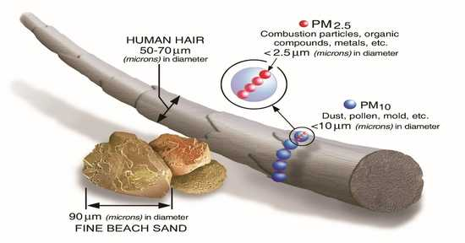
The Global Dependence of Transportation on Oil
Two-thirds of oil consumption is devoted to transportation, providing fuel for cars, trucks, trains and airplanes.
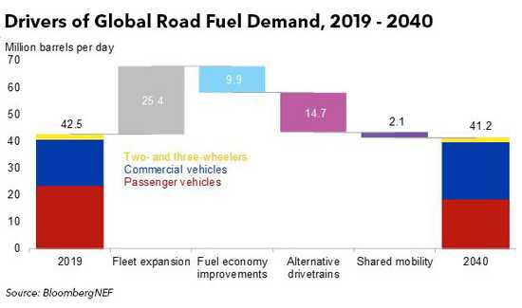
Lesson No. 83
Non-Renewable Energy Resources
Coal
A combustible black or dark brown rock consisting chiefly of carbonized plant matter, found mainly in underground seams and used as fuel.
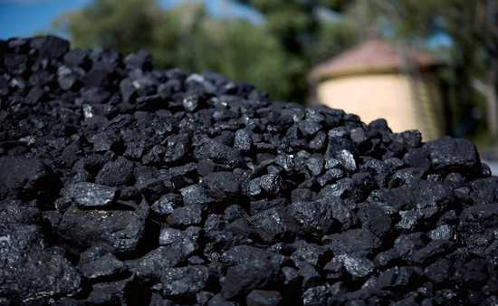
Coal (Pollution Source)
Coal is plentiful and inexpensive, when looking only at the market cost relative to the cost of other sources of electricity, but its extraction, transportation, and use produces a multitude of environmental impacts that the market cost does not truly represent.
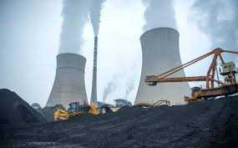

Coal (Pollution Source)
Coal emits sulfur dioxide, nitrogen oxide, and mercury, which have been linked to acid rain, smog, and health issues. Burning of coal emits higher amounts of carbon dioxide per unit of energy than the use of oil or natural gas.
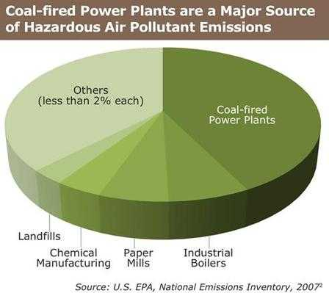
Mountaintop mining (MTM),
Mountaintop mining (MTM), while less hazardous to workers, has particularly detrimental effects on land resources. MTM is a surface mining practice involving the removal of mountaintops to expose coal seams, and disposing of the associated mining waste in adjacent valleys
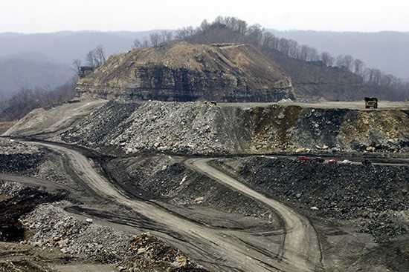
Lesson No. 84
Non-Renewable Energy Resources
Natural Gas
Flammable gas, consisting largely of methane and other hydrocarbons, occurring naturally underground (often in association with petroleum) and used as fuel is known as natural gas.Natural gas meets 20% of world energy needs and 25% of United States needs. Natural gas is mainly composed of methane (CH4) and is a very potent greenhouse gas.

Types of Natural Gas
There are two types of natural gas:
Biogenic gas is found at shallow depths and arises from anaerobic decay of organic matter by bacteria, like landfill gas.
Thermogenic gas comes from the compression of organic matter and deep heat underground. They are found with petroleum in reservoir rocks and with coal deposits, and these fossil fuels are extracted together.
Natural Gas: Preferred Fossil Fuel
Natural gas is a preferred fossil fuel when considering its environmental impacts. Specifically, when burned, much less carbon dioxide (CO2), nitrogen oxides, and sulfur dioxide are omitted than from the combustion of coal or oil. It also does not produce ash or toxic emissions.
Natural Gas (Pollution Source)
Natural gas production can result in the production of large volumes of contaminated water.Extraction of shale gas is more problematic than traditional sources due to a process nicknamed fracking, or fracturing of wells, since it requires large amounts of water.If mismanaged, hydraulic fracturing fluid can be released by spills, leaks, or various other exposure pathways. The fluid contains potentially hazardous chemicals such as hydrochloric acid, glutaraldehyde, petroleum distillate, and ethylene glycol.
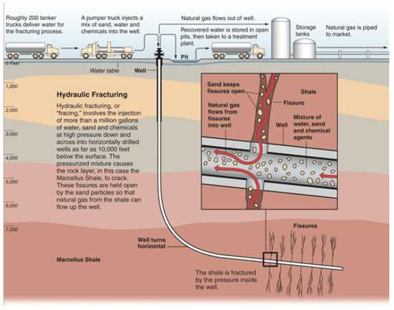
Nuclear Power
Nuclear power is energy released from the radioactive decay of elements, such as uranium, which releases large amounts of energy.
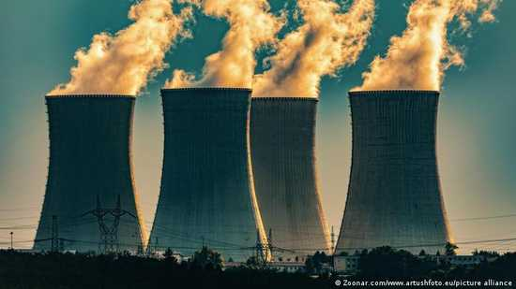
Environmental Challenges due to Nuclear Power
Mining and refining uranium ore and making reactor fuel demands a lot of energy.Nuclear power plants are very expensive and require large amounts of metal, concrete, and energy to build. The main environmental challenge for nuclear power is the wastes including uranium mill tailings, spent (used) reactor fuel, and other radioactive wastes. These materials have long radioactive half-lives and thus remain a threat to human health for thousands of years. The half life of a radioactive element is the time it takes for 50% of the material to radioactively decay. By volume, the waste produced from mining uranium, called uranium mill tailings, is the largest waste and contains the radioactive element radium, which decays to produce radon, a radioactive gas. High-level radioactive waste consists of used nuclear reactor fuel. This fuel is in a solid form consisting of small fuel pellets in long metal tubes and must be stored and handled with multiple containment, first cooled by water and later in special outdoor concrete or steel containers that are cooled by air.
Lesson No. 85
Renewable Energy Resources
Hydropower
Hydropower (hydroelectric) relies on water to spin turbines and create electricity. It is considered a clean and renewable source of energy because it does not directly produce pollutants and because the source of power is regenerated. Hydropower provides 35% of the United States’ renewable energy consumption.
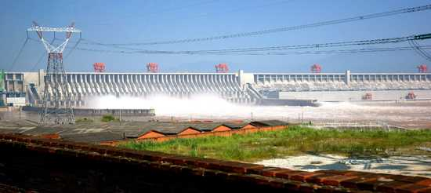

Environmental Impacts of Hydropower
Migration of fish to their upstream spawning areas can be obstructed by dams.Fish traveling downstream can get killed or injured as water moves through turbines in the dam.
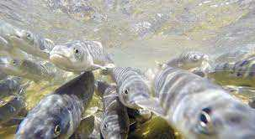
Environmental Impacts of Hydropower
Reservoirs and operation of dams can also affect aquatic habitats due to changes in water temperatures, water depth, chemistry, flow characteristics, and sediment loads, all of which can lead to significant changes in the ecology and physical characteristics of the river both upstream and downstream. As reservoirs fill with water it may cause natural areas, farms, cities, and archeological sites to be inundated and force populations to relocate.
Municipal Solid Waste
Municipal solid waste (MSW) is commonly known as garbage and can create electricity by burning it directly or by burning the methane produced as it decays.
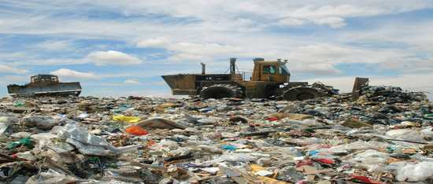

Environmental Impacts of MSW
.Many of the environmental impacts are similar to those of a coal plant: air pollution, ash generation, etc. Because the fuel source is less standardized than coal and hazardous materials may be present in MSW, incinerators and waste-to-energy power plants need to clean the gases of harmful materials. Also, while incinerating at high temperature many of the toxic chemicals may break down into less harmful compounds. The ash from these plants may contain high concentrations of various metals
Lesson No. 86
Renewable Energy Resources
Biofuel
Biofuel is a fuel that is produced over a short time span from biomass, rather than by the very slow natural processes involved in the formation of fossil fuels, such as oil.


Biofuel: Role in Carbon Cycle
Livestock manure and human waste could also be considered biomass. The use of biomass can help mitigate climate change because when burned it adds no new carbon to the atmosphere. Photosynthesis removes CO2 through the process of carbon fixation. When biomass is burnt, CO2 is created, but this is equal to the amount of CO2 captured during carbon fixation. Thus, biomass is a carbon neutral energy source because it doesn’t add new CO2 to the carbon cycle.

Landfill Gas or Biogas
Landfill gas (biogas) is a sort of man-made “biogenic” gas.Methane is formed as a result of biological processes in sewage treatment plants, waste landfills, anaerobic composting, and livestock manure management systems. This gas is captured and burned to produce heat or electricity.
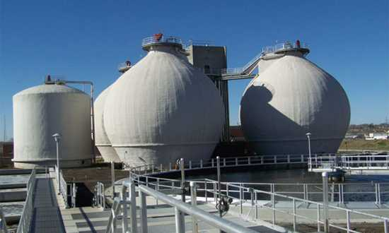
Geothermal Energy
Geothermal energy is the thermal energy in the Earth's crust which originates from the formation of the planet and from radioactive decay of materials in currently uncertain but possibly roughly equal proportions.
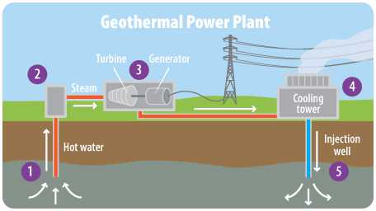
Geothermal power plants do not burn fuel to generate electricity so their emission levels are very low.
They release less than 1% of the carbon dioxide emissions of a fossil fuel plant. Geothermal plants use scrubber systems to clean the air of hydrogen sulfide that is naturally found in the steam and hot water.
They emit 97% less acid rain-causing sulfur compounds than are emitted by fossil fuel plants. After the steam and water from a geothermal reservoir have been used, they are injected back into the earth.
Lesson No. 87
Renewable Energy Resources
Solar Energy
Solar energy is radiant light and heat from the Sun that is harnessed using a range of technologies such as solar power to generate electricity, solar thermal energy (including solar water heating), and solar architecture.
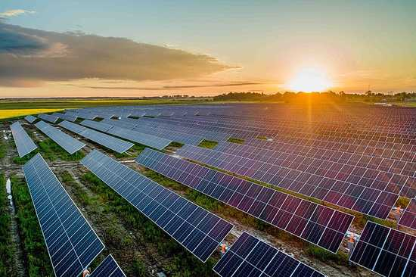
The manufacturing of photovoltaic (PV) cells generates some hazardous waste from the chemicals and solvents used in processing. Often solar arrays are placed on roofs of buildings or over parking lots or integrated into construction in other ways. However, large systems may be placed on land and particularly in deserts where those fragile ecosystems could be damaged if care is not taken.
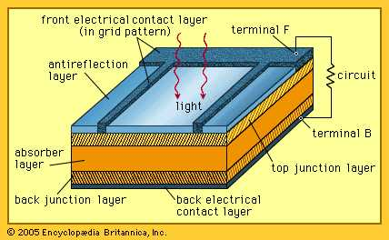
Some solar thermal systems use potentially hazardous fluids (to transfer heat) that require proper handling and disposal. Concentrated solar systems may need to be cleaned regularly with water, which is also needed for cooling the turbine-generator. Using water from underground wells may affect the ecosystem in some arid locations.
Wind
Wind power or wind energy is mostly the use of wind turbines to generate electricity. Wind power is a popular, sustainable, renewable energy source that has a much smaller impact on the environment than burning fossil fuels.
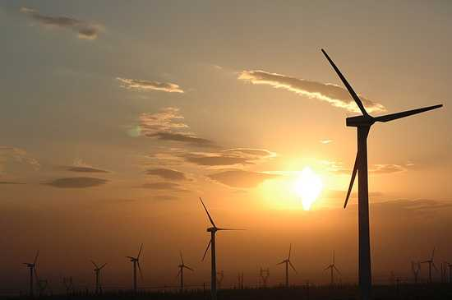
Because a wind turbine has a small physical footprint relative to the amount of electricity it produces, many wind farms are located on crop and pasture land.They contribute to economic sustainability by providing extra income to farmers and ranchers, allowing them to stay in business and keep their property from being developed for other uses.
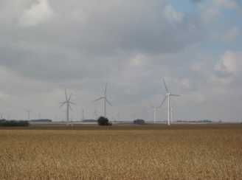
Lesson No. 88
Depletion of Resources
Resources are depleted when it is being used faster than it can replenish itself. The problem is, we’re using too much and without care. Our planet just can’t keep up with our ever-increasing demands.
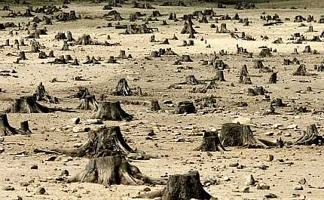
Causes of Depletion
- Overpopulation With 7 billion people on the planet, the demand on Earth’s resources continue to increase.
- Overconsumption and waste. This is the excessive and unnecessary use of resources.
- Deforestation and the Destruction of Ecosystems leading to loss of biodiversity.
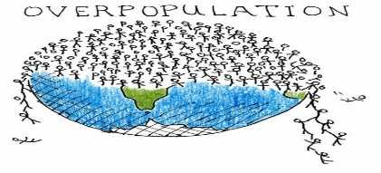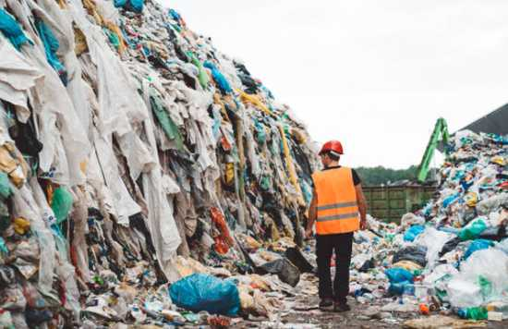

- Mining of Minerals and Oil.
- Technological and Industrial Development.
- Erosion.
- Pollution and Contamination of resources.
Depletion of Water
Even though you see water everywhere and our planet is 70% water, only 2.5% of that 70% is fresh water. The rest is salt water and not useful to humans at all. That small percentage of fresh water is mostly in the form of ice or permanent snow cover. So, we really have only a few percent available for use. The Food and Agriculture Organization of the United Nations predict that by 2025, 1.8 billion people will have no water to drink.
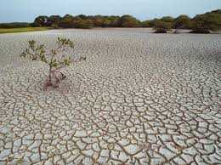
Depletion of Coal
This is the most used fossil fuel and a non-renewable energy source. Peak coal extraction is predicted between 2025 and 2048. In 2011, it was estimated that we have enough coal to meet global demands for 188 years. If the demand increases, the timeframe will decrease.
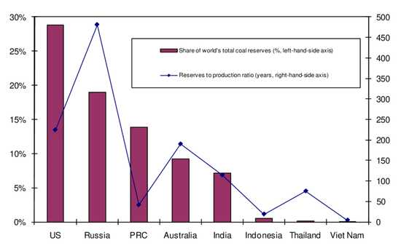
Without oil, global transportation will be severely debilitated.
The BP Statistical Review of World Energy estimates that there is 188.8 million tons of oil left in the known oil reserves as of 2010. If our current demand continues, this oil will only be enough to supply the world demands for the next 46.2 years.
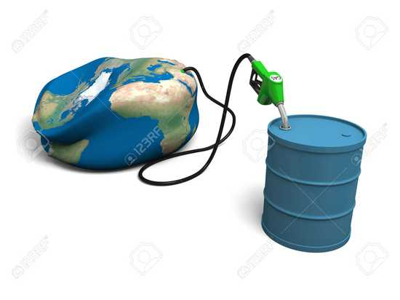
Depletion of Natural Gas
As of 2010, the known reserves of natural gas was estimated to last 58.6 years with the current global production.
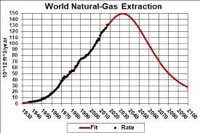
Lesson No. 89
Eutrophication
Eutrophication is the process by which an entire body of water, or parts of it, becomes progressively enriched with minerals and nutrients, particularly nitrogen and phosphorus.
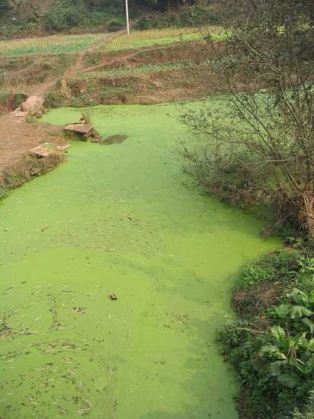
Sources of nutrients
The sources of excess phosphate are phosphates in detergent, industrial/domestic run-offs, and fertilizers, industrial/domestic run-off and sewage and agriculture.Main sources of nitrogen beside natural nitrogen fixation are from agricultural runoff (from fertilizers and animal wastes), from sewage and from atmospheric deposition of nitrogen originating from combustion or animal waste.
Increasing biomass generation
Eutrophication is a process of increasing biomass generation in a water body caused by increasing concentrations of plant nutrients, most commonly phosphate and nitrate. Increasing nutrient concentrations lead to increasing growth of aquatic plants, both macrophytes and phytoplankton. As more plant material becomes available as a food resource, there are associated increases in invertebrates and fish species. As the process continues, the biomass of the water body increases and biological diversity decrease
Types of Eutrophication
There are two types of Eutrophication:
  - Natural Eutrophication
  - Cultural Eutrophication
Cultural Eutrophication
Cultural or anthropogenic eutrophication is the process that speeds up natural eutrophication because of human activity. Due to clearing of land and building of towns and cities, land runoff is accelerated and more nutrients such as phosphates and nitrate are supplied to lakes and rivers, and then to coastal estuaries and bays.
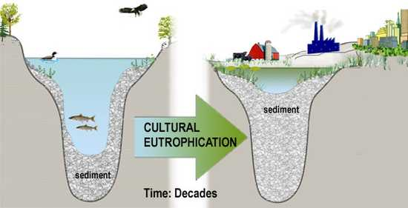
Although eutrophication is commonly caused by human activities, it can also be a natural process, particularly in lakes.Climate change, geology, and other external influences are also critical in regulating the natural productivity of lakes.
Effects of Eutrophication
There are following effects of eutrophication:
  - Ecological effects
  - Decreased biodiversity
  - New species invasion
  - Toxicity
  - Economic effects
  - Health impacts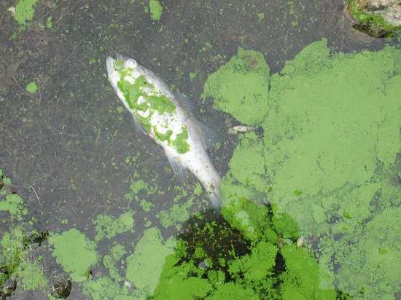

Lesson No. 90
Effects of Eutrophication
Ecological effects
Eutrophication can have the following ecological effects:
  - Increased biomass of phytoplankton,
  - Changes in macrophyte species composition and biomass
  - Dissolved oxygen depletion
  - Increased incidences of fish kills
  - Loss of desirable fish species
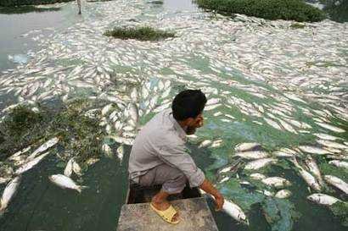
Decreased Biodiversity
When an ecosystem experiences an increase in nutrients, primary producers reap the benefits first. In aquatic ecosystems, species such as algae experience a population increase (called an algal bloom). Algal blooms limit the sunlight available to bottom-dwelling organisms and cause wide swings in the amount of dissolved oxygen in the water. Oxygen is required by all aerobically respiring plants and animals and it is replenished in daylight by photosynthesizing plants and algae. Under eutrophic conditions, dissolved oxygen greatly increases during the day, but is greatly reduced after dark by the respiring algae and by microorganisms that feed on the increasing mass of dead algae. When dissolved oxygen levels decline to hypoxic levels, fish and other marine animals suffocate. As a result, creatures such as fish, shrimp, and especially immobile bottom dwellers die off. In extreme cases, anaerobic conditions ensue, promoting growth of bacteria. Zones where this occurs are known as dead zones.
New species invasion
Eutrophication may cause competitive release by making abundant a normally limiting nutrient. This process causes shifts in the species composition of ecosystems. For instance, an increase in nitrogen might allow new, competitive species to invade and out-compete original inhabitant species.
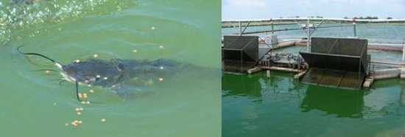
Toxicity
Some harmful algal blooms resulting from eutrophication, are toxic to plants and animals. Toxic compounds can make their way up the food chain, resulting in animal mortality
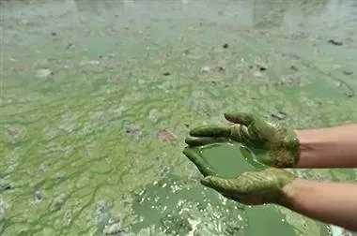

Economic effects
Eutrophication and harmful algal blooms can have economic impacts due to increasing water treatment costs, commercial fishing and shellfish losses, recreational fishing losses (reductions in harvestable fish and shellfish), and reduced tourism income (decreases in perceived aesthetic value of the water body).
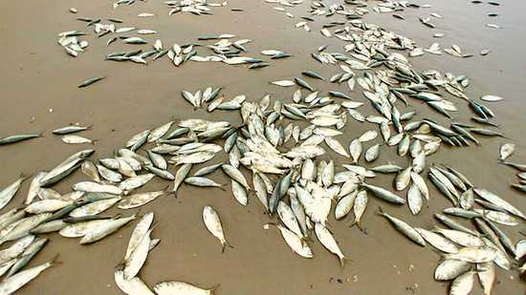
Health impacts
Human health effects include excess nitrate in drinking water (blue baby syndrome); disinfection by-products in drinking waterSwimming in water affected by a harmful algal bloom can cause skin rashes and respiratory problems
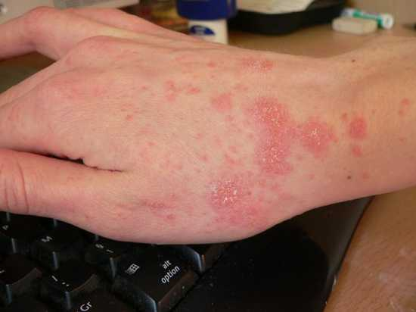

Think positive you will get positive .

