E-commerce Management

Contents

1. Online Store: Components of Online Store -- Active Online Presence 4
2. Online Store: Components of Online Store -- Mobile Responsive Website 4
3. Online Store: Components of Online Store -- Guest Sign In 4
4. Online Store: Components of Online Store -- Product Catalogue and Branded Products 5
5. Online Store: Components of Online Store -- Product Review and Rating 5
6. Online Store: Components of Online Store -- Recommendations 5
7. Online Store: Components of Online Store -- Efficient Search Capabilities 6
8. Online Store: User Experience (UX) 7
9. Online Store: Components of Online Store -- Inventory Management 7
10. Online Store: Components of Online Store -- Supply Side Management 7
11. Online Store: Components of Online Store – Drop Shipping 8
12. Online Store: Components of Online Store -- How Drop Shipping Works 8
13. Online Store: Components of Online Store -- Pros and Cons of Drop Shipping 9
14. Online Store: Components of Online Store -- Reliable Shopping Cart 9
15. Online Store: Components of Online Store -- Secure Online Payment 10
16. Online Store: Components of Online Store -- Shipping Information and Charges 10
17. Online Store: Components of Online Store -- Easy Checkout Process 10
18. Online Store: Components of Online Store -- Order Tracking 11
19. Online Store: Components of Online Store -- Loyalty Program 11
20. Online Store: Components of Online Store -- Customer Relationship Management 11
21. Refresher on Database: Database Basics 12
22. Refresher on Database: Entities in Databases 12
23. Refresher on Database: Example of Identifying Entities from Real-time Scenario 13
24. Refresher on Database: Keys in Databases 13
25. Refresher on Database: Example of Identifying Primary Key and Foreign Key with Real-time Scenario 14
26. Refresher on Database: Relationships 15
27. Refresher on Database: Relationship -- Optionality 15
28. Refresher on Database: Relationship – Cardinality 15
29. Refresher on Database: Relationships -- (One - to - One) 16
30. Refresher on Database: Relationships -- (One - to - Many) 16
31. Refresher on Database: Relationships -- (Many - to - Many) 16
32. Refresher on Database: Example of Identifying Relationships in Real-time Scenario 16
33. Refresher on Database: Workshop - I -- Creating Entity Relationship Diagram from Real-time Scenario 17
34. Refresher on Database: Workshop - II -- Creating Entity Relationship Diagram from Real-time Scenario 18

Online Store: Components of Online Store -- Active Online Presence
Just like another business, online businesses need to attract customers in order to successful generation of business. So online store businesses must focus on continuous marketing activities while using multiple channels so the customer know about the existence of online store. Not only this, customers should be updated regularly by running different campaigns in order to attract them. Promotions, offers, sales and discounts should be properly communicated to customers constantly and they must be related to customers in order to increase their interest in buying and for that content on store should be updated in real-time.

Online Store: Components of Online Store -- Mobile Responsive Website
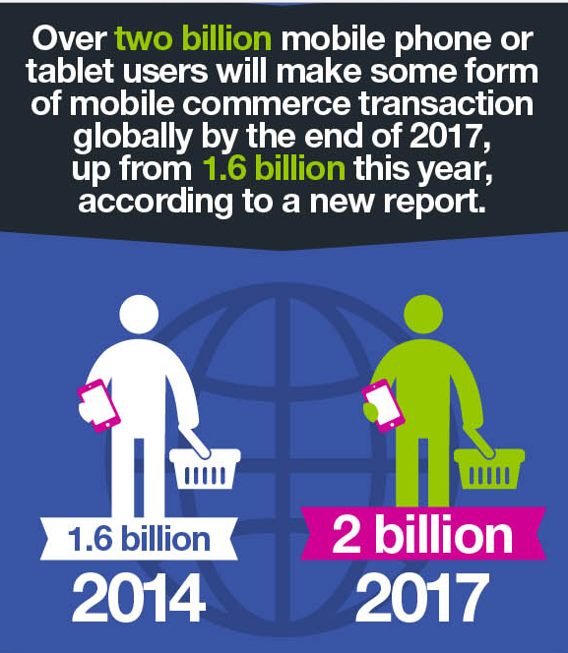
Technology not only makes things easy for businesses but add challenges as well. Customers are accessing Desktop and Mobile devices to access online stores, ecommerce store must ensure customers enjoy same user experience regardless of the device. One such thing is responsive website which means website should be open properly without disorientation in Mobile and other devices (tablet). Mobile users are increasing day by day; roughly there are 5 billion mobile users in 2018 as compared to 4.01 billion in 2013. This increase in numbers makes responsive website a key success factor for online businesses. Examples of responsive websites are as follows:
- www.amazon.com
- www.aliexpress.com
And the example of non-responsive website is:
- www.fccollege.edu.pk

Online Store: Components of Online Store -- Guest Sign In
Another important factor is the ease of purchasing a product from an online store because online shopping is about convenience with no-bargain facility. Some store required a hectic procedure to create an account before they can actually checkout with the product. Guest Sign is to enable customer to proceed with online shopping without forcing to register first. According to a research in 2017, “creating an account” was the second biggest reason behind abandoning purchase during checkout followed by “too long and complex checkout process” on third number.
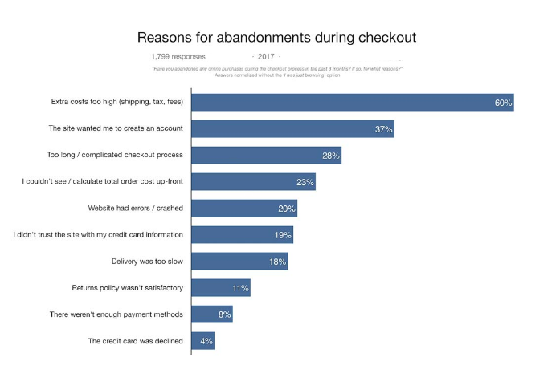

Online Store: Components of Online Store -- Product Catalogue and Branded Products
Customers’ needs information about the product they are interested to purchase. Not only this, they want to see the product online just to increase their level of satisfaction. So it is of utmost importance to create a product && product details page along with add high quality product images in different zoom/angles. In order to support customers in making buying decision, an online store must have:
- Product description, price, quantity available should be mentioned explicitly
- Specification of product to be mention with warranty
- High quality images of the products
- Shipping details like time and cost etc.

Online Store: Components of Online Store -- Product Review and Rating
Product reviews and rating from previous buyers are another source of convincing a customer to make a purchase decision. Customers may find information about the utility and quality of the product they are interested in and that increase the probability of checkout. Positive reviews will increase the level of trust between the store and customers, which is the biggest challenge in ecommerce, as they give good impression about the product quality, utility, reliability of product and store.

Online Store: Components of Online Store -- Recommendations
Another strategy to convert a visit into a sale is to provide product recommendations, like similar product that can be compared and purchases in competition or in compliment of the product in which the customer is actually interested. Sales can be increase this way. Here are few facts:
- A Gartner study predicts engines that gauge and react to customer intent will be capable of boosting ecommerce profits as much as 15 percent by 2020
- An Accenture report says personalization increases the likelihood of a prospect purchasing from you by 75 percent
- 35 percent of sales on Amazon.com and 75 percent of Netflix sales were directly related to product recommendations

A good example on Amazon:
https://www.amazon.com/gp/product/0201517841/ref=oh_aui_detailpage_o01_?ie=UTF8&psc=1

Online Store: Components of Online Store -- Efficient Search Capabilities
E-Commerce store should enable customers to search for product in clear cut way and navigation to reach required product via search should be easy not messy. This is another factor that makes sure a perfect user experience and makes it easy for customers to look for the product(s) they want to purchase among, may be, thousands of other available products. Customers may abandon purchasing products because they find it difficult or time taking to find / search relevant product. Search box should be large enough and easy to spot in web design. It can also be with auto search functionality that can search within specific product category and give accurate results. Good examples are as follows:
- www.zara.com
- www.johnlewis.com

Online Store: User Experience (UX)
Design of the store website has a significant impact on customers experience and they may find it very complex to messy at times. As a best practice, the web design must be smart and sleek and the pages must not be over flooded with the information. Good navigation to different section of the website, like different product categories, will help the customers in a significant manner to find their relevant products. Another important factor in User Experience is the loading time of the website as user will definitely avoid store with very heavy pages that take long enough to load. Too much loading time is the top complaint from mobile users, according to research. Examples are as follows:
Good UX
- https://www.abof.com/
- www.zara.com
- www.lookhuman.com/
Bad UX
- http://www.arngren.net/
- http://ronoslund.com/

Online Store: Components of Online Store -- Inventory Management
Inventory is products mostly in possession of company offering products on online store. Along with other above mentioned factors, on time delivery of the products to the customers is a key success factor. So the store must have all the products it is displaying on the online in inventory. Some stores fake inventory but this practice ultimately leads lost in trust of customer instead of giving actual benefit. Stock or inventory management helps owners to avoid overselling of the product. On the other side, too much inventory increase business cost and reduces revenue because of high storage cost. So inventory must be planned in a very strategic way.

Online Store: Components of Online Store -- Supply Side Management
Availability of product determines whether a client purchase from you or from your competitor. Just managing inventory is not enough, the supply side is also critical because long-time to delivery leads to losing the customers. The mantra is: delivering the right product in the right quantity at the right time. Here is why:
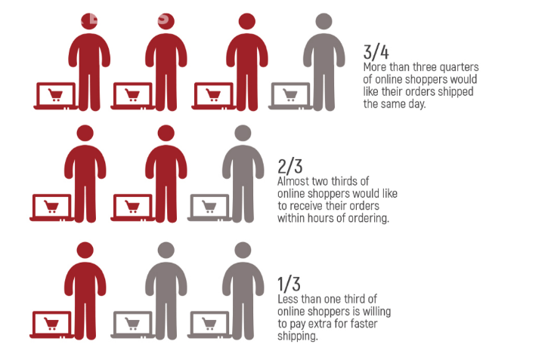

Online Store: Components of Online Store – Drop Shipping
Dropshipping is relatively new concept in stock management. Through this, efforts are made to reduce/avoid the complexity involved in inventory management. It is a method where store need no stock of product it is selling. Instead, the product is shipped directly from third party to the customer instead of store itself. In this method, the store silently works as an intermediary and forwards the order the supplier that ship product directly to the customer. Here is how it works.

Online Store: Components of Online Store -- How Drop Shipping Works
This is how drop shipping works:
- The customer order the product(s) to the online store and pay the retail price
- Online store forwards the order to the supplier of the product and pay the wholesale price only, keeping the profit.
- The supplier ship the product directly to the customer
Same example is illustrated in the image below:
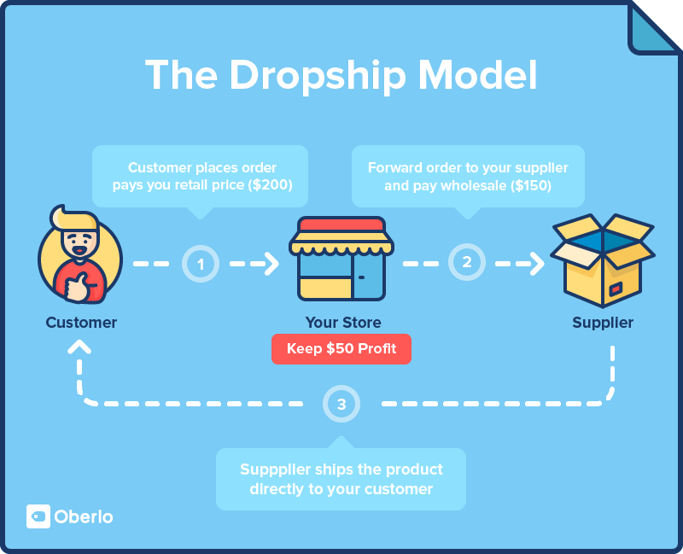

Online Store: Components of Online Store -- Pros and Cons of Drop Shipping
Every business strategy has its own positives and negatives and so does drop shipping. Listed below are the major pros and cons of drop shipping:
Pros of Drop Shipping:
- No Inventory Management
- Reduce Overheads related to efforts and cost involved in inventory management
- Increased Product Variety: as the online store does not need to pre-buy any product and order are directly forwarded to different vendors that manages the product(s)
- Low Risk
Cons of Drop Shipping
- Less Control: Customer satisfaction is under third party control
- Reliance on Stock of the product owner
- No Bulk Inventory and hence no discounts

Online Store: Components of Online Store -- Reliable Shopping Cart
This is one of the most essential parts of any online store and reliability of this part has huge impact on the success of store. Its reliability is defined in terms of features offered by the shopping cart like the accuracy of price calculator and its ability to accept major credit cards and cash on delivery etc. User must be able to add, delete and update the product and quantity in the shopping cart till the final checkout click. This would be a good example; http://www.chocomize.com.

Online Store: Components of Online Store -- Secure Online Payment
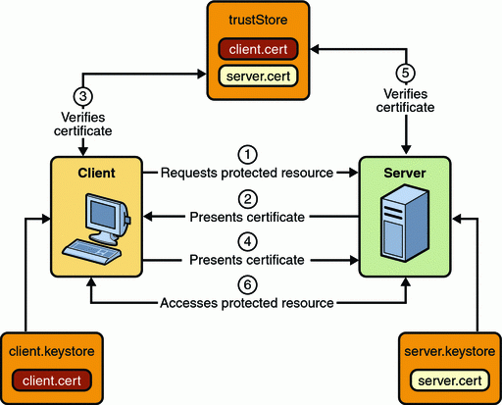
The biggest concern of any online buyer is the privacy and security of the information and it is the responsibility of the online store to keep the customer information secure. Considering this component of highest priority, the online transaction should be secured and must be communicated to the customers. SSL Certificate should be part of payment mechanism as Credit Card information become secure with SSL. Another security strategy is ‘two factor authentication system’ that ask for system generated code send via email in addition to Username and Password.

Online Store: Components of Online Store -- Shipping Information and Charges
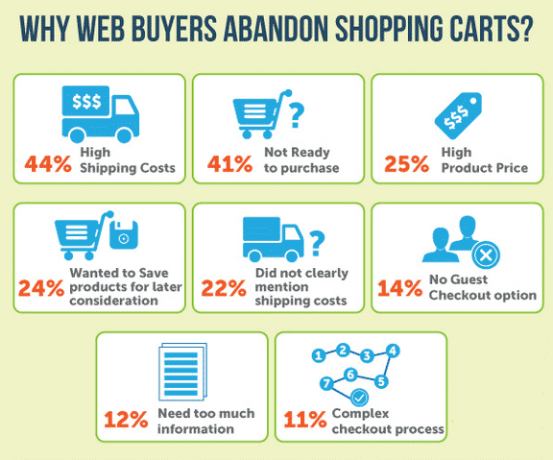
Misguiding or no shipping information can be a disaster for an online store because 44% of the online buyers abandon purchase because of higher shipping cost and 22% do the same because the shipping cost is not mentioned properly. A must component of an online store is to provide shopping cost clearly early in the shopping cart especially for international shipment. Moreover, billing information and delivery address should be provided accurately. Another research reveal that online user spend 30% more if free shopping is provided.

Online Store: Components of Online Store -- Order Tracking
User should be able to place and track order delivery progress clearly. When the order is placed, buyer should be notified via automated email stating the order as this practice build confidence and trust among the two parties. Further, the user must be able to see order status in real-time along with the estimated arrival time. Online store must assign each order a unique tracking number that can be used by the buyers for easy tracking of the products they have ordered. Another way could be the customer account; user can login to the online store anytime to view their order status.

Online Store: Components of Online Store -- Loyalty Program
Acquiring new customers for business is always a difficult task and requires a lot of resources in terms of time, money and efforts. That makes customer retention a very critical factor for the success of business. Retuning customers spend more than the new customers so right amount of efforts should be put on customer retention. Appropriate loyalty programs can increase retention and motivate customers to come back again to make a purchase. ‘Reward Points’ is a strategy used as a loyalty program where customers earn point on every purchase. Those points can be used to get discounts on next purchase. Another strategy is the social shopping where customers can give away discounts to other potential customers.

Online Store: Components of Online Store -- Customer Relationship Management
Last but not the least; customer relationship management (CRM) is an important component of any online store. It is used to:
- Provide support to the customers
- Listening to their queries and responding to them
- Resolving their complaints
- Provide information required by the customers
CRM can help not only in managing current but also future customers and to track their activities. Tracking customer activities is very crucial for customer retention and to predict their purchases. Online business can send specific and targeted messages to the potential customers in order to persuade them to purchase.

Refresher on Database: Database Basics
Data can be referred to raw material from which we can draw conclusion after analysis or the facts from which we can infer new facts. Data is collected and further analyzed to convert it into information suitable for decision making. Data and information are two separate things and are not to be confused with each other.
Consider the following example to understand the difference between Data and Information:
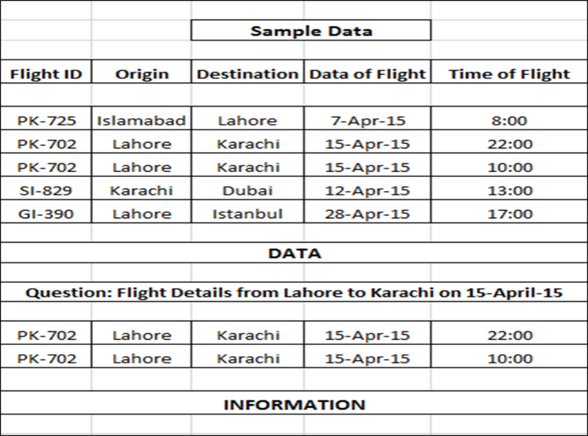
Consider a file storing flight routes from one city to another. Data is structured in the form of Flight ID, Origin, Destination, Date of Departure, Time of Departure etc. The file contains two thousand numbers of routes. This file qualifies to be called Data because it’s a huge set of structured data.
This huge data will turn into information when processed or filtered to get information about flight for a specific destination, let’s say from Lahore to Karachi on April 15th.
Database is all about design and structure of the data and DBMS works as a tool to manipulate or analyze the data inside the databases. DBMS is a whole system to manage a digital database, its storage, creation and retrieval (information). Entity Relationship Diagram is method to design database. Differentiating between database and DBMS; Database is a huge set of data while DBMS is a tool to manage or control that data in a database with major function of data retrieval.

Refresher on Database: Entities in Databases
The word entity is rooted from the Latin word “en” which means being. Entity is name of place, person or thing about which something can be stored in a system. An entity can be a real-world object that can be easily identifiable. For example, in a school database, students, teachers, classes, and courses offered can be considered as entities. All these entities have some attributes or properties that give them their identity. An entity set is a collection of similar types of entities.
Entities are represented by means of their properties, called Attribute or Column. All attributes have values which are the qualities or data about Entities that is to be stored. An Attribute describes a property or characteristics of an entity. Continuing with the above example, a student entity may have name, class, and age as attributes. Attribute is the smallest storage unit of any database.

Refresher on Database: Example of Identifying Entities from Real-time Scenario
Consider the following scenario and observe how the entities are being determined from the requirements.
Scenario:
In a Building apartment renting scenario, there are apartments, buildings and customers. There are multiple floors in the building and on each floor there are multiple apartments, floor can have zero or no apartment. Each apartment can be rented at most one customer but customer can rent out multiple apartments from same building and apartment can be available on multiple floors or same. At the end of month a receipt is generated against which a rent is deposited.
The following entities can be derived from the above stated scenario:
- BUILDING
- APARTMENT
- CUSTOMER
- FLOOR
- RECEIPT
Considering this, attributes against each derived entities can also be determined. Recall the concept of attributes; an attribute describes the facts, details or the characteristics of an entity. From the above scenario, the following and many other attributes can be defined.
Entity | Attributes
Building | Building Name (bname), Address, Phone Number…
Apartment | Apartment ID (aid), Covered Area, Status (available/rented), Rent…
Customer | Customer ID (cid), Name, Contact, CNIC…
Floor | Floor Number, Number of Apartments…
Receipt | Receipt ID (rid), Apartment Number, Date of Receipt, Amount…

Refresher on Database: Keys in Databases
Few important concepts related to keys in database are given below:
Primary Key:
The primary key of a relational table uniquely identifies each record or row in the table. As its name suggests, it is the primary key of reference for the table and is used throughout the database to help establish relationships with other tables. It usually comprises of a single table column, but may consist of a multiple columns as well. It is possible for a table to have more than one column with unique values in the table, however only one primary key can be defined. Each row in a table must have a distinct value (or a set of values) in the column marked as the primary key. As a rule, primary key cannot contain a NULL value.
Unique Key
A table in a database has unique key to identify a record or row within a table. In an entity-relationship diagram of a data model, one or more unique keys may be declared for each data entity. Each unique key is composed from one or more data attributes of that data entity. From the set of unique keys, a single unique key is selected and declared the primary key for that data entity. But unlike the primary keys, unique keys can have null values. Super keys, primary key can be declared as a type of unique keys.
Foreign Key
The foreign key is the field or attribute (or collection of fields) that is logically relate two table via common fields, in other words, foreign key is used to create relationship between two tables. The primary key of the first table or parent table becomes the foreign key of the child table. When an attribute appears in more than one relation, its appearance usually represents a relationship between tuples of the two relations. Foreign key is not the primary key by default but it can serve the purpose of the primary key, but this is not a rule. Just like unique keys, foreign keys can have NULL values.

Refresher on Database: Example of Identifying Primary Key and Foreign Key with Real-time Scenario
As per the above-explained concept of the primary and foreign key, and the requirement scenario mentioned in the beginning of this lesson, the primary and foreign key can be identified in the following manner.
Attributes in Bold : Primary Key
UK = Unique Key | FK = Foreign Key
Entity | Attributes
Building | bname, address, phone#, NTN # (UK)
Apartment | aid, covered area, status(available or rented), rent
Customer | cid, name, CNIC (UK), contact #, email (UK))
Floor | floor#, no_of_apartements
Receipt | rid , cid (FK), aid ( FK), date_of_receipt, amount
As a rule, a primary key should be minimal and it should not contain unnecessary information. So in the above case, building name fits into the criteria or becoming a primary as rest of the attributes can be complex containing unnecessary information.

Refresher on Database: Relationships
Relationship define how data is connected among the entities in a given system or in other words how one entity is logically connected with another entity of the system. Relationships in a database are said to be a combination of cardinality and optionality where optional relationship is one in which there may or may not be a matching record in parent / child table and cardinality represents the concept of “how many” and normally it is 0 or more. Equation for creating relationship is as follow:
R$elationship \left(R\right)=Cardanilty \left(C\right)+Optionality (O)$
The concepts of cardinality and optionality are explained below in details.
Relationships are bi-directional in nature; Relationship between two entities A and B is as follow:
- Relationship from A to B
- Relationship from B to A

Refresher on Database: Relationship -- Optionality
Optionality is minimum number of record that can exist in child table per parent record.
Participation in entity relationship is either optional or mandatory (…. Or ______). This means that one entity occurrence may or may not require a corresponding entity occurrence in a particular relationship. If you examine the Parent & Child relationship, it is quite possible for parent not to have any child record. Therefore, child is optional to parents.
On the other side, a child must have a parent and therefore, parent is mandatory to child. Hence minimum number of child record per parent in child table will show either 0 (…) or one (______). A dotted or solid line shows this kind of relationship. To translate …… or _____ following rules are to be followed:
Optional: -----: zero or one
Mandatory: ____: Exactly one

Refresher on Database: Relationship – Cardinality
Cardinality expresses the maximum number of entity occurrences associated with one occurrence of the related entity. The cardinality tells what kind of relationship an entity has with another but it does not state whether it’s mandatory or optional relationship. In the relational model, tables can be related as any of "one-to-many" or "many-to-many." This is said to be the cardinality of a given table in relation to another. Following rule are to be followed when translating cardinality
< or >: More than one
Cardinality is read with opposite entity.

Refresher on Database: Relationships -- (One - to - One)
A one-to-one relationship is a type of cardinality that refers to the relationship between two entities A and B in which one element of A may only be linked to one element of B, and vice versa. As the one-to-one label implies, in this relationship, one entity can be related to only one other entity, and vice versa. It is important to note that a one-to-one relationship is not a property of the data, but rather of the relationship itself as there is no parent-child relationship in on-to-one relation scenario. The following are rules to implement One-to-One:
- There will be foreign key in any one of the participating table.
- Foreign key will be made as Unique key.

Refresher on Database: Relationships -- (One - to - Many)
A one-to-many relationship is a type of cardinality that refers to the relationship between two entities A and B in which element of A may be linked to many elements of B, but a member of B is linked to only one element of A. One-to-many relationship is the most common type of relationship. In this type of relationship, a row in table A can have many matching rows in table B, but a row in table B can have only one matching row in table A. One-to-many relationship occurs when a parent record in one table can potentially reference several child records in another table.
As a rule, the Primary key of Parent table acts as Foreign Key in Child Table. Foreign Key is usually created as Composite Primary Key with PK of child table but this is no specific rule.

Refresher on Database: Relationships -- (Many - to - Many)
A many-to-many relationship is a type of cardinality that refers to the relationship between two entities A and B in which A may contain a parent record for which there are many children in B and vice versa. This means that a parent row in one table contains several child rows in the second table, and vice versa. Many-to-Many relations are tricky to represent and are not supported directly in the relational environment. To represent this kind of relationships, a third entity or intersection table is created where PK of two table act as FK and CPK in third table.

Refresher on Database: Example of Identifying Relationships in Real-time Scenario
Scenario:
In a Building – Apartment renting scenario, there are Apartments, building and customer. There are multiple floors in the building and on each floor there are multiple apartments, floors can have zero or no apartment. Each apartment can be rented at most by one customer but customer can rent out multiple apartments from same building, apartment can be available on multiple floors or same. At the end of month a recipe is generated against which a rent is deposited
The entities and attributes can be derived in the following way:
Entities & Attributes:
Entity | Attributes
Building | Building Name (bname), Address, Phone Number
Apartment | Apartment ID (aid), Covered Area, Status (available/rented), Rent
Customer | Customer ID (cid), Name, Contact, CNIC
Floor | Floor Number, Number of Apartments
Receipt | Receipt ID (rid), Apartment Number, Date of Receipt, Amount

Based on the above scenario, following relationship can be made.
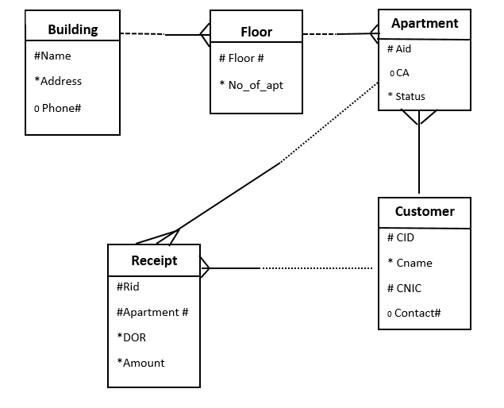

Refresher on Database: Workshop - I -- Creating Entity Relationship Diagram from Real-time Scenario
Scenario:
There are musical bands which record songs and request musical companies to launch their songs in the form of Album. Songs are written by song writers. Album can contain at least one song to be album and max of 12 songs. Writer can write multiple songs but songs are usually written irrespective of the number of person in the bands.
The entities and attributes can be derived in the following way:
Entities & Attributes:
Entity | Attributes
Bands | bname, total person, cat
Songs | sname, duration, language
Writer | wid, wname, charges, category
Company | cname, address, phone#
Album | aname, total_songs

Generating ERD of the Scenario
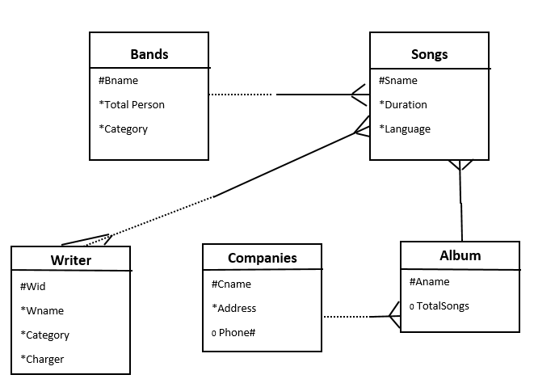

Refresher on Database: Workshop - II -- Creating Entity Relationship Diagram from Real-time Scenario
Scenario:
In airport management system, there are several flights which are either landing or taking off from Airport. There is more than one passenger on a particular flight. Passengers are allocated seat # when they purchase ticket. Plane can be associated to different flights during its lifecycle. Passenger can order different meals during flight and details are mentioned on the ticket in the form of either Asian or Non-Asian. Airport is managed by a manager.
Entities & Attributes:
Entity | Attributes
Airport | Aname, capacity, annual traffic
Manager | Employee ID (eid) ,Airport Name (aname), name
Flight | Flight ID (fid), Date of Departure (dod), Time of Dep. (tod) ,destination, aname
Passenger | Passenger ID (pid), pname, fid, contact, address, date
Ticket | Flight ID (fid), Ticket ID (tid), Passenger ID (pid), seat number, meal
Plane | Plane ID (pid), capacity, age

Generating ERD of the Scenario

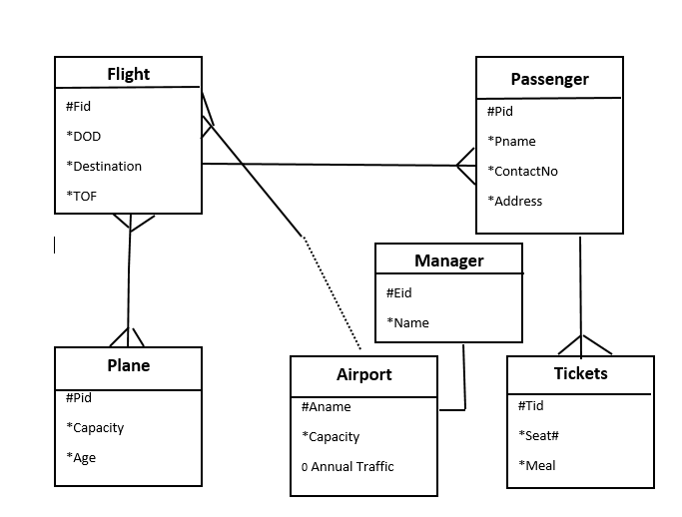

https://www.mckinsey.com/industries/retail/our-insights/how-retailers-can-keep-up-with-consumers

