Introduction to Guidance and Counselling (EDU 304)
Table of Contents:

Lesson No. | Lesson Title | Pg. No.
Lesson 01 | Introduction to Guidance and Counselling (Topics 1-6) | 3
Lesson 02 | Comparison and Purpose of Guidance and Counselling (Topics 7-12) | 5
Lesson 03 | Significance of Guidance and Counselling (Topics 13-16) | 7
Lesson 04 | Significance and Areas of Guidance and Counselling (Topics 17-24) | 9
Lesson 05 | Principles of Guidance and Counselling (Topics 25-30) | 14
Lesson 06 | Empathetic Understanding (Topics 31-36) | 17
Lesson 07 | Types of Guidance and Counselling (Topics 37-42) | 20
Lesson 08 | Directive/Perspective Counselling-1 (Topics43-48) | 22
Lesson 09 | Theories of Guidance and Counselling Client-Centered (Rogerian)Theory-1(Topics 49-54) | 25
Lesson 10 | Existential Theory-1(Topics 55-60) | 29
Lesson 11 | Importance of Affective Education (Topics 61-66) | 33
Lesson 12 | Humanist Theory of Affective Education (Topics 67-71) | 37
Lesson 13 | Affective Cognitive Education (Topics 72-77) | 40
Lesson 14 | Hindrance in the Development of SEL (Topics 78-83) | 44
Lesson 15 | Importance of SEL Programs (Topics 84-89) | 47
Lesson 16 | Integration of Character Education Along Side Standard Curriculum-1(Topics 90-95) | 50
Lesson 17 | Merits of Moral and Character Development (Topics 96-101) | 54
Lesson 18 | Sources of Acquiring Self-Efficacy-1(Topics 102-107) | 58
Lesson 19 | Self-Monitoring and Self-Assessment to Enhance Self-Efficacy (Topics 108-113) | 61
Lesson 20 | Social and Emotional Development (Topics 114-119) | 64
Lesson 21 | Strategies for Implementing SEL in the Curriculum-Flexibility for Lesson Planning (Topics 120-125) | 68
Lesson 22 | Effective Teacher-Attitude Towards Teaching (Topics 126-132) | 72
Lesson 23 | Hindrances for Teacher in providing Counselling services (133-136) | 76
Lesson 24 | Essential Qualities of Teachers as Counsellors (1) (Topics 138-144) | 79
Lesson 25 | Teacher as a Counsellor (Topics 145-151) | 84
Lesson 26 | Counselling Services: The Counselling Service (1) (Topics 152-156) | 92
Lesson 27 | Importance of Ethics in Counselling (Topics157-163) | 99
Lesson 28 | Ethics in Guidance and Counselling (Topics 164-169) | 107
Lesson 29 | Organizing Guidance and Counselling in Schools-Procedures-1(Topics 170-175) | 114
Lesson 30 | Organizing Guidance and Counselling in School-Procedure-7(Topics 176-181) | 118
Lesson 31 | Counselling Competencies-Knowledge (Topics 182-189) | 123
Lesson 32 | Competencies-Professional and Ethical Attitude and Practice (Topics 190-197) | 134
Lesson 33 | Who Requires Counselling Services? (Topics 198-204) | 139
Lesson 34 | Problem Solving Therapy-Introduction (Topics 205-210) | 146
Lesson 35 | Problem Solving-Identifying Problems (Topics 211-216) | 152
Lesson 36 | Referral in Case of Severe Behavioral Problems- Introduction (Topics 217-222) | 156
Lesson 37 | Referral for Severe Behavioral Problems-Effective Referral 1(Topics 223-228) | 161
Lesson 38 | School-Wide Guidance and Counselling (Topics 229-231) | 165
Lesson 39 | Challenges for Guidance and Counselling in School System-System Challenges (Topics 232-236) | 167
Lesson 40 | Challenges for Guidance and Counselling in School-Institutional Theory 2 (Topics 237-242) | 171
Lesson 41 | Guidance and Counselling Programs in a School Setting-Counsellor as a Facilitator 1(Topics 243-247) | 175
Lesson 42 | Guidance and Counselling Programs in a School Setting-Counsellor as a Coordinator 1(Topics 248-252) | 178
Lesson 43 | Collaboration and Communication with Stakeholder-Parenting (Topics 253-258) | 181
Lesson 44 | Implementing Guidance and Counselling in School Setting-Initial Phase 1(Topics 259-262) | 186
Lesson 45 | Implementing Guidance and Counselling in School Setting-Formulating Relevant Policies (Topics 263-270) | 189

Lesson 01
INTRODUCTION TO GUIDANCE AND COUNSELLING
Topic: 001 – An introduction
There are very important principles of student guidance and counselling that needs to be integrated in school system. In this course, the following objectives will be assessed:
1. Explanation of the terms, guidance and counselling and establishment of the difference and link between them.
2. Social and emotional development of students and strategies for its integration in the education system.
3. The role of teacher as a guide and counsellor
4. Procedures and tools for guidance and counselling
5. School-wide guidance and counselling
Topic: 002 – An introduction to guidance & counselling
- Sometimes, it is presumed that guidance and counselling are the two sides of the same coin.
- These are not synonymous terms. Counselling is a part of guidance.
- Guidance and counselling both are very important procedures.
- Both are the processes of helping individuals in choosing from a variety of available options to make a wise decision.
Guidance:
- In educational context, it is a process of helping young person learns to adjust to self, to others and to circumstances (Skinner)
- A process of helping individual through his/her own effort to discover and develop potentialities for personal happiness and social usefulness. (Ruth Strang)
- Through guidance and counselling, we take care of the personal growth of the individuals.
Topic: 003 – Functions of Guidance and Counselling
1. Educative: how can we appropriately guide students to choose their topic areas, interests or career areas.
2. Reflective: We must make the students able to reflect on things.
3. Welfare: We should prepare students in a way that they can co-exist properly in society.
Guidance and counselling programs:
1. Facilitate social and emotional development of students.
2. Encourage teacher support.
3. Require whole school commitment
Topic: 004 – Guidance
- Guidance is a continuous process of advisement
A process that assists individuals to:
- Understand and accept him/herself and live effectively in his/her society.
- Set realistic goals
- Carry out adequate plans to achieve those goals
Topic: 005 – Counselling
Counselling is:
- More specialized service for serious problems.
- Offered to the individual who is undergoing a problem and needs professional help to overcome it.
- Involves active listening and empathetic understanding.
- Facilitate counselee’s personal growth and brings about change through self-knowledge.

Topic: 006 – Levels of Counselling
Level 1
Teacher should be able to listen to students and to react to and respond in the emotional domain.
Level 2
School should provide continuity of care through system of early detection, provision of coordinated approaches and links with other agencies.
Level 3
More specialist activity where teacher/counsellor works with a group or an individual in great depth.
Lesson 02
COMPARISON AND PURPOSE OF GUIDANCE & COUNSELLING
Topic: 007 – Difference between Guidance & Counselling - 1
Guidance | Counselling
Guidance focuses on helping individuals choose what they value most | Counselling focus on helping them make changes
Guidance is put in place at the time a choice is to be made | - Helps with considering all sides of a potential choice even before the choice is made.  - Takes place when a choice has been made and there is a need to modify, reinforce or abandon such a choice.

Topic: 008 – Difference between Guidance & Counselling - 2
Guidance | Counselling
Guidance is pre-problem service that aims to improve the adjustment of individuals. | Counselling is a post-problem service to address the problem.
Guidance is an act of making decisions for another person to help them set or achieve their goal. | Counselling assists a person in finding the correct answer or behaviour themselves.

Topic: 009 – Guidance & Counselling – A Comparison
Guidance: Intellectual attitudes are raw material of guidance.
Counselling: Emotional attitudes are raw material for this process.
Guidance and counselling both are aimed for helping people in personal and professional development and social adjustment.

Topic: 010 – Purpose of Guidance & Counselling – 1
- Guidance and counselling provide required information and assistance to students.
- It brings the teacher and the student closer together. This is important not only for the school but for the student in special.
- Both facilitate wise decisions and choices.
- Both develop better self-understanding.
Topic: 011 – Purpose of Guidance & Counselling – 2
- Guidance and counselling facilitate the adjustment with one’s surrounding.
- In order to avoid bullying in school, it is important to provide guidance and counselling to students so that they don’t become victims or bullies.
- Both help in adaptation process.
It is not the strongest of the species that survive, or the most intelligent one… It is the one that is most adaptable to change.
- Both develop independence and confidence.
Topic: 012 – Purpose of Guidance & Counselling – 3
- Guidance and counselling improve the productivity and capabilities.
- Both groom an individual to become a successful person.
There are various dimensions in which we can guide the individual:
- We teach individuals to be diverse.
- We help students to meditate.
- It motivates and polish themselves.
- They work as an effective member of the society and achieve their goals.

Lesson 03
SIGNIFICANCE OF GUIDANCE & COUNSELLING
Topic: 013 – Significance of Guidance & Counselling - 1
It cultivates essential life skills in students. It is a responsibility of a school to teach life skills with academic skills so that they can merge well in society. These life skills are:
- Empowerment: students should feel empowered not only in the school setting but also in society at large. They empower students to plan and manage their own future through better self-awareness.
- Progress: they help students to progress specifically in academics and generally in every field of life.
- They help sort out in school problems thus reducing dropouts.
Topic: 014 – Significance of Guidance & Counselling - 2
Deduction of anti-social behavior
They reduce or eliminate anti-social behaviors like:
- Bullying
- Racism
- Discrimination
- Prejudice
- Conflict: conflict management strategies should be employed and they can be safely employed through proper guidance and counselling.
- Fights
Topic: 015 – Significance of Guidance & Counselling - 3
Self-Understanding
- They facilitate personal growth and positive change through self-understanding.
- Self-understanding helps students to improve:
- Manners and etiquettes which eventually develops healthy relationships with others.
- Personal appearance and hygiene which boosts their confidence.
Topic: 016 – Significance of Guidance & Counselling – 4
Realization of Potential:
- They assist students to become psychologically mature and realize their potential.
- Students must be confident in their potentials.
They enhance career and job prospects of the students by:
- Creating awareness in their career and planning choices.
- Cultivating appropriate work attitudes.

Lesson 04
NEED, SIGNIFICANCE AND AREAS OF GUIDANCE AND COUNSELLING
Topic: 017 – Need of Guidance & Counselling in Academic Settings – 1
In academic settings, it is needed when:
- Students require making choices of courses.
- Students require assistance in turmoil and confusion.
We must teach students how to make good choices.
Topic: 018 – Need of Guidance & Counselling in Academic Settings – 2
It is required to:
- Develop readiness for choices and to face new challenges.
- Make up the deficiencies of home.
- Seek solutions of diverse learner students.
- Check the migration to prevent brain drain.
Topic: 019 – Need of Guidance & Counselling in Academic Settings – 3
How can teachers help in guiding students and counselling them appropriately?
It is needed when:
- Students require an intelligent listener who understands his/her difficulties and provides good suggestions for his/her working plan.
- A teacher needs to be well grounded in social and emotional learning so that he/she is able to listen to the student appropriately.
- Minimize the incidence of indiscipline.
Topic: 020 – Need of Guidance & Counselling in Academic Settings – 4
It is needed to:
- Ensure proper utilization of time spent outside the classrooms.
- Helps students in vocational development.
- Help students gain an insight into the origins and development of emotional difficulties.
Topic: 021 – Significance of Guidance & Counselling – 1
Why is guidance and counselling significant? Why it is important to have guidance and counselling strategies in use in the classroom?
- It is important in terms of behavioural development.
- Counselling is a series of direct contact with the individual that offers him/her assistance in changing the attitudes and behaviours. (Carl Rogers)
- It provides opportunities to each student to reach his/her full potential. Moreover, when we talk about potential development, it is necessary to ensure that from where the potential development must start? For example, if we look at Maslow’s Hierarchy of Needs; students have different needs at different stages of life.
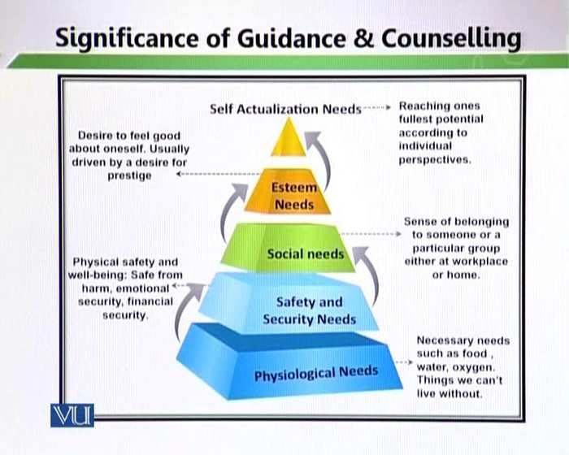
When individual needs of the students are addressed, students feel confident. It is a very important part of guidance and counselling procedures.
Topic: 022 – Significance of Guidance & Counselling – 2
- It helps students for optimum achievement and adequate adjustment in varied life situations.
Counselling:
- Develops decision making skills.
- Assists in resolving conflicts.
- Relieves the discomfort caused by the conflicts.
- When we talk about decision making, there are many other things involved in it. Like;

Benefits of Counselling:
- Students feel less anxiety.
- Greater self-confidence
- Better relationships with others
- Regain emotional balance.
- Increased assertiveness
- Counselling brings stress relief.
- Ability to set boundaries.
- Trauma resolution
Topic: 23 – Areas to be Addressed in Guidance and Counselling-1
Firstly, here we discuss some special problems
- Guidance and Counselling address special educational needs of students.
- Those students who are extremely defiance in subject areas. They will be sending to the senior guiders and counsellors. For these students’ remedial programmers will be developing
- Guidance and counselling are also deals with those areas that are not main steam. Some students that are physically disable but we cannot consider those students disable in education. Their physical disability will be over come through guidance and counselling.
- Those students who face anxiety, disability, mental health, learning, hearing and physical problems. For those student’s guidance and counseling is very necessary.
- Some students are gifted. They are exceptionally high talented and bright in classroom as compare to the other students. Here we can develop guidance and counselling programmers.
- Because of some domestic problems some students feel depression. It is very important to deal this problem.
- It is a main part of guidance and counselling to help those students who are facing family break up problems.
- Guidance and is very important for those who are victimized because of major accident or incident.
- Guidance and Counselling are actively engaged to address the needs of the students in the above specific areas.
Topic: 24 - Areas to be Addressed in Guidance and Counselling-2
- The first area that to be addressed in Guidance and Counselling is egocentrism problem. The student thinks about himself. He does not think anyone’s welfare.
- The other area is disability/bereavement. If a child is facing any physical disability, in this area the student’s friends will play the best role.
- They should not give any message that will identify his/her disability.
- The teachers and student’s friends should guide and counsel those students.
- Through violence/abuse, some students make the life of other students miserable. They create lot of problems for other students. They misbehave with other students and talk in a wrong manner. Here guidance and counselling deals with such students.
- Some students are disruptive. They do not work other appropriately.
- Some are facing development problems. As they are growing up, they face developmental problems. They need guidance and counselling.
- Some students face socio-economic problems. They come to school with certain socio-economic problems. When they compare themselves with other students, they feel impressed.so that proper guidance and counselling is very necessary.
- Some guidance and counselling help students to choose their appropriate career, so problem of vocational choice is discussed in guidance and counselling.
- Some students are of nerves type. They are not confident. Guidance and counselling deals with nervousness issues.
- These problems need to be solved. The best way is that teacher should talk to the students that are facing the above problems.

Lesson 05
Principles of Guidance and Counselling
Topic: 25 – Principles of Guidance and Counselling
There are several principles that guide counselling procedures and this need to keep in mind while we are implementing these principles in schools. When we talk about the principles of guidance and counselling. It has many important features. For example:
1. Continuity refers to develop permanent relational ship with students. In we not only understand the problems of students but also solve their problems. Guidance is not a one-off event; rather it is a continuous process of assisting an individual.
2. Assistance refers to help individuals in the development procedures. It develops the problem-solving skills in the students. And it basically enhances the self-discovery process. It provides assistance in the developmental process rather than giving direction.
3. Support is very necessary. That is an important feature for the students. Teacher need to be ready all the time for the students. Counselors and teacher should available all the time in the school for guidance and counselling of the students.
- Respecting Individuality means respect of individuality. Students are different. They have different academic and behavioral issues so one each to understand. For example:
4. If there are twenty students in the classroom, they may have twenty different problems, they may have twenty different academic issues and behavioral issues. So, we cannot deal students properly. So, respect of diversity is very important. Individual differences must be taken into account.
These are principles that need to be implemented
Topic: 26 - Stakeholder’s position:
While we are discussing the principles of guidance and counselling it is very important to determine stakeholder’s position.
- Parents, teachers, students, community general, community particular, administrative staff, principal and vice principal are all part of the stakeholder.
- But the important parts of stakeholder community are parents and teachers. Because they influence the life of the students. It is offered by a trained person. It is very impotent the stakeholder community should be trained. Teachers need to be prepared to act like a counselor.
2. Parents and teachers need to discover their role as counsellors. Primarily it is the parents’ and the teachers’ responsibility to guide children and students. Parents and teacher should be prepared and well-groomed to act as a student’s or child’s counsellor.
3. Guidance programmers need to hold a regular assessment (evaluation). Continuity and yearly assessment are very necessary. It is very necessary to know how the programmers are running.
4. It is intended for all-round development of a person. The intension is the overall development of the students. For all round development of the students the stakeholder community should be preparing.
5. It deals with every aspect of life. It is not enough for the stakeholder to know the teaching methods but it is also very necessary to be trained in the guidance and counselling process.
Topics: 27 - Cooperation and flexibility
Another important principle is cooperation and flexibility. It requires a lot of cooperation and flexibility,
- Cooperation and flexibility refer to ‘it applies all’. It is not necessary for specific issues.
- It caters to everyone regardless of age, gender, ethnicity, religion and socioeconomic status. This principle is applied across the board. So, the label should not be done in the schools. We should not label the students. If a student is facing domestic problems. We should deal this student with cooperation and flexibility.
- Guidance and counselling require cooperation among persons. While we deal with students all of us need to be on the same platform.
- It is very important that element of guidance and counselling must be flexible. Guidance programmer must be flexible and tailored to the individual and community needs.
Topics: 28 - Self-awareness and dignity of individuals:
- A very important feature of guidance and counselling is self-awareness and dignity of individuals. It is itself a learning process.
- Students discover themselves. They analyze their strengths, abilities and capabilities. They reflect their strength, abilities and capabilities so in the educational process reflection is very important. Teachers and parents should respect the dignity of individuals.
- Knowing of you is very important. The result is that the student knows his personality in perfect manner. Teachers and parents should help the students to understand him/her.
- Self-awareness is probably the most important thing towards being a champion. We should need to develop the dignity of individuals. Guidance and counseling values the dignity of individuals.
- Guidance and counseling determine that person’s attitude and personal perception are the basis of his acts. Thoughts create feelings. Feelings and behavior have a close relationship. Feelings create behavior and behavior reinforce thoughts.
Topic: 29 - Student focused:
- Another important a feature of guidance and counselling is that it is student focused It is problem- focused, and concentrates on student’s difficulties.
- Counselling effectiveness is determined by students’ readiness to make a change. So, readiness needs to be there. The triangle of teacher, parents and students should be active. The proper support system is very important. If student realizes the support of teacher and parent, he/she will be ready to bring change in his/her personality.
- The important point is that commitment and capability will bring change readily. Commitment will bring will and conviction in the students and capability will bring individuals skills. It will enable the students to bring change in their personalities. So, change readiness depends upon commitment to change and capability to change.
- Counselling’s effectiveness is determined by a student’s relationship with the counsellor.
Topic: 30 - Goal Directed and Confidential:
- Guidance and counselling are always a goal directed activity. It is also a confidential activity. In this principle we guide a child to a proper goal. If a student is weak in a language so we are basically constructing remedial program for the student so that student reaches to a proper goal. It is important to give guidance and counselling orientation to the student
- Another important feature is that it is confidential. Confidentiality is essential in this process. A guide and counsellor should not explain openly the domestic problems of the students. Maintaining student’s privacy is the key aspect to develop trust among the counselee and the counsellor.

Lesson 06
EMPATHETIC UNDERSTANDING
Topic: 31 - Empathetic Understanding:
Counsellors believe in empathetic understanding. Empathy refers to the power of understanding and imaginatively entering into another person’s feeling. There are two levels of empathy:
1. Primary Empathy: Responding in such a way that exhibits that the counselor has understood the counselee’s major theme.
2. Advanced Empathy; exploring themes, issues, meanings and emotions that are below the surface of what is being shared by the counselee.
Topic: 32 - Genuine Concern for Students
- A guider and counsellor should be genuine in the problems of the students. The counsellor must be open, sincere and honest to his/her student. Genuine includes congruence which means that the counselor is consistent in his/her words, action and feelings. Spontaneity is the ability to express oneself without being blunt.
- The genuineness also includes positive regard. The guider and counsellor should behave in a polite manner so that students feel free in the explanation of their problems. The counsellor must treat the student as a person with inherent worth and dignity regardless of his/her behavior or appearance.
Topic: 33 - Raising Awareness and Respecting Uniqueness
- Raising awareness and respecting uniqueness is another very important feature. Counsellors should concentrate to create insight and awareness among students. Counsellor and guider should raise awareness of problems among students and then give respect to everyone.
- A counsellor should work on weakness so that weakness become strength and then work on strength, in this way strength can be maintained. Application of strength is important because the insight is several in every student.
- Counsellor should focus on the unique issues of students and not generalize problems. Problems are unique. They cannot be generalized. Every principle of guidance and counselling has their importance they cannot be applying on all the students. We should not try to generalize issues and look for generalize solutions because students are individuals. They have individual problems.

Topic: 34 - Development of Self-Efficacy and Rapport
- Development of self-efficacy and rapport building is a main part of guidance and counselling. Counsellor should support self-efficacy and help students to make decisions themselves. When we discuss self-efficacy in which we tell our students that you stand here in terms of your personality development. We try to show the mirror to our students and tell them these are the strengths and these are the weaknesses. Then they are ready to make their decisions. When there is self-efficacy the self-esteem will automatically develop. Again, it is a process of discovery.
- Counsellors should develop good rapport with the students. Good rapport building is very important. If you will develop good relationship with your students then the students will explain their problems without any hesitation.
Topic: 35 – Warmth and Encouragement of Decision Making
- Showing warmth towards students is extremely important and helping them to make their decision on their own is equally important. Counsellor should show concern for students through verbal way (like smile, voice tone and facial expressions). We need to show a genuine concern for the students. Students must feel that you are listening to their problems and are ready to solve their problems. Guider and counsellor should be warmth in nonverbal actions like eye contact, gestures, facial expressions and body language.
- Verbal and nonverbal both are important. Guider and counsellor need to show verbal and nonverbal warmth through their actions and through their behavior. Warmth should be directed to the development of individuals who are facing problems.
- Decision taking must be the individual’s own choice and not because of other’s insistence. Students should take their decision by themselves.
Topic: 36 - Focus on Social Adjustment
- A very important principle of guidance and counselling is that it helps students to socially adjust themselves in their surroundings. There should be flexibility for the student’s needs. The main object of schooling is preparation of individual. In a teaching process the behavioral application is very important. So, flexibility needs to be worked on.
- Counsellors normally help students in bringing flexibility among them. Counselling deals with matters influencing mental/physical adjustment of the individual. At home, at school or in social settings.
- A counsellor should try to bring the following features in the students:
1. Adaptability
2. Change
3. Evolve
4. Improve
5. Adjust
6. Perform
7. Grow
Counsellors, teachers, parents and all the stakeholders should work seriously on these features.
- Counselling is a professional activity. Normally schools give importance to the teaching process. There is lot of emphasis on the academic development of the students. That is not the only important activity, however together that we need to have socially function on human being.

Lesson 07
TYPES OF GUIDANCE AND COUNSELLING
Topic: 37 – Types of Guidance and Counselling
Educational Guidance provides assistance to students in:
1. Their choices and adjustment to the school’s curriculum.
2. Adjustment to school life.
3. Pursuing the right type of education in which the right balance is met for accommodating the human resource needs of a nation.
Topic: 38 – Educational Guidance-2
Educational Guidance is related to all aspects of the curriculum, methods of instruction, discipline and co-curricular activities. The counsellor gives directions to the students about the curriculum content. He or she tells some method of instructions that are related to the curriculum content. The counsellor guides in discipline matters. He or she also guides the students to choose their co- curricular activities.
Topic: 39 – Vocational Guidance
Vocational guidance is a process of helping students to choose an occupation. Preparing for entering into and making progress in the vocation of choice. The primary focus of guidance is helping the students make right decisions and planning their future and building their careers.
Topic: 40 – Personal and Social Guidance
Personal and social help to a student to behave with consideration to other people. It helps students in acquiring a sense of security, a feeling of being accepted, tolerance towards others, religious maturity, national integration, political responsibility, international understanding, empathy and sympathy.
Topic: 41 – Types of Guidance and Counselling
Avocational guidance
- It refers to give proper guidance to a person so that they spend their leisure time in a positive manner. Avocational guidance helps a person to judiciously utilize the leisure time.
- Normally students do not realize that how they can spend their leisure time, so here proper guidance is very necessary. If there is no proper guidance, the students will engage in non-academic activities.
- Avocational guidance caters to those students who are facing lack of interest in, or over enthusiasm for sports, music and art etc.
- Avocational helps to bring balance in academic or non-academic issues. Avocational guidance brings inability to engage in sports due to health issues or physical activities.
- Avocational guidance also caters in limited means or excessive means. For example: If a student belongs to a particular economic status. He/she cannot give interest in studies here controlling provides through avocational guidance.
- Avocational guidance is very important where there is:
• Lack of interest in reading
• Lack of interest in handicrafts
We can bring positive balance between academic and non-academic issues.
Topic: 42 – Health and Moral Guidance
- Normally health guidance does not exist in schools. Many difficulties may be crop up if there is no health guidance.
- When students are sick, they are unable to concentrate on their studies. When they cannot concentrate on their studies, they will face academic issues. It is very important to take care of the health and moral of the students.
- Health guidance means total health of the students.
- Goal of health guidance is preventive and curative.
- Health guidance may be a cooperative effort of principal, doctor, counsellor/psychology, teacher, student and parents. This only possible when the system is available in the school.
- When we talk about preventive health guidance measures, there are two issues. The hostels and canteens need to be measures hygienically neat and clean. Many diseases will be crop up when the hostels and canteens are not properly checked. Hygienic level should be maintained.
- In curative health guidance awareness is very necessary. Awareness on nutrition, body fitness, physical exercises and about prevention of pollution is provided.
- Moral guidance helps in their all-round development. Students should be strong academically, morally and socially.
- It becomes a base platform for their social as well as cultured development.
Lesson 08
DIRECTIVE/PERSPECTIVE COUNSELLING
Topic: 43 – Directive/Perspective Counselling – 1
- This type of guidance and counselling is counsellor- centered. The counsellor directs the student to take steps in order to resolve conflicts. The counsellor tells that this a problem and this is its solution.
- The main role in this type of guidance and counselling is of counsellor. The counsellor should be properly trained.
- The counsellor tells what is right and what is wrong.
- It gives more importance to intellectual aspect than emotional aspects. So, orientations and arguments are important.
- Directive counselling is less time consuming as compare to other types of guidance and counselling. Discovery process takes much time.
Topic: 44 – Directive/perspective counselling - 2
- Directive and perspective counselling are yet very important type of guidance and counselling.
- Directive and perspective counselling are best for less matured and less intelligent students who cannot analyze on their own decisions. They cannot solve their problems by their intelligent. They need to be led. They need to be given proper guidance and counselling.
- In this student’s autonomy becomes weak. Personal autonomy and integrity of students is not respected which leads to new adjustment of problem.
- Steps for directive counselling are as below:
a. Analysis (find out the problem)
b. Synthesis (collective thought)
c. Diagnosis (find out the solution)
d. Prognosis (predicting the development of the problem)
e. Counselling (directions)
f. Follow up (extremely important to follow up the process)
Topic: 45 – Non- Directive/Permissive counselling – 1
- Directive counselling is counsellor focused counselling but non-directive/permissive counselling is student focused counselling.
- It is student focused process. ‘’It’s your world – change it!’’
- It brings a lot of autonomy to the student to discover their problems. It gives lot of opportunities to the students to find out the causes of the problems and weakness and strengths of the problems.
- The main function of the counsellor is to facilitate the student for working out his/her problem. The main advantage of this counselling is that the confidence level of a student will be high. They will not be running behind the teachers.
Topic: 46 – Non – Directive/Permissive counselling – 2
- Emotional elements rather than intellectual elements are stressed upon.
- In non – Directive counselling emotions play a great role because we are encouraging the students to take an active involvement in their own life and to go through their self-discovery to find out their problems. And that is only possible when ones he or she study the emotional domain.
- Counsellor is independent, self – reliant and self – directed in his or her thoughts.
- Non-directive counselling is time consuming. Because the student solves their problems by their own understanding, so it takes lots of days or months.
Topic: 47 – Electric Counselling
- It takes into both directive and non-directive guidance and counselling. It is a combination of first two types (directive and non-directive counselling). The role of counsellor is very flexible.
- Here the counsellor is neither too active nor too passive; rather he/she follows the middle course. The counsellor does not play a commanding nor massive position.
- It depends on the situation where the counsellor comes. Counsellor may be a teacher or a specialized helper.
- It is highly flexible and balance method. Because as when it is required you can be changed your role from direction or non-direction.
- There are certain steps in electric counselling.
a. Establishing rapport
b. Problem diagnosis
c. Analysis
d. Tentative planning
e. Counselling
f. Follow up
Topic: 48 – Crisis, Prevention and Facilitative Counselling
- Crisis counselling focuses on single or recurrent problem that is overwhelming or traumatic.
- It not only educates students but also guides and provides required support to solve their crisis.
- Crisis counsellor helps facing and moving past distressing and traumatic life events. It can be a simple emotional problem.
- Preventive counselling should also be implemented. It is an attempt to reduce emotional and physical distress thought prevention.
- Facilitative counselling helps students to correct their mistakes, solve problems and plan for their future. ‘’Go on. Do it now. ‘’
- Its primary concern is to help the client deal with negative feelings that arise during implementation of plans.

Lesson 09
THEORIES OF GUIDANCE AND COUNSELLING. CLIENT- CENTERED (ROGERIAN) THEORY
Topic: 49 – Theories of guidance and counselling. Client- Centered (Rogerian) Theory – 1
- Client-centered theory is also known as non- directive or Rogerian theory.
- It places much responsibility for the treatment process on the client/student.
- Counsellor takes/play a non-directive role. He/she is in a supportive role.
Primary goals
Its primary goals are:
• To increase self-esteem
• To develop greater openness to new experiences
• To foster a closer agreement between the client’s idealized and actual selves
• To lower levels of defensiveness, guilt and insecurity.
Techniques
Its techniques are:
• Listening
• Accepting
• Respecting
• Understanding
• Responding
Topic: 50 – Client – centered (Rogerian) theory – 2
Major components
1. Congruence: It refers to the counsellor’s openness and genuineness and his/her willingness to relate to the students without hiding behind a professional facade.
2. Unconditional positive regard: Counsellor accepts the students totally without disapproving of particular feeling, action or characteristics. Positivity must be given to the students.
3. Empathy: showing on emotional understanding of and sensitivity to the students feeling throughout the counselling session.
This theory helps in self-exploring, self-acceptance and self-changes.
Counsellor’s role
• To be instrument for change
• To be present and accessible
Topic: 51 – Holistic Health (Bio psychosocial) Theory - 1
- It is an important theory that needs to be implementing in the school.
- There are three factors in this theory:
1. Biological
2. Social
3. Psychological
- These three factors are very important in human development. This theory posits that psychological and social factors play a significant role as biological factors do in human functioning; therefore, health must be understood in combination of all three.
- There are various factors that needs to be considers. This theory links science with humanism
- It involves various environmental factors that affect human personality and behavior.
Principles:
• Counsellor should use self-awareness as a diagnostic and therapeutic tool.
Topic: 52 – Holistic Health (Bio psychosocial) Theory - 2
There are two main principles of holistic theory:
1. Empathy:
Social and emotional learning develops empathy. So, when you put yourself in the issues of others and feel the same thing as others feeling. You are more consciousness about other people’s feeing. Counsellor is very sensitive towards the feelings of others feeling.

2. Cultivation of mutual trust:
It is very necessary to bring mutual trust between counsellor and counselee.
3. Self-calibration to reduce bias:
Counsellor should consciously learn and objectively monitor various habits to maintain client’s centrality and to relieve his/her problem.
Critique:
1. Being eclectic in approach results in the ultimo paradox. One enacts one’s own dogmas (conscious or unconscious)
2. It does not guide how to prioritize biological, psychological and social factors.
Topic: 53 – Solution Focused Theory – 1
- Social focused theory is client-centered theory. It approaches that focuses on individuals of the client or the student.
- “Ones size fits all” does not apply. Every person has individual needs and individuals’ problems and we need to act accordingly. We cannot apply the same principles to everyone
- Employs therapies that tend to be hopeful and solution oriented.
Core Concepts:
3. Its core concept is postmodern approach that focuses on future rather than examining past. Counsellor should guide the student in a way that he/she can concentrate on his/her future in a good manner.
4. There are no fixed truths or realities. The only reality is that what the clients/students present.
Topic: 54 – Solution Focused Theory – 2
Core Concepts
5. The counsellor takes a “not-knowing “stance. He/she shows that he/she does not know anything about the student. A student tells everything in detail.
6. Client/student is basically an expert, not the counsellor.
Conceptualization of problem:
7. Client/student only determines the goals of counselling, not the therapist.
8. Change takes place throughout and fosters change.
9. Counsellor should avoid analyzing the problem.
Solution focused theory’s interventions:
• Not knowing
• Complementing strength
• Exception questions
• Coping questions
Critique:
There is some critique on this theory:
1. It lacks empirical research to support it.
2. Inadequate for client with serious problems

Lesson 10
EXISTENTIAL THEORY
Topic: 55 – Existential Theory 1
- Existential Theory is a humanistic approach. It focuses on the issues central to human existence. Social emotional thoughts are the basis of humanistic thoughts. This is essentially humanistic in nature. It depends a lot upon the social and emotional development of the students.
Core Beliefs:
- In existential theory, people are essentially good in nature and growth oriented. Human growth depends upon environmental factors, socio-economic and social emotional factors. Everyone is good in nature, so basically the element of good is there.
- If a person deviate from basic nature may lead him towards destruction acts. He/she may face problems.
- For human being, it is very necessary for developing trust, respect and care. This will be very helpful for human being in regaining emotional and spiritual equilibrium.
- Many choices are there; people can choose what they become. It depends upon a person that what he/she want to become. It is necessary to give proper guidance and counselling to a person so that he/she can properly choose his/her choices.
- The basic concern of this theory is that everyone is open his/her choices. The main focus of existential theory is on “Man is nothing else but he makes of himself” (Jean Paul Sartre)
Topic: 56 – Existential Theory 2
- Basic Principles
1. Self-awareness:
We are finite with limited time. We have the potential to make choices and reflect on them.
2. Isolation:
The concept of isolation means we were born alone and will die alone, so we must give a sense of meaning to life. This gives a sense to life. A guide/counsellor should sue the humanistic approach so that the students can reduce their isolation.
3. Freedom and responsibilities:
This theory teaches us freedom and also makes us responsible. In this theory we have many approaches and alternatives and we are free to choose among alternatives. We are responsible for our lives, actions and their consequences.
4. Identity:
Try to trust yourselves and try to discover ourselves. Relate to others, and build a relationship with them.
5. Objectivity:
Objectivity refers to search for meaning and purpose in life. Life is not mangling. Mindlessness leads to hollowness.
Topic: 57 – Cognitive Behavioral Theory (ABC Model) 1
- Actions are driven by thoughts. We do those things which are in our mind. This one of the core principles of this theory.
- Personality includes both genetic endowment and social influence.
- Our perception, interpretations and assumptions shape our behavior and emotions.
- Maladjustment is a result of inaccurate cognition.
- Increasing repertoire of adaptive behavior gives freedom.
Topic: 58 – Cognitive Behavioral Theory (ABC Model) 2
The Basic Structure
1. Cognitive method
a. Explaining the problem
b. Identifying and challenging negative thoughts
c. Cognitive restructuring
2. Behavioral method
a. Relaxation
A counsellor can use some relaxation strategies, imagery, breathing exercises, progressive muscle relaxation.
b. Distraction – object focusing
c. Distraction – sensory awareness
d. Monitoring activities
e. Scheduling activities
Strategies:
a. Cognitive modeling: Firstly, the manifestation of the student’s behavior is necessary. And a counsellor will tell the student about the manifestation of his/her behavior.
b. Thought stopping: We need to be worked on those factors which are troubling the students. We can stop negative thoughts by using relaxations and exercises.
c. Cognitive restructuring: We again try to model the behavior of the student.
Critique:
- This theory requires a lot of training and skill.
- It doesn’t consider complexity of lives.
Topic: 59 – Strength Based Theory 1
- Strength based theory is also known as “Positive thinking” and “Learned optimism” theory. This theory talks about the positive elements of the human beings.
- It deals with positive elements. This theory emphasizes positivity.
- “Problem” is not the focal point; instead “What can I learn from this?” is the central question.
- A negative situation is not a complete defeat. Instead, it is a learning lesson, a temporary setback.
Key Rules
- A counsellor should be as concerned with strength as with weakness.
- He/she is interested in building the best things in life as in repairing the worst.
This theory builds a repo between the counsellor and counselee.
Topic: 60 – Strength Based Theory 2
- Strength based theory as explained earlier emphasizes on positive elements of the human beings.
Key Rules
- This theory is concerned with making people’s lives fulfilling as with healing them. A counsellor must give hope to the students. Negativity lowers down the self-esteem of the students and when the self-esteem is lowered, the student stops thinking about himself or herself.
- A teacher should give hope to the students. If a student is weak in mathematics and good in language, a teacher should ignore his or her weakness and encourage his or her strength. Constructive or hopeful people fare better in almost all aspects of life. Everyone may have some weakness and strengths. This theory actually focuses on positivity.
Critique
- Self-help does not adequately recognize structural inequalities in society that can impinge on personal and social development.

Lesson 11
IMPORTANCE OF AFFECTIVE EDUCATION
Topic: 61 – Importance of Affective Education
What is Affective Education?
- Affective education is the way to deal with feelings and values. In this emotion is a central element.
- It also deals with appreciation, enthusiasm, motivations and attitudes. When we look for human believes and attitude as oppose to cognitive and academic development were the focus is only on teaching methods. Teaching method and affective education develop the concept of education. When we develop curriculum, there is a lot of emphasis on cognitive education. If we are said that affective education deals with emotions, feelings and attitudes of a human then it needs to be interrelated affective education in the curriculum.
- Affective education has three main dimensions:
- Feelings: That is a central part of affective education. To give regards to human feelings and emotions when a student comes us. We should try to understand their feelings.
- Emotions: Affective educations and emotions they go side by side. Emotions need to be a central place when we are talking about education.
- Self-esteem: We must build the self –esteem of the students.
When we talk about guidance and counselling these domains needs to be absolutely
Implemented.
“Emotions is central to the development of morality and learning”
Goleman (1996)
“Linguistic, social, emotional, and cognitive development are complementary processes that ultimately work together to shape a child’s literacy growth”
Vygotsky (1978)
Topic: 62 – Elements of Affective Education – 1
- Elements associated with affective education include:
a. Interpersonal relations:
The concept of interpersonal relationships involves social associations, connections, or affiliations between two or more people. Such persons may interact face to face or may remain effectively unknown to each other. Interpersonal relationship is very important in affective education. Every student comes from different social status.
Students should communicate and work with other students. For this group and peer teaching should be applied.
b. Humanitarianism:
Humanitarianism is a moral of kindness, benevolence, and sympathy extended to all human beings. It is connected with interpersonal relationship. Human feeling is very necessary. Teacher should teach the students that they have to live with existence with others.
c. Curiosity and risk-taking:
Curiosity is a strong desire to know or learn something.
Curiosity, the desire for new information and sensory experience that motivates exploratory behavior, is the fuel of learning, development, and adaptation throughout the lifespan.
Risk taking is related to a combination of the chance for loss, the possibility of significant loss, and uncertainty. Curiosity is very natural. A teacher should make attempt to bring curiosity between students by asking them questions. To make students risk taker is very important. When a teacher makes students risk taker, he will develop critical thinking in students.
Topic: 63 – Element affective education – 2
- Elements associated with affective education includes:
d. Complexity and imagination:
When we work on educational process then student become more imaginative and complexity of human behavior develop in them. It is very important to understand feelings and emotions for students. Complex human behavior helps them in their practical life. They can grow up and become a powerful member of the society. As we set earlier complex human behavior into the curriculum the result is that you need not to give attention to human behavior. Already when things are interrelated into the curriculum and par of lesson plan then you teach on pronged approach. Students also realized that teaching process and behavioral elements are both should be practiced.
- Affective education also develops leadership skills.
e. Character:
Character building is absolutely important. That needs to lot of attention in the school. When we give attention only to teaching process and not give attention to character building then it becomes an incomplete process. When we talk about school development and individual development so their character building in an extremely important element. Schools are mini societies that give an opportunity for the student to teach behavior. In this the role of character development is very important.
Topic: 64 – Why is Affective Education important?
- There is too much emphasis on academic development in schools. Students think that the objective of school is only getting education but there are other things that need to become the part of the character of he studies.
- Academic and affective education not work in a fine balance when there is lack of balance between the affective domain and cognitive domain. Then we are not giving the best to the students. So that affective education is very necessary.
- When school curriculum focuses only on cognitive development, the other domains develop unevenly.
- Students suffer emotionally as a result. Teacher should be professionally trained. When the emphasis is done on cognitive development then students suffer emotionally. If we raised academic standards then it became more important to give value to the affective domain. Students may suffer from:
a. Anxiety
b. Depression
c. Poor self-image
d. Anti-social behavior
- Inclusion of affective component within the curriculum enhances the whole student rather than a mere focus upon cognitive development.
Topic: 65 – The neglect of Affective Education
- Why we neglect affective education. For this there are different reasons.
1. There is a traditional lack of concern in education for the affective domain. The concept is “just not there”. It means that it is not responsibility of school. We only understand that the responsibility of the school is to give education to the students so that they can pass their classes.
2. There is misconception that emotions are to be dealt with at home rather than in the school.
3. Fear of indoctrination:
We try to impose the things on the students. We only say to the students for smile and take of others. We should bring affective education for the social emotional learning.
4. There is a misperception that if the school meets the child’s cognitive needs, affective development will automatically follow.
Topic: 66 – The neglect of Affective Education
1. There is lack of reliable and valid tools for assessing functioning.
2. There is lack of clarity as to the optional level of affective functioning to be attained.
3. There is a belief that healthy emotional development among students is automatic.
Role of a teacher
“The good news: a teacher can shape a classroom culture that has a high chance of motivating students.
The bad news: there is no magic bullet.”
Stevi Quate in Education Week Teacher.

Lesson 12
HUMANISTIC THEORY OF AFFECTIVE EDUCATION
Topic: 67 – Humanistic Theory of Affective Education
- To Humanistic, the goals of education are related to the ideals of:
• Personal growth
• Integrity
• Autonomy
Mcneil (2009)
• Personal growth: It includes social emotional learning.
• Integrity: Human integrity is very important. How people respect themselves? How to the respect others? That is also very important part of humanistic trends. It includes self-efficacy, believe and self-esteem.
• Autonomy: Autonomy is a thing that comes start when students developing awareness of themselves when they began to discover themselves.
- Development of healthier attitudes should be towards:
• Self: You need to develop healthy attitude about yourself. We need to think of ourselves. This means you have good self-efficacy and good self-esteem. You need to develop positive image of yourself.
• Peers: You need to have healthier attitude towards peers. You need to co-exist with them and understand them very well.
• Learning: You should develop positive attitude towards learning.
- The proponent of humanistic education theories is:
• John Dewey
• Francis Parker
• Charles Judd
- John Dewey is also called father of democratic education. Parker and Judd extend humanistic.
- The unbalance of teacher pupil relationship needs to be humanized for affective personal development of the students.
Topic: 68 – Carl Roger’s Theory of Affective Education
- Carl Rogers (1951) Advocates counseling methods to facilitate learning.
- Rogers’s views therapy as a learning method to be used by the curriculum worker and teacher.
- He believes that positive human relationships enable people to grow.
- Interpersonal relationships among learns are as important as cognitive scores.
- According to this method counselling is very important. Counselling techniques need to be developed in the classroom so that they can be used for healthy and social interactions.
Topic: 69 – Maslow’s Theory of Affective Education:
- Maslow is one psychologist who talked about the principles of affective education.
- Maslow’s hierarchy of needs (Maslow, 1970) expresses the human desire for love, belongingness, friendship, and intimacy.
- Maslow looks at the:
• Physical
• Emotion
• Social and intellectual qualities of an individual and how they impact human learning.
- Students need to feel emotionally and physically secure and reach their full potential.
- Students must be shown that they are value and respect in the classroom and the teacher should create a supportive environment.
Topic: 70 – Empathy as a vital component of Affective Education:
1. The empathy response to situation and behavior is empathy
2. Empathy may be expressed as putting oneself in the shoes of another person.
Difference between empathy and sympathy:
• Sympathy: In sympathy you will sorry for someone.
• Empathy: You take a step ahead. In Empathy, you seriously work towards resolving the conflict and problems.
- Schools play an essential role in preparing children to be knowledgeable, responsible, caring adults.
- Empathy must be modeled for students and daily interactions with them in school may be more critical them the specifics of curricula designed to teach. Empathy is a part of school culture.
- Empathy “Plays a crucial role in development kindness and peaceful conflict resolution and decreasing disruptive classroom behavior.”
(Bumside, 2012, p.2-3)
Topic: 71 – Pro-Social Behaviour as a vital component of affective education:
- Pro-social behaviours:
They are attribute and voluntary actions to help others feelings of cooperation and voluntary imply to help out others. They help in peer interactions.
- Pro-social skills are the abilities to affectively:
• Interact with peers and adults.
• Accommodate and cooperate with others.
• Praise and help others.
• Actively listen, and display socially acceptable behaviours.
- Pro-social behaviours are students’ ability to:
• Cooperate with others.
• Participate in classroom discussions and activities.
• Follow classroom rules.
• Share with others.
• Treat others with kindness.
- All these things are extremely important. Pro-social behaviour involves empathy. Both skills are extremely important and this can be safely developed through integrated these skills in the classroom.

Lesson 13
AFFECTIVE COGNITIVE EDUCATION
Topic: 72 – Affective Cognitive Education:
- Normally the school curriculum focused on academic and cognitive domain. Affective elements are rarely implemented in the schools. We think that the affective elements should be implemented in co-curricular activities.
- Cognitive and affective both are important. Cognitive and emotion work in unison; one without is ineffective.
- Curricula that integrate cognitive and affective skills have been found to yield academic and social success for students.
- Together with academic skills students learn to:
• Respect others’ perspective and feelings.
• Understand and manage intense emotions.
• Negotiate conflicts.
• Develop healthy personal and professional relationships.
• Avoid dangerous situations and relationships.
• Accept responsibility of actions.
Topic: 73 – SEL and Personality Development:
- What is Social and Emotional Learning?
- It helps in personality development
- SEL is a process of integrating. To become aware of the self and other, three things are very important.
• Thinking
• Feeling
• Behaviour
- SEL helps us to make responsible decisions, and regulates human behaviours. It basically makes us to make responsible decision.
- Focus on SEL is seen to have:
• Increased academic success.
• Improved quality of relationships between teachers and students.
• Decreased problem behaviour.
- Focus on SEL is seen to have also improved the learning environment. So, focus on SEL is absolutely important. Learning will be positively changed.
- SEL needs to be take care at every level of schooling.
Topic: 74 – The Need for Social and Emotional Learning:
- SEL skills are referred to as ‘Soft’ skills and enable students to reach their full potential.
- SEL is needed to help students:
• Make responsible decisions.
• It regulates their behaviour through social and emotional learning. Students are sensitive towards the needs of others so that they try their best not to manifest bad behaviour.
- In school there is a need:
• To foster caring relationships between teachers and students.
• For cooperation among all stakeholders.
• To reduce conflict among students.
• For a greater sense of school safety.
- All of these possible when we give due regard to Social Emotional Learning. When we integrate these things in the school curriculum in the way that is systematically planned and implemented in each and every classroom. And all stakeholders take responsibility to manifest these behaviours and they not only teach students these behaviours at the same time through careful planning. They integrated in their lessons and in school procedures.

Topic: 75 – SEL standards for schools:
To integrate SEL in schools’ certain standards need to be met.
1. Schools need to enhance the social and emotional assets and learning of students across the curriculum.
2. Schools need to improve the quality of the environment in which academic, social, and emotional learning occurs.
- The success of any attempt to educate the whole child is dependent upon the extent to which learning occurs in caring, supportive, safe, and empowering settings.
Topic: 76 – Ecological system theory of SEL
Ecological systems theory posits that the settings youth inhabit, like school, shape their development.
(Bronfenbrenner, 1979)
- Focus should not be only on academic development but also on social, emotional and behavioral development. For the clarification of this concept the picture is below:
- Features of school settings that are related to positive youth development include:
• Opportunities for empowerment.
• Skill building.
• The presence of supportive adults and peers.
• Being safe and orderly.
(Catalano et al., 2004)
Topic: 77 - Self-Determination Theory
- According to self-determination theory, youth are more likely to flourish when in settings that address their social and emotional needs. Social and emotional learning should be a very strong part of school development.
- If we give importance to social and emotional learning then it results in meaningful relationships. Students develop good relationships and rap building with teacher and students follow.
- They also develop confidence in their abilities because when they are given and provided opportunities to talk, to cooperate and to meaningfully enter into dialogues.
- They also feel autonomous. Because when they are self-directed this feeling of autonomy that comes in. So that is something which comes through social and emotional learning.
- Students are more likely to thrive in classroom that foster:
• Meaningful
• Caring
• Safe and empowering interactions

Lesson 14
HINDRANCE IN THE DEVELOPMENT OF SEL
Topic: 78 – Hindrance in the Development of SEL
- The hindrance in the development of SEL are as following:
1. Low family socioeconomic status
2. Economically depressed neighborhoods
3. Poor learning climate
4. High stakes testing regimes
5. Poor teaching
6. Poor demonstration of social and emotional skills by teachers and elders.
Topic: 79 – SEL and Self-Awareness
- SEL builds self-awareness by encouraging students to:
• Accurately assess feelings
• Interests
• Value their strength
• Maintain a well-grounded sense of self-confidence
Topic: 80 – SEL and Self-Management
- Self-management regulates one’s emotions to handle:
• Stress: There are various stresses that are rounded in the school. For example; classroom setting stresses, exams stresses, listening to teacher stresses and group working stresses. When these stresses come together then to handle students become difficult. But when students are stronger in social and emotional learning then these stresses will be controlled very easily.
• Control impulse: Impulse control is very necessary. Normally students behave emotionally outpour which is considered in discipline. Indiscipline is something’s which is not accepted in the school settings. When there is loss impulse control there will be emotional outpours and conflicts among students. With the help of social and emotional learning impulse control becomes easier.

- Self-management helps in:
• Overcoming obstacles
• Setting and monitoring progress
Topic: 81 – SEL and Social Awareness
- Social awareness helps in:
• Taking the perspective of and empathizing with others.
• Recognizing and appreciating individuals and group similarities and differences.
• Recognizing and using family, school, and community resources.
- So social awareness is a big concept and it comes through social and emotional learning. It is important to have social and emotional learning in the schools. So the social awareness can be raised to the maximum level.
Topic: 82 – SEL and Relationship Management
- SEL helps in:
• Establishing and maintaining healthy and rewarding cooperative relationships.
• Resisting inappropriate social pressure.
• Preventing conflicts and social pressures.
• Managing situations.
• Resolving interpersonal conflicts.
• Seeking help when needed.
- SEL helps us to control impulse. It also helps a lot in building good relationships among stakeholders
Topic: 83 – SEL and Responsible Decision Making
- SEL not only helps in developing good behavior but also in developing good decision making.
- SEL helps in:
• Making decisions based on consideration of ethical standards.
• Realizing consequences of various actions.
• Applying decision-making skills to academic and social situations.
• Contributing to the well-being of one’s school and community.

Lesson 15
IMPORTANCE OF SEL PROGRAMS
Topic: 84 – Importance of SEL Programs
- SEL programs are very important in any school conditions. SEL skills among students are critical for student success in schools. For example. Self-regulation skills teach greater impulse control to students. As a result, they are able to pay more attention in school. Students can easily realize their strengths and weakness.
- The SEL skills develop better concentration which leads to higher academic grades as well as better performance on standardized tests.
- Students who do not develop SEL are likely to meet with failure in schools and society at large.
Topic: 85 – Moral and Character Development
What is Moral and Character Development?
- Moral and character development is extremely important in guidance and counselling.
- Character:
- Character is a set of emotional, cognitive and behavioral patterns learned from experience.
- All these factors of character build human character.
- Character continues to evolve throughout life and is dependent on one’s moral development.
- Moral development:
- Moral development is a development of proper attitudes and behaviours towards others, based on social and cultural norms, rules and laws.
- Character and moral development are important principles. They are closely related and basically it depends upon the social, behavioral and cognitive attributes then students display anywhere in the society.
Topic: 86 – Factors that Influence Moral and Character Development
1. Temperament: (genetic factors, nature)
- Human temperament difference. It is greatly depended on genetic factors. In this gene play an important role. Normally in the classroom some students are cool minded, some hot headed, some are compromising nature and not compromising nature, some are dominant, some are non-dominant, some are shy and some are cooperative so all of these are depended on genetic factors.
- Researchers estimate that around 50% traits may be heritable.
- Genes do not determine character but they do control development of nervous system, which in turn controls behavior.
2. Environment:
- Environment is a big factor in character and moral development.
a. Environment plays a significant role in character building.
b. This factor is controllable. Parents and teachers can modify and improvise certain practices for better character development.
Topic: 87 – Components of Character – 1
1. Compassion and Empathy:
- Elements of care and taking care of others people’s feelings. All of these come in this component. One must be considerate to other’s feelings. Trough demonstration and modeling a teacher can teach compassion and empathy.
2. Fairness:
Fairness means to taking turns, sharing, and listening to what others have to say.
• You need be open-minded.
• You have to follow the particular in rules. When you are being faired you would defiantly follow the rules. But again, when you are being un faired then you would try to bypass rules and break rules.
• When you are fair you will share things in a very nice manner.
Topic: 88 – Components of Character – 2
Ethical behaviour is characterized by honesty, fairness and equity in interpersonal, professional and academic relationships and in research and scholarly activities. Ethical behaviour respects the dignity, diversity and rights of individuals and groups of people.
Ethical behaviour
- One must be:
• Caring
• Kind
• Tolerant
• Having gratitude
Integrity
Integrity is the quality of being honest and having strong moral principles; moral uprightness. It is generally a personal choice to uphold oneself to consistent moral and ethical standards.
In ethics, integrity is regarded by many people as the honesty and truthfulness or accuracy of one's actions. Integrity can stand in opposition to hypocrisy, in that judging with the standards of integrity involves regarding internal consistency as a virtue, and suggests that parties holding within themselves apparently conflicting values should account for the discrepancy or alter their beliefs. It involves:
• Moral self-efficacy
• Honesty
• Truthfulness
• Reliability
• Loyalty
Topic: 89 – Lack of Emphasis on Character and Moral Development
Lack of Emphasis
- There is too much emphasis on standard-based education in the schools.
- Character education, which has its roots in the affective domain, is bypassed as an essential part of regular school instruction.
- Designing standard-based lessons that simultaneously develop cognitive affective skills is an effective way to develop the character.
- A successful adult is mature in both cognitive and emotional intelligence.

Lesson 16
INTEGRATION OF CHARACTER EDUCATION ALONG SIDE STANDARD CURRICULUM-1
Topic: 90 - Integration of Character Education Alongside Standard Curriculum – 1
- Identify the values and character traits that reflect community consensus.
- Identify values through good decision making. In psychology, decision-making is regarded as the cognitive process resulting in the selection of a belief or a course of action among several alternative possibilities. Every decision-making process produces a final choice that may or may not prompt action.
- If you want to make good decisions, you must plunge in and make them with full awareness of the human situation. If instead you try to reduce every big decision to a dry, rational computation, you will shut out the very things that go into a good decision.
- So, what makes a good decision good? There are four human elements.
- Emotions - Your choice must fit in with your most positive emotions and avoid negative ones.
- Self - Your decision must match who you are as a person.
- Vision - Your decision must accord with your long-term goals.
- Surroundings - Your decision must be compatible with the situation you find yourself in.
- Professional development of teachers is very necessary. So that guides teachers in analyzing national standards to determine teaching targets. And identifying character education traits that can be integrated in the curriculum.
- Proper coaching of teachers and professional development by offering periodic workshops and training over a period of time is very necessary. Because our teachers focus on standard based curriculum. They think that teaching targets will meet in the lesson plan. But if we want integrated curriculum, we must need to give professional development of the teacher and tell them how we can intergrade affective and cognitive education.
Topic: 91 – Why Emphasize Cognitive-Affective Skills in Schools
- Successful adults are strong in both cognitive and affective processing.
- Students are equipped to engage in cognitive processing cognitive processing such as:
• Analysis
• Synthesis
• Evaluation
- They have also refined affective skills such as:
• Receiving
• Responding
• Valuing
• Resolving conflict
• Applying a value system to a situation.
- The affective skills help to respond to questions such as:
• How should I regard the rights of others?
• How should I treat others who are unlike me?
• How should I carry out my responsibilities?
• How should I manage power?
Topic: 92 – Integration of Character Education Alongside Standard Curriculum – 2
- In this the role of teachers is very important. Professional development should be provided to the teachers so that they can work on moral and character development of the students. Staff training and planning time for teachers should be provided.
- It is important to support teachers in implementing those activities that emphasize character development learning experiences. The promotion of performance-based assessment is necessary. In affective domain demonstration is required. When you will assess students then you can assess through practical demonstrations.
Topic: 93 – Teaching Character Education
- Character education is everything you do that influences the character of the kids you teach. But to put it in a more focused light, we like Dr. Thomas Lickona’s definition, that “character education is the deliberate effort to help people understand, care about, and act upon core ethical values.” In his landmark book, Educating for Character, 1 Dr. Lickona asserts that “When we think about the kind of character we want for our children, it’s clear that we want them to be able to judge what is right, care deeply about what is right, and then do what they believe to be right—even in the face of pressure from without and temptation from within.”
- While examining the standard solely for its cognitive emphasis, teachers should teach in the affective domain as well.
- For example, while you are teaching Math and Science, it is easy to incorporate instruction on:
• Conflict resolution
• Respect
• Collaboration
• Interpersonal skills
- Topics of character education like:
• Interdependence
• Cooperation
• Relationship among human beings
• Value of work
• Tolerance
- Can also be incorporated into Science, Social Studies or Language teaching.
Topic: 94 – Building a Caring Classroom Community
- Transforming into a caring classroom community requires four characteristics:
1. Teacher should:
• Model respectful behavior
• Exhibit warm, accepting and supportive attitude for the students
2. Students must have influence on important classroom discussions and autonomy to make important choices regarding their self-development. A caring teacher always makes students an autonomic learner. Teacher can help students to take their own decisions. Teacher should come out of their traditional role and give importance to the students only then teachers can form caring communities in the classrooms.

Topic: 95 – Building a Caring Classroom Community – 2
3. Students must have opportunities to interact, collaborate and discuss important issues with one another. The result is that the turn taking skills will develop.
4. Students must practice social skills and get the opportunities to help each other.
Social-Emotional skills:
Research suggests that emotional intelligence has more bearing on life and school outcomes than academic intelligence. An emotionally intelligent student can easily work on his/her cognitive development. Emotional intelligent has a strong bearing on the cognitive development of the students. Emotional development involves:
• Self-Awareness
• Self-leadership
• Social Awareness
• Relationship Management
And students can learn these skills by practicing them but the idea is to provide the right kind of opportunities to students so these skills can be practiced.

Lesson 17
MERITS OF MORAL AND CHARACTER DEVELOPMENT
Topic: 96 – Merits of Moral and Character Development
- Moral and character development through social-emotional learning lead to improvement in student performance.
1. Student get equipment with:
• Strong sense of community
• Better understanding of behaviour consequences
• Positive attitude towards school and learning
2. Student improve their behaviour when they:
• Demonstrate more pro-social behaviour
• Become more regular in attendance
• Show reduction in behaviour problems
• Choose to work out their own way of learning
3. Students improve their school performance through showing:
• Higher achievement in test scores
• Improved learning-to learn skills
• Better problem-solving and planning abilities
• Higher-level of reasoning skills
Topic: 97 – Self-Esteem, Self-Efficacy and beliefs
- Self-esteem, self-efficacy and beliefs are important components of guidance and counselling.
- What is Self-Esteem?
- This is the person’s overall sense of self-worth or personal value. Self-Esteem could be defined as: What our unconscious believes to be true about how worthy, lovable, valuable and capable we are.
- Dimensions of Self-esteem:
a. Competence (efficacy-based self-esteem)
To what degree people see themselves as capable and efficacious. Competence is the ability of an individual to do a job properly. A competency is a set of defined behaviors that provide a structured guide enabling the identification. This is actually very important phenomenon and in this phenomenon a student to have a good knowledge about himself or herself. The students analyze their capabilities.
b. Worth (Worth based self-esteem)
To what degree individuals feel they are persons of value. Worth is related to competence. An ethical culture starts with the assumption that every human being counts. Each person is to be treated as a unique and important member of the human family. This respect for human worth is based on our intrinsic human nature rather than on anything a person does.
Attributing worth to human beings is accepting on faith and acting as if each person has within himself or herself the possibility for kindness, fairness, joy, and the capacity to create ethical relationships. Given this capacity for goodness each person deserves to be treated with dignity.
Topic: 98 – Self- Esteem Level
- In every human being, there are various degrees of self-esteem. Raising students’ self-esteem would be beneficial for both, the individual and society as a whole. The self-esteem of every student should be at required level. In this parents and teachers again play a very important role because they are posting the moral of the students. Teacher should deal carefully the negative behaviours of the students
- Self-esteem levels at the extreme high and low ends of the spectrum can be damaging. In this balanced approach is very necessary. The definition of balanced approach is mutual consensus.
- One must have realistic yet positive view of the self. Too little self-esteem can leave people feeling defeated or depressed.
Low self-esteem may lead people to:
• Bad decision or wrong choices
• Fall into destructive relationship
• Fail to live up to their full potential
On contrary to that, too high self-esteem leads towards narcissism or egotism. Students become selfish and only think about their own lives. We need to defeat these negative behaviours. This can only happen once we fight for a balanced approach. We determine the required and accepted behaviours and we work with students towards the development of those particular behaviours.
Topic: 99 – Components of Self-Esteem
According to one definition (Braden, 1969), there are three key components of self-esteem:
1. Self-esteem is an essential human need that is vital for survival and normal, healthy development.
2. Self-esteem arises automatically from within based upon a person's beliefs and consciousness.
Picture
Thoughts, beliefs, feelings and actions they get together and they move in a cycle to form self-esteem. Thoughts give raise to beliefs and beliefs give raise to feelings and through feelings you develop your actions.
3. Self-esteem occurs in conjunction with a person's thoughts, behaviors, feelings, and actions.
Topic: 100 – Self-Efficacy
- Self-efficacy refers to an individual's belief in his or her capacity to execute behaviors necessary to produce specific performance attainments (Bandura, 1977, 1986, 1997). Self-efficacy reflects confidence in the ability to exert control over one's own motivation, behavior, and social environment.
- A person’s beliefs or expectations about his/her capabilities to produce given attainments successfully or demonstrate certain behaviours. Optimism is the faith that leads to achievement.
“Nothing can be done without hope and confidence."
~Helen Keller~
"If I have the belief that I can do it, I shall surely acquire the capacity to do it even if I may not have it at the beginning."
~ Mahatma Gandhi ~
- Weak self-efficacy leads towards:
• Avoidance to life challenges
• Focus on failures and negative outcomes
• Low confidence
Strong sense of self-efficacy:
• Encourages to take challenges
• Develops interest in given tasks
• Develops strong commitment to the interests
• Enables quick recovery from setbacks and disappointments
Topic: 101- Sources of Acquiring Self-Efficacy
- Students with low self-efficacy expectation are more apt to give up at the first sign of difficulty.
- According to Bandura (1997) there are four ways of learning and acquiring self-efficacy expectations.
- Performance accomplishments
- Vicarious learning
- Verbal persuasion
- Physical/affective status
- Performance accomplishments
- Gaining relevant experience to achieve success
- Success boots up one’s self-efficacy

Lesson 18
SOURCES OF ACQUIRING SELF-EFFICACY
Topic: 102 – Sources of Acquiring Self-Efficacy – 2
- Vicarious modeling
- Vicarious Learning, although originally coined by Bandura (1962) to refer to learning of behavior (e.g., aggression) form watching videos of that behavior, it is used here to refer to a instructional method that occurs when learners see and/or hear a learning situation (i.e., a observed learner in an instructional ...Dec 11, 2007
- Vicarious Learning, although originally coined by Bandura (1962) to refer to learning of behavior (e.g., aggression) form watching videos of that behavior, it is used here to refer to a instructional method that occurs when learners see and/or hear a learning situation (i.e., a observed learner in an instructional situation) for which they are not the addressees and do not interact with the observed learner nor the observed learner's instruction(Gholson & Craig, 2006; Rosenthal & Zimmerman, 1978). Although the learning situation is often presented as video recordings of human interactions or as cartoon-like recreations of learning situations (Bandura, 1986), the definition encompasses live vicarious learning, e.g., students watching another student at the front of the class interacting with the teacher.
- Beliefs are acquired through observation and interpretation
- By observing other doing the same/similar task learner gets encouragement
Topic: 103 – Sources of Acquiring Self-efficacy – 3
- Verbal persuasion
- Beliefs about self are influenced by other opinions
- Encouragement supports self-efficacy while criticism hampers it
- Friends, family and teachers influence one’s educational and vocational interests, choices and decisions
- Physical/affective status
- Stress and anxiety have a negative effect on self-efficacy as well as learning
- Brain functions best in a supportive environment rather that under perceived threats

Topic: 104 – Strategies for Development Positive Self-Efficacy in Students – 1
- Schools must employ efficacy-based interventions to develop positive self-efficacy expectations in students that leads to their career development
- Like:
- Contextual Learning
- Knowledge is socially shared
- Thinking is shaped by engagement with tools
- Learning is engaged with objects and events
- Learning is situation specific
- The emphasis is on application of knowledge and skills in the context of real-life experience, problems and events
- Teamwork, negotiation, leadership and conflict resolution are encouraged
Topic: 105 – Strategies for Developing Positive Self-efficacy in Students – 2
- Problem-Based Learning (PBL)
- Connecting learning to its application in the workplace
- Students are engaged in investigating a problem situation
- There is no right or wrong answer
- The situation raises relevant concepts and principles that reflect-life issues
- Observation, investigation, solution building and resolution by student are applied
- Teacher’s role is that of a coach and facilitator
- He/she may model a behavior, demonstrate a procedure or role play a situation
- The role of teacher is very important.
- He/she is directive to nondirective. He/she should provide support system to the students. A teacher needs to be very knowledgeable.

Topic: 106 – Strategies for Developing Positive Self-Efficacy in Students – 3
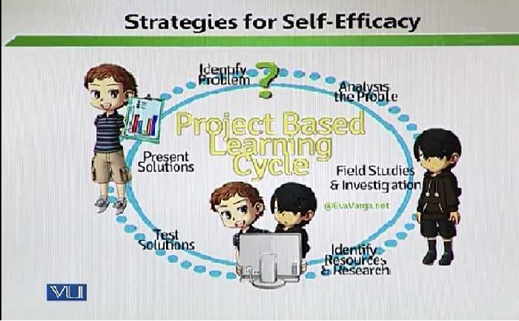
To help students improve their self-efficacy beliefs, teacher in PBL must
- Act as a resource person than judge
- Focus on process than outcomes
- React to errors as natural and useful part of learning rather than evidence of failure
- Stress effort over ability and personal standards over normative standards when giving feedback
Topic: 107 - Strategies for Developing Positive Self-efficacy in Students – 4
- Community-Based Learning
- Another form of contextual learning
- It connects school work to career goals
- It includes project-based workshop learning, apprenticeship and school-directed worksite learning
- Students, teachers and community partners mutually set goals
- Real-world problem is focused
- Teacher and community partners provide coaching and advice
- Inquiry, investigation, hypothesizing, articulation, collaboration, negotiation, practice and reflection are tools
- Achievement is demonstrated through multiple types of assessments
Lesson 19

SELF-MONITORING AND SELF-ASSESSMENT TO ENHANCE SELF-EFFICACY
Topic: 108 – Self-Monitoring and Self-assessment to Enhance Self-efficacy
- Contribution to self-efficacy is embedded in reflection
Means of assessment enable students to:
- Contextualize their learning
- Reflect on their performance
- Compare their current with prior work
- Recognize their potential for continued growth
Self-mentoring enables students to:
- Know themselves
- Identify their mentoring needs
It empowers the students and contributes towards enhanced self-efficacy
Topic: 109 – Guidance and Counselling
Need to integrate Social-Emotional Learning (SEL) into School Curriculum (1)
- Researchers strongly suggest that the learning process is 50% social-emotional and 50% cognitive.
- Social-emotional skills are implicitly embedded in standard curriculum whether the implementers are aware of it or not.
- Empathy, problem-solving and self-awareness are implicitly embedded into the curriculum. It has to be a properly directed activity where a lesson plan integrates the aspects of the academic world as well as the social and emotional world.
Topic: 110 – Need to integrate Social-Emotional Learning (SEL) into School Curriculum (2)
- Social Emotional skills like, hope, optimism, perseverance, self-management, problem-solving etc. Already align well with various topics in different subjects
- Intentional preparation and teaching would facilitate incorporation of SEL. Professional development of teachers is very important.
- Teacher’s enthusiasm and passion plays significant role in developing SEL. Teachers needs to give proper demonstrations of their behavior. A teacher is the one who actually guides and supports the social and emotional learning of the students.
Topic: 111 – Key Elements for Implementing SEL (1)
- Web of structural support to ensure that teachers do know their students and their needs very well and address them accordingly.
This structural support includes:
- Advisory periods
- Purposeful teacher-student relationship
- Small class size
- Support-focused formal assessments
- No censure
- Grade-level and subject-area meetings to create professional learning community among faculty members
Topic: 112 – Key elements for Implementing SEL (2)
- Cultivation of a community through shared norms, values and language. When people get together in a school and there are various stakeholders who are responsible for a child. In this the development of sense of community is necessary. When there is sense of community develop then emotional learning is taken in care. In teaching method in our schools there is no belongingness. The only target is to complete the syllabus. If classroom will be considered in sense of community and muncher society then there is belongingness.
- Acceptance of differences, inclusive practices, promoting sense of belongingness. If we treat people equally and we do not give regards to the individual differences than students come up with then it became difficult to guide them and counsel students because different students may have different needs, different interest level and different issues so if the objective is to guide and counsel them then it is important to give regards to these differences. Inclusive practices should be in concerned. One teaching method should not be applied. Different teaching and assessment method should be applied. Inclusive practices may lead to successful result because sense of belongingness promotes in different teaching and assessment methods. If we want academic development than it is important that all stakeholders belong to the classrooms, they belong to the school and what they cultivate in a sense of community. That is important and that is key element of social and emotional learning.
Topic: 113 – Key elements for Implementing SEL (3)
- Constructive alternatives to destructive disciplinary policies. One must be given importance to the constructive mechanism. In school, students have different attitudes. To analyze their attitudes is very necessary. To bring changes in attitudes then you need to deal with issues constructively. Constructively means to realize the students who have broken down the rules at surface level then you are not including the social and emotional aspects. You are dealing the issues at the surface level. Students would know that if he/she misbehaves there are rules and regulations attached to it, there are punishments available then he/she will get a punishment and that is it. And that is not what we want. We want to come out the students from malpractices. For this constructive analysis is necessary. There are various alternatives that are available. These alternatives include:
- Peer mediation or juries
- Peace circles
- Meeting students’ basic need
- Student’s motivation through adopting learner-centered approaches. Teacher directed learning should not be applied. Different methods of teaching should be used.

Lesson 20
SOCIAL AND EMOTIONAL DEVELOPMENT
Topic: 114 – Social and emotional development Strategies for Implementing SEL in the school curriculum-Responsive classroom (1)
- Responsive classroom:
Teacher should:
- Share a common set of values, vocabulary and skills for social-emotional domain
- A teacher needs to be responsible in the classroom. Teacher should be there to listen the issues that crop up in the classroom and should there to teach. He/she needs to be closer to the lives of the students.
Teacher should:
- Engage students in formulation of rules
- Arrange for guide discovery and academic choice
- Facilitate collaborative problem-solving
Topic: 115 – Strategies for implementing SEL in the School Curriculum-Responsive Classroom (2)
- Responsive classroom is one of the important strategies.
- Components of responsive classroom:
- Student’s inclusion in role setting for developing safe, respectful and caring classroom environment
- Modeling and role-play rules and procedures for students
- Careful selection of words and tone to promote sense of community i.e.,
- Express faith in children’s abilities and intensions
- Know when to be silent
- Use proactive, descriptive and reflective language
- Avoid general statements be direct, elicit solutions
- Usage of energizing activities when students seem lethargic. For example:
- Morning meetings for a warm startup of the day
Topic; 116 – Strategies for implementing SEL in the School Curriculum-Violence Prevention Program
- Violence is negative behavioral element.
- Violence prevention curriculum integrates social-emotional and academic learning by addressing.
Key qualities:
- Empathy, elements of care, kindness and taking of care
- Impulse control
- Problem-solving
- Anger management
Tools:
- There are certain tools which we can teach these things
- By taking photographs
- By using puppets
- Through audio tape
- Videos
- Posters followed by discussion, role play, activity suggestion, wrap up ideas.
- A reminder needs to be given for parents to support children on the learnt skills. They also reinforce the same behaviours in the home because we say that learning is done in through various stakeholders and parents are one of the stakeholders.
Topic: 117 – Strategies for Implementing SEL in the School Curriculum-Interplay Solution
- With the help of interplay, we can integrate/implement SEL in the classroom.
- Interplay solutions approaches uses:
- Stories
- Role-play
- Structured activities to develop supportive classroom communities.
- Role play is an active medium.
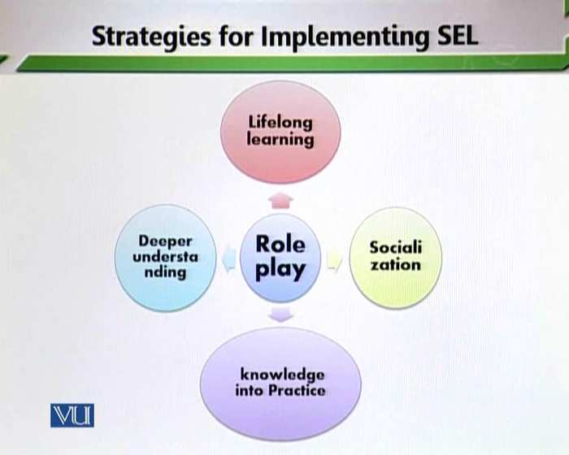
- Role-play help in lifelong learning:
- Socialization
- Knowledge into practice
- Deeper understanding
- Role is an active medium to teach different aspect of language at the same time it is a key aspect to teach the aspect of social and emotional learning.
- This approach enhances students’ listening and focusing skills.
- Students write down their reflection about their experiences.
Topic: 118 - Strategies for Implementing SEL - in the School Curriculum-Teachers ‘Autonomy
- Normally the role of the teacher is very debatable. Teacher-preparation programs can equip teachers with core competencies necessary to foster social and emotional learning.
- Professional development should be periodic. Continuous professional development of teachers is very important.
- Guidance enables them to develop innovation modes of teaching that nurtures social consciousness as well as addressing to academic goals. Teachers should attend workshop and conferences. Professional degree programmers should be available for the teachers.
Topic: 119 – Strategies for Implementing SEL in the School Curriculum-High Order Thinking
- High order thinking must be developed in every subject (Math, Science, Social Studies etc.)
- High-order thinking includes following skills:
- Information-processing
- Enquiry
- Creative thinking
- Reasoning
- Evaluation
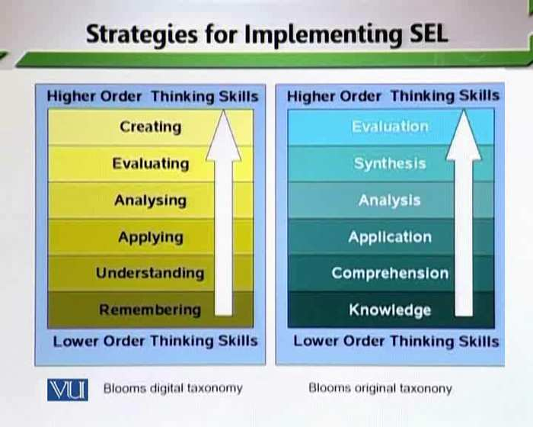
- It will facilitate relating math problem, scientific concept and Social Studies knowledge to real life issues and foster essential skills to address these.
Lesson 21
STRATEGIES FOR IMPLEMENTING SEL IN THE CURRICULUM-FLEXIBILITY FOR LESSON PLANNING

Topic: 120 - Strategies for implementing SEL in the School Curriculum-Flexibility for lesson planning
- According to the needs of the students, a teacher can change his/her lesson plan. Curriculum must be flexible in the term of lesson plan. Because sometimes on the spot changes cannot be implement.
Teacher must be:
- Clear About the topic objectives
- Able to think ahead
Then:
- Design structure and sequence for SEL
- Plan lesson
Final thought: There are numerous ways to link your targets to SEL skills.
Be vigilant and execute them
Topic: 121 – Teacher as a Counsellor
Effective Teacher-Caring
The role of the teacher is very important towards the development of the students. Teachers need to emerge as counsellor; they need to emerge as guides to the students. Teachers should show their personality traits, one of the Personality traits is caring. Teachers should need to emerge as caring individuals in the classroom.
“Teacher as a person” must possess following 7 indicators of effectiveness Stronge (2007)
Caring
- Core component
- Crucial for effective instruction and classroom management
- Listening
- Gentleness
- Understanding
- Knowing students as an individual
- Warmth and encouragement
These are vital characteristic that built caring.
Topic: 122 – Effective Teacher-Fairness and Respect
- Fairness and respect
- An effective teacher needs to:
- Models
- Demonstrates and
- Practices
Fairness and respect
Fairness means everyone gets that they need not everyone gets the same things.
An effective teacher:
- Enforces rules and consequences, without any sort of favoritism
- Is honest to students
- Follows through on commitments
- respects students
- does not make students embarrass in front of others
Topic: 123 – Effective Teacher – Interaction with Students
3. Interaction with student:
- Interaction. A teacher should not be limited to the classroom. A teacher should know his/her student very well.
- Teacher must develop social relationship with students. He/she should be available all the time. Since you consistently interact with your students then it becomes easier for you to solve their issues
- For the solution of the problems an effective teacher:
- Works with students on their projects
- Shares personal anecdotes with them
- Share jokes with them then students become his/her friends. Students idealize their teachers
- Treats them like people/normal human beings/common people. Students may not share their problems with their parents but they may share their problems with their teacher. If a teacher may emerge as a companion, they may share their problems.
- Students-teacher positive social connection enhances student’s self-esteem and promotes their sense of belongingness to school.
Topic: 124 – Effective Teacher – Enthusiasm
4. Enthusiasm
Enthusiasm is very vital in the classroom.
Enthusiasm means:
- Great excitement for or interest in a subject or course.
- A source or cause of great excitement or interest.
- ‘’The real secret to success is enthusiasm.’’ (Walter Chrysler)
- ‘’Enthusiasm moves the world.’’ (Arthur Balfour)
Teacher efficacy is strongly conveyed through enthusiasm.
Students will imitate what the teacher modes.
Enthusiasm is a positive reinforcement that:
- Gets students ready and willing to learn.
- Attracts the curiosity.
- Meets safety, boosts self-esteem and belongingness.
- Teacher’s enthusiasm engages students in learning process.
- They are more likely to remember when element of fun is associated.
Topic: 125 – Effective Teacher – Motivation
5. Motivation
- Motivation is an important characteristic of being an effective teacher.
- Motivation is a theoretical construct used to explain behavior.
- It represents the reasons for people’s actions, desires, and need.
- Motivation can also be defined as one’s direction to behavior or what causes a person to want to repeat a behavior and vice versa.
- ‘’When you want to succeed as bad as you want to breath, then you’ll be successful.’’ (Eric Thomas)
- Only motivated teacher can motivate students to learn.
- A motivated teacher is an inspiring, engaging, passionate, and Amazing Human being! – Ty Howard
Motivation comes through:
- Encouragement and appreciation
- Empowering students
- Collaboration
- Setting high standards
- Assessing appropriate challenges

Lesson 22
EFFECTIVE TEACHER-ATTITUDE TOWARDS TEACHING
Topic: 126 – Effective Teacher – Attitude towards Teaching
Attitude towards Teaching
Effective teacher:
- Is always dedicated
- Willingly collaborates
- Shares ideas and strategies
- Teachers, who love teaching, teach children to love learning. These teachers are highly motivated for their professional development. They keep on moving their education. They might conduct research in school and publish in academic journals.
Topic: 127 – Effective Teacher – Reflective practice
Reflective Practice
Refection
‘’Careful review of and thoughtfulness about one’s own teaching process.’’
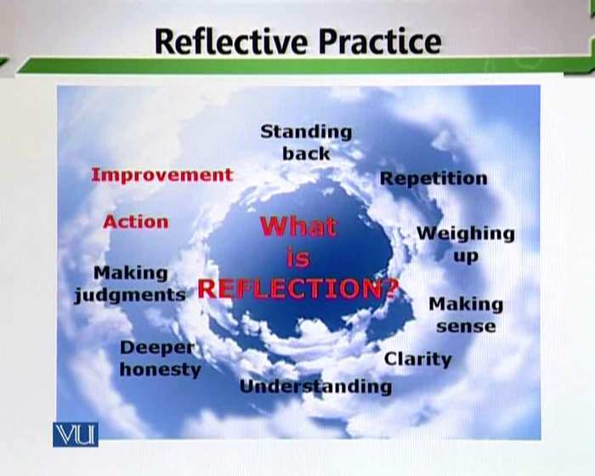
- Evaluating own practice helps improving upon it.
- An effective teacher is fully aware of own strengths and weakness.
- They do not hesitate taking feedback from their colleagues.
‘’we do not learn from experience…. We learn from reflecting on experience.’’
John Dewey
Topic: 128 – Role of Teacher as a Guide (1)
- Guidance in coping with separating anxiety.
- In early years, many children face fear of separating from parents.
- Teachers play an important role.
- Caring and nurturing teachers create a comfortable and friendly environment and reassure safety to the students.
- Teacher who fail to effectively guide their students at this stage, face hard time in setting children and developing good rapport.
Topic: 129 – Role of Teacher as a Guide (2)
Academic Guidance:
Primary concern of school is considered to be academic achievements.
- Teacher is the person directly in charge of this area.
- She/he knows where the student’s lack and what remedy is required.
Teacher can effectively address this problem by:
- Developing good rapport with the students
- Employing suitable strategies to provide better understanding and they are extremely important and they need to be employed into the classroom.
Topic: 130 – Role of Teacher as a Guide (3)
Confidence Building:
Teacher guidance can play a significant role in student’s confidence building; it is the teacher who raises the confidence level of the students and maintains the confidence level of the students. The role of the teacher in confidence building is very important.
By providing various in-class opportunities like:
- Open discussion
- Peer review
- Group assignments
- Providing constructive feedback on their performance
Teacher can reinforce these skills outside the classroom too by:
- Constant motivation
- Encouraging co-curricular activities. For example, teacher can give gesture to the student that ‘’you can do it!’’
- Listening to their issues
- Respecting their confidentiality
- Providing appropriate guidance
Topic: 131 – Role of Teacher as a Guide (4)
We are discussing various ways which teacher can act as a guide. One of the ways which teacher can act as a guide is Behavior Management.
Behavior Management is an effective way in which teacher can control the students. It is very important task that only an effective teacher can achieve.
- Empathetic understanding of the problem is important for effective solution
- An effective teacher knows her/his students as an individual
- Some behavioral problems require quick fixes whereas some need long-term guidance
Topic: 132 – Role of Teacher as a Guide (5)
- Teacher can identify the trigger of the problem and control it.
- Teacher sets the rules and effectively implements them.
Teacher can fix the problem through:
- Providing positive attention and affiliation
- Developing a sense of protection
- Delivering control
- Providing justice (All students are equal, in the concept of fairness, equality and justice, and students will obey the rules with whole heartedly and they work own to develop their personality)

Lesson 23
HINDRANCES FOR TEACHER IN PROVIDING COUNSELLING SERVICES
Topic: 133 – Are Teachers in a position to provide Counselling?
- Teachers have various roles to play. Teachers have a long tradition of helping students with personal problems.
- They interact with their students daily which put them in the most appropriate position to provide guidance.
- Effective teacher and effective counsellor both share the same traits.
- Good teacher habitually develops positive relationship with both students and parents that their role closely allied to that of counsellor.
Topic: 134 – Hindrances for Teacher in providing Counselling services (1)
- When we determine the teacher can emerge as a good counsellor in the classroom then we have to see the problems associated with them.
- Many teachers act as counsellor and help the students however many problems that do not allow them to do so.
- Time:
- Counselling is a time taking and a continuous process. One needs series of counselling sessions to overcome their problems. Our teachers are already overwhelmed with tough schedules and responsibilities.
- They have to:
- Achieve their academic targets
- Do lesson planning
- Prepare formative and summative assessments
- Complete reports
- Contribute to co-curricular activities
- Do recess time and off-time duties

Topic: 135 – Hindrances for Teachers in providing Counselling services (2)
Number of students:
- In early years (toddlers-class3) teacher can manage to integrate counselling into that teaching. In these classes, one teacher spends most of the time with one class.
- But middle and senior school teachers and tertiary educators have to deal with a huge number of students.
- They hardly spend an hour with each class which makes it difficult for them to know them individually. So that they cannot understand the problems of their students and also cannot handle the students. The students face many social, emotional, behavioral and academic problems. These problems affect their studies and balance development.
Topic: 136 – Hindrance for Teachers in Providing Counselling Services (3)
Training:
- Counselling is a professional service. It is a skill to be learnt. School must provide teachers with multiple opportunities for professional development. In a school year and in one year how much professional training is given to the teachers in terms of they make good guides and counsels.
- Counselling is attached with teaching. When a teacher teaches, he/she need to counsel the students. There will be proper counselling if there is proper training. When you developed proper skills in counselling. For example:
- Regular training programs
- In-house support
- Flexible timing for peer interaction and team meetings for sharing ideas
- Teacher should use counselling services so professional support and guidance of teachers is important.
Topic: 137 – Hindrance for Teachers in Providing Counselling Services (4)
Lack of awareness:
- There are many misconceptions about counselling which hinder schools from considering it seriously.
Like:
- Counselling deals only deals with severe psychological problems or emergency situation.
- Counselling for personal, emotional and social problem is parents’ responsibility, not the teacher’s (But that’s none of my business)
- A teacher cannot be a counsellor OR every teacher can be a counsellor without training or specific skills.
- We should be on one platform when it comes to solving issues. For example:
- Teacher cannot become counsellor, this is wrong. Teachers are counsellors in their own right. When they counsel and advice students then they are actually providing counselling services. You make it another name. When you are providing academic advice, when you are providing a social advice. You are counselling them, so you are definitely counsellors. When you are determining your role and broaden your role, so you need to think in a very broad framework and you need to broaden your horizon. When it comes to the application of the certain abilities in the classroom so teachers can defiantly emerge as counsellors.

Lesson 24
ESSENTIAL QUALITIES OF TEACHERS AS COUNSELLORS
Topic: 138 – Essential Qualities of Teachers as Counsellor (1)
- If we determine the fact that the teachers are counsellors and we remove several hindrances that we have discussed about and determine the teachers can emerge and can act as counsellor then there are essential qualities that they need to be accepted.
- Keen Observant:
- You need to be a keen observant and remember students’ names; it shows how much you care. You need to know your students very well that built a caring connection between you and your students. When we talk about empathetic and pro-social awareness you need to know the names of the students.
- Know their interests and perspectives.
- Identify their strengths and weakness.
- Pay attention to the shy or quieter students. Sometimes quiet people really have a lot to say, they’re just being careful about whom they open up to.
Topic: 139 – Essential Qualities of Teachers as Counsellors (2)
- Being Sensitive towards:
- Students’ needs
- Feelings
- Students learning style and effective use of pedagogical tools
- It is very necessary to know the community need of the students. There are many classroom and cultural sensitivity issues that teacher must address to ensure they are delivering language instruction without prejudice, discrimination or bias.
- In a classroom with a sensitive teacher, students learn to see that teacher as a source of support, guidance, and reassurance.
- Teaching sensitivity helps students feel comfortable with sharing their ideas, taking risks, and challenging themselves academically and socially. It also allows students to work comfortably on their own and in groups because they know they can approach the teacher and she/he will be helpful.
Topic: 140 - Essential Qualities of Teachers as Counsellor (3)
- We have seen that sensitivity is one chief quality of being a counsellor. Associated with sensitivity is the issue of being empathetic.
- Being Empathetic:
- Responding to feelings students express at appropriate level of intensity.
- Taking all the aspects into account, understand the context when talk about the academic needs of the students, there are also emotional needs. What are the emotional needs of the students?
What are the spiritual needs of the students of the students? What are the physical needs of the students? A teacher should concern all these needs of the students holistically.
- Being Objective:
- staying unbiased
- Refrain from emotional involvement (no agitation, no distress)
- Teacher need to be objective. Favoritisms should not be done into the school.
- A teacher has to emerge as an unbiased figure. As somebody who becomes emotionally involved with students so that issues can be resolved and at the same time he/she needs to build caring connections with the students. So that issues are known, dealt with and problems are solved.
Topic: 141 – Essential Qualities of Teacher as Counsellor (4)
- Holding High Expectations:
- Expecting great accomplishments given them confidence and they work to make it happen. In a classroom, there are different students with their different strengths, weakness and needs. When a teacher builds high expectations then he/she is giving a challenge to the students. Giving challenge to the students is very important.
- Motivating:
Motivation increases:
- Students’ self-confidence
- Eagerness to improve
- Overall performance
- They should not build only high expectations they should works towards the fulfillment of the expectations. A teacher must emerge as a supportive figure in the classroom so that students maintain their expectations, they keep on their academic areas, they working on their behavioral areas and they reach their targets in safe and secure manners. But if that supportive mechanism are not in place then students will also be relocated to reach the areas that you have set for them so be supportive for the students and set high expectations for them and then provide the required support so that students can meet their targets.
Topic 142 – Essential Qualities of Teachers as Counsellor (5)
- Trustworthy and Reliable: Reliable means that you will consistently behave in a certain way; trustworthy means that you can be given responsibility for doing or looking after something valuable with high confidence that you will do it.
- Being a reliable and trust worthy teacher. Students must feel comfortable that their confidentiality will be maintained.
Topic: 143 – Essential Qualities of Teacher as Counsellor (6)
- When we come to think of teacher being a counsellor the essential quality is interpersonal skills.
8. Interpersonal Skills: One of the essential things that teachers must have interpersonal skills. Teacher need to have good interpersonal skills and need to taking about the issues of the students.
- Teaching as well as counselling both professions requires very strong interpersonal skills. It is something that is required in the classroom. Teachers must talk on various issues. In counselling, interpersonal skills are also very important. It’s also a big requirement. A teacher as well as counsellor both need to be very good in term of social interactions.
- Verbal and nonverbal cues are equally important. It is the responsibility of the teacher that he or she should be expert in verbal and nonverbal interaction. Verbal interaction means conversation that we talk. Nonverbal should be considered in eye contact, facial expressions. Teacher need to have smiling face when talking with students. Teacher’s face should show kind concern for the students. These are nonverbal cues that a teacher gives to the students. Which determine that teacher is taking interest in teaching. Teachers can solve the problems of the students through verbal and nonverbal interactions. They can become good teacher in and out of the classrooms.
- Active listening, clarification and effective questioning skills are of utmost important. This can enhance the abilities and capabilities of the students.

Topic: 144 – Essential Qualities of Teachers as Counsellor (7)
9. Leadership: One of the qualities of the teacher being a counsellor. Teacher is defiantly leader in the classroom.
They must be:
- Capable of making wise decisions. You need to handle issues and problems of the students that arise because of some certain issues.
- Courageous to take skills to take risks and overcome fears.
- A teacher needs to be fully trained and professionally developed to be a leader in the classroom.
Leader:
These are the following elements that are very important for a teacher as leader.
- Empowerment: means a teacher can solve problems in ab autonomic manner.
- Encouragement: teachers are fully encouraged and they should be encouraged to make decisions in the classroom.
- Values: teachers must come forward with certain value system and then they transfer value system in the classroom. So, depending on the cultural norms and cultural values teacher comes and demonstrate that value system.
- Vision: means teacher are visionary. They have the philosophy of education. They have their own visionary system.
10. Professional competence:
- The must be dedicated and equipped with sufficient knowledge and understand about their jobs. They must invest in their professional development. A teacher will be a leader when he/she is professionally equipped.
Categories of professional competence:
Some important categories of professional competence are as following:
- Teacher should have content knowledge. Content knowledge gives confidence to the teachers.
- Teachers must have pedagogical knowledge because pedagogical knowledge teaches them how to experiments with various methods in the classroom.
- Teachers should have proper classroom management. They should be good managers in the classroom.
- Teachers must have good social and emotional knowledge because social and emotional deals them how to support mechanism in the classroom.
- They must be known for their professional development. Teacher should develop themselves professionally in the above four categories. Then they become strong leader in the classroom.

Lesson 25
TEACHER AS A COUNSELLOR
Topic: 145 – Counselling Services Appraisal Service (1)
Appraisal Service:
- In order to better understand each student, assist them to understand themselves.
- When we talk about teachers as counsellors then the appraisal of the students is the responsibility of the teachers. A teacher grooms the personalities of the students as a leader. There are many roles of the teachers on of the role of the teachers is to appraisal students. It is important to develop appraisal. It is necessary for the teachers to understand that where the students are weak. To convert the weaknesses of the students into strengths is the responsibility of the teachers. That’s why teachers called counsellors.
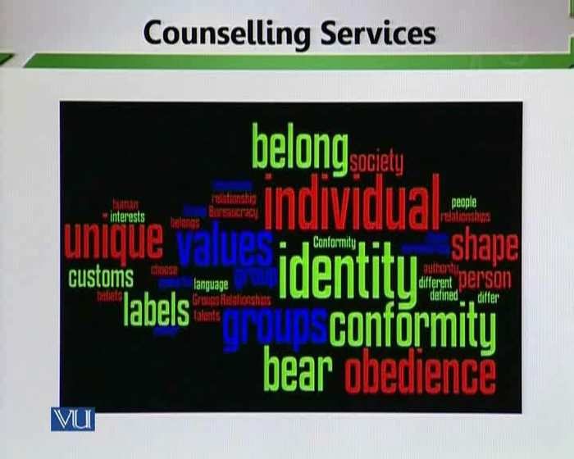
- When we talk about appraisal then there is necessary to teach some things. For example:
- To give sense of identity
- To teach conformity
- To teach that he/she belongs to a particular cultural system and society
- To give sense of obedience ( how to obey certain commands)
- To teach how to use custom and language correctly
To give appraisal about all the above relationships is the responsibility of the teacher. This is why counselling is very important. Counselling, in this form is seen as assistance to attain a clear sense of identity,
The main objects of the appraisal are that:
- We are preparing the students for the society.
- Students can adjust themselves better in the society.
- We can judge students likewise.
- To encourage them to adopt suitable behaviour, those behaviours that are suitable in the school and society.
Topic: 146 – Counselling Services Appraisal Service (2)
In appraisal service, teacher
- Collect
- Analyze
- Use variety of objective and subjective psychological and social dat.
- Appraisal service helps students to understand their:
- Personal ability (Those students who cannot recognize their personal ability they need to give help.)
- Teacher is only personality who can help students because he/she know students very well.

Layers of Ability
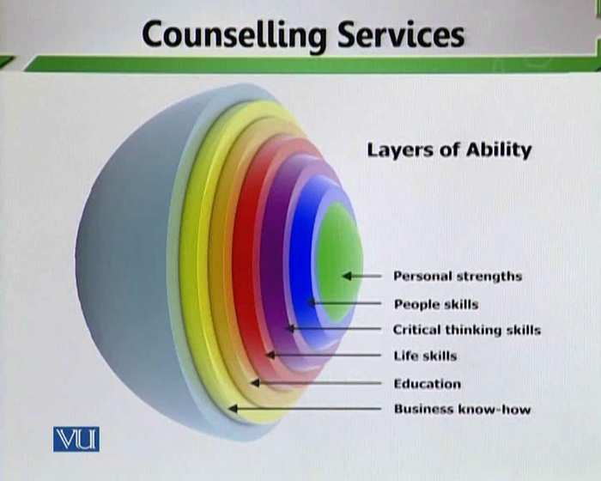
- Personal strengths (What are the personal strengths of the students? Where he/she is strong or not.)
- People skills (People to people skills means the social interaction skills that the students carry while they are in the schools.)
- Critical thinking skills (Are students able to think critically?)
- Life skills (What are the other life skills that the students carry themselves)
- Education (How much they are interested in their education whether at school or whether it is subject based education or it is otherwise.)
- Business know-how (In their daily interaction how do they daily interact with other people? What is the ability to understand others?)
- Unlocking our Potential is very important.

- A student must unlock his/her potential. As set earlier that sometimes students do not understand their potential. They do not recognize that they have certain potential that need to be marked and that need to be worked upon.
- Appraisal service helps students to understand their:
- Interests
- Motivation
Topic: 147 – Counselling Service Information Service
- Information service:
- Information service means to help students in their career development. If a teacher is professionally trained then he/she can give guidance to the students.
- Types of information service:
To provide students with gather knowledge of:
- Educational: it helps students to improve their educational journey. If a teacher is good then students will learn more.
- Vocational: We also help them to choose their careers. What do students want to do when they grow? This process starts from primary level.
- Personal-social opportunities: How does a teacher prepare their students for society.
- Educational information:

Provides a range of activities designed to assist people to make appropriate learning choice.
- Educational information service includes:
- Discussing with students in their early years about how school operates.
- Seminars information future path
- Advice for co-curricular activities.
Topic: 148 – Counselling service information service (1)
The very important part of the teacher’s job is to give information about vocation and tell them about the choice of careers
- Vocational/career service:
- A planning, placement and follow-up service
- Designed to enhance student development
- Assist students in selecting and utilizing opportunities within school and in outside labor market.
- Supporting activities:
There are supporting activities which can help teachers to guide and counsel their students about their jobs or careers.
- Seminars, workshops on effective resume and application writing
- Job posting and dissemination
Topic: 149 - Counselling Service Information Service (2)
Vocational information:
- Provides valid and useful data about jobs and occupations. For any job it is very necessary to know the background knowledge of the jobs. It is very necessary for the students that they have to be a close correlation between what he/she studies and what he/she works for. Sometimes when students start their jobs they are not happy with their jobs that that are doing and one of the reason is that the knowledge that they have, the knowledge that they have secured by studding in the school or college it has no match with the kind of job that he or she does.
- So that vocational information is very necessary. It is important to tell the students that what is that they care about? What is that they are interesting? What profession they like to take up later on? What they are good at? What skills they do have? How do they further advance polish those skills through hard work? To aware students that what is something that base them well in the end?
- Proper joy of education career when students go through these three elements. For example:
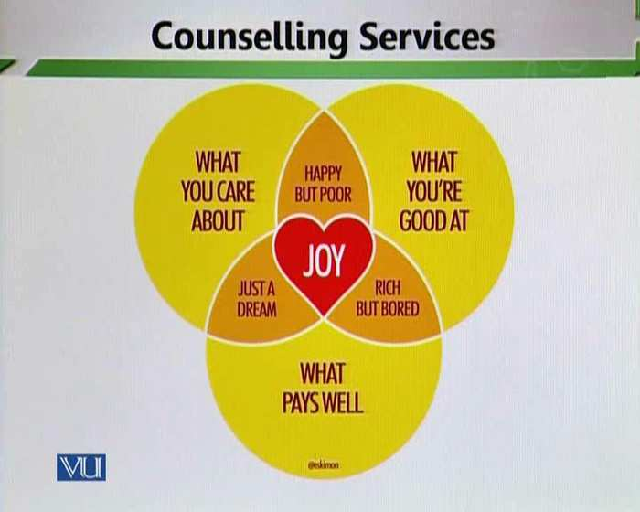

- What is that they care about?
- What is that they good act?
- What pays well at the end? To give information about these elements is the responsibility of the teacher.
This service informs about:
- Work condition
- Duties and requirements
- Rewards offered
- Demands and supply
- Promotion patterns
Tools for this service:
- Classroom discussions
- Mock interviews
- Mock job fair can be effective tools for this service.
Topic: 150 - Counselling Service Information Service (3)
Personal Social opportunities:
It provides them with skills and awareness that enables them to confront social inadequacies. When we talk about personal social opportunities then it is necessary to tell the students if they look five to ten years ahead where is that they want to progress and how do they work on their strengths and weakness. So that they go up the educational ladder which ultimately will help them to go up the professional ladder. It is important to fight those inadequacies and to prepare themselves wholesomely for the society for that it is important to work in education and it is important to work towards career development and that is why providing right kind of information becomes for student.
Aim:
To enable students to:
- Make better informed choices
- Take better decisions in an increasingly complex society

Topic: 151 - Counselling Service Information Service (4)
Personal-social counselling service includes guidance about:
- Personal appearance how he/she can enhance personal and social capacities. In this for example how does a person look like? How a person can carry himself/herself well? A lot of social interaction depends on how you say? What you look and how interact appropriately with other human beings because teaching process is linked with yourself but when we talk about social development the other dimensions have their importance. To active and to work on these dimensions is very important.
- Teacher should teach the content to the students and also groom their personalities because in job career with the knowledge your social dimensions also work. For example, how you talk with the people? How you behave in the social status?
Home and family relationship:
- Proper information needs to be given about home and family relationship. How we should interact with our parents and society? You domestic and school front become closer. School helps you that how your domestic front can groom.
Social skills:
- It is very important to consider school as a minister society. To teach those ways those are accepted and acceptable in the society.
Manner:
- How do students act in different situations? What are the attitudes that are need to embody?
Health:
- How would they take of their health? It is the responsibility of the teacher to give information about health issues.
Leisure time activities:
- How would they spend their leisure time? Teacher should guide and counsels in various dimensions. He/she provides the right kind of information not only in the knowledge domains but in different personal and social domains also. School will help in the overall development of the students.

Lesson 26
COUNSELLING SERVICES: THE COUNSELLING SERVICE
Topic: 152 – Counselling Services: The Counselling Service (1)
Counselling service facilitates:
Self-understanding:
- Awareness of and ability to understand one’s own actions: self-understanding is the key to the successful resolution of any emotional problem
- A teacher can facilitate students in self-understanding. He or she can convert weakness of the students into strengths. If child is weak in mathematics. The reason is not he or she has no abilities and skills. The reason is that he or she ca not focuses on his or her skills. He or she has certain kinds of fears about mathematics. It is the responsibility of the teacher that he or she should be focused on abilities and also on fears of the students. It is very necessary to tell the students that he or she does not lack in understanding. He or she has to work on psychological aspects of his or her personality.
- Self-development:
- Self-development is taking steps to better yourself, such as by learning new skills or overcoming bad habits.
- efforts toward self-fulfillment, either through formal study programs or on one's own
- Development of one's capabilities or potentialities.
- Self-development means how to put systematic journey of school on track for the progress. When we talk about track so linear improvement is important. What a child was yesterday she or he has to go ahead from that point. Self-development is extremely important and that only comes through realization. And that only again comes because of certain responsibilities that a student feels about the development of himself or herself.
- Environmental knowledge:
- Students can learn environment through small-group, society and relationship.
- Means total awareness about environment. Proper social relationship development is extremely important. In order to development healthier relationships it becomes important for teachers and students to work closely together. So that facts of the problems can be solved out.
- This service is provided in the wake of a pressing need for the student.
Topic: 153 – Counselling Service- The Counselling Service (2)
Types:
1. Group Counselling
- Group activities are aimed to assist each student solving his/her problems and making adjustments in group.
- Group counselling can hold a variety of benefits for therapeutic work with youth in group homes and residential treatment centers.
- Group counselling may also benefit counselling services in residential treatment settings in ways not directly linked to the clientele. Other potential benefits of group counselling include: efficiency of groups in terms of time and financial resources (Akos, Hamm, Mack, & Dunaway, 2007; Corey & Corey, 2002), positive impact of group work on relationships between youth (Sayder, 2008; Wright, 2006), improvement in working relationships between staff (Doel, 2006), and an improvement in staff’s generic counselling skills (Corey & Corey 2002; Doel 2006; Sayder, 2008).
- Group counselling helps students to solve their teaching, behavioral and personal problems. If a teacher solves their problems through group counselling then students begin to realize the problems of other students. When you tend to share your problems then you drive strength out of it. You associate yourself with others and you feel that you are not the only one who is facing a particular problem.
- So, when you sit in a group you tend to counter your problems in a more positive manner. Through group counselling you can make adjust in your academic as your behavioral life. Here the proper mentorship of the student is very important.

- When a student is living in his or her individual tower. And if he or she live isolated the he or she thinks that he or she is a unique human being who has a particular problem and other people are not facing any kind of problem but in group he or she realizes that there are many people who are facing problems. They try to associate themselves with others and people solve their problems by sharing.
- Individual Counselling:
- Student gets individual attention and support on how he/she behaves in.
- Individual counselling provides when students have specific problems.
- Purposes of group and individual counselling:
- To help students develop self-understanding and self-awareness
- To build self-confidence and self-esteem
- To encourage students to recognize and make good choices
- To provide opportunities for students to feel successful
- To give students an opportunity to discuss their concerns
- To encourage students to respect themselves and others
- To help students learn to solve conflicts peacefully
- To help students better adjust to school
- To teach students the decision making & problem-solving process
Topic: 154 – Counselling Services: Vocational Services (2)
- With the large number of career choices available, it can be difficult for people to pick the one that's right for them. Vocational counseling helps people narrow down the options and makes an informed career decision.
- Vocational counseling can take place as early as junior high school, with help from school guidance counselors. It also occurs via academic advisement in college and through job-placement agencies. Adults considering a career change also may seek the assistance of an employment counselor.
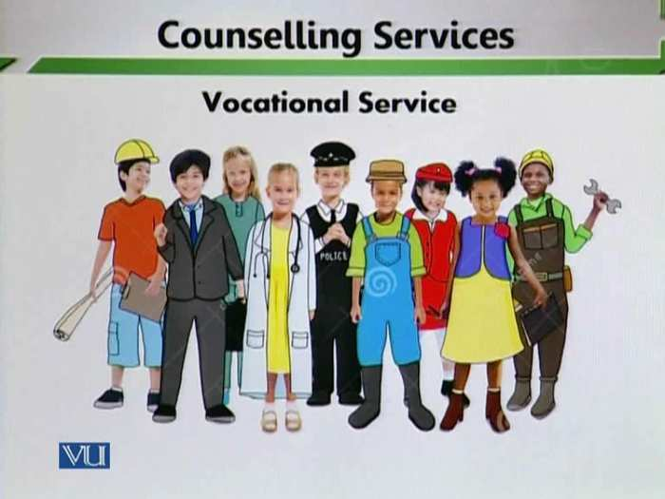
- It is very necessary to inform the students about the different vocations in a broad manner. So that students can develop their interests. Teachers should not work in limited areas. They should also guide parents about professions.
- Teachers are in best position to provide guidance for vocational choice BECAUSE…
- Teachers are fully aware of their students’:
- Strengths
- Weaknesses
- Aptitudes
Topic: 155 – Counselling Service – Remedial and Enrichment Service
1. Remedial and Enrichment Service:
- Caters to curriculum related needs of learners.
- Especially offered to those who need more attention to cope up with regular classes.
- This service is designed for students that need to be supervised and have enough focus regarding their academic standing. This service is available for students who have learning difficulties to enhance their capabilities and strengths regarding a subject matter. It is also designed to provide parents new opportunities to make sure their children receive the very best education possible.
- Remedial education (also known as developmental education, basic skills education, compensatory education, preparatory education, and academic upgrading) is education designed to assist students in order to achieve expected competencies in core academic skills such as literacy and numeracy. abilities and strengths regarding a subject matter. It is also designed to provide parents new opportunities to make sure their children receive the very best education possible.
- Objectives
1. To help students come up with their learning difficulties.
2. To enhance students’ capabilities and strengths through attending special classes.
3. To improve student performance and help all students achieve effectively.
- It is the job of the teacher to provide remedial and enrichment service.

Tool:
- Remedial classes: Remedial classes are often used to stress the basics in a subject such as math or language. They can help students who are having problems with advanced concepts to fully understand the basics of a subject. Students can also use them to catch up on material after a long break from education. Some people look upon remedial classes as embarrassing, but they can in fact be useful tools to gain a more complete grasp of difficult ideas or rules.
- Subject specific groups/clubs: Put students into groups and assign each team a topic for which they will become “expert” thinking of ways they can teach and explain the topic to the rest of the class. Students can use printable worksheets as tool to help build their presentation.
Topic: 156 – Counselling Service – Follow-up Service
1. Follow- up Service
- It ensures continued services for the students even after they leave school.
- A continuous monitoring program designed to evaluate the effectiveness of the intervention procedures in relation to student progress and adjustments.
- This service is undertaken as systematic evaluation of whether the guidance service in particular and the educational program in general have satisfied the needs of students.
- Refers to the formal and systematic monitoring of the individual progress of current students who have undergone academic advising, counseling, referral, placement, or any special intervention program. Returning students and those who are in academic probation are also monitored whenever needed
- An integral part of guidance services is the follow-up • It is concerned with what happens to students while in school or after they have left schools
Purpose of Follow-up
1. To ascertain the progress and status of students within the various classrooms, courses and curricular areas.
2. To gain data which may identify weakness in the various phases of the school progress?
3. To evaluate the effectiveness of the school’s placement activity. 5. To learn why pupils leave before graduation
4. To discover grade levels at which most dropouts occur.
5. To obtain opinions concerning needed modification of the curriculum in the light of the experiences of former pupils.
Types of Follow-up service:
  - In school follow up service
- Reduces the number of drop-outs.
- Helps in adjustment to student life.
  - Out-school follow-up
- Instills a sense of belongingness in alumni.
- Helps the school analyze its effectiveness.

Techniques of follow- up service include:
- Postcard survey, or questionnaire
- Each has its own advantages and disadvantages
Tools use in follow- up:
- Conducting surveys
- Use of telephone
- The use of follow up letters.
Important of follow- up service:
- Information obtained through follow-up techniques can be used for improving the curriculum stimulating better teaching, increasing the value of the guidance services and establishing better college and community relationships.

Lesson 27
IMPORTANCE OF ETHICS IN COUNSELLING
Topic: 157 –Important of Ethics in Counselling – 1
- Ethics are highly important in any kind of counselling. When we talk about ethics then we talk about moral dimensions. It means a teacher should discuss student’s personal issues with others. It is unethical to discuss student’s personal issues with others
- Ethics can be an extremely difficult subject to define and discuss as it closely related to one’s own unique moral, cultural, and spiritual values. Within the counselling profession however there is a strict ethical framework which must be adhered to. This framework has been developed over the years to ensure integrity, confidentiality, and responsibility on the part of the counsellor.
“The primary role of the counsellor is not one of merely using techniques. It is essentially an ethical task. Simply stated, it is to serve the clients best interests.” {Pg 126 of Ursula o Farrells first steps in counselling}
- Ethical Standards
1. Transparency is practiced in companies, organizations, administrations, and communities. It guides an organization's decisions and policies on the disclosure of information to its employees and the public, or simply the intended recipient of the information.
- Ethical framework crates transparency. A student and teacher need to understand each other’s very well. And relationship building needs to be very strong not only strong but transparent.

- For example: If a student is facing any problem, he or she needs to explain his or her problem full honestly so that problem can be solved. Similarly, teacher needs to be transparent in the relationship with the students. It means if a student confides his or her problem in this first of a teacher should deals transparently and does not make his or her secret staffroom talk. That is why transparency in relationships is extremely important.
- Transparency develops equality between counsellor and counselee. It is a relationship of trust. Students and teachers have trust with each other’s.
Topic: 158 – Importance of Ethics in Counselling - 2
2. Development of trust:
- Following ethics enhances counselee’s trust in counsellor and in the progress
- Trust is a specific ethical standard that needs to be followed. The establishment of trust between a teacher and a student is very important. Similarly, establishment of trust between a student and school is important. Establishment of trust between a student and other stakeholders in education is extremely important.

- It is important because the responsibility of the school is to prepare students for balance personality and prepare students for society. Many problems will be solved because of trust.
- Trust is the key to success in this process. When the student explains his or her problem with full honesty then teacher will solve the problem of the student and will not explain his or her problem with other staff members. The ultimate goal is to help the student so that thinks can be worked out and then a student can proceed in systematic and smooth fashion in the school.
- Students exhibit high levels of trust at school by listening, enacting and persisting when teachers and others encourage them to be able to do so. The role of the family, school, peers and self-confidence all play a role in how individuals construct their self-identity and persistence towards their desire goal of college.
- In addition to the role of family, the role of the school is an essential component to helping foster persistence. Specifically, educator's build trust by being approachable to their students. Allowing students to feel value and respect in high school, with closer personal relationships with their teachers, allow these students to ask for help when struggling in college because they see teachers as approachable human beings. Additionally, the school requirement to participate in extra-curricular activities during the school year exponentially increase student exposure to new and challenging situations as well as increase students' confidence in leadership roles.
- Ultimately, family members, teachers and peers demonstrate a message of trust in these students' ability to achieve academically and socially, which help students to do so even when they doubt themselves. The messages we convey to students matter. They are deeply embedded long after they leave our classrooms. As we begin this school year, let's make sure we choose the right message.
Topic: 159 – Ethics in Guidance and Counselling – 1
Confidentiality:
- It is an important ethical principle.
- It ensures success through the development of trust.
- A teacher will not be able to guide and counsel unless trusted by the student.
- Confidentiality refers to the ethical obligation to conceal information obtained through a professional relationship (Jacob & Hartshorne, 2007).
- In schools, an added complexity exists since students are entitled to confidentiality rights; however, because they are minors’ parents are given the right to access information regarding the services received by their children (Jacob, 2008).
- This is particularly important in the case of direct service delivery (such as counseling), which may affect professional practice. Isaacs and Stone (2001) found that often adolescents feel reluctant to participate in counseling because they do not have the same entitlement as adults do. Consequently, building a therapeutic relationship with the child or adolescent may become difficult, as some information intended to not be disclosed will have to be shared with parents. Nonetheless, school psychologists should explain to parents the importance of confidentiality and seek parents’ agreement to only inquire about general information (Jacob & Hartshorne, 2007). A trusting relationship needs to be built in order to effectively help children and adolescents reach positive outcomes.
- Confidentiality is an ethical principle to ensure the privacy of clients, whether they are students, parents, teachers, or another interested party. It serves the purpose of preventing improper dissemination of information that may result in bias and fosters an environment of trust and safety. Although applications of confidentiality can be confusing, a strong knowledge base of ethical standards and the law can improve and facilitate the practice of psychological services in schools.
Topic: 160 –Ethics in Guidance and Counselling – 2
1. Students at times have to discuss very personal and sensitive issues. Students and teachers must have a trusty relationship. Students must feel it convenient to talk about their problems with teachers and they must also be very confident and teachers would not share their personal issues with anyone. Personal and social can be discussed with the teacher because a teacher knows the social issues very well. Teachers are basically familiar with all the students and at the same time children are familiar with the teachers but they may be a single teacher that a child or student identifies to talk too.
2. They need assurance that their privacy will be respected and maintained. If privacy is not respected the result is that the students may never discuss their issues with the teachers and issues will not be solved and become complicated.
Failure in maintaining confidentiality may:
- Cause extreme embarrassment for the counselee. A student feels extremely embarrassed and then feels defeated also. Defeated in the sense that he or she had confided in the teacher however teacher could not maintain the confidentiality and shared it in the public. This break of trust may have very bad affect.
- The factor of discouragement will come in the students. Discourage others from seeking guidance.

Topic: 161 –Ethics in Guidance and Counselling – 3
- Tolerance: definitions
- willingness to accept feelings, habits, or beliefs that are different from your own
- the ability to accept, experience, or survive something harmful or unpleasant
- the ability or willingness to tolerate the existence of opinions or behaviour that one dislikes or disagrees with
- The capacity to endure continued subjection to something such as a drug or environmental conditions without adverse reaction.
- Teacher must be sufficiently tolerant to hear out counselee. Teachers must listen to the students with close attention. To give attention to the students is very important.
- Teachers should have enough time to listen the students and give attention to the students with full body language. Body language plays a very important role.
- You should give impression to the students that you are all ears and you are listening the students
- Your eyes will see the students and focus the students.
- You should be quiet. It means your mouth should be quiet.
- Your shoulders should be facing the students. Your hands should be still and your feet should be calm. Sometimes teachers move their feet which can create disturbance. It shows you are not listening to the students.

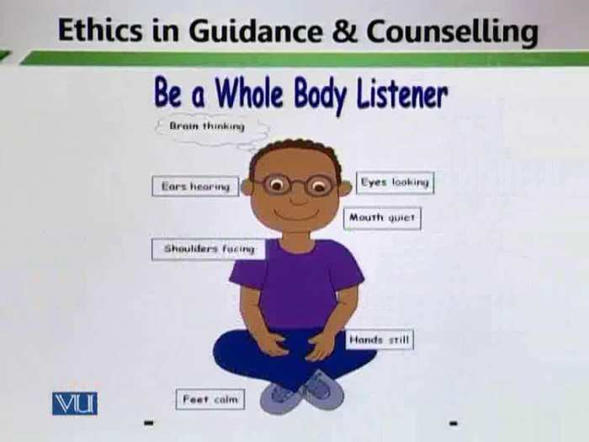
- In many cases, all a counselee needs are, to be heard. Sometimes needs to be heard. If teacher will give proper space to the students it will bring positive changes. Sometimes students need emotional shoulders to speak out the things and teacher can actually pass on those emotional shoulders where students can actually confide their teachers and can actually raise their issues. Academic and behavioral issues go side by side. Teachers can solve issues of students by giving tolerance to the students.
Topic: 162 – Ethics in Guidance and Counselling – 4
- Counsellor’s tolerance brings about the openness in the counselee’s attitude. When you are tolerant with the students it basically opens the minds of the students. A student actually exhibits into openness with the teacher which is required for the solution of the problems.
- Patience of teacher is very important. “Patience is the key which solves all problems.” (Sudanese proverb)
- “Patience is the best remedy for every trouble.” ~ Plautus
- You have to listen to the students with lot of patience and not tell them through your body language perhaps there is wasting your time. Students never waste the time of the teachers. Every move of the student is the learning experience of the teacher.
- Being tolerant can get a teacher maximum amount of information that is required for good counselling.
Topic: 163 – Ethics in Guidance and Counselling – 5
4. Autonomy:
- Autonomy is a concept found in moral, political, and bioethical philosophy. Within these contexts, it is the capacity of a rational individual to make an informed, un-coerced decision.
- Autonomy is another highly important ethic in counselling that needs to develop in students.
- Decisions should never be forced upon students. Students should be talked about to make their own decisions. And make decisions according to different circumstances. The best thing that we can do with the students as teachers and as parents is to give them and independent thought process.so decisions should not be imposed on the students. Students of early age cannot make their own decisions but through proper guidance and counselling of teachers and parents, students will make their decisions by their own. When we do not let the students to think independently, they cannot make their decisions by their own.
- The negative in our society is that we make decisions for children. Teachers make decisions for students for example students will give the exam of Mathematics. Teachers do not ask students about the preparation of the exam. So autonomous decision making is not generally rest with the students and children. In school, teachers make decisions for the students and in home, parents make decisions for the students in this way the development of decision making in students stop.

- The result is that the students are unable to make their own decisions by themselves. If we develop decision making in students it will be very helpful for the students in their practical life. When we prepare students for making decisions by their own them will think critically and take reflective measures. When your role the ball in their court then it becomes easy for them to make decisions and to analyze things. The best gift that you can give to students and children as teachers and as parents teach them autonomous thinking and tell them to make their own decisions in the light of advice that you give them.
- Autonomy of decision making should reside with the counselee.

Lesson 28
ETHICS IN GUIDANCE AND COUNSELLING
Topic: 164 – Ethics in Guidance and Counselling – 6
- Continuing a discussion on aspect of giving autonomies to the student, it is important to realize the respect that must be giving to the student.
- Teacher should respect a student’ right to choose. The opinion of students must be important. Normally in our society the opinion of students is not be respected. What they say is never considered. Teachers and parents both do not give proper attention to what the student and children are saying and the result is that parents and teachers they sometimes ridicule the students and children. This is very wrong. When you ridicule the opinion of the student and children the confidence level of the student will be grounded.
- Student’s opinion should not be steered by the teacher. Teacher should give respect the students and children so that they give their opinion with full confidence because when they do not give their opinion the problems will not be resolved. The basic point is that teacher should give respect the student and listen the student’s problem.
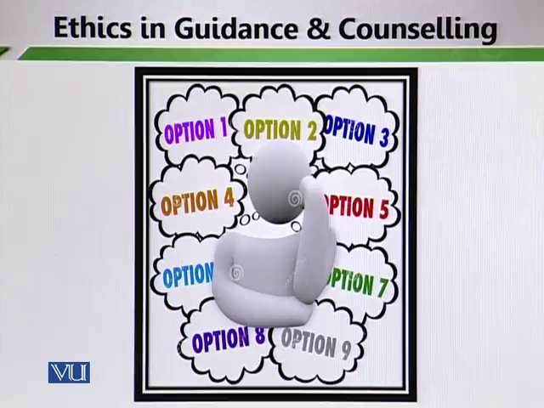
- Teacher should listen all the problems of the students and give proper attention to the students. Teacher should encourage the student for the opinion because independence opinion develops critical thinking. Students are able to better reflect on issues. They go deep and they go in a deeper analysis which is basically important in the longer run. We must develop these skills in students so that when they grow up they are better able to understand issues.
- Teacher should provide options, stating merits and demerits. One sided issue does not lead to the critical thinking which is extremely important for the students and it is extremely important for the betterment of the education in Pakistan. Choices must be given and student’s autonomy must be respected.
Topic: 165 –Ethics in Guidance and Counselling – 7
5. Exceeding Competence
- Teacher must be well trained to provide effective counselling service. For teachers, Professional preparation is very important. Normally teachers say that they do counsel students and in profession counseling basically falls in. However what needs to be understood is that whether teachers are professionally trained to be counsellors. Student’s career is at risk because of wrong perception. Social and emotional aspects become injure because of teacher’s wrong opinion. So professional training of teacher is very important. In professional development training programs counselling programs should be considered. The following aspects should be kept in mind:
- How many programmers run for teachers as counsellors?
- How many facilities provide for the teacher to become counsellors?
- What is the role of the schools?
- How many courses are in teacher education programs?
- In a year how much training programs are arranged or the teachers?
- Teacher should give their opinion on professional ground. Normally teachers give their opinion without any professional training. Their opinion is not on research based. It is not based on any kind of experiential learning. It is only on surface level. Teachers should be properly trained to give opinion to the students.

- Teacher should avoid presenting herself/himself as more qualified then she/he actually is. Schools are reflection of society. Their problems may be at social level. For the solution of the problems there is a need of proper trained stakeholders. It is very important to higher trained psychologists; problems are of different kinds. A teacher must be honest enough to admit that he or she is not competent to solve the problems. A teacher cannot solve any kind of problem so in school there is a need of proper trained people. Teacher must present themselves as counsellors and they should be trained as counsellors.
Topic: 166 – Ethics in Guidance and Counselling – 8
6. Countertransference;
- Teacher’s perceptions of students are influenced by his/her own past experiences. Teacher’s personal perception and mind set play a very important role in understand, analysis and synthesis the student’s issues so a lot depends on the mind set of teachers.
- How do teachers perceive the philosophy of education? How do teachers perceive how students grow up? How teachers do perceive student’s progress in their academic work? It all depends on the perception of teachers and how are perception made?
- Perceptions are made because of several reasons. For example, teachers think that it is their duty to transform knowledge which they have studied. Teachers carry legacy with them without sometimes analyzing that legacy may be faulty.
- Some perception of teachers is made by environment. The environment from where teachers come. What is the kind of domestic environment that the teachers are coming from? What is the kind of professional environment that the teachers are in?
- Another reason of perception is social interaction. What is the particular group of teachers? So, development of perception plays a very important role in behaves with students and in understand attitude of others. When a teacher’s mind set fails to understand attitudes of the students it creates lots of problems. The first thing is that the approach of flexibility is very important. When you counter transfer your own perceptions to others and when you judge others not only on what the standards are, what is in front of you but you think the problem may be then the issues are not resolved properly.

- Do not take the decisions on the basis of past experiences because your mind set plays an important role in any kind of problem and its solution.
- Teacher’s feelings and attitudes may get influenced by how he/she perceive the student. You must continuously learn and once you develop this habit in yourself than it becomes easy to analyze problems. You must deal objectively. It is important to perceive things according to what ha situation is all about. You need to perceive it according to h different environmental standards. You need to change your mind set and avoid countertransference. You need to look objectively and avoid subjectivity.
Topic: 167 – Ethics in Guidance and Counselling -9
- Countertransference may result in the counsellor:
- Getting too over-protective: Teacher deals the student in specific moods. He or she tries to overpower the student by giving his or her decision and by giving strong opinion. He or she does not give independence. When you try to be very protective with students then students do not find the space to think on their own. Sometimes they do not find the space to actually lead their life the way they want to. At home, parents sometimes are too over protective about their children. They are so over protective that they sometime inhabit their independent growth mental as well as physical. So it is important to understand that teachers need not to be protective about students. It is important to show caring attitudes however over protection may lead to negativity because sometime students want autonomy, they want to grow in an open world but if you do not provide the open world to them then students feel inhabited.
- Treating client too cautiously: When you use countertransference then you are too cautious. When you treating client cautiously then the element of risk taking becomes decrease. You do not encourage student to become risk takers. Similarly, at home, when parents are over cautious about their children then the element of risk taking does not crop up. You must understand that risk taking is important because it leads to the discovery processes. That is important for the mental and physical development of human beings.

- In this student becomes puppet in your hand and you try to control them in the way to control a puppet. You do not see the other side of the picture. You need to avoid this and lead students towards autonomies thinking and self-directed learning.
- Perceiving him/her as in the counselee position. It is important to show empathetic and caring connection with the students.
- Developing excessive emotional attachment with counselee. You try to enforce your mind set on others.
Topic: 168 – Ethics in Guidance and Counselling - 10
- Countertransference can be beneficial if it is confined only on to empathetic feelings. It is right if you feel about your students, you care about your students, you put yourself in their shoes for a moment and think their problems or you begin to realize them well.
- But when you think according your own mind set or perception then you cannot solve the problem. To solve the problems, you need to analyze the problems and think critically the right and wrong factors so that you can reach the positive consequences.
- In any case, a teacher’s feelings should never become problematic. Your own feelings may never get problematic. Some teachers are extremely emotional, they are so emotional that sometimes when a student cries they start crying, so when the student and teacher both cry then how will solve the problem. It is important to be empathetic that is a skill that teachers must have, they must have a caring connection with the student but boundaries need to be drown, if you are too emotional with the students and if you enter the life of the student and you get so involved then it will becomes difficult to come out of it, then it is difficult to solve the problem. Teacher’s professional training is very important.
- Such emotions must be diagnosed timely and get solved immediately. Emotions may not let loose for a long time. As a teacher, if you are very emotional then it becomes difficult to solve the solution of the problem. Some teachers listen the problems of the students and discuss with others, they do no resolve the problems because they have different mindset. If there are genuine problems and conflicts, they need to be resolved timely.
Topic: 169 – Procedures & Tools for Guidance & Counselling
Organizing Guidance & Counselling in Schools – Prevention Level
- There are proper tools for organizing guidance and counselling in schools.
- Counselling services functions at prevention level as well as intervention level. At prevention level we need to prevent problems from occurring and at intervention level we find out the solution of the problem that is occurred. For prevention level organized mechanism is very important.
- At the prevention level, it intends to:
- Prevent a problem from occurring. We need to be professionally well prepared to solve these issues. So, when we operate at a prevention level, we basically do not let the problem from occurring. We do not let the problem to surface. We basically solve it and try to resolve it at the very basic level. For prevention level, the development of organized principal and mechanism is very important so that problem can be systematically resolved.
- Respond to early indication to lessen the impact of a problem. We need to respond very early. If we have to lessen the impact of a problem, we need to deal with it immediately. We need to react very early and at the outside of the problem so that problem does not intensify.
- Minimize the immediate consequences of the current problem at school or at classroom level. We need to be prepared to minimize immediate consequences of the current problem. If we are dealing with guidance and counselling, we need to move in a very organized fashion. Because if the system is in place then it becomes easier to resolve issues and deal with problems.

Lesson 29
ORGANIZING GUIDANCE AND COUNSELLING IN SCHOOLS-PROCEDURES-1
Topic: 170 – Organizing Guidance & Counselling in Schools – Procedures – 1
- To set up a counselling program in school or college, following procedures are required:
- Introducing Guidance to the principal.
- Adequate briefing facilities assistance and support from the principal. The basic role is of the principal. We need to define guidance and counselling to the principal and take principal on the board because the principal is the leader and manager of the school. It is also important all the stakeholders on board. Principal can give command to all the stakeholders to solve the problem that is occurring in the school. Principal as the school leader and manager needs to be informed about certain guidance and counselling principles so that they can be in acted in school properly.
- When we talk about the principles of guidance and counselling the following questions merges:
- Who: who will guide and counsel the students? Will teacher guide the student or there will be a counsellor in the school that he or she will guide and counsel the students. So, the question of who appears and the principal needs to be there to solve the problem and issues.
- Why: Why should guidance and counselling being in schools? So, the why element needs to be discussed. A principal should need to understand it very well.
- Where: where should these procedures be held?
- in classroom, outside the classroom or in a special room
- When: when the procedures of guidance and counselling organized?
- How: How the procedures of guidance and counselling are carried in schools?
- What: The factor of what basically tells about the perception of all the stakeholders.
- If we want to organized the procedures of guidance and counselling in schools all these questions need to be answered properly.
Topic: 171 -_Organizing Guidance & Counselling in Schools – Procedures – 2
Space is big problem in organizing the procedure of guidance and counselling in schools.
2. Office Space
- Acquire suitable space for office. When we guide students in the classroom the element of privacy does not exist and ethical standards will be at risk. For guide and counselling there is a need of specific rooms. In schools a specific room must be dedicated for guidance and counselling. The element of privacy and the element of confidentiality are extremely important. Student cannot have trust building relationship with their counsellors unless the element of privacy is not there. So that office space is very important.
- Office must be fairly distant from the principal office because in principal office there is lot of public relationship. Teachers, parents and other people visit principal office. At one level it (guidance and counselling can be disturbing factor. You can meet the ethical standards of guidance and counselling if you have considerable space between the principal office and the office which is kept foe guidance and counselling purpose.
- You should decorate the room in such a way that students should feel at home. He/she feel stress free.
- Office must be equipped with:
- Comfortable furniture
- Cabinet for record keeping
- Computer, printer etc.
Topic: 172 – Organizing Guidance & Counselling in Schools – Procedures – 3
3. Introduction to stakeholders:
Counsellors and teachers must be introduced to:
- Students: Student should know that they will be guided on their negative behavior. Counselling can either be vocational or social and emotional. The various elements of guidance and counselling procedures must be introduced to students. Students should not be got unaware.
- Parents: Parents must come on board. They must be introduced about the counselling procedures that are implementing in the school setting. They must be understood that when and where the need arises that the students or children will be counseled. Parent’s help play an important role in the counselling procedures. Sometimes can emerge as good counsellors.
- Staff members: it is also very important to introduce counselling procedures to the staff members. All staff members need to be on board as far as guidance and counselling is conserved. A formal introduction should be given to the staff.
Formal introduction to staff will:
- Promote cooperation
- Eliminate/reduce rivalry
- Help in winning their confidence building
Topic: 173 – Organizing Guidance & counselling in Schools – Procedures – 4
4. Introduction to students informs them about:
- Who should be consulted for their problems? Students must be informed that how they explain their problems and who will be consulted their problems.
- What is the significance of counselling? Students must be informed about what is the importance of guidance and counselling procedures and how will it solve it the problems. They also are introduced about the basic purpose of guidance and counselling procedures. Things need to be explained in the black and white to students so that students find it easy to go people and find it easy and continent to go and take suggestions from their teachers if they are counsellors.
5. Introduction to parents helps in:
- Getting their support and cooperation:
The school cannot organize guidance and counselling procedures in a proper manner without parent’s support and cooperation.
- Minimizing their rigidity in coercing for certain subjects and courses:
Parents must be introduced about the guidance and counselling procedures so that they minimize their rigid behaviours and mechanisms that they have set for their students or children
Topic: 174 – Organizing Guidance & counselling in Schools – Procedures – 5
6. Procurement of Appraisal and Information Data
All available resources for student’s appraisal should be collected.
Like:
- Aptitude tests
- Interest inventories
- Personality test
- Anecdotal records
- Class results
- Scholastic achievement test
- Institution’s brochures and hand books
- Newspaper advertisements
Topic: 175 – Organizing Guidance & counselling in Schools – Procedures – 6
7. Needs Assessment and Ascertainment
Needs assessment gives information about strengths, weakness, problems and level of confidence of the students.
Needs analysis should cover 3 domains:
- Educational
- Vocational
- Social
a) Educational:
Educational domains give information about strong areas of the students. It also informs in which subjects’ students are good and in which subjects they need more struggle.
An educational domain determines students’:
- Proficiency in a particular area.
- Difficulties (strengths and weakness)
- Exam phobia

Lesson 30
ORGANIZING GUIDANCE AND COUNSELLING IN SCHOOL-PROCEDURE-7
Topic: 176 – Organizing Guidance & counselling in Schools – Procedures – 7
b) Vocational endeavors:
- Suitability of subject combination
- Awareness & skills
- Probable occupational demand & supply
It informs the teachers about the career choices of the students. It helps the teachers to provide guidance and counselling in choosing career of the students.

c) Social domains:
It informs about the behavioral principal. It helps teachers to improve the behavioral aspects of the students. Social domains look for:
- Self-concept
- Interpersonal skills
- Coping
- Crisis handling
- Financial management
- Prevalence of anti-social activities
Topic: 177 – Organizing Guidance & Counselling in Schools – Procedures – 8
8. Settlement & Action phase
This procedure must be kept and given importance in the school settings. It means:
- Try to win confidence of the school members
- Dispense various services
Following principles must be conformed to:
- Discrimination must be avoided
- Cooperation environment must be established
- Manipulating environment can benefit in certain situations
- Individual’s respect and dignity must prevail
Topic: 178 – Organizing Guidance & Counselling in Schools – Procedures – 9
8. Evaluation
Evaluation is a systematic determination of a subject's merit, worth and significance, using criteria governed by a set of standards. It can assist an organization, program, project or any other intervention or initiative to assess any aim, realizable concept/proposal, or any alternative, to help in decision-making; or to ascertain the degree of achievement or value in regard to the aim and objectives and results of any such action that has been completed. The primary purpose of evaluation, in addition to gaining insight into prior or existing initiatives, is to enable reflection and assist in the identification of future change.
Evaluation is often used to characterize and appraise subjects of interest in a wide range of human enterprises, including the arts, criminal justice, foundations, non-profit organizations, government, health care, and other human services.
- Periodic evaluation is happening regularly over a period of time.
- Periodic evaluation is very important. Periodic Assessments are standards-based and aligned to grade-level, content-specific instructional guides.
- Loopholes need to be adjusted and improved
- Teachers/Counsellors must be adequately trained to enact evaluation procedures
- Students must participate in evaluation procedures so that they can take ownership of their actions
Topic: 179 – Organizing Guidance & Counselling in Schools – Steps of Counselling 1
Steps of counselling:
There are certain steps in counselling that need to be followed in the schools.
1. Building positive relationships with students.
- The students need to feel very comfortable in your presence. A teacher needs to provide a stress-free environment where students feel very convenient to discuss their problems and issues. Students need to engage in exploring the issue.
- Avoid advice, lecture and unnecessary questions:
A teacher should not give lectures to the students. Let the students talk, express the issues and discuss the problems because if you lecture and if you moralize, and give premature advice then you are basically influencing the student’s mind. The student may not be able to convincing his self or herself about the existence of the problem. Students must feel free in explaining the issue or problems. Teachers should not impose his or her mind set and perception on the students.

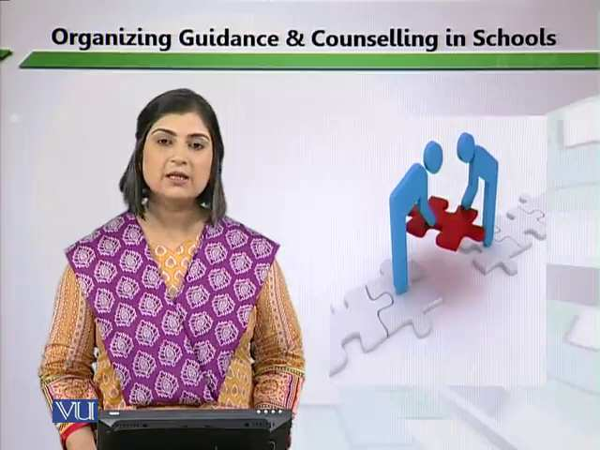
- Problem assessment:
Try to let the students speak about the issues or problems and analysis their issues or problems. Students must solve their problems or issues by their own understanding. The duty of the teachers is to provide guidance to the students. Teachers should tell the students about the solution of the problems through discussion. Teachers need to give open choice to the students and assess the problems or issues of the students.
- Goal setting:
Goal setting will be easy after assessing the problems. Teachers should set goals so that students can understand the problems.

Topic: 180 – Organizing Guidance & Counselling in Schools - Steps of Counselling 2
2. Intervention
- You need to devise a plan together with the students. A plan is devised basically to put the problem in a specific framework.
- The implementation of the plan is important. Proper procedures, systematic development and framework are necessary for the implementation of a plan.
- You must get verification of procedures from others. Other stakeholders should be on board.
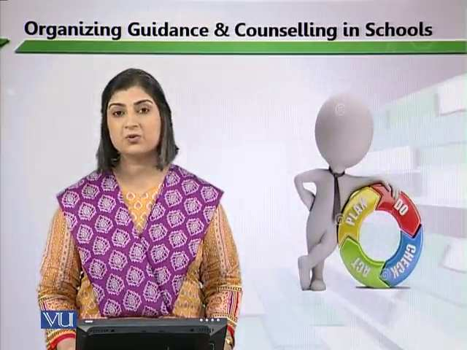
- In the development of a plan your reflective element is very necessary. Reflective element means you to follow the reflective cycle. Which means that you plan, do, check and act.
3. Evaluation
It will determine:
- Follow-up
- Termination
- Referral of the procedure

Topic: 181 - Counselling Competencies
Counselor must excel in the following competencies:
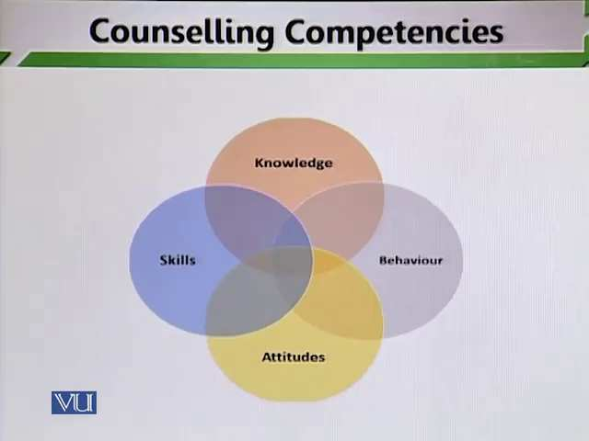
- Knowledge:
Counsellors, teachers and teachers as acting as counsellors they must possess the necessary knowledge in order to solve the day to day problems of students.
- The counselling relationship:
Apart from knowledge another important factor is the counselling relationship. The counsellor and the counselee must possess good relationship unless they do not possess good relationship. It becomes difficult to maintain counselling services.
- Counselling skills:
How do you translate and bring knowledge in action? When you bring your knowledge in action it becomes a skill that you practice. Demonstration of knowledge is very important.
- Professional and ethical attitudes and practice:
You need to use counselling skills in a specific framework and follow moral attitudes in using counselling skills.
Counsellors must possess these core competencies for easy problem solution.

Lesson 31
COUNSELLING COMPETENCIES-KNOWLEDGE
Topic: 182 – Counselling Competencies – Knowledge 1
1. Knowledge
Counsellor must have knowledge of major theories like:
- Counselling and psychotherapy:
Teachers and counsellors must know about the functions of counselling and therapy so that problems can be resolved easily. Well-grounded knowledge is very important to develop.
- Functioning and leadership:
It means that teachers and counsellors are involved in functioning and leadership. They are functioning human being whose practice counselling skills in students so that they solve their issues. Demonstration of leadership is very important. A Teacher who works as a counsellor should broad his or her knowledge base, look for psychological theories and its applications. Limited knowledge sometimes becomes very dangerous because in limited knowledge a teacher starts to generalize the things.
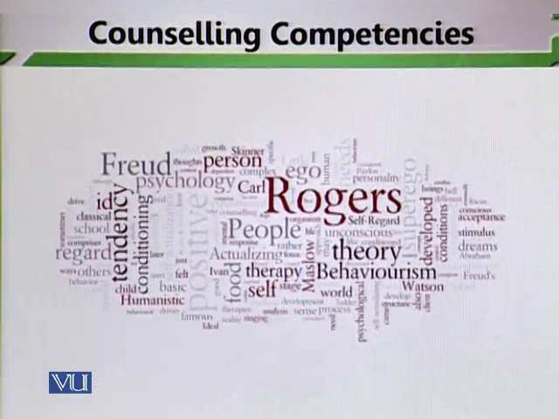
Teachers and counsellors should study all the psychologists, their views and analysis about counselling.

Developmental principles should also be studied. It is very necessary to see the developmental cycle of the students
- Understanding of developmental psychology and its relationship to counselling.
Topic: 183 – Counselling Competencies – Knowledge 2
Counsellors must have understanding of:
- Contextual systemic factors that affect human functioning:
Is a counsellor the social context? Awareness and discovery about social context of students is very important. Because all the problems of the students are linked with the social context. For example a teacher should know the social context of the student in resolving the domestic problems of the students. Students comes from different social context and different cultural background so it important to understand those different backgrounds only then we are able to judge a person by keeping him or herself in a proper context
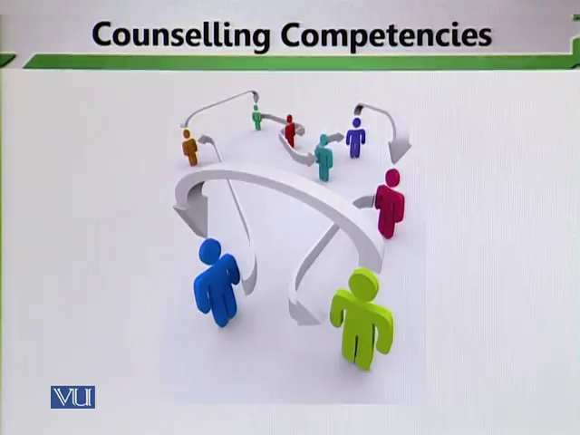
It is very important to analyze the students when they socially operate. Students behave in different ways in different environment. Classroom may be an artificial environment in which is in full command so sometimes it is important to analyze a student’s behavior in social context only then some solutions can be reached because sometimes students may not be performing their best because of certain pressures.
- Factors affecting wellbeing distress:
A counsellor must know the factors that affecting the smooth functioning.
- Cultural diversity:
Cultural diversity is the quality of diverse or different cultures, as opposed to monoculture, as in the global monoculture, or a homogenization of cultures, akin to cultural decay. Cultural diversity determines the personality of the students. It is very important for the counsellor to understand the cultural background of the students. School environment directly comes from the cultural background of the students.
Topic: 184 – Counselling Competencies – Knowledge 3
Counsellor must be aware of:
- Relevant professional development opportunities:
Teachers and counsellors should increase their professional development so that they can solve complex problems of the students. if they think that after acquiring a specific degree there is no need to enhance their professional skills, that is a wrong perception. One should always learn. Professional development opportunities must around the counsellors and teachers. They must take the opportunity to develop themselves so that problems are found and the solutions are reached in a professional manner.
There are different ways of professional development. For example, it can be as short as attending a small workshop or attending a seminar or attending a conference.
Professional development refers to the development of a person in his or her professional role. According to Glattenhorn (1987), by gaining increased experience in one’s teaching role they systematically gain increased experience in their professional growth through examination of their teaching ability. Professional workshops and other formally related meetings are a part of the professional development experience (Ganzer, 2000). Much broader in scope than career development, professional development is defined as a growth that occurs through the professional cycle of a teacher (Glattenhorn, 1987). Moreover, professional development and other organized in-service programs are designed to foster the growth of teachers that can be used for their further development (Crowther et al, 2000). One must examine the content of those experiences through which the process will occur and how it will take place (Ganzer, 2000; Guskey, 2000).
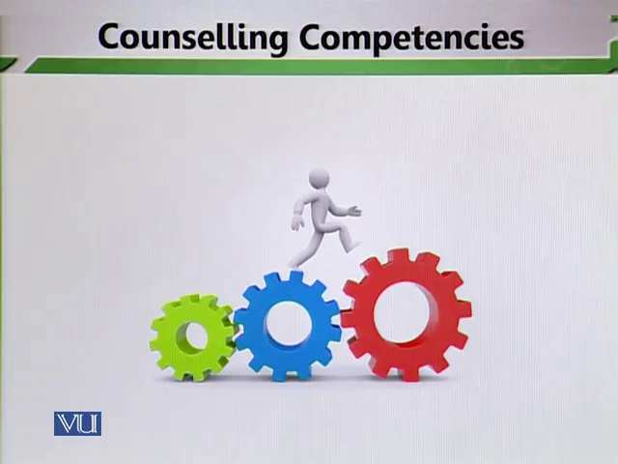
Even if you are giving the opportunity to go for a professional development pregame but if you are not trying yourself and if you do not to go yourself then it hardly makes a difference. So, the important thing is that one should feel encouraged and motivated to capitalize on these professional development opportunities.
- Research underlying effective practice:
Teachers and counsellors should use research opportunities. Researches that have been done on counselling in different countries should be used. They should be used for more affective practice. These will inform not only your practice but also enhance your learning as a teacher or a counsellor.
Topic: 185 – Counselling Competencies – Counselling Relationship 1
2. The Counselling relationship
Counsellor must:
- Explain the scope of counselling:
The counsellor must take the counselee on board. Counselling and the scope of counselling must be explained to the counselee.
- Attend to counselee’s expectations:
When the counselee sits in the counsellor’s office, the counsellor must know about the core expectations that he or she has come with. The role of the counsellor and the counselee should be strong.

- Discuss confidentiality limits, obtain informed consent:
The counsellor and the counselee must keep the information within closed boundaries. Information should not be discussed with others. So, the boundaries need to be defined. To take the informed consent of the counselee that the counselling procedures will continue in a typical duration of time.
- Collaborate:
The counsellor and the counselee must come in a collaborative relationship where they cooperate with each other.
- Pay attention to non-verbal communication and respond appropriately:
The body language and non-verbal communication of the counsellor play a very important role. When the body language and non-verbal communication of the counsellor suggest that the counsellor is genuinely interested in the counselee and the counselee finds it very easy to talk about the problems. However, when your body language and non- verbal communication is such that it shows that you are not genuinely interested then the counselee also can switch off.

- Demonstrate core conditions of counselling relationship:
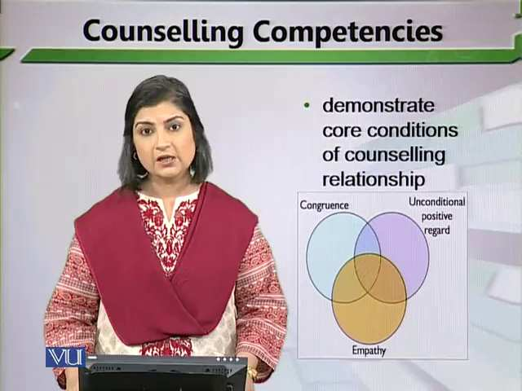
The development of empathy, unconditional positive regards and congruence is very important in relationship. It means that the counsellor should respect the counselee and listen his or her problems with genuine concern. And there should be a congruence in the counselling process.
Topic: 186 – Counselling Competencies – Counselling Relationship 2
Counsellor must employ:
- An eclectic and balanced approach:
The counsellor should move with an eclectic and balanced approach. It means that your knowledge about different theories, social context and problems of the students. Through this approach the counsellor can apply theories on the problems of the students. One formula and one size cannot fit on the problems.
- Range of individual and group counselling communication skills:
The counsellor and the counselee must demonstrate adequate communication skills. A teacher should have good relationship with the students by using good communication skills.

The counsellor and the counselee come and act in a very strange matrix where communication skills a very important role.
- Support students on varied issues:
The counsellor should mentally prepare to solve the different problems of the students.
- Identify and respond to their vulnerabilities, strengths, resilience and resources:
It the responsibility of the counsellor to know and response the weakness and strengths of the students. Teachers should understand the different behavior of the student.
Topic: 187 – Counselling Competencies – Counselling Relationship 3
Counsellors should:
- Help students change the focus of discourse:
In order to maintain a reasonable focus, it is important to tell the students to remain in a proper framework when they are discussing their problems. In this relationship building it is very important to set a framework.
- Have the confidence to challenge and get challenged:
The counsellor should have confidence. The counsellor should face the changes. The counsellor needs to be ready to face the challenges.

- Recognize and manage conflicts:
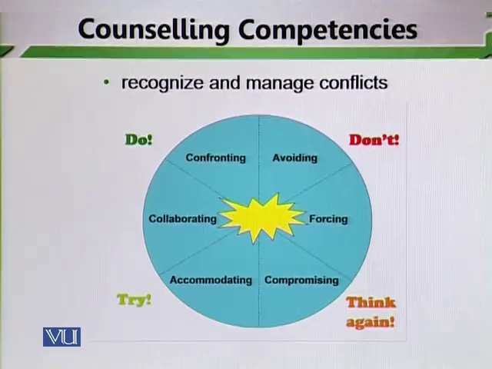
The counsellors should recognize and manage conflicts. Conflicts may be of six type and their strategies may also be of six type. For example:
- Avoiding
- Forcing
- Compromising
- Accommodating
- Collaborating
- confronting
Provide awareness of:
- Their unique social, cultural and economic circumstances
- Support them on emotional and behavioral issues
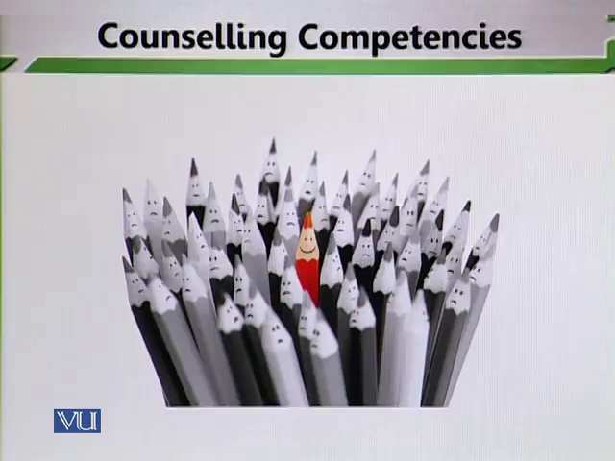
- Beware when losing ground and act appropriately
- Recognize when to conclude and facilitate effective closure process
Topic: 188 – Counselling Competencies – Counselling Skills 1
3. The Counselling Skills:
- Counselling mode must be based on a framework of counselling theory and development psychology. In counselling demonstration skills research base and proper psychological theoretical base are very important. On these bases you can apply any procedure.
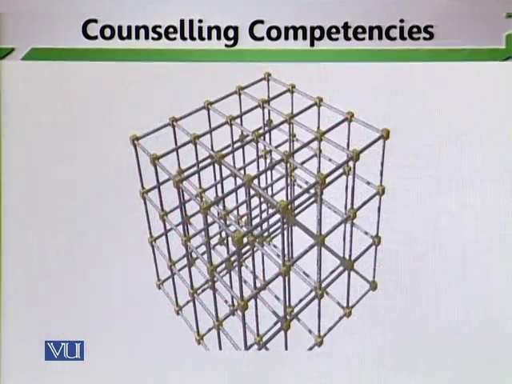
This becomes a strange phenomenon when you do not apply the psychological principles that you have studied and you take things at the surface level. These are complex procedures that need professional importance and professional knowledge base is extremely important in order to demonstrate these skills. You need to solve the problems of the students by applying those theories that you have been studied.

Counsellors should:
- Work within their level of skills and knowledge:
The counsellor cannot use the same type of skill to all students. Students operate at different levels. They are at different developmental level. They face different psychological problems. They come with different ambitions. The problems may be academic, psychological and also behavioral in nature. So, the first need is to analyze properly in light of psychological inputs that you have studied.
- Prioritize issues:
The counsellors must prioritize the things. If you do not prioritize things then you will not be able to operate in a systematic fashion. In order to solve in a systematic fashion, it becomes important to prioritize the things.
Topic: 189 – Counselling Competencies – Counselling Skills 2
Counsellor should:
- Monitor progress:
Progress monitoring is used to assess students' academic performance, to quantify a student rate of improvement or responsiveness to instruction, and to evaluate the effectiveness of instruction. Progress monitoring can be implemented with individual students or an entire class. The counsellor should design proper frameworks to monitor the progress of the students.
- Assist in development sense of awareness and self-worth:
It is the responsibility of the counsellor to raise the self-esteem of the students. A counsellor must see that the students are able to raise the self-worth.
- Assist them in dealing with conflicts:
The counsellors must prepare students to deal and manage the conflicts.
- Consider culturally relevant resources:
The counsellor should know the cultural relevant resources. He or she should know how to use cultural awareness to solve the problems of the students.
- Identify relevant community resources:
The counsellor should know how to use community resources. He or she can take help from elders to solve the problems of the students. In communities there some other people, there are some other valuable resources who can be utilized in order to solve the problems.
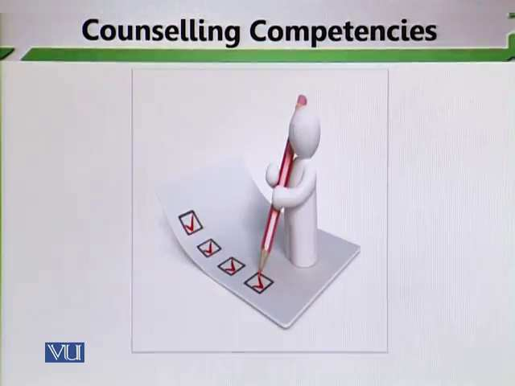
- Remain grounded in all circumstances:
The counsellor should remain grounded in all circumstances. It means that a counsellor should not come in front to confront the problems. The counsellor should take a back a back seat. The counsellor should work ads facilitators.
- Evaluate outcomes and practitioner’s role in process:
It is important to evaluate the performance. Evaluation again comes as a forceful activity. Evaluation of procedures is very important. The role of the practitioners and his or her evaluation about him and evaluation of procedures becomes very important.

Lesson 32
COMPETENCIES-PROFESSIONAL AND ETHICAL ATTITUDE AND PRACTICE
Topic: 190 – Competencies – Professional and Ethical attitude and Practice 1
4. Professional and ethical attitudes and practice.
- Recognize the professional responsibility:
The counsellor needs to genuine concern to the problem of the students and works to words to their solutions. Otherwise problems will prevail and they will never be able reach to the solutions. It is the responsibility of the counsellor to react professionally.
- Engage in ongoing supervision:
It means to analyze and monitor the counselling procedures. The counsellor should prepare framework, deadlines and meet counselee properly. The supervision is required for all these things. The counsellor needs to give ourselves time and monitor ourselves when he or she becomes counsellor so that the counsellor and counselee can enjoy the good relationships.
- Develop and implement methods to assess overall effectiveness:
The counsellor should judge the effectiveness of the counselling procedures. He or she should involve other stakeholders to assess the effectiveness of the counselling procedures.
- Be open to ongoing reflection and dialogue:
The counsellor should be open to going reflection and dialogue. Reflection is a very deep activity to do. It enables teachers, counsellors and students to reflect on different activities that they are engaged in. things should not take at surface level. Things are experienced, analyzed and then they e improved in the light of that analysis. The counsellor should improve the counselling procedures in the light of reflection and dialogues.
Topic: 191 - Competencies – Professional and Ethical attitudes and Practice 2
- Engage in ongoing professional development:
Professional development is a core thing which needs to be taken up by counsellors or teachers. A counsellor needs to be trained to solve the problems of the counselee. The counsellors should know about what is happening in the world and what research are going on in this particular field.
- Recognize own limitation and seek appropriate professional support:
The counsellor should recognize his or her limitations which are an acceptable thing and then seek for appropriator support.
- Differentiate the role of counsellor from other professionals while collaborating with others:
A counsellor differentiate himself or herself from others professions in the fields. The counsellor should collaborate with others in order to seek support and in order to solve the issues of the counselee.
- Be aware when it is appropriate to refer to more specialized professionals:
The counsellor should aware about specialized professions for the solution of the problems. These are ethical standards that need a bit of attention.
Topic: 192: - Competencies – Professional and Ethical attitude and Practice 3
Counsellors should:
- Establish secure, effective and ethical system of maintaining confidentiality:
The confidential measures should operate in a secure and effective manner. It means how security mechanisms are effectively used in schools. You cannot provide counselling in the classroom there should be a separate room for counselling. The counsellor should ensure discussion beyond the door. He or she should use security measures and follow ethical systems; he or she should not discuss the problems of the counselee with others. These are the defined frameworks that counsellors and teachers need to work.
It is also important for the counselee that he or she should not discuss with others. The confidentiality measure applies both on counsellors and counselee.
- Deal effectively with client crisis and emergency situation:
The teachers and counsellors should prepare to manage the crisis in the schools. Crisis management needs a bit of training.
Topic: 193 – Who Requires Counselling Services? 1
- Students with low motivation and unclear goals:
Students feel less motivated and they do not want to study. At the same time, they may have unclear goals. They do not know to what to do. There is a need of counselling services. In this teacher helps the students because he or she knows day to day development. It is very necessary to know the facts in which students feel less motivated. The reasons may be linked to the classroom or to the life of the students.
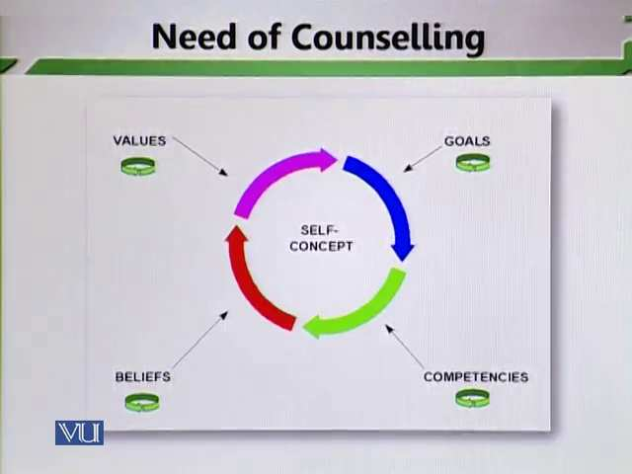
- Counselling helps in motivating such students and providing better self-understanding:
Counselling can help in motivating the students. Different strategies can be used to improve the self-understanding of the students. Self-concept is an important skill to have and ones the motivational level are enhanced the development of self-concept becomes easy. And then it gives raise to determinations of goals. At the same time, it also develops certain competencies in students. The belief and value system of the students becomes strong.
- Improved self-understanding facilitates adjustment to self and society:
It helps in the overall adjustment of the individual. When an individual is able to understand his or her value system and qualities then adjustment in social groups becomes very easy.
Topic: 194 – Who Requires Counselling Services? 2
Need of Counselling
- Students who need assistance in making proper choice of courses and career:
This area deals with vocational development. Some students face difficulty in choosing some courses career. The counselling services should provide to the students in choosing career. In some schools there is no concept about vocational development. The students face difficulties in their future about their career. The teachers should know the positive negative features of the students.
- Counselling develops readiness of choices and changes to face new challenges. With the help of counselling services students can choose their career.
- It also helps them in vocational development. From the primary grades the teachers should know the strengths and weakness of the students. They should the strong area of the students. All students have different strengths and weakness. Strengths need to be capitalized and worked on. So that students can make their subjects choices. It is the responsibility of the teachers that they should monitor systematically.
Topic: 195 – Who Require Counselling Services? 3
Need of Counselling
- Students who require guidance in dealing with adolescent issues and in facing life situations boldly:
The adolescent issues of the students require counselling services. In this student need emotional support. When students grow up and become adult then they find lot of difficulties in adjusting. They face lot of psychological turmoil and ashy are growing they need lot of support from other stakeholders that are round them. Teachers should be mentally prepared to face challenges when students arrived at particular stage.
Counselling helps them in their period of turmoil and confusion. Because at this stage some students think that they have become adult. Teacher and parents should make deeper connections and support with each other’s and then putting that child in a specific becomes easy. Teachers should identify the problems so that the solution of the problems becomes easy.
Topic: 196 – Who Requires Counselling Services? 4
- Gifted students:
This is another category of students who required counselling services. Gifted students are those students whose learning abilities are better than average students.
Gifted students need counselling services. There are different categories in gifted students for example some students are extremely good in the development of language patterns. They develop language faster than others. Some are good in mathematical abilities. They do much better than others in the classroom. Now what to do with these students because these students do their work earlier? These students will feel bore if you do not attend them properly. To manage these gifted students, it is the challenge of the teachers.
- These students may be gifted ones whose intellectual needs are not addressed adequately. If the intellectual needs of the students are not addressed properly then they can detract themselves. The negative behaviour can follow. We have to be very careful and imagine the dangerous that can happen if these students not put on track. First of the identification of gifted students is very important. Teachers should generalize the abilities of these students. Otherwise they can follow into self-depression. Gifted students can help other students in managing work. They can assist other low average and below average students in complete the tasks. Teachers can generalize their abilities in a better way. You can prepare extra worksheet for gifted students for more work and stay focused because lack of focused may result in different element and negativity also. This negativity then may be give raised to certain other classroom-based issues, classroom management being one of them. So teachers should aware of dangerous. The parents need to be knowledge about these abilities of gifted students.
Topic: 197 - Who Require Counselling Services? 5
Need of Counselling
- Shy or withdrawn Students
These students are usually very shy and they do not participate in class discussions, shy of from work and at the same time they are poor participants in peer and group work also. Their identification is easy for the teachers. The teacher needs to work for these students
- These students find it difficult to interact with others. For them interaction is a big problem. The teachers and counsellors need to find out the cause of shines. These students are not aware about their capabilities. They do not understand themselves well then, they keep drawing from classroom procedures. The teacher should let them, be there and use different strategies.
- Counselling can reduce their sense of insecurity and discomfort in social situations. The friends of shy or withdrawn students can play an important role. And proper counselling procedures can be used.

Lesson 33
WHO REQUIRES COUNSELLING SERVICES?
Topic: 198 – Who Requires Counselling Services? 6
Need of Counselling
- Students having school phobias or separation anxiety
These students have certain kind of phobia and separation anxiety. For example, going to school is an anxiety situation. Sometimes they disturb from school building. In order to work on these phobias, counselling procedures needs to be in place.
- If this phobia or anxiety is not treated appropriately, it can lead towards drug usage or other anti-social behaviors. Some students fear about exams. They may be extremely good in the different subjects’ areas but when they enter in exam or when they sit in exam situation, they make lot of mistakes. Some students do not like some personalities and they develop phobia. These phobias lead to the psychological and behavioral disorders. The issues need to be solved out. Teachers and parents’ collaboration are very important. Teachers should not ignore this type of students. Because this type of students can become victim of extremely behavioral disorders. For example, they can resolve to drugs and they can resolve to big anti-social activities. Because their anxieties were not addressed in their very young. They feel defeated and uncared for. This is an element that we need to address. We need to take care for those students which are anxiety producing for those students. The schools should be safe for students and they should be very pleasing places for the students as well as for the other stakeholders.
Topic: 199 – Who Requires Counselling Services? 7
Need of counselling
- Students with family problems
In providing counselling to this type of students the teachers should look for two types of perspectives.
- Classroom perspective
- Domestics perspective
First of all the teachers should know classroom perspective. If the classroom perspective of the student is good, clean and clear then he or she should look for domestic’s perspective. To know the domestics perspective of the student is very necessary. It is the responsibility of the teachers to report specific problems of the students. Some students do not give proper attention to their studies and their social interactions become problematic. Family problems of the students may be of different types.
Those who:
- Belong to a broken family
- Experience unfriendly and unsupportive home environment
Parents should behave all children equally and continue the relationship in a balance way. If parents do not give friendly and supportive environment the problems may be cope up which directly affect the education of the students. Here the role of counsellor and teacher is very important. First of all the teacher should identify the problems and report the problem on time. When the problem report on time then it becomes easy for the teacher to diagnose the problem and solve the problem. Teachers can manage parents’ meetings to give awareness to the parents because the problems are connected with home.
Students need special attention and support for handling tough situation.
Topic: 200 - Who Requires Counselling Services? 8
8. Bereavement and loss situations
Almost every person in the world, at one time or another, experiences events that can be considered major losses (Harvey and Weber 1998). A loss occurs when an event is perceived to be negative by individuals involved, and it results in long-term changes in one's social situations, relationships, or way of viewing the world and oneself.
- Loss or Death of closed one leaves bad impact on one’s personality
Some students go in isolation which means they do not talk to anybody less. They remain quiet and they strict to themselves. On contrary some students became very aggressive. They fight with others and insult others. They do not have coping mechanisms to stay calm in the school. A teacher needs to attend such children.
If not handled carefully, these traumas can lead to serious psychological problems.
Topic: 201 – Who Requires Counselling Services? 9
Need of Counselling
- Indiscipline Students
These students not only create problems in the classroom but they actually effect the smooth functioning of classroom teaching and learning.
Those students who lack sense of:
- Direction
They lack direction. This type of students does not know where and how to focus.
- Purpose
They do not have any purpose in their life. They work in a purposeless fashion and that is why they make problems in the classroom.
- Fulfillment
They do not have sense of fulfillment. Which basically means that they are always angry about something? They always want more things but still they are not satisfied.
Often indulge in destructive activities. They can actually involve in maladaptive activities and become bully. They need proper attention because they act different. Indiscipline is a big classroom management issue and if it is not resolve at proper level then it becomes highly problematic for teacher to conduct their class lessons. To deal with parents and their feedback is very important. Some parents create problems for the teachers when they do not develop the personality of their children in balance manner.
Counselling can be very useful to alter maladaptive behaviour.
Topic: 202 – Who Requires Counselling Services? 10
Need of Counselling
10. Students facing bully-ism and harassment:
Bullying is the use of force, threat, or coercion to abuse, intimidate, or aggressively dominate others. The behavior is often repeated and habitual. One essential prerequisite is the perception, by the bully or by others, of an imbalance of social or physical power, which distinguishes bullying from conflict.
This type of students faces difficulties from bullies. The effects are also signing that kids may exhibit when being abused by bullies. Kids who are bullied can lose interest in school. They may suffer physical injuries and mental health issues. They may suffer depression and anxiety.
These behaviours damage students’ personality by:
- Lowering their self-esteem:
They do not feel good about themselves. They feel that they do not have the required capabilities to co-exist with other peoples. And this can affect their teaching and learning:
- Shaking their confidence:
This behaviour must be identified.
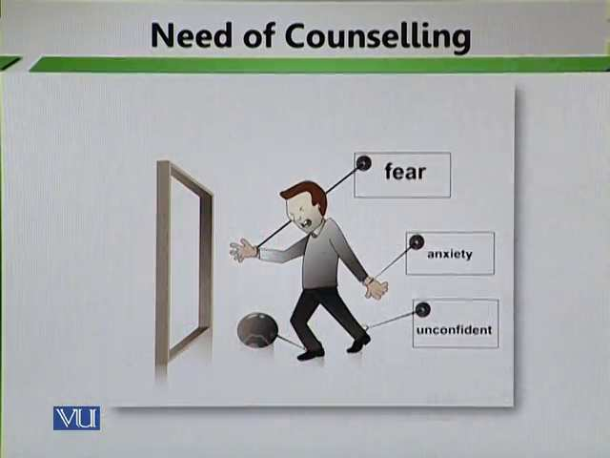
Teachers should inform the bully that this behavior is negative. He or she should give support to the victim because victim feels fear, anxiety and unconfident.
They must learn how to tackle such situations. The teachers can work with counsellors and parents.
Topic: 203 – Who Requires Counselling Service? 11
Need of counselling
There is another category of student who may require counselling services.
11. Students who require special educational needs:


It has different categories:
- Backward or handicapped students:
For students with physical handicaps, self-image is extremely important. Teachers need to ensure that the child's self-image is positive. Physically handicapped students are aware of the fact that they are physically different that most others and that there are certain things they cannot do. Peers can be cruel to other children with physical handicaps and become involved in teasing, casting insulting remarks and excluding physically handicapped children from games and group type activities. Physically handicapped children want to succeed and participate as much as they can and this needs to be encouraged and fostered by the teacher. The focus needs to be on what the child CAN do - not can't do. Backward students are those who belong to specific society. They also need proper attention of teacher.
- Those learning with difficulties:
Some students face specific learning difficulties. Learning difficulties may be subject base or general. There are some learning difficulties:
- Dyscalculia
- Dysgraphia
- Dyslexia
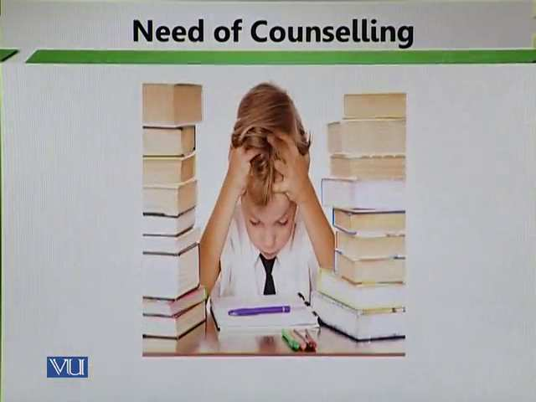
For such students you need to design some specific programs. If specific programs are not developed then these students might face a lot of problems. For example, these students can draw themselves away from education. These students can fall into depression and then these students may become aggressive also.
- They require special attention and opportunities. Teachers should show their sensitivity.
Topic: 204 – Who Requires Counselling Services? 12
Need of Counselling
12. Students who need guidance about spending their leisure time.
They do not know that how they spend their time. They need guidance in how to meaningfully spend their life. Today's children are busy, and when a child enters middle school schedules can get even busier. But free time is important for children, especially as they enter puberty and adolescence. While too much free time can become problematic, it's important for parents to make sure that their tween has a balance between scheduled activities and time for him or her.
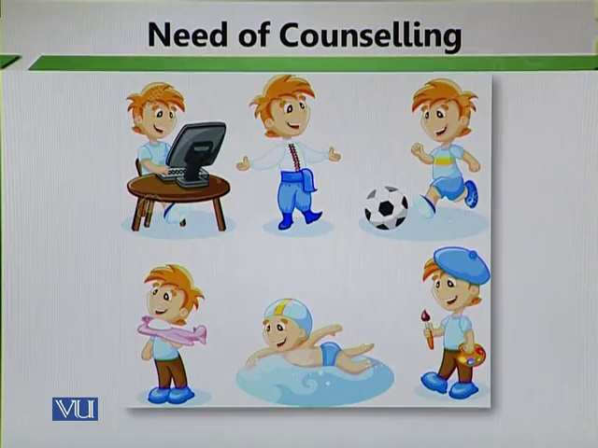
Teachers and parents should look for leisure activities of children. Internet is a good source for information to educate the students but internet can become a dangerous source for students where students can actually detract themselves very easily.

The basic element in leisure is of sports. Teachers should know that how much time students spend in sports. The chief object of sports is, of course, bodily exercise. It is a famous quote, “A sound body has a sound mind”. The health of the body is essential for success in life. An unhealthy man always feels weakness, thus losing confidence and hence become very dull and in active. To keep healthy, one must take an active interest in sports and games. Thus, sports and games serve an essential purpose in life because they ensure good health and build a fine physique. If one is bodily fit, one feels capable of hard endeavor and life without endeavor s useless.
- Non-class hours have a strong influence on student’s success in achieving both, academic and personal competence. Teachers and parents should manage timetable for students. Students need to be active. They need to engage in themselves in healthy activities. So that they can stay focus on their academics also. When we say healthy activities that basically means proper social interaction, sports activities and enhancement of general knowledge. These are some healthy activities that students can engage in and if they engage in these good activities and spend their leisure time meaningfully then it directly impacts their personality, academic journey, facilitates learning and teaching learning becomes easy. It not only becomes easy it actually compliments the different processes that a student is involved in. so teachers and other stakeholders must educate students of how to spend their leisure time in a meaningful manner.

Lesson 34
PROBLEM SOLVING THERAPY-INTRODUCTION
Topic: 205 - Problems-Solving Therapy – Introduction
- Problem-solving therapy refers to a psychological treatment that helps to teach you to effectively manage the negative effects of stressful events that can occur in life.
- PST is a cognitive-behavioral intervention to improve an individual’s ability to cope with stressful situations. This process in self-directed, conscious, effortful, cogent, and focused.

- With the long-term solutions, students deeply analyze their own issues and problems. They find the causes of their issues or problems and then act in an appropriate manner.
- PST is a positive and goal-oriented approach of solving problems.
Topic: 206 – Problem - Solving Therapy – Significance
- Problem solving is an essential skill for all employees, supported and led by leadership and it is possible to hone your ability to solve problems and make your business run more effectively and, therefore, provide the foundation and framework for continual improvement.
PST assists individuals to:
- Adopt a realistically optimist view of coping:
This therapy helps in building confidence level of the students. This is very useful for students with low esteem or low efficacy because its purpose is to enhance the element of positivity among individuals. It makes and gives them an optimist purpose of life.

- Effectively understand emotions:
With the help of this therapy students can cope with their emotions. It means that students should be able to understand their emotions. Sometimes students find it very difficult to cope with certain realities and they do not have the positive and required emotional capabilities to deal with different situations. Through this therapy students know first of all how to optimistically deal with issues and secondly how to balanced out the emotional behaviours.
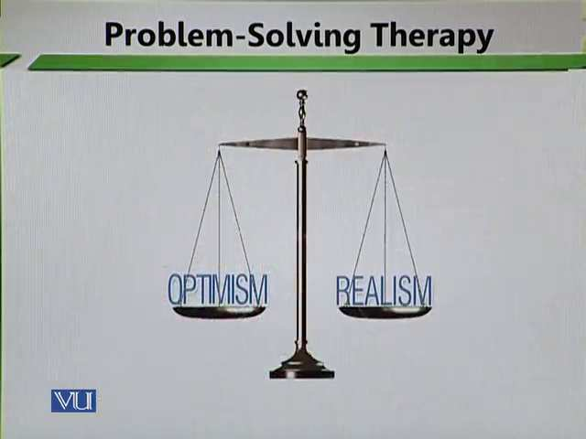
In these two things are very important:
- Optimistic view of life
We teach those positive behaviours through which students solve their problems.
- Realistic view of life
- We lead them to the realism. We tell them how to cope with emotions. Optimism and realism are two copping mechanism that are developed by virtue of practicing this therapy.
- Creatively develop an action plan:
Through problem solving therapy, we prepare students to make action plans for them. We teach students to make improvement in themselves step by step.
- Enhance overall well-being:
With the help of this therapy students feel good about themselves because they are in charge of their lives. They are made to take charge of their lives and they are made to feel important enough to solve their issues. That is way problem solving is very important.

Topic: 207 – Steps in Problem – Solving Therapy
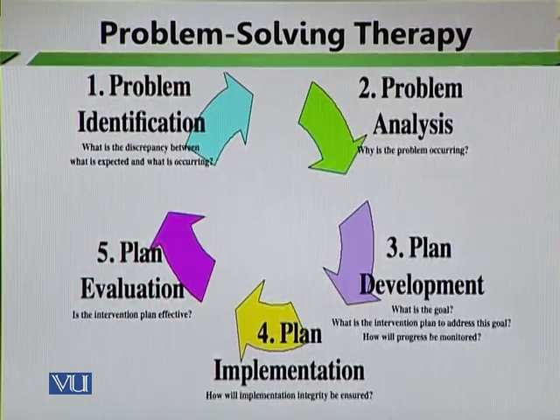
PST assists the students in:
- Identifying problems
- Coming up with all possible solutions
- Selecting the best one
- Developing and implementing an action plan
- Assessing the efficacy of the process
Topic: 208 – Problem – Solving Therapy – Problem Orientation 1
Problem Orientation is defined as the schemas one holds about problems in everyday life and one’s assessment of their ability to solve said problems. The Problem Orientation may be positive and constructive to the problem-solving process or negative and therefore dysfunctional in the process.
Problem orientation means a student’s attitude towards solving a problem.
Problem orientation has two elements:
- Student’s thoughts and feelings about problems:

Sometimes students feel very heavy about their issues and problems. They attach lot feelings towards their issues. They have specific thoughts and feeling about their issues and problems. They face many difficulties. They become hesitate and their defense mechanisms become weak. For example, they may not be able to give appropriate attention to their academics. They may feel heavily sensitive about their issues. Here they need proper help.
- Their thoughts and feelings about their own ability to solve problems:
It is very important to give awareness to students about their abilities. Sometimes do not have the required ability to solve their problems. It is very necessary to develop proper feedback.
Topic: 209 – Problem- Solving Therapy – Problem Orientation 2
Positive orientation is linked to a rational and effective problem-solving style.
Rational problem-solving style – the extent to which an individual approaches a problem in a systematic, planful, organized manner is likely to impact on how effectively they can solve a problem (Nezu et al. 2001). This will be largely dependent on inbuilt personality characteristics, but individuals may also be able to learn to behave in this rational way when required though it won’t come as easily as if it would if part of their personality make-up.
Effective problem solving does take some time and attention more of the latter than the former. But less time and attention than is required by a problem not well solved. What it really takes is a willingness to slow down. A problem is like a curve in the road. Take it right and you'll find yourself in good shape for the straightaway that follows. Take it too fast and you may not be in as good shape.
Sometime students deal problems rationally and effectively. They have the defined proper coping mechanisms which they firth with their issues. However, there are some students who are unable to do so. When we talk about the problem orientation then sometimes, we need to look at the rational and effective ways in which problems are solved and problems are looked at.
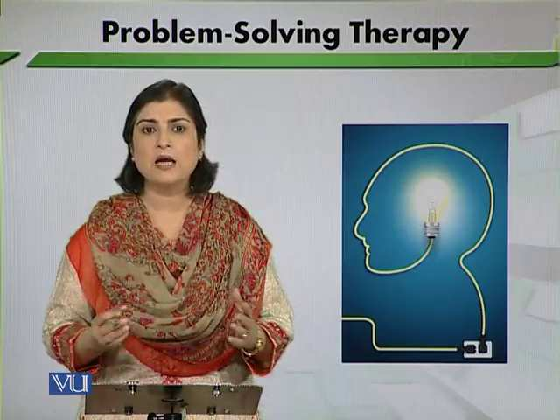
We have discussed above about those students who can deal problems rationally and effectively. They can identify and find the solution of their problems by their own abilities.
Negative problem orientation is linked with either impulsive/careless style.
On contrary, there are some students who cannot do so. These students go in negativity. They become depressed and disturb other students. When you have negative attitudes towards your problems then you act in an impulsive manner and you may act carelessly. Because of your own behavior you may disturb the existence of others around you. In this teachers’ intervention and counsellors’ intervention becomes very important because these are those students who cannot solve their problems by their own abilities. They need help and therapy. Parents can help them.
…or an avoidance style
Some students believe on avoidance principles. They avoid the problems. This is something that need attention. By avoiding the problems, you cannot solve your problems. These students need proper help of teachers and parents.
Topic: 210 – Problem-Solving Therapy – Problem Orientation 3
The aim of problem-solving therapy is to develop more positive orientation
It is the responsibility of the counsellor to give positive orientation to the students. If a teacher is working as a counsellor then it is his or her responsibility to help students in developing positive attitudes. There has to be positivity attached when it comes to coping with problems. When we cope with problems with negative attitudes and think that problems can never be solved because they may give frustration and may be very frustrating then negativity brings down the element further and it can land students in further disappear.

For this purpose, a student is provided with:
- Relevant knowledge
- Assistance for recognizing their attitudes
- Training for challenging negative attitudes
- Encouragement for improving their self-efficacy/belief

Lesson 35
PROBLEM SOLVING-IDENTIFYING PROBLEMS
Topic: 211 – Problem-Solving Therapy – Identify Problems
Student is taught how to recognize an existing problem. Sometimes students are unable to recognize their problems. A teacher should teach the students that how to recognize the problems.
There are three parts to this step:
- Positive list
Inviting to spontaneously report the problem:
The problem should report on time. Do not think deeply.
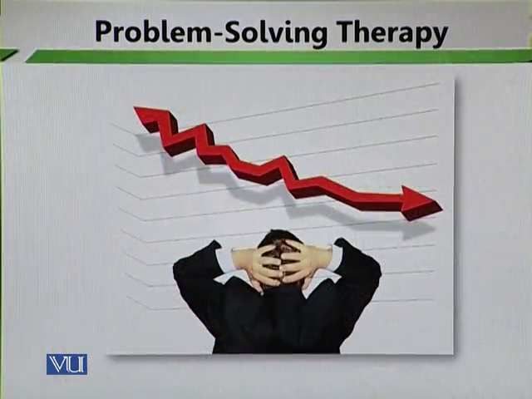
Normally when students face the problems, they keep thinking about it. They think weather to report it, not to report it, ignore it, and avoid it what to do. But according to the problem-solving therapy when an issue crops up it must be reported immediately.
- Recognizing & identifying problem worksheet
Tracking problem indicators:
We need to track down a problem worksheet. Which basically means that we need to see why the problem has occurred and what the systematic procedures that can be follow to track down the problem?

- Problem checklist
Using checklist:
After developing the procedure, there is a need to make checklist. Checklist basically helps you and it basically gives not only a timeline to what you are saying it also gives a proper direction to the solution of the problem. Good checklists are precise. They are efficient, to the point, and easy to use even in the most difficult situations. They do no try to spell out everything–a checklist cannot fly a plane. Instead, they provide reminders of only the most critical and important steps–the ones that even the highly skilled professionals using them could miss. Good checklists are, above all, practical.
Topic: 212 – Problem-Solving Therapy – Selecting & Defining a Clear Problem
- At this step, a student is provided with the assistance for selecting one clear problem to work on. Students need a lot of guidance and support in not only the identification of the problem but the proper identification of the problem. Students need to identify the right kind of the problem and they need to prioritize the problems. First of all, students need to explain what their problems are and then they need to prioritize them.
- Which problem stands at the top and which problems can wait for some time? For example, if the student is facing problems in mathematics which affects his or her grades and he or she cannot understand the next unit, which is a problem that needs an immediate solution. The same student cannot utilize his or her problem in a proper manner and he or she feels frustrated so that problem can be worked out later on. The foremost problem is that a child needs to do something with the mathematical skills which is not enabling them to secure well and not understand some basic mathematical concepts so prioritizing is something that needs to be practice with students. They need to first explain the problems and after that they to define and gather data.
- Then they are asked to define it by gathering all facts and writing them objectively. They need to first explain the problems and after that they to define and gather data. We need to tell students of how to gather data about their specific problems. The data needs to be gathered. Information needs to be collected from various resources and when information is collected from various resources then teachers and counsellors are better able to decide for a problem.
Topic: 213 – Problem-Solving Therapy – Generating Solution
- Students are now asked to brainstorm to identify possible solution. This is a kind of non-directional therapy. It is not counsellor and teacher centered approach. In this student play an active role. They explain their problems and find the solution of the problem by using their abilities. The role of the teacher or the counsellor is to facilitate the students. They enable students to think independently encourage them to brainstorm ideas. They try to prioritize the things.
- They need to sort out and prioritize issues. They need to put a cross on those ideas that can wait and that are irrelevant. The relevant ideas are ticked and they are pushed to the top.
- It will help them to consider all possibilities and alternative solutions. Students are not puppet in the hand of the teacher or the counsellor. The teacher or the counsellor should guide and give support to the students but they should not take decision about the issues or the problems of the students because the student knows his or her local context best. The counsellor and the teacher may not know the significance context from which the student has come. A student is better able to analyze issues because his or her specific context. Thereby he or she better able to find workable solutions.
Topic: 214 – Problem-Solving Therapy – Decision Making
- This step requires in-depth analysis of all possible solutions, weighing up advantages and disadvantages. As a society we need to push the things under the carpet. We do not talk about issues. We normally tell children that this not a require thing to do. Portents and teachers tell children that decision is not possible. When decision is not possible then how will things be analyzed and how will change positive come. We need to understand that when we work towards solutions, we need to educate our students to work towards solution in very dispassionate manner which basically means that if they think that this solution is the best solution then they have to weigh the pros and cons to that solution.
- Counsellor assists in decision making through teaching initial selection and grouping solution techniques. The counsellor should play a supportive role.
Topic: 215 – Problem-Solving Therapy – Creating & Implementing a SMART Action Plan
- Student is asked to outline the step by step process to carry out their chosen solution. A student is required to do this and manage it on his or her own which basically means that the student is encouraged to construct an action plan that can be implemented and then given to the student so that the student can work on it. The student is encouraged to develop an action plan by following a step by step procedure. For example, he or she is unable to manage his or her anger then what action plan can be made. First of it is important to identify the problem which is the inability to manage anger because of this problem there are other students who are suffering. It also is a frustrating experience for the student because the student knows that it is a negative behavior manifestation. He or she needs to work on this. The counsellor guides the student of how to make an action plan.
- Action plan must be broken down into small achievable steps. You need to move simple to complex procedures and see the advantages and disadvantages. The first action plan that you may want to take is to manifest tolerance and patience. You need to listen to people, develop listening mechanisms and have good listening skills. This is the one action or step that you will follow.
Topic: 216 – Problem- Solving Therapy – Reviewing Progress
Final step is to review the progress:
The final stage in problem solving therapy is to review the progress that a particular student is making with regards to his or her problem. In this a systematic review is very necessary.
The purpose is to evaluate:
- The desired impact
- The need for improvement in plan
- Further development areas in student’s problem-solving skills

Lesson 36
REFERRAL IN CASE OF SEVERE BEHAVIOURAL PROBLEMS- INTRODUCTION
Topic: 217 – Referral in case of Severe Behavioral Problems – Introduction
Sometimes teacher cannot solve the problems of the students. Some issues or problems need specialized help. Teachers need to connect with specialist to solve the problems of the students.
In case of severe behavioral issues, request a specialist for:
- Investigation
- Opinion
- Treatment/solution
- Management
The schools must have referral forms so that behavior can be identified.
COUNSELLING REFERRAL FORM
STUDENT NAME: --------------------------------------------------------------
GRADE: ----------------------------------------------------------------------------
TEACHER: -------------------------------------------------------------------------
REASON FOR REFERRAL: ---------------------------------------------------
------------------------------------------------------------------------------------------------------------------------------------------------------------------------------------------------------------------
BEST TIMES: TO MEET WITH STUDENT----------------------------------------------
(TEACHERS ONLY):
NAME: ----------------- Date: -----------------------------
Referral is made by an authorized person. Pepper documentation is extremely important.

Topic: 218 - Referral for Severe Behavioral Problems – Significance
- Referrals are required when a student is at risk of significance harm. It is extremely important to attend the smaller issues right in the very beginning. When we ignore these issues or problems then these issue or problems become complicated.
- When you feel that a student is at significant harm, a student will harm himself or she or others then you must need specialized help. That is why it is very important. You need to see that why a student is at risk.
- Referral provides the students with the opportunity to discuss their concerns with a qualified person. Students must be provided this opportunity that they raise and voice out their concerns before others so that issues can be resolved timely.
- The qualified persons need to be very empathetic towards the students and move strategically towards the solutions. The specialist needs to listen the concerns of the student very carefully because if you listen to students with lot of attention and care then students will definitely voice out their concerns.
Topic: 219 – Referral for Behavioral Problems – Needs Assessment 1
The most common problem that requires referral is conduct disorder. The problem crops up when a student does not meet desire standard. Need assessment help teachers to solve the problems of the students? Code of conduct is very important. Do you have a specific line against which you mark the behaviour of the students? If you say that students have accede limits then they needed referral. And then for that need assessment is required.
Conduct disorder is comprised of repetitive and persistent patterns of:
- Anti-social behaviour
If a student is involving in anti-social behaviour that is a case of referral.
- Aggression
If a student’s is exhibiting extreme aggression that student needs referral.
- Defiance
It means students refuse to follow rules, abide by certain rules, they defiance them and they say no.
Significant and persistent violation of age appropriate social expectations indicates need of referral.

Topic: 220 – Referral for Severe Behavioral – Need Assessment 2
Behavioral difficulties usually indicate some other underlying problems.
Referral is needed when a student:
- Have co-morbid symptoms that require special intervention. For example, students may face:
- Depression
- OCD
- Autistic spectrum disorders
- Anxiety
- ADHA
- Bipolar
- Social responsiveness is poor
- Unusual repetitive is observed
- Suicidal or self-harm is suspected
- Learning difficulties are seen
- Low-self-esteem and anxiety is developed
- Developmental progression is delayed or uneven.
Topic: 221 - Referral for Severe Behavioral Problems – Needs
Very few numbers of emotionally disturbed students are lucky enough to receive any treatment, even in developed countries. There are few students who find the proper treatment and even if they do that treatment may be at a very surface level.
Unfortunately, our country does not adequately support a national policy for child mental health. Even if the policies are in place they are not practiced. They are not practiced in either the public or the private school systems. Students feel problem in their social and academic issues. We need to work on it. Adequate policies should be developed on national level so that the students can acquire the referral on proper time. It is our responsibility as a school, teacher, counsellor and other stakeholder to look and talk on the following wellness wheel:
- Intellectual
- Social
- Physical
- Spiritual
- Occupational
- Emotional
- Environmental
We should follow the all above wellness. The development should be in a positive manner. If the student is remaining untreated then they become dysfunctional adult later on. Untreated children with behaviour disorder may grow up to be dysfunctional adults.
Topic: 222 – Referral for Severe Behavioral Problems – Where to get help?
If we consider that referral system is extremely important for students and we find it as a way to reform problem behaviors than where we can find this help from. There are many sources from we can get help. These are the following sources where we can get help:
- School
The school is the f first sources. Teacher should be trained to identify and solve the problems.
- Child psychologist
If teachers cannot solve the problem of the student. They can prefer child psychologist. There are some students who need psychological treatment. They face depression and anxiety. It is very necessary to give them specialized help. Child psychologist is medical doctor. He or she has excelled about particular field. He or she knows how to deal with such severe cases.
- Pediatrician
A pediatrician is medical doctor who manages the physical, behavioral, and mental health of children from birth until age 21. A pediatrician is trained to diagnose and treat a broad range of childhood illnesses from minor health problems to serious diseases.
Pediatricians have graduated from medical school and completed a three-year residency program in pediatrics.
A pediatrician is a child's physician who provides: preventive health maintenance for healthy children. medical care for children who are acutely or chronically ill. Pediatricians manage the physical, mental, and emotional well-being of their patients, in every stage of development -- in good health or in illness.

Lesson 37
REFERRAL FOR SEVERE BEHAVIOURAL PROBLEMS-EFFECTIVE REFERRAL 1
Topic: 223 – Referral Severe Behavioral Problem - Effective Referral 1
Referral provides the opportunity to address student’s unmet needs. Sometime student does not focus and understand them. They do not have information and awareness about themselves. This lake of information basically makes them indulge in maladaptive behaviours.
For effective referral, collaboration is the key. Collaboration among teachers and parents is very important.
Parents Education
Parents should be taught how to communicate and manage such children. They belong to different backgrounds and socio-economic status. They also have different level instinctual behavioral development patterns. If parents are taken on board then it becomes easy for the referrals to become effective also.
Topic: 224 – Referral for Severe Behavioral Problem – Effective Referral 2
Family therapy
Entire family is assisted in improving communication and problem-solving skills. We should help parents in communication and problem- solving skills. Some parents do not communicate well with their children. They do not have communication skills with them. Some parents especially fathers hardly talk to their children. It is very important that parents and children have good relations.
Teachers’ cooperation in this regard is also essential. A teacher must cooperate with the students because there has to be very firm bounding between a teacher and a student. A student must find it extremely continent to talk to the teacher about the problems. A teacher should think that it is his or her responsibility to look into the problems of the students. Only then healthy teaching and learning can be proceeding in the school.
Educational psychologist and occupational therapist: and in some cases, speech therapist and physiotherapists may also need to assist. They can put their acts together and they can help students who may be facing specialized issues.

Topic: 225 - Referral for Severe Behavioral Problems – Barriers to Collaboration
Taking responsibility
Presence of multiple professionals may cause the issue of taking credit for the success? Who takes responsibility for what? All the stakeholders should feel this responsibility. When we talk of education, we talk of education for all. When everyone does not take the responsibility then the solution of the problem becomes difficult. One has to see what the problem is and according to one has to feel the responsibility to solve the problems of the students.
Structural Barriers
Do school policies support such interventions? If there are no policies then it becomes highly problematic of how to designate the problem and who does what. So, when the policies are in place then it becomes extremely easy to go in a systematic manner to solve the problem.
Confidentiality issue may also hinder collaboration. Joint training can solve this issue. if stake holders are unable to keep thinks to themselves then it shows a degree of un professionalism.
Topic: 226 - Referral for Severe Behavioral Problems – Major Behaviour Problem 1
Oppositional defiant disorder (ODD)
This ODD means that students refuse to abide within specific boundaries. These students define in their behaviours. Boys outnumber girls in this disorder by two to one. Means boys face these disorders then girls.
When we talk about ODD there are different kinds of behaviours. It includes the following:
- Frequent temper tantrums
- Display of easy annoyance
- Refusal to obey rules
- Deliberate attempt to annoy others
- Low self-esteem
- Blame transfer on others for misfortune or misdeed

Topic: 227 – Referral for Behavioral Problem – Major Behaviour Problem 2
Conduct disorder (CD)
"Conduct disorder" refers to a group of behavioral and emotional problems in youngsters. Children and adolescents with this disorder have great difficulty following rules and behaving in a socially acceptable way. They are often viewed by other children, adults and social agencies as "bad" or delinquent, rather than mentally ill. Many factors may contribute to a child developing conduct disorder, including brain damage, child abuse or neglect, genetic vulnerability, school failure, and traumatic life experiences.
This includes:
- Refusal to obey
- Repeated truancy
- Lack of empathy
- Tendency of drug usage at very young age
- Sadistic behavior
- Keenness for physical fights
- Frequently lying
- Criminal behavior like stealing, deliberately lighting fire etc.
- Tendency to run away from home
- Suicidal tendencies
Teachers should identify these behaviours properly and work on these behaviours. With the help of referral system teachers can help the students.
Topic: 228 – Referral for severe Behaviour Problem - Major Behaviour Problems 3
Attention deficit hyperactivity disorder (ADHD)
Attention deficit hyperactivity disorder (ADHD) is one of the most common childhood disorders and can continue through adolescence and adulthood. Symptoms include difficulty staying focused and paying attention, difficulty controlling behavior, and hyperactivity (over-activity).
ADHA includes:
- Inattention
- Impulsivity
- Hyperactivity
There are some common traits among different behavior disorder. These problem behavior needs to be properly identified.
Correct identification and appropriate treatment is essential. We need to identify these behaviours and work with them by remaining in a proper framework. And refer to these cases to proper people if want these students to have a meaningful life.

Lesson 38
SCHOOL-WIDE GUIDANCE AND COUNSELLING
Topic: 229 – School- Wide Guidance & Counselling
Challenges for Guidance & counselling in School
- Early years of schooling requires development and preventive counselling rather than remedial. The teachers need to fully understand the different psychological issues that may happen with students. On one hand they need to be very good as far as their content and methodological knowledge is concerned. The teachers should aware about those behaviours and development patterns. When a student is getting a maximum kind of attention in school and at home then a student will not demonstrate maladaptive behaviours unless in some otherwise situation. We need to have very comprehensive view of schooling.
- With adequate facilities, effective counselling can have a lasting effect on a student’s personality. It is very necessary to give better facilities in the schools. Effective counselling should be done on a proper time. That comes and emerges as a big challenge in order for the successful implementation of guidance and counselling programs.
- We do not provide adequate facilities in schools for guidance and counselling programs to flourish and on the other we are not watchful as far as the different developmental patterns of students are concern. We only act when there is a problem. We only act when a problem crops up and becomes a mega problem. So should not let the problem to get negative. We should always look towards the positivity of and let not the problem happen. The challenge is that we do not realize importance of guidance and counselling
Topic: 230 - Challenges for Guidance & Counselling in School- Internal Challenges
Internal challenges
- Teacher’s attitude towards counselling
Teachers sometimes refuse to act as counsellors. Their attitudes are a problem. They do not take the responsibility of guidance and counselling. They do not realize that they have mega role play in human child. A teacher needs to have good counselling skills so that small day to day problems of the students can be handling appropriately. A teacher can be a best guide for the student.
- Pupil’s willingness to seek counselling
Sometime students do not think that they require counselling. They are so overconfident on their own skills and own behaviours. They do not realize that they may need counselling.

Topic: 231 – Challenges for Guidance & Counselling in School – External Challenges
External Challenge
1. Socio-economic issues beyond the school e.g.:
- popular culture
What is the popular culture of a present age that directly affects the personality of students? Popular culture can shape the personality of a child. It can be a conflicting situation when the environment outside is different from the environment that the child sees at home. This conflict sometimes can result in problem behaviours.
- Globalization
Globalization is a process of interaction and integration among the people, companies, and governments of different nations, a process driven by international trade and investment and aided by information technology. This process has effects on the environment, on culture, on political systems, on economic development and prosperity, and on human physical well-being in societies around the world. The student may feel difficulties to adjust with this popular culture and globalization.
2. Social trends of people moving abroad
When students migrate then they can face adjustment problems. The school should collect the information of different places.

Lesson 39
CHALLENGES FOR GUIDANCE AND COUNSELLING IN SCHOOL SYSTEM-SYSTEM CHALLENGES
Topic: 232 – Challenges for Guidance & Counselling in School – System Challenges
System challenges
- This challenge is related to school system.
Issues within the guidance program like:
- Law establishing its practice in schools. The system can become a problem in the establishment of guidance and counselling services in school.
- Do we have proper referral procedures in school or not? This may become a big challenge.
- The schools do not have human resource planning and structural services in the school system. The school does not have proper offices and furniture in providing guidance and counselling services. The schools must have appropriate resource planning.
- It is very necessary to use your resource:
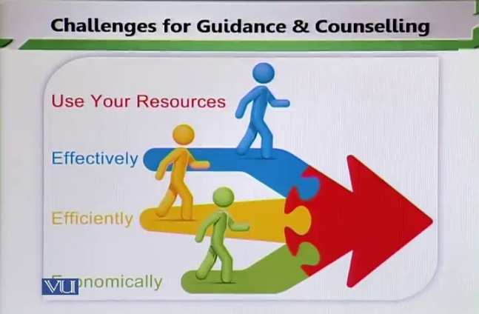
- Effectively
- Efficiently
- Economically

Topic: 233 – Challenges for Guidance & Counselling in School – Personal Challenges
Personal challenges
- Counselor’s skills and techniques:
If counselors have not appropriate skills and techniques then it will become for a counselor to judge the problems or issues of the students. The counselors easily label students that he or she is weak in reading or writing without knowledge.
- Training:
It means what kind of professional development has happened in the past with you. It is very necessary to look into your training factors. You need to be very smart in updating your knowledge.
- Supervision:
You need to be professional trained in to supervise students. If you are properly trained and if you know how supervise students very well then you will investigate the problem in a much more professional manner.
- Attitude towards school system
Your attitudes towards school system are very important. It means your perception about school system. Your perceptions should be positive so that guidance and counselling procedure becomes easy.
Topic: 234 – Challenges for Guidance & Counselling in School – Organizational Theory 1
Organizational Theory
This theory may help us in understanding challenges for guidance and counselling in school.
- In any school we look that how effectively and efficiently an organization is achieving intended goals. Organizational theorist basically sees how well an organization is meeting its goals to implement certain programs. Through this theory we can meet our targets effectively and efficiently and successfully implement guidance and counselling in the school.
- School counselling (in most of cases) is seen as inconsistent and fragmented due to lack of
- Planning
- Accountability
- Evaluation
Organizational theory effectively analysis and institution in the above three categories. It looks at the planning part and it sees how well a program¾’ is planned and then how will it implement, what are accountability features and lastly it sees how well a program is evaluated in the school.
Topic: 235 – Challenge for Guidance & Counselling in School – Organizational Theory 2
Organizational challenges can be addressed in 2 ways
- Program evaluation
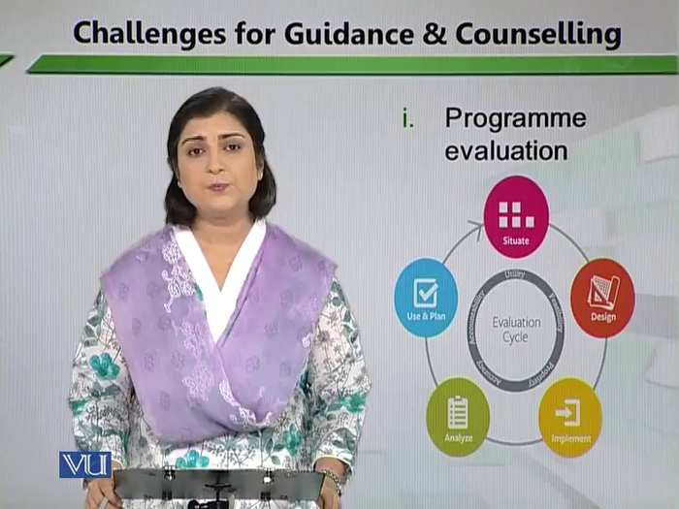
It means that the periodic evaluation and assessment of guidance and counselling is very important. First of all, we see on which bases that the plan is designed and how is it implementing? After the implementation its analysis is very important. We need to have proper analysis of the program. All these things need proper structure. On the basis of analysis, you reach to the consequences. If the program is effective then proper measures needs to be taken to address the program. We can effectively operate the guidance and counselling with the help of program evaluation. When we are talking about the introduction of guidance and counselling, we need to keep the facts that it needs to be embedded in the mission of the school. Because goals and objectives develop after mission. After goals and objectives, we find outcomes. Then outcomes assess which inform us the effectiveness of the program.
- Program improvement
Program improvement will be done after the placement of system. If we prioritize the guidance and counselling programs then we will mention it in the mission statement that guidance and counselling will be done in the school. We make its goals and objectives systematically and then find its outcomes. In the light we will make assessment and reach to the effectiveness. This is a systematic procedure and If we want to have a good organizational theory in our school then we need look at these two very important points which basically look at program improvement. In order to have good programs running and effective guidance and counselling program it is important to look at program effectiveness
Topic: 236 Challenges for Guidance & Counselling in School – Institutional Theory 1
Institutional Theory
- Operational legitimacy:
- Structural elements are not institutionalized. There is no operational legitimacy. Guidance and counselling are not implemented structurally. In our school’s guidance and counselling is considered at surface level. We do not institutionalized guidance and counselling in the schools. When we talk about professional ethics then it will become necessary to institutionalize the professional ethics. There is a problem of legitimacy in institutional theory. Its main objects are that all those structural elements which start from mission. In mission statement you elaborate this thing that in order to polish the personalities of students and address problem behaviour, you will have guidance and counselling in schools and then they are objectified and explained learning outcomes. It also elaborate that specific behaviour manifestation will be guided and counseled. Basically, this should come in print and should be sent to different stakeholders including the parents. For example, the parents should know that in case of a particular behavioral manifestation they need to immediately report the behaviour to the school and then the school will look into it and sent the student to proper person. When you do not institutionalize the things then you will deal at surface level. There is no depth in any kind of working relationship that you may have with different people
- No awareness of standards or model:
Structurally speaking, we need to emplace the things and if we do not do so then we will talk on the cough. There is a lack of awareness among people because we look thing at surface level. It is very important to deal elements at structural level.

Lesson 40
CHALLENGES FOR GUIDANCE AND COUNSELLING IN SCHOOL-INSTITUTIONAL THEORY 2
Topic: 237 – Challenges for Guidance & Counselling in School – Institutional Theory 2
Institutional Theory
- Social legitimacy
It means the perception of stakeholder about guidance and counselling.
- No involvement in site leadership
The role of stakeholders in this is very important so a challenge comes when the school principle himself or herself does not realize the importance of guidance and counselling and they take it not only at the surface level but sometimes they also neglect the importance of it. When the leader does not lead from the front then the other people who follow him or her may also be on the losing end. Because they would not realize the importance of such programs.
- No legitimacy voice in programs, or policies
It is a systematic procedure that needs to be implemented in the school. If you put it on paper that we have guidance and counselling facilities in schools but you do not put it in action then legitimacy is questionable. You as a head need to see that the programs are in placed then lead to the front. The school heads should know the guidance and counselling programs. It becomes highly important to realize the importance of such programs and then to properly institutionalized them by making them legitimate parts of school program.
Topic: 238 – Challenges for Guidance & Counselling in School – Institutional Theory 3
Address these challenges by:
- Reporting program result
- Marinating balance between student needs and social & cultural pressures
- Educating standards and model programs
- System change
- Getting involved in decision making
- Student advocacy
Topic: 239 – Challenges for Guidance & Counselling in School – Political Theory 1
Political theory
- Value versus resources:
Things become very political because a conflict comes between what you value, what you consider important and then what is given to you. On one hand you are asked to do something and on the other hand you are unable to do it because of lack of resources. Thing can go political.
- Undervaluing profession:
Things become very political when you continuing to devalue your own profession and that do happen when we talk about the teaching profession. We keep undervaluing our profession by looking at those things which are in our control.
DON’T
UNDERVALUE
YOUR
WORK
- Increased non-school counselling responsibilities:
If you are involved in non-school activities then it will be a challenge. For example, your duty out of the school this is something which we can call political. We need to realize that what is the duty of a school head, other administrative staff including school administrator, including school coordinator, counsellor and teachers.
Topic: 240 – Challenges for Guidance & Counselling in School – Political Theory 2
Addressing these challenges
- Reporting program results
One way to address these issues is to present the program results. It means we need to report everything that we feel. Instead of talking among themselves it is important to report the things. Evaluation should be done on yearly and monthly basis. The systemic growth of things means that things are in place. It means that principals and procedures of guidance and counselling services are providing and students are reporting programs. If we are not learning anything from our program result it basically means that the status will be continued then we will never improve the programs. Proper evaluation and investigation of procedures is very important which informs us how is the counsellor working, how is a teacher is working as a counsellor if we have told the teacher that one of the responsibility of a teacher is also become a counsellor and to investigate behavioral issues of students then a teacher has to do it and there has to be a program available and there has to be a system available whereby we judge a teacher that he or she is doing this particular service or not. If we do not do so then we will face problems.
- Marketing
Another important thing is marketing. How are we marketing our programs? How are we marketing our guidance and counselling services? Are we making people aware this facility that is available in the school? We need to market our service. We need to tell our parents and other stakeholders that there is a particular facility available in school and that has to be utilized. Childhood is a major stakeholder in his or her education needs to know that there is guidance and counselling facility available and if there is a need, he or she can resolve top that service.
Topic: 241 – Guidance and Counselling programs in a School Setting – Counsellor as a Teacher 1
Counsellor as a Teacher:
- Implements effective lessons
A teacher should deliver his or her lessons properly and effectively. Effective lessons link with behavioral issues. For example, if a lesson is conducted successfully and if students are satisfied then they will be happy with the lesson and they will be happy to understand different issues and there will be no management issue in the class.
- Focus on understanding self and others
A teacher must focus on his or her self and personality. He or she also understand others and knows his or her reflection on others.
- Inculcates coping strategies
A teacher must teach or educate students to have coping strategies. Apart from teaching their daily lessons it is important to apply to use certain strategies in the classroom where students learn to cope with things. So coping mechanisms need to taught and need to be used in the classroom.
- Fosters peer relationship
A teacher must encourage the healthy relationships and must encourage students to socially interact with others so that they also learn from the different personality patterns of others because it is not always important to focus on your own personality patterns sometimes it is also important to focus on hoe others are behaving and it is good to learn from the strengths and weakness of others also.
Topic: 242 - Guidance and Counselling Programs in a School Setting – Counsellor as a Teacher 2
A teacher needs to focus on other aspects of schooling when it comes to polishing the personality of a particular student.
Counsellor, in a teaching role emphasizes on:
- Academic requirements:
This is the responsibility of a teacher to lay in front of the student every academic requirement and that academic requirement needs to be fulfill timely.

- Social development:
It is the responsibility of the teacher to aware students about the relationship with students, teachers and other stakeholders. We give focus on teacher because there is a constant relationship building between the teacher and the student and at the same time the teacher and the student, they spend maximum time together that is why they also know each other better.
- Career exploration and growth:
The teacher needs to guide students properly and periodically about their career growth and career plans and what is that they want to become in the future
Develops:
- Problem-solving:
When a teacher works as a counsellor, he or she also teaches students problem-solving skills
- Decision making:
Teacher also teaches decision making skills. He or she tell the students how to take the decisions and how to solve the things.

Lesson 41
GUIDANCE AND COUNSELLING PROGRAMMES IN A SCHOOL SETTING-COUNSELLOR AS A FACILITATOR 1
Topic: 243 – Guidance and Counselling Programs in a School – Counsellor as a Facilitator 1
Counsellor as a Facilitator
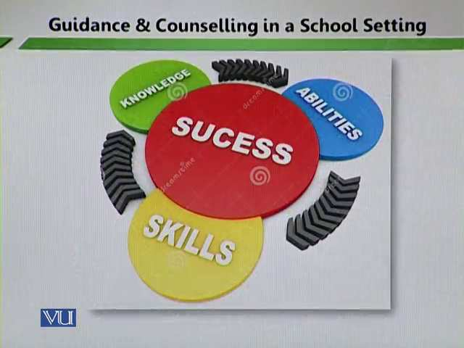
Helps students identify their:
- Skills
The counsellor should facilitate in basically providing students with a chance to look at their skills.
- Abilities
He or she also should facilitate in providing students with a chance to look at their abilities. A counsellor should come forward and help students to discover their skills and abilities. The students do not their abilities and skills very well. In the presence of a counsellor we can talk n the knowledge, abilities and skills domains.
- Achievements
A counsellor needs to help students about their abilities. Sometimes students do not realize that they have some abilities and certain skills and these skills and abilities need to be brought out, in front and worked on. Because it helps in better achievements. A counsellor basically facilitates students to achieve their targets by utilizing their skills and abilities fully.
- Interests
A counsellor helps students to maintain their interests and in sometimes to discover their interests.
Topic: 244 - Guidance and Counselling Programs in a School – Counsellor as a Facilitator 2
Counsellor as a Facilitator
- A counsellor provides transition between elementary and middle school: middle and high school. Some students feel hesitation when they go elementary to middle and middle to high schools. There is fear of unknown. In this the role of a counsellor is very important because he or she facilitates those things and laws which are Appling in the other schools. Basically, the role of a counsellor is to prepare them for that bigger classes and unseen world. The students may be victimized by other students so that the role of a counsellor is very important.
- A counsellor assists students with college selection and application process. A counsellor should provide the facilitation for moving from one place to another.
- He or she provides career guidance. In this teachers and counsellors can acts together and they can help the students to not to make these easy transition and at the same time they can make good career choices which are basically not only theory based but also they are giving proper counselling on the basis of which they make their selections.
Topic: 245 - Guidance and Counselling Programs in a School – Counsellor as a Manager 1
Counsellor as a Manager
- A counsellor should review educational records and plan appropriate academic programs. A counsellor should aware about the curriculum. Once a curriculum is developed and objectives are laid out then how do those objectives fall into the learning outcome mood and then how do those learning outcomes are achieved in the classroom. How does teacher satisfy their demands of the curriculum by enacting the objectives in the classroom and by satisfying the learning outcomes? A counsellor can review all the academic records.
- A counsellor should disseminate information to parents/guardians about graduation requirements. Because the parents do not know about the graduation and career. So here the role of a counsellor as a manager becomes very important.

Topic: 246- Guidance and Counselling Programs in a School – Counsellor as a Manager 2
Arrange workshops for parents to inform about:
- Academic programming
It is very important to take parents on board. There is a lot of gap between parents and the school. Parents do not about what is happening in the school and sometimes they are interested at all. A counsellor can give awareness to the parents about all the academic programming by arranging workshop. Its benefit is that the students, parents, counsellor and teachers can come on a platform.
- Post-secondary planning
A counsellor should give awareness to the parents about the postsecondary planning. So that they can understand their students’ academic planning very well.
- Review confidential and other school record
A counsellor should review confidential and other school records which can be linked with student’s personal life and academic issues. A counsellor has an important role in the school.
Topic: 247- Guidance and Counselling Programs in a School – Counsellor as an Advocate
Counsellor as Advocates:
- A counsellor works with specialized populations which require special attention. These students may face physical and psychological problems. These are also those students who are gifted and their giftedness may become problem for them. It is very necessary to work with these students. it is their basic right to acquire normal education. When we talk advocacy, we basically take all those people on board who are concern with education of human child who can play a lead role in seeking the solution of the problem.
- A counsellor should serve on school community committees. So that we can give all facilities to the students.

Lesson 42
GUIDANCE AND COUNSELLING PROGRAMS IN A SCHOOL SETTING-COUNSELLOR AS A COORDINATOR 1
Topic: 248 - Guidance and Counselling Programs in a School – Counsellor as a Coordinator 1
Counsellor as Coordinators:
A coordinator is a person who helps in planning, organizing and executing events or performances needed. There are different types of coordinators such as a wedding coordinator, stunt coordinator, production coordinator and marketing coordinator. A counsellor should coordinate information.
- A counsellor can communicate and exchange information with parents via conferences, newsletters etc. a counsellor plays an important role in the communication and dissemination.
- He or she can coordinate activities to promote student’s personal growth and skill development. Counsellors are in a better position to give information because they are more knowledgeable. To promote student’s personal growth and skill development a counsellor can coordinate with different activities. So that students can use those abilities and skills in specific activities to improve themselves.
Topic: 249 - Guidance and Counselling Programs in a School – Counsellor as a Coordinator 2
Counsellors as coordinators:
- Serve as a liaison between school and community resources. Community relationship means that school exists in particular community. This community has its own norms, values, cultural understanding and value system. Sometimes school exists in an isolation. A counsellor can build a good relationship with the community. The community needs to understand the school and also needs to understand the reasons that why certain activities are enacted in a school and why things are practiced in a school. To educate community is very important stakeholder in a child’s education. A coordinator can act as a layer between the school and the community.
- Coordinate meetings between parents, school staff, students and the community. So that better relationships are build and programs are conducted well.

Topic: 250 - Guidance and Counselling Programs in a School – Counsellor as Consultants 1
A consultant is usually an expert or a professional in a specific field and has a wide knowledge of the subject matter. The role of consultant outside the medical sphere (where the term is used specifically for a grade of doctor) can fall under one of two general categories:
Counsellors as Consultants
- Provide consultation to teachers, administrators and staff. They give specialized to teachers, administrative staff and students. If a consultant works with a school principal. Then he or she will look for different methods to manage the school, different theories, the of the principle, leadership potential and how to use these potentials, what are the strategies that a principle can follow the law and order situation and how a principle can display leadership qualities. When consultants work closely with the teachers, they provide a lot of service in term of telling teachers which particularly methodology to employ in a particular classroom and at the same time how to use different classroom management approaches in the classroom.
- Make appropriate referrals. A consultant on the basis of analysis and experience can give advice to various stakeholders in education accordingly.
Topic: 251 - Guidance and Counselling Programs in a School – Counsellor as Consultants 2
Counsellor as consultant:
- Provides information to assist in meeting student’s academic and emotional needs. Counsellor as a consultant, on one hand the consultant is able to judge the academic world of a child properly and on the other he or she is also able to judge the social and emotional world of the student. The consultant analysis these two domains in a better way. He or she is able to basically formulate the academic standards for students of various age groups and at the same time he or she is better able to decipher the social and emotional needs of students at various age and stage levels.
- Identify the causes and determine the ratio of specific behaviors, e.g. absenteeism
- Propose solution

Topic: 252 - Guidance and Counselling Programs in a School setting – Role as a Counsellor
Role as a counsellor:
- Provides individual and group counselling. A counsellor can provide individual and group counselling. Individual counselling is required to those students who are facing specific problems. And group counselling is required to those students who are facing domestic problems. The counsellor can help students to solve their problems.
- Deals with self-image, interpersonal concerns, academic development and personal concern. Sometimes students have very low image about themselves because they suffer from low sell steam. Students can improve their self-image and they can work with a counsellor in which confidence measures are taken and students are encouraged to feel more confident. Some students have interpersonal concerns they do not go well with certain students. Sometimes they do not have good relationships with their teachers, so here a counsellor can come forward and he or she can help the students in building relationships.

Lesson 43
COLLABORATION AND COMMUNICATION WITH STAKEHOLDER-PARENTING
Topic: 253 - Collaboration and Communication with Stakeholders – Parenting
1. Parenting
Parenting or child rearing is the process of promoting and supporting the physical, emotional, social, financial, and intellectual of a child from infancy to adulthood. Parenting refers to the aspects of raising a child aside from the biological relationship.
Parents are important stakeholders in their children’s education then we need to have an inclusive program in which we can take help from the parents and at the sometime we also give help to the parents and that is only possible once we look at the totality of perceptive and once we have programs in which we not only progressed with guidance and counselling but also take the opinions guided and advices for various stakeholders in education.
- School can assist families in providing basic needs. Parents can assist the school and they can not only assist the school at the same time they can help the brining the children not only their children but children at large. School can play role in helping families.
- Improved quality of life ensures better learning.
School gives them the improved quality. When we assist the parents and families and provide them the require support, we actually helping the students who set in the classroom. By virtue of proper support to the parents we are indirectly helping the child to come up to a require level of competence. When establish good relation with parents then it becomes easily to bring the child in main stream education.
BASIC NEEDS
- Food
- Water
- Shelter
- Clothing
These are basic needs. Through the fulfillment of these basic needs the other need automatically get fulfilled. So, in order to give and enriching experienced to student in school it is important to look after these basic needs. These basic needs are fulfilled at home first then in school.

2. Forms of family interaction should be facilitated:
- Educating children with value of education. It is very important to have a proper interaction with families because of the interaction we know the problems. So, it is important to interact with families and to know about their issues and problems and then to help the families out so that the children can be educated in a more meaningful and appropriate manner.
Topic: 254 - Collaboration and Communication with Stakeholders – Communicating
2. Communication
Communication is yet an important tool that establishes a kind of relationship between the family and the school and between the school and the other stakeholders. the act or process of using words, sounds, signs, or behaviors to express or exchange information or to express your ideas, thoughts, feelings, etc.
- Positive and regular communication between parents and school plays an important role in student’s personality development. Many teachers underestimate the value of building relationships with their students’ parents. Parents can be your best friends, and they can be your worst enemy. It is hard work for a teacher to build trusting cooperative relationships, but it will be well worth all the effort in the long run. The following five tips can you help you build quality solid relationships with parents.
Effective ways of communication:
- newsletters
- personal phone calls
- home visits
- Early notification of difficulty or a problem is considered more effective. When we have the delayed mechanisms in the schools then the problems remained there.
- Purposeful dialogue breaks the perception that school-to- home communication is always negative. This actually helps in a constructive relationship between the different stakeholders. This can only happen once a purposeful relationship takes place.
Topic: 255 - Collaboration and Communication with Stakeholders – Volunteering
3. Family volunteerism
- Schools should encourage family and community involvement. Families have some skills that can be brought to the school level. For example, there is expertise available with parents and parents can help the school in giving that kind of expertise. For example, some parents are medical practitioners; some parents have other kinds of professional expertise like engineering and medical skills. Schools can give skill training to the parents.
Strategies:
- Recruitment and training programs for volunteers.
- Acknowledgement and appreciation strategies. School can involve parents in school activities. For example, sports, funfair and play. In these activities’ parents can participate and help them teachers.
Topic: 256 - Collaboration and Communication with Stakeholders – Home learning
4. Learning at Home
School should encourage home learning.
- School should design interactive homework and assignment to involve parents and community. There has to be a connection between the school and home. When students go home sometimes, they have a lot of leisure time then they do not know to what to do. Sometimes the dangerous is that they may get involved in uncalled activities. So, in order to keep them on task parents can be involved in further educating their children through the establishment of activities. The school can play an important role and encouraged activities which can be used with the help of parents. So, this also establishes a good repo between parents and children. This is basically an attempt to bring the parent and the child together and to have good repo building between them.
Such activities enable families to better:
- Support
- Listen
- React to
- 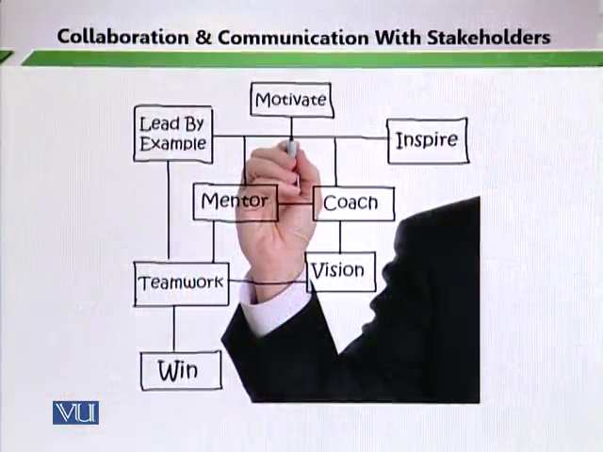
- Guide &
- Mentor their children
Topic: 257 - Collaboration and Communication with Stakeholders – Decision Making
5. Family’s involvement in Decision Making
- Schools need to involve students’ families into decision making. Parents need to make inform decision based on the needs and interests of their children. In this there is a need of help of school which can tell parents about the strengths and weakness of the students. The parents need to stay connected with the lives of their children and at the same time they need to know the progress of their students both in the academic world and also in the behavioral world. Their decisions help the children in staying connected in their education process.
- Parent organizations can be helpful. It means that we encourage parent to come at one platform and also assists the school in proper decision making for their children. Parents organization can actually play a bigger role in not only educating their children at the same time they can help the schools in the day to day developments not only of their children but also of the school plan.
- Families from lower educational and social background should not be alienated. Normally specific category of parents stays active in schools however there is still another category which is not active and which is never consulted in day to day proceeding of schools.

Topic: 258 - Collaboration and Communication with Stakeholders – Collaborating with Community
6. Collaborating with Community
The connection between schools and communities should be two ways. Educational changes need to inform to the community. There should be a concept of give and take. These two ways of communication must be done and must be established for the smooth flowing education system.
Community linkage
Collaborating with community:
- Develop linkage with agencies. It means there is interplay of different agencies in the community. There are different thought processes that are going on.
- Provides requested resources/services. For example, you can convert a ground into a good support complex. So that community members can use this ground and play there. If you have the required facilities you can certainly help the community so that the community also benefits from you and in return also benefits you.
Service Integration
This collaboration brings about service integration that is a more efficient service for children and their families. It becomes very important to get collaboration and also help the community seek community support.

Lesson 44
IMPLEMENTING GUIDANCE AND COUNSELLING IN SCHOOL SETTING-INITIAL PHASE 1
Topic: 259 – Implementing Guidance & Counselling in School Setting – Initial Phase 1
1. The school guidance – planning group
- Set up a task group. If you want that there should be guidance and counselling services then there is a need of a plan.
Expected members:
- Guidance counsellor
- Learning support teacher
- Home/school/community teacher
- Any interested staff member
- Year head
- Class teacher
Topic: 260– Implementing Guidance & Counselling in Primary School Setting – Initial Phase 2
Objectives of planning group
- To ensure support for ALL students
- To provide decision forum
- To focus on area of development
- To arrange for monitoring, implementation and evaluation of proposals
Meeting schedule of planning group
- Twice a week at initial stage
- Once program is functional, once a month meeting will suffice

Topic: 261– Implementing Guidance & Counselling in Primary School Setting – Guidance Plan
2. The school Guidance Plan
- Establishing features of guidance plan
- Aims
It means why we are establishing guidance and counselling services in the school and what are its benefits. We need to see the efficacy of the plan in terms of establishing and running aims. When aims and objectives are established then it becomes easier to not only establishing the plan but also run it well. Any program should have aims and objective.
- Record of current guidance, provision and resources.
You need to know what are features of your guidance plan are and what are the policies of your guidance plan.
- Policies
Policies tell you the rules and regulations, role and boundaries. These are very important part of guidance and counselling. You cannot implement any plan without policies. In these three things are very important
- Policies
- Procedures
- Records
- Areas of Development
- Guidance priorities
- Action plans
- Implementation/monitoring/evaluation procedures
Topic: 262 – Implementing Guidance & Counselling in School Setting – Identifying Problems
2. Who are School Guidance Partners?
- Identify all potential partners who can contribute to the development of guidance plan. Some wants to help the school. We should look for potential partners and we should also advertise if we need be that a particular the service of guidance and counselling. Teachers, school heads, counsellors and community members are the member of your core group. Psychologists, psychiatrics and petition can also join your group.
- It must be decided after developing mutual understanding in planning. It is very important to identify your local partners who are your invited partners and let them have a dialogue with other stake holders. Because they will tell them about the importance of their role in the group and about the importance of their presence in the school.

Lesson 45
IMPLEMENTING GUIDANCE AND COUNSELLING IN SCHOOL SETTING-FORMULATING RELEVANT POLICIES
Topic: 263 – Implementing Guidance & Counselling in School Setting – Formulating Relevant Policies
4. Formulating Relevant Policies:
When we talk about the implementation of guidance and counselling program and when we see it in the perspective of a larger community and in the perceptive of larger program development then we have to focused a lot on policy development.
Steps:
- Description of current practice drawn up by relevant practitioner.
- Discussion and amendment of initial drafts.
- Consultation process
- Preparation and submission of final draft
- Adoption as policy
There should always be a room for improvement and that can only happen once a constant monitoring system and constant evaluation system which could your policy.
Topic: 264 – Implementing Guidance & Counselling in School Setting _ Carrying Out Stock-Take 1
5. Stock-take of current guidance program
Once guidance and counselling policies are implemented, they need to be reflected upon. You need to stock take as to how the programs are running. Periodic and continuous stock taking is very important.
- What personal and social education takes place at this school?
When we talk about stock taking, we give regard to the education input that we give to the student. And at the same also talk about the social and emotional input that we give to the student. Academic as well as affective elements are very important because we are talking about overall personality development. We are not talking that it is the responsibility of the school to give academic element to the student but we are talking that a school not only give importance to the academic element but also give importance to behavioral element of the students. so, we are looking at a child’s development in terms of academic and in terms of affective education which means looking at the behavioral and attitudinal development.
For example:
- Counselling
When we are talking about the stock taking in this, we need to what type of counselling service is providing.
- Inviting guest speakers
Do we have service which we call the inviting guest and inviting them as speakers? We need to take stock of that aspect.
- Healthy eating week etc.
Do we have healthy eating week? We also need to take stock of that aspect. If guidance and counselling programs initiate school activities so need to take a feedback as weather to those activities are implemented are not. We need to evaluate those activities. For example, why do we have a healthy eating week? We have healthy eating because we want to ensure that students know the difference between healthy eating and eating junk foods. Basically, stock taking means to look and review for successful implementation of programs about guidance and counselling.
Topic: 265 – Implementing Guidance & Counselling in School Setting-Carrying Out Stock – Take 2
- What career education takes place at this school?
It means that how a school can provide help to students in career choices.
For Example:
The school provides:
- Information on courses. The school needs to tell them about the various subjects’ areas.
- Job search skills and search engines.
- Interview techniques etc.
It is important to guide the students so that they can make career choices because it is the purpose of schooling. It is very important to guide them so that they can reach the self-understanding because of that they can know their needs, interests, strengths and weakness. They can easily choose their subjects. Through career choices we can polish student’s aptitudes, interests and work values.
- What educational guidance takes place at this school?
What kind of educational guidance we are providing to the students?
- Subject choice
Are we helping to our students to select the right kind of subject? Which comes to at a particular stage? For example, selection of subjects at matric level.
- Study skills
What type of study habits that we are developing in the students?
- Motivation etc.
Motivational skills directly link with classrooms. Basically, teacher is the main motivating factor which means that he or she is good in content, methodology, classroom management and he or she knows how to conduct the daily affairs in a way that he or she raises the motivational level of students.
Topic: 266– Implementing Guidance & Counselling in School Setting – Carrying Out Review 1
6. Carrying out school guidance review
Following aspects of support for students must be reviewed.
- Provision for:
- Students with special educational needs. If there is a handicap student in your classroom or if there is a student who is facing a physical handicap so what kind of facility are you providing to that particular student? In order to make him enjoy main stream education then it is extremely important to look after the needs of the special need student.
- Students from disadvantaged background. These students are required the extra effort and services from the guidance and counselling department to help, guide and provide them with the secure environment. Because these students are financial insecure and at the same time, they are emotional insecure so they need your support.
- Students from minority groups. It is their basic right to give them proper confidence. For example, festivals of minority group need proper attention. In Pakistan, there are different minority groups. These people will feel connected. They not only feel connected they considered themselves as important individuals as part of being Pakistanis. When we talk of reviewing such policies and we talk of reviewing of these programs it is important to look after the needs of this particular people. We must look after the needs of these peoples because we want them to come in main stream education and to lead meaningful lives. Those kinds of lives which do not have any kind of security.
Topic: 267 – Implementing Guidance & Counselling in School Setting – Carrying Out Review 2
- Student must be consulted in guidance review through questionnaires. We can seek feedback from students through the administration of questionnaires. A questionnaire is a research instrument consisting of a series of questions and other prompts for the purpose of gathering information from respondents. Although they are often designed for statistical analysis of the responses, this is not always the case. Questionnaires reduce bias. There is uniform question presentation and no middle-man bias. The researcher's own opinions will not influence the respondent to answer questions in a certain manner. There are no verbal or visual clues to influence the respondent.
- Staff review is also very important to review progress. Through staff review we can find out the strengths and weakness of the programs.
- Questionnaires could be distributed and completed at a staff meeting. Staff members can also give their feedback through questionnaires.
- Results can be communicated after analysis in next meeting. Through analysis we can know the strengths and weakness of the programs. Opinions of staff members and students are very important. These opinions should be incorporated in further giving a meaning to your program.
Topic: 268 – Implementing Guidance & Counselling in School Setting – Action Plan 1
7. Action Planning
You need to make good action plans so that the program is not only implemented properly they are successfully run. So, when it comes to implementation of guidance and counselling program there is a need of action planning.
Action planning basically means that how would to put your act together to plan something that would enable the successful implementation of a particular target.
Action planning is a process which will help you to focus your ideas and to decide what steps you need to take to achieve particular goals that you may have. It is a statement of what you want to achieve over a given period of time.
- Keep SMART targets/objectives
It means the plan should be:
- Specific
You need to make specific targets so that problems can be resolved.
- Measurable
Your target should be measurable. When it comes to changing a particular behavioral pattern then the behavioral pattern should be measurable in the sense that there is improvement in the behavior, you can see the improvement in the human behavior.
- Achievable
Do not make such objectives which are beyond the scope of action. So, make those targets which you can achieve in a SMART manner and easily. Do not make your life difficult by over reaching the limits.
- Relevant
The action plan should be relevant to the particular needs and interests of the students. it should address the particular needs of a particular student. It should not be a way beyond the expectation of any target.
- Timed
Your target should be time bound.
A single development area may require a number of action plans to bring about desired improvements.
Topic: 269 – Implementing Guidance & Counselling in School Setting – Action Planning 2
b. Implementing and monitoring the action plan. We monitor action because we want to see whether it is running successful or not or weather its changes are required or not.
Prompts:
- What is the objective in relation to this development area?
For example, if a student is in the classroom. He or she is unable to participate in the classroom discussions. If he or she is shy we can make an action plan. We can seek help of a guide; a counsellor and we work for that particular student. Our objective is to make able the student to work with other students. This is called implementation stage.
- How can we ensure the action plan is being implemented?
Program implementation is very important because it basically tells us how the programs are being run.
- What are desired outcomes?
The shy student, who does not participate well, will be participating well now, will fell encouraged to participate in a group and then will find the confidence to talk to the teacher.
- What are the indicators of improvement?
Giving the same example, the indicators of improvement in this particular case is that the child has started speaking, the child has stared gaining confidence and that is a mark of improvement. That is a success of a program and particular action plan.
- Do we need an interim review of progress?
It means the plan needs to be improvisation. There is always room for improvement and that improvement should be given and it should happen when it is required.
Topic: 270 - Implementing Guidance & Counselling in School Setting – Evaluation
8. Evaluation
This is the last factor which works towards the successful implementation of guidance and counselling. Evaluation
- Measures the progress
- Examine the impact
- Identifies areas for further attention
- Establishes a focus
- Keeps planning to the forefront
The steps of the program:
Steps:
- Decide what needs to be evaluated
- Collect data
- Collate, analyze and interpret data
- Present findings
- Reflect on report
- Follow through
When we talk about the systematic development of the program we also need to look at the systematic evaluation of the program and through evaluation we think of ways in which can further improve the program because the whole issue is to have the successful implementation of guidance and counselling and that is only possible once we have SMART objectives, proper action plans, administer those plans and then evaluate them. And we evaluate them we will ensure that we make use of the data, findings to further strengthen these programs.

