Classroom Testing and Evaluation (EDU404)
Lesson |  | Topic
01 | Introduction to classroom assessment and basic terms |  | What is classroom assessment
01 | Introduction to classroom assessment and basic terms |  | Emerging Points from These Definitions
01 | Introduction to classroom assessment and basic terms |  | Classroom Assessment: Classroom Context
01 | Introduction to classroom assessment and basic terms |  | Measurement
01 | Introduction to classroom assessment and basic terms |  | Testing
01 | Introduction to classroom assessment and basic terms |  | Assessment
01 | Introduction to classroom assessment and basic terms |  | Evaluation
01 | Introduction to classroom assessment and basic terms |  | Modification or improvement
02 | Types of assessment |  | Types of assessment
02 | Types of assessment |  | Formative assessment
02 | Types of assessment |  | Summative assessment
02 | Types of assessment |  | External and internal assessment
02 | Types of assessment |  | Process assessment
02 | Types of assessment |  | Product assessment
02 | Types of assessment |  | Diagnostic assessment
02 | Types of assessment |  | Norm reference assessment
02 | Types of assessment |  | Criterion reference assessment
02 | Types of assessment |  | Norm vs criterion referenced assessment
03 | Reliability |  | Reliability and related concepts
03 | Reliability |  | Test-retest procedure
03 | Reliability |  | Alternative-test form procedure
03 | Reliability |  | Split halves procedure
03 | Reliability |  | Internal consistency procedure
03 | Reliability |  | Coefficient range
04 | Validity |  | Validity and related concepts
04 | Validity |  | Face validity
04 | Validity |  | Content validity
04 | Validity |  | Construct validity
04 | Validity |  | Criterion and predictive validity
04 | Validity |  | Link between reliability and validity
05 | Biasness |  | Free from bias
05 | Biasness |  | Unfairness
05 | Biasness |  | Offensiveness
05 | Biasness |  | Assessment and physically challenged people
05 | Biasness |  | Equality and equity
05 | Biasness |  | Measures to eliminate bias
06 | Tools of assessment |  | Tools of assessment
06 | Tools of assessment |  | Observation
06 | Tools of assessment |  | Interview
06 | Tools of assessment |  | Projects
06 | Tools of assessment |  | Diaries and portfolios
06 | Tools of assessment |  | Tests
07 | Observation |  | Observations
07 | Observation |  | Overt and covert observation
07 | Observation |  | Participation of the observer
07 | Observation |  | Conducting observation
07 | Observation |  | Merits of observation
07 | Observation |  | Demerits of observation
08 | Questionnaire |  | Questionnaire
08 | Questionnaire |  | Types of questionnaire
08 | Questionnaire |  | Some more types of questionnaires
08 | Questionnaire |  | Interpreting questionnaire
08 | Questionnaire |  | Merits of questionnaire
08 | Questionnaire |  | Demerits of questionnaire
09 | Interview |  | Interview
09 | Interview |  | Structured and semi-structured interviews
09 | Interview |  | Transcribing an interview
09 | Interview |  | Interpreting an interview
09 | Interview |  | Merits of interview
09 | Interview |  | Demerits of interview
10 | Portfolio and projects |  | Portfolio
10 | Portfolio and projects |  | Project and growth portfolio
10 | Portfolio and projects |  | Achievement and competence portfolio
10 | Portfolio and projects |  | Process and showcase portfolio
10 | Portfolio and projects |  | Merits of portfolio
10 | Portfolio and projects |  | Demerits of portfolio
11 | Diaries writing and Projects |  | Diaries and projects
11 | Diaries writing and Projects |  | Diary writing as reflective writing
11 | Diaries writing and Projects |  | Assessment of diary writing
11 | Diaries writing and Projects |  | Projects as a part of class work
11 | Diaries writing and Projects |  | Assessment of project
11 | Diaries writing and Projects |  | Merits and demerits of projects
12 | Types of Test |  | What is a test?
12 | Types of Test |  | Diagnostic test
12 | Types of Test |  | Standardized test
12 | Types of Test |  | Achievement test
12 | Types of Test |  | Proficiency test
12 | Types of Test |  | Psychometric test
13 | Objective type questions |  | Types of questions
13 | Objective type questions |  | True/false/not given
13 | Objective type questions |  | Filling the blank
13 | Objective type questions |  | Multiple choice questions
13 | Objective type questions |  | Matching sentences/ columns
13 | Objective type questions |  | Assessment of objective questions
14 | Other types of questions |  | Some other types of questions/ arranging information
14 | Other types of questions |  | Labelling a figure/ diagram
14 | Other types of questions |  | Short answers
14 | Other types of questions |  | Some other types of questions/assessing short answers
14 | Other types of questions |  | Essay types answers
14 | Other types of questions |  | Assessing essay type answers
15 | Objectives |  | Objectives and assessment
15 | Objectives |  | Difference between an aim and objective
15 | Objectives |  | Teaching process reflective objectives
15 | Objectives |  | Linking objectives with assessment
15 | Objectives |  | Objectives and assessment: Examples
15 | Objectives |  | Mismatch b/w teaching and assessment
16 | Bloom’s Taxonomy |  | What is taxonomy?
16 | Bloom’s Taxonomy |  | Bloom’s taxonomy
16 | Bloom’s Taxonomy |  | Bloom’s taxonomy: Three domains
16 | Bloom’s Taxonomy |  | Explanation and significance
16 | Bloom’s Taxonomy |  | Cognitive domain
16 | Bloom’s Taxonomy |  | Explanation of cognitive domain
17 | Knowledge Level of Blooms Taxonomy |  | Knowledge level
17 | Knowledge Level of Blooms Taxonomy |  | Knowledge level
17 | Knowledge Level of Blooms Taxonomy |  | Knowledge level objectives
17 | Knowledge Level of Blooms Taxonomy |  | Knowledge level questions
17 | Knowledge Level of Blooms Taxonomy |  | Same level objectives and questions
17 | Knowledge Level of Blooms Taxonomy |  | Mismatch between objectives and questions
18 | Comprehension level of Bloom’s Taxonomy |  | Comprehension level
18 | Comprehension level of Bloom’s Taxonomy |  | Related verbs and words
18 | Comprehension level of Bloom’s Taxonomy |  | Comprehension level objectives
18 | Comprehension level of Bloom’s Taxonomy |  | Comprehension level questions
18 | Comprehension level of Bloom’s Taxonomy |  | Same level objectives and questions
18 | Comprehension level of Bloom’s Taxonomy |  | Mismatch b/w objectives and questions
19 | Application level of Bloom’s Taxonomy |  | Application level
19 | Application level of Bloom’s Taxonomy |  | Related verbs and words
19 | Application level of Bloom’s Taxonomy |  | Application level objectives
19 | Application level of Bloom’s Taxonomy |  | Application level questions
19 | Application level of Bloom’s Taxonomy |  | Same level objectives and questions
19 | Application level of Bloom’s Taxonomy |  | Mismatch b/w objectives and questions
20 | Analysis level of Bloom’s Taxonomy |  | Analysis level
20 | Analysis level of Bloom’s Taxonomy |  | Related verbs and words
20 | Analysis level of Bloom’s Taxonomy |  | Analysis level objectives
20 | Analysis level of Bloom’s Taxonomy |  | Analysis level questions
20 | Analysis level of Bloom’s Taxonomy |  | Same level objectives and questions
20 | Analysis level of Bloom’s Taxonomy |  | Mismatch b/w objectives and questions
21 | Synthesis level of Bloom’s Taxonomy |  | Synthesis level
21 | Synthesis level of Bloom’s Taxonomy |  | Related verbs and words
21 | Synthesis level of Bloom’s Taxonomy |  | Synthesis level objectives
21 | Synthesis level of Bloom’s Taxonomy |  | Synthesis level questions
21 | Synthesis level of Bloom’s Taxonomy |  | Same level objectives and questions
21 | Synthesis level of Bloom’s Taxonomy |  | Mismatch b/w objectives and questions
22 | Evaluation level of Bloom’s Taxonomy |  | Evaluation level
22 | Evaluation level of Bloom’s Taxonomy |  | Related verbs and words
22 | Evaluation level of Bloom’s Taxonomy |  | Evaluation level objectives
22 | Evaluation level of Bloom’s Taxonomy |  | Evaluation level questions
22 | Evaluation level of Bloom’s Taxonomy |  | Same level objectives and questions
22 | Evaluation level of Bloom’s Taxonomy |  | Mismatch b/w objectives and questions
23 | Item analysis I |  | Item analysis
23 | Item analysis I |  | What is item difficulty?
23 | Item analysis I |  | Calculating item difficulty
23 | Item analysis I |  | High and low performance
23 | Item analysis I |  | What is discrimination index?
23 | Item analysis I |  | Calculating discrimination index
24 | Tem analysis II |  | More about item analysis
24 | Tem analysis II |  | What is distractor analysis?
24 | Tem analysis II |  | Analysing distractor
24 | Tem analysis II |  | Interpretation of the analysis
24 | Tem analysis II |  | Putting responses on a sheet
24 | Tem analysis II |  | Significance of distractor analysis
25 | Marking |  | Marking and assessment
25 | Marking |  | Clarity in questions
25 | Marking |  | Clarity in marking scheme
25 | Marking |  | Level of question and marks
25 | Marking |  | Co-ordinations
25 | Marking |  | Sharing with students
26 | Rubric I |  | Rubrics
26 | Rubric I |  | Elements in rubrics
26 | Rubric I |  | Examples from IT
26 | Rubric I |  | Examples from speaking task
26 | Rubric I |  | Objectives & rubrics
27 | Rubric II |  | Significance of rubrics
27 | Rubric II |  | More about rubrics
27 | Rubric II |  | Challenges
27 | Rubric II |  | Some requirements
27 | Rubric II |  | Developing rubrics
27 | Rubric II |  | Scoring rubrics
28 | Displaying data |  | Displaying data
28 | Displaying data |  | Representation
28 | Displaying data |  | Tables
28 | Displaying data |  | Graphs
28 | Displaying data |  | Some principles
28 | Displaying data |  | Some recommendations
29 | Item development |  | Item development
29 | Item development |  | Item format
29 | Item development |  | Objective questions
29 | Item development |  | Essay type items
29 | Item development |  | Marking scheme
30 | Outcomes of assessment |  | Outcomes of assessment
30 | Outcomes of assessment |  | Learner’s skills
30 | Outcomes of assessment |  | Learner’s knowledge
30 | Outcomes of assessment |  | Guiding teaching
30 | Outcomes of assessment |  | Involving many parties

CLASSROOM TESTING AND EVALUATION (EDU 404)

LECTURE 01
Introduction to classroom assessment and basic terms
Topic 1: What is Classroom Assessment?
Definition-1:
Assessment is the systematic collection, review, and use of information about educational programs undertaken for the purpose of improving student learning and development. (Palomba & Banta, 1999)

Definition-2:
Assessment is the process of gathering and discussing information from multiple and diverse sources in order to develop an understanding of what students know and understand; the process culminates when assessment results are used to improve subsequent learning. (Huba & Freed, 2000)

In short, the main points in these definitions are:
- Process of gathering information
- Multiple sources
- Develop and understand
- Improvement
Topic 2: Emerging Points from These Definitions:
1. Assessment is a systematic process: certain circumstances, goals and planning must be kept in mind while assessment. Nothing can take place haphazardly. See the image below:
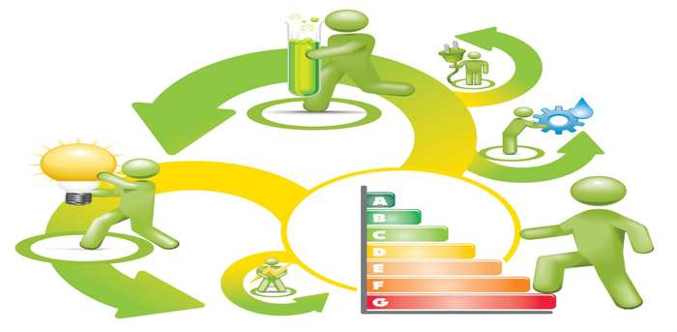
- Information is gathered from different sources:
There are many sources to get information about the students like homework, exam papers, class test, projects etc.
- Judgment:
We gather all the information for judgment about what has yet achieved and what is still missing. Making such judgments is the essential part of process of improvement.
- About a process or product:
Now this judgment is made for the assessment about a process or product. All the classroom activities and learning are a process and the knowledge gained by the students and a competent student is the product.
- Improvement:
These judgments are made for improvement in the process and the product. Assessment is just like a bridge that is connecting behind as well as the future of the students.
Topic 3: Classroom Assessment: Classroom Context:
1. Information is gathered systematically: It is a systematic process, for example; a teacher teaches in a classroom and then at the end gives an assignment to the students as quiz, midterm exam and final term exam. Final term exam is never taken at the start of the academic session. So, a sequence is followed that is systematic.
2. From different sources to make improvements in teaching and learning: Assessment of students is done through a variety of ways like questioning in classroom, assignments, quizzes, exams etc. The information gathered from all the sources make your assessment.
3. To make improvements in teaching and learning: The results of assessment always open grounds of improvement.
4. To make changes in syllabi, curriculum or policies: All the results of assessment can be reviewed critically to make changes in the system for improving the teaching and learning process at policy making level.


Topic 4: Measurement
Measurement: refers to dimensions/quantity/weight. Measurement is normally shown by using numbers. For example, measuring a box, or weighing it. Measurement is always with reference to some scale.
Topic 5: Testing
Testing: refers to the process of judging some ability or deciding about some ability. For example, testing your ability for driving or in classroom; testing IQ.
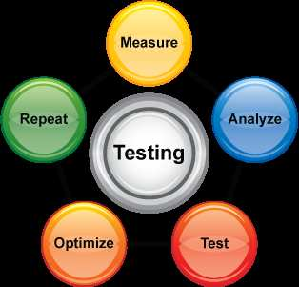

Topic 6: Assessment
Assessment: is a broader term and including measurement and testing also; it is usually with reference to some goals. For example, your assessments; like you have to learn hundred words by this weekend. So, your assessment will be related to those 100 words that how much and how firmly you have learnt them. Assessment is also related to organizations. All organizations assess their employees such as audit teams and inspection teams visits the organization.

Topic 7: Evaluation
Evaluation: is a complex process and broader term including measurement, testing and assessment. All these things give you the value of the product/process that you are going to access. Evaluation also provides us with the ground for improvement.
Topic 8: Modification or Improvements:
The basic purpose of every assessment is to make changes. There is no use of assessments if improvements are not made. The teacher develops a lesson plan to be followed in classroom; the lesson plan is then implemented in classroom. At the end there is evaluation of it. The purpose to evaluate it is modification/improvement.

Lecture 02
TYPES OF ASSESSMENT
Topic 9: Types of Assessment:
There are different types of assessment; for example,
- You have midterm exams
- You have final term exams
- House exams and board exams
- Your classroom as a process
- Your result as a product
Names of these assessments are:
- Formative
- Summative
- External and internal
- Product
- Process
Topic105: Formative Assessment
Formative is a type of testing in which a range of formal and informal assessment procedures employed by teachers during the learning process in order to modify teaching and learning activities to improve student attainment.
Key points use for formative assessment:
- Range of formal and informal assessment
- During the learning process
- To modify teaching and learning
- To improve

Topic 11: Summative Assessment
Summative assessment refers to the assessment of participants, and summarizes their development at the particular time. In contrast to formative assessment, the focus is on the outcome of the program.
Key points use for summative assessment:
- Assessment of participants
- Development at a particular time
- The outcome of a program

Topic 12: External and Internal Assessment
Internal assessment is the process by which an organization assesses its policies and systems internally. It is carried out by the departments within the organization and employees themselves are skilled at managing internal assessment.
External assessment on the other hand involves an external organization or a consultancy firm to judge and monitor the organizational procedures and give an unbiased opinion for betterment.
Focus is on internal system vs external agencies. For instance, your house exam and board exam.
Topic 13: Process Assessment
Process assessment means the assessment of process taking place including the factors involved in it. ‘During any process’ is the key word. For example, classroom proceedings.
Topic 14: Product Assessment
Product assessment means the assessment of product at the end of some process. Achievement at the end with reference to some goal is important here. For instance, your final grades.

Topic 15: Diagnostic Assessment
- Diagnostic assessment helps to diagnose weak areas of learners. It has normally been studied with reference to language learning.
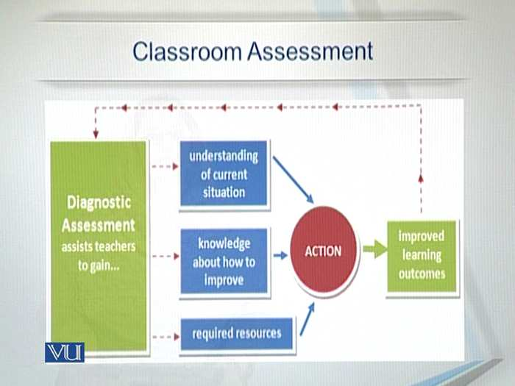
- Diagnostic assessment looks for problem areas for a student during the learning process. It has been helpful especially in language and mathematical field.
Topic 16: Norm Referenced Assessment
- A norm referenced assessment makes judgments about people, on the basis of sources and distributions of scores. For instance, the top 10 percent of the class are awarded first class and the next 15 percent are awarded second class.
- A norm referenced assessment has been the most common type of assessment used in education.
- Though norm referenced assessment is very common, but does not give accurate and exact assessment. For example, a student who fails in one year may well have passed in others. Similarly getting higher grades does not mean higher capabilities.
Topic 17: Criterion Referenced Assessment
- Criterion referenced assessment makes judgments about performance, rather scores. It assesses the extent to which a student has received the performance outcomes of a subject.
- For example, oral presentations may be judged on the following criteria: knowledge of subject material, ability of responding to the questions, structure of presentation, use of audio/visual aids, pace and timing and delivery style.
Topic 18: Norm vs Criterion Referenced Assessment
- Norm referenced is more common and has been in practice for years where as criterion referenced is new and less practiced as compared to norm referenced.
- Norm referenced focuses more on scores where as criterion referenced targets the performance of students. Criterion is closer to real life situation as compared to norm referenced.

LECTURE 03
RELIABILITY
Topic 19: Reliability and Related Concepts
Reliability refers to the extent to which assessment results are consistent. The assessment that maintains the consistency in results is known as reliable.
“Reliability is the extent to which a measurement instrument or procedure yields the same results as on repeated trails (Carmines and Zeller, 1979)”
For example, a calculator cannot be reliable if it gives wrong calculations or results. The weight of an object is not reliable if machine is not working properly. Same is the case of the results obtained from assessments.
What is meant by the term of unreliable results? The unreliable results of assessment mean inconsistency. Keeping these views in mind, we can trust the results if these are consistent. It is the evidence of an accurate system of assessment. Keeping in view the significance of reliability, different methods are used to attain reliability. For example, test-retest procedure, the alternative–test form procedure and the split halves procedure.
Topic 20: Test-retest Procedure
Same test, given two (or more) times. Example: One might develop a test and will be administered twice with the same students. If the subject provides very small answers both times, it means results will be similar. Then one can assume that the assessment results are reliable.
Advantages of using ‘Test-Retest Procedure’:
- This procedure has strong logical appeal, one is measuring more than once with the identical test.
- One avoids the problem of developing more than one test.
Disadvantages of using ‘Test-Retest Procedure’:
- Events taking place
- Persons might change
- Students become more practiced second time.
Topic 21: Alternative-test Form Procedure
Create two forms of the same test (vary the items slightly). Reliability is stated as correlation between scores of Test1 and test 2. If students give similar answers, it means the results will be the same and it will have reliability.
Advantages:
- As tests differ though slightly, students cannot apply their guess work
Disadvantages:
- One has to develop two tests.
Topic 22: Split Halves Procedure
- Same test, administer once, grade each half separately, compare grades from each half.
Advantages
- Need to develop just one test.
- No maturation
- No cueing
Disadvantages
- What is the criterion of splitting halves?
Topic 23: Internal Consistency Procedure
- Same test, administered once, score is based upon average similarity of responses to the items. It is a measure of reliability used to evaluate the degree to which different test items that probe the same construct produce similar results.

Advantages
- Need to develop just one test.
- No maturation.
- No cueing.
Disadvantages
- Scholars do not agree on the formula applied to calculate internal consistency.
Topic 24: Coefficients Range
- The value of reliability coefficients range from 0 to 1.0.
- A coefficient of 0 means no reliability.
- 1.0 means perfect reliability but hard to claim.
- If it is above .80, it is said to have good reliability; if it is below .50, it would not be considered a very reliable test.

LECTURE 04
VALIDITY
Topic 25: Validity and Related Concepts
- Validity means how well a test measures what it is supposed to measure.
- A vocabulary test can not be valid if it measures your grammar ability. Similarly, a comprehension test can not be valid if it measures vocabulary.
- What is meant by the term of ‘invalid test’? it means a test fails to measure what it is supposed to measure.
- We can trust the results if these have been attained from a valid test. It is the evidence of an accurate system of assessment.
- There are different types of validity like face validity, content validity, construct validity, criterion validity and predictive validity.
Topic 26: Face Validity
- Does the test appear to test what it is supposed to be tested?
- A drawing test must be related to figures, so the question paper should appear with figures. A test that asks for filling some blanks must have blanks on paper. A multiple choice question must have options along with it.
Topic 27: Content Validity
- Content validity refers to the contents a test is suppose to measure.
- For instance, a book has ten chapters; these chapters are the contents of the book.
- The topics of your course of assessment are the content of this course:
{ A,B,C,D,E.F.G,H…..}
- Test: {B,C,F,H}
Topic 28: Construct Validity
- Construct validity refers to the construction of a test.
- You have the contents; how do you make a test? How do you tackle the questions? The contents of the course should be aptly covered in the question paper.
- For instance:
Contents: {A,B.C,D,E,F,G,H}
Test questions: a1, a2, a3. e1, e2, e3.
Test questions: b1, d1, f1,h1,a1.
Topic 29: Criterion and Predictive Validity
- How much a test can measure some performance with reference to some defined standards? It is known as criterion related validity.
- For instance, one is expected to be able to speak fluently after completing a course. So the test is valid if it can measure spoken ability.
- How much a test can predict future performance with reference to some defined standard? It is known as predictive validity.
Topic 30: Link between Reliability and Validity
Reliability and validity are related concepts. A test can not be reliable if not valid.

LECTURE 05
BIASNESS
Topic 31: Free from Bias
What is Bias?
- Inclination for or prejudice against one person or group, especially in a way that is considered to be unfair; systematic unfair treatment of a particular group of individuals.
- There are different types of it:
- Unfairness
- Offensiveness etc.
Topic 32: Unfairness
- When some one’s right denied due to like or dislike. In assessment, normally it is associated with teachers.
- It creates a mistrust among the stakeholders of assessment and hence affects the whole process. Unfairness questions the standards of assessment.
Topic 33: Offensiveness
- Using such language in question or such attitude that may offend some one. For instance the conflict between the white and the black in America during the civil war.
- Offensiveness not only deforms the image of the teacher, but also proves that assessment system is not reliable.
Topic 34: Assessment and Physically Challenged People
- Those who have some physical disability, must be facilitated in a balanced way.
Topic 35: Equality and Equity
- Giving equal opportunities to all is an important step to avoid biasness. Equality in time, in opportunities and equal standards for all in grading help to reduce biasness.
- Giving equal opportunities to all creates a harmony that leads towards equity.
Topic 36: Measures to Eliminate Bias
- Striving for diversity in test-development staffing and training test developers and scorers to be aware of the potential for cultural, linguistic and socioeconomic bias.
- Having test material reviewed by experts and trained.
- Screening for and eliminating items, references and terms that are more likely to be offensive to certain groups.
- Using multiple assessment measures to determine academic achievement and progress.

LECTURE 06
TOOLS OF ASSESSMENT
Topic 37: Tools of Assessment
An assessment tool is a method of collecting information about a learner’s performance and understanding about a certain topic. There are different types of these tools like observation, questionnaires, interviews, tests, projects etc.
Topic 38: Observation
Classroom observation is a process by which a teacher observes one or more class sessions, records the practices and student actions.
Topic 39: Interview
A formal face to face meeting normally designed with the purpose of assessment.
Topic 40: Projects
- An individual or collaborative enterprise that is carefully planned to achieve a particular aim and with the purpose of assessment.
Topic 41: Diaries and Portfolios
- A daily record, usually private, especially of the writer’s own experience, observations, feelings, attitudes etc. here with the purpose of assessment.
- Portfolio assessment is an assessment form that learners do together with their teachers and is an alternative to the classic classroom test. The portfolio contains samples of the learner’s work and shows growth over time.
Topic 42: Tests
A series of questions, problems or physical responses designed to determine knowledge, intelligence or ability.

LECTURE 07
OBSERVATION
Topic 43: Observation
Observation is the active acquisition of information from a primary source. In living beings, observation employs the senses. In science, observation can also involve the recording of data via the use of instruments. The term may also refer to any data collected during the scientific activity.
Topic 44: Overt and Covert Observation
- Observation can be overt when everyone knows that they are being observed.
- Observation can be covert when nobody knows that they are being observed.
- The benefit of covert observation is that people behave naturally if they do not know they are being observed.
- However overt observations are preferred due to ethical problems.
Topic 45: Participation of the Observer
Participating role: when the observer takes part in activity and observes it as well.
Non-participating role: when the observer does not take part in activity and only observe it.
Topic 46: Conducting Observation
- Observations of others offer many possibilities for learning. Through observations, it is possible to discover causes of behavior, to increase acceptance of individual variations in growth and development, and interact with others on a more meaningful level.
- There are several observation techniques, such as a running record, factual record time sampling, checklists, hypothetical statement supported by facts, and others

Topic 47: Merits of Observation
- Direct
- Independent
- Natural
Topic 48: Demerits of Observation
- Observer’s bias.
- Effect of observer.
- Time consuming.
- Less understanding.

LECTURE 08
QUESTIONNAIRE
Topic 49: Questionnaire
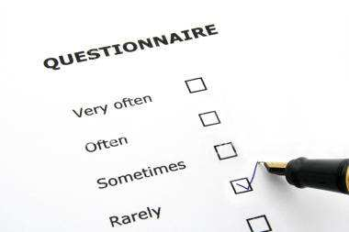

What is a Questionnaire?
A set of printed or written questions with a choice of answers, devised for the purpose of a survey or statistical study.
It serves four basic purposes:
- Collect the appropriate data.
- Make data comparable to analysis
- Minimize bias in formulating and asking the question
- Make questions engaging
Topic 50: Types of Questionnaire
Open ended: an opportunity to express the opinions in a free-flowing manner.
Closed format: respondents are restricted to choose among any of the given multiple choice answers.
Yes/No format: respondents are to choose positive or negative answers.
Topic 51: Some More Types of Questionnaires
Likert questions: how strongly respondents agree to a particular statement.
Bi polar questions: two extreme answers written at the opposite ends of a scale.
Leading questions: that lead to a particular type of answer.
Topic 52: Interpreting Questionnaire
Calculation like percentages and make inferences.
Topic 53: Merits of Questionnaire
- Practical
- Large amount of information
- Easy to manage
- Easy to analyze
- More reliable
- More valid
- Comparable
Topic 54: Demerits of Questionnaire
- Inadequate for certain information like thinking process, behavior.
- Questions are the reflection of the person who asks them.
- No way to tell how true the information is.
- No way to tell how thoughtful the respondent is. Respondents may understand differently.

LECTURE 09
INTERVIEW
Topic 55: Interview
A formal face to face meeting normally designed with the purpose of assessment.
It serves the purpose to get some specific information and also some assessment about the interviewee.

Topic 56: Structured and Semi Structured Interviews
- A structured interview, or a standardized interview is a method used in the survey research. The aim of this approach is to confirm that each interview is offered with exactly the same questions in the same order.
- The structured ones emphasis the Reliability- how accurately different respondents answers can be compared.
- A semi structured is open, allowing new ideas to be brought up during the interview as a result of what the interviewee says.
- In depth interviews emphasis validity-How close answers get to the respondents’ real views.
Topic 57: Transcribing an Interview
- Interview transcription is a word-to-word written documentation of a taped or live interview.
- Words like “OK” and “Good bye” have also been picked through apparently these do not carry any information.
Topic 58: Interpreting an Interview
We interpret the interview through the transcription.
Topic 59: Merits of Interview
- Practical
- Face to face
- Human side direct
- Body language
- Not influenced by others
- Higher response rate
- Participation from both sides
Topic 60: Demerits of Interview
- Time consuming (setting up, interviewing, transcribing, analyzing, feedback, reporting)
- Cost
- Inferences from transcription

LECTURE 10
PORTFOLIO AND PROJECTS
Topic 61: Portfolio
What is a Portfolio?
- A portfolio is a purposeful collection of student’s work that exhibits the student’s efforts, progress and achievements in one or more areas of the curriculum.
- It helps to get some specific information and also record of the progress made by the students in specific area.
Topic 62: Project and Growth Portfolios
- Project portfolios organizes a series of projects into a single portfolio of reports that capture project objectives and other critical factors.
- Growth portfolio organizes a record of the progress made in some specific area. For instance, about reading certain books or covering a certain syllabus.
- Record from starting point to the final stage is maintained.
Topic 63: Achievement and Competence Portfolios
- Achievement portfolio maintains the record of one’s achievement in certain area against specific targets.
- Whereas competence portfolio maintains the record of competition.
Topic 64: Process and Showcase Portfolios
- Process portfolio records all phases of the learning process. They are particularly useful in documenting students’ overall learning.
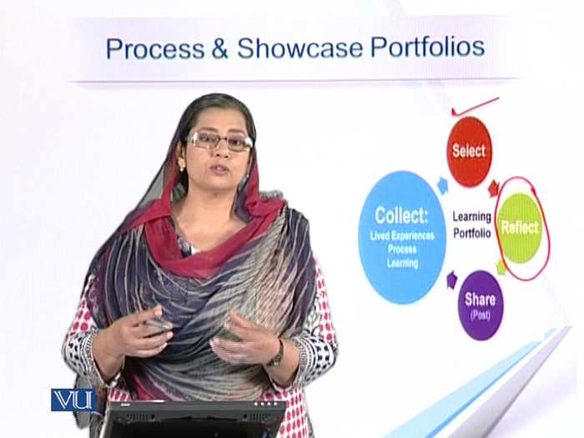

- Whereas showcase portfolio shows a record of your best achievements throughout the session with the purpose of assessment.
Topic 65: Merits of Portfolios
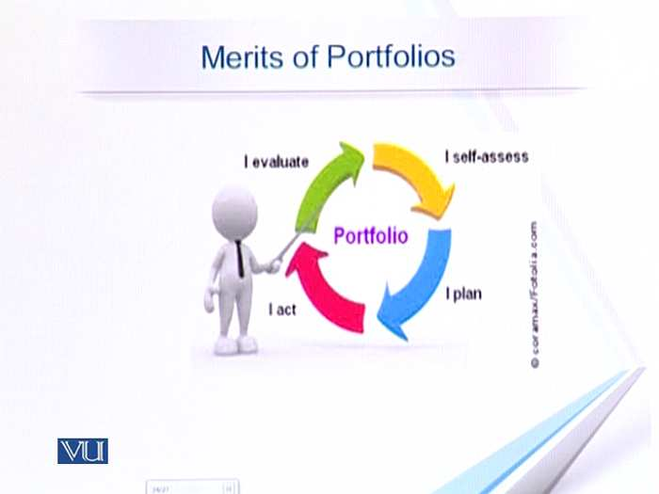
- Individualized instruction
- Self learning and competence
- Confidence
- Self trust
- Healthy competition with others
- Helping each other
Topic 66: Demerits of portfolios
- Measures relatively superficial knowledge
- Sometimes do not match the specific goals of program.
- Norm- referenced data may be less useful than criterion-referenced.
- More summative user and difficult to receive the results in a formative manner.

LECTURE 11
DIARY WRITING AND PROJECTS
Topic 67: Diaries and Projects
Writing a Diary
To write a good diary entry you need to include …….
- Date
- Dear diary….to start
- First line summary
- Chatty style
- Written in the first person
- Written in the past tense
- Questions hope for the day
When someone maintains a date wise record of some routine by writing in diary.
Topic 68: Diary Writing as Reflective Writing
It is interpreted as reflective writing: looking back, analyzing the event or idea; thinking carefully about what the event or idea means. Reflective writing is considered more personal.
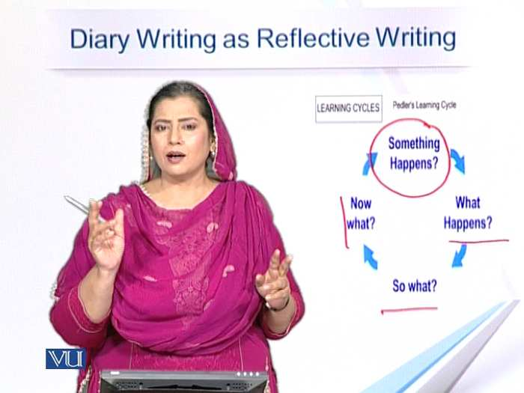
Reflective writing provides an opportunity for you to gain further insights from your work through deeper reflection on your experiences.
Topic 69: Assessment of Diary Writing
A diary records behavior over a period of time. Often the information recorded shows changes in behavior, trends in performance, results of participation, progress or the regularity of physical activity. Students can be assessed on the basis of these standards.
Topic 70: Projects as a Part of Class Work
Projects assess student’s understanding of a subject or a particular topic. Projects typically require students to apply their knowledge and skills while completing the prescribe task.
Individual projects assigned to a student require student’s knowledge, critical thinking, application of knowledge, time and work plan.
Group projects involve a number of students working together on a complex problem that requires planning, research, internal discussion and presentation. Group projects should include a component that each student completes individually.
Topic 71: Assessment of Project
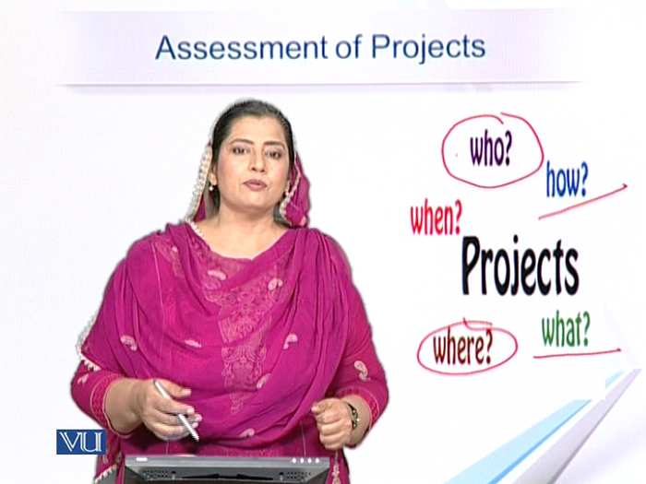

Students can be assessed on the basis of these standards given in the figure.
Topic 72: Merits and Demerits of Projects
Merits
- Individualized instruction
- Self learning and freedom
- Confidence
- Self trust
- Critical thinking
- Healthy competition with others
- Helping each other
- Social interaction
Demerits
- Time consuming
- Financial resources
- Control
- Just focus on the project
- Clarity about assessment

LECTURE 12
TYPES OF TESTS
Topic 73: What is a Test?
A procedure used to establish quality, performance or reliability of something (here the quality of teaching and learning). There are different types of tests.
Topic 74: Diagnostic Test
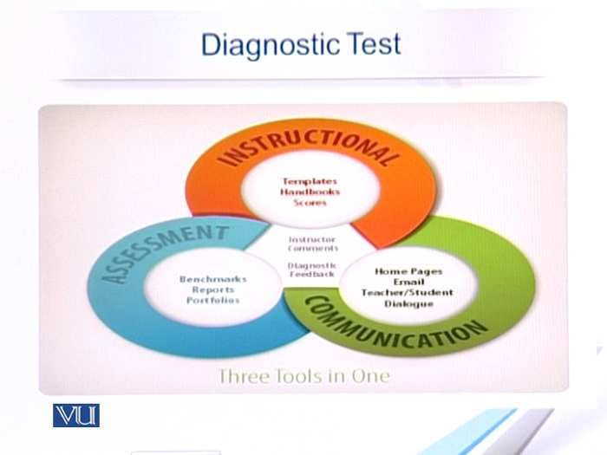

Diagnostic tests measure students’ weaknesses in subject area or skills. Teachers typically administer diagnostic test for reading and math skills, using the results to provide remedial instruction.
Topic 75
Standardized tests
A standardized test is any form of test that:
- Requires all test takers to answer the same question or a selection of questions from common bank of questions, and that
- Is scored in a “standard” or consistent manner, which makes it possible to compare the performance.
Topic 76
Achievement test
An achievement test is a test of skill and knowledge gained in a grade or level, usually through planned instruction, such as training or classroom instruction. Achievement is tested against certain objectives.
Topic 77
Proficiency test
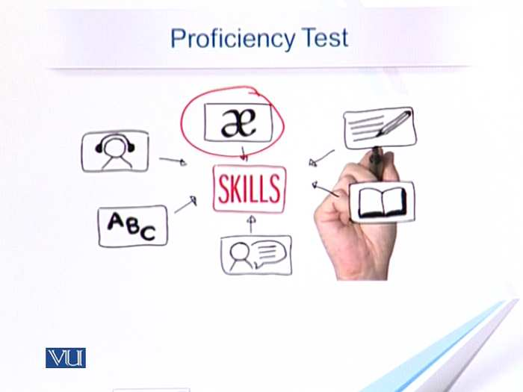
A proficiency test measures a learner’s level of language. It can be compared with an achievement test, which evaluates a learner’s proficiency of specific skills.
Topic 78
Psychometric test
A psychometric test is an objective and standardized measure of a sample behavior.

LECTURE 13
OBJECTIVE TYPE QUESTIONS
Topic 79: Types of Questions
Objective: Yes/No Questions

Yes/No questions are simple questions with two possible responses. Such questions allow the rapid assessment of large amounts of material.
There is very little educational benefit in using these questions.
Topic 80: True/False/Not Given
The student:
- Analyses a statement
- Assess whether the information is true or false or not given.
- Marks an answer
- Effective
- Simple logic
- More reliable than yes/no questions
Topic 81: Filling the Blanks
- In practice
- Simple logic
- Particular/common information
- Information and vocabulary
- Close test
- Needs more comprehension
Topic 82: Multiple Choice Questions
- One statement with choices given to be filled
- Correct answers with distractors
- Students analyze the statement and mark the correct answer
Topic 83: Matching Sentences/Columns
- Two lists of words/phrases/sentences
- Multiple choice
- Used for recognition of relationships and making associations
- Used for a wide range of subject matter
Topic 84: Assessment of Objective Questions
- Easy to make and mark
- Standardized responses
- Should be written with clarity
- Clearly communicated

LUCTURE 14
OTHER TYPES OF QUESTIONS
Topic 85: Some Other Types of Questions
Arranging information
- Sequencing events in a story.
- Analysis and reasoning is used and the information is arranged in a correct sequence. Re-writing or the use of vocabulary is not required from the student’s side.
- Such questions can be assessed like objective questions, so there is no difficulty in marking them. Reasoning can be tested, but these type of questions cannot be used in all of the subjects.
Topic 86: Labeling a Figure/Diagram
- Exact knowledge about specific parts is required to attempt the question which means the students must be having the complete understanding of the object being asked about.
- Such questions are normally used in science or geographical subjects. These might used not to be in every subject. These are assessed as objective questions.
Topic 87: Short answers
The student needs to give:
- Precise information
- Specific information
- Complete understanding
Topic 88: Some Other Types of Questions
Assessing Short Answers
These can also be covered under the heading of objective questions. Students may often memorize short answer questions with rote learning. If assessors wish to use short answer questions to assess deeper learni9ng, careful attention (and many practices) on appropriate questions are required. It is very important that the assessor is very clear on the type of answers expected when setting the questions, because these are open-ended questions, students are free to answer any way they choose; short answer questions can lead to difficulties in grading if the question is not worded carefully.
Topic 89: Essay Type Answers
- Very common
- Explain in detail, based on the information
- Critical analysis
- Cause/effect
- Compare/contrast
Answers are written according to the general rules of academic writing. Use indications; being each paragraph with a topic sentence; support the topic sentence(s) with reasons and/or examples; use translation words to show logical organization; write a conclusion. Use correct punctuation throughout.
Topic 90: Assessing Essay Type Answers
- Introduction
- Explanation
- Critical analysis
- Cause/effect
- Compare/contrast
- Academic writing
- Coherence
- Sunning up and conclusion

LUCTURE 15
OBJECTIVES
Topic 91: Objectives and Assessment
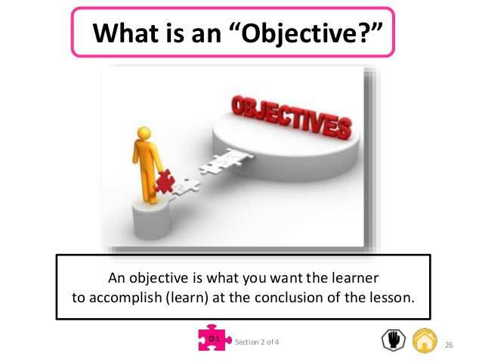
What is an objective?
- A specific result that a person or system aims to achieve within a time frame and with available resources.
- Something that one’s efforts or actions are intended to attain or accomplish; purpose; goal; target; the objective of this lesson; the objective of a seminar; the objective of a fund raising etc.
Topic 92: Difference between an Aim and Objective
- The aims of a course are broad statements of its purpose or intent. The aim encompasses the purpose and philosophy of the course, specifying its overall direction and content. - -They let students know what you will be teaching them over a study period and what they may learn by taking the course.
- Learning objective is to be explicit about what the students do, and what we need them to learn to achieve the aim. Learning objectives may be written with respect to knowledge, skills and attitudes. For an objective to be claimed it must be assessed; therefore there must be an alignment between objectives and assessments.
- The principal difference between aims and objectives is that aims represent the broad goal of your course while the objectives are the steps the students need to take in order to get there.
Topic 93: Teaching Process Reflective Objectives
- Objectives articulate the knowledge and skills you want students to acquire by the end of the course.
- Instructional strategies are chosen to foster students learning towards meeting the objectives.
- Methods, techniques, strategies and materials all are decided in the light of objectives.
Topic 94: Linking Objectives with Assessment
- Objectives articulate the knowledge and skills you want students to acquire by the end of the course,
- Assessment allows the instructor to check the degree to which the students are meeting the learning objectives.
- Assessment must align with the instructional techniques; otherwise objectives will not be attained.
Topic 95: Objectives and Assessment: Examples
Example # 1 Teaching of definitions
Assessment: Define so and so ….
Example 3 2 Teaching explanations
Assessment: Define, explain …..
Example # 3 Teaching diagrams
Assessment: Draw a picture of …..
Example # 4 Teaching comparisons
Assessment: compare, contrast ….
Topic 96: Mismatch b/w Teaching and Assessment
Example#1
Teaching: definitions
Assessment:
Explain…….
Example#2
Teaching:
Explanations
Assessment:
Compare, contrast ……
Example#3
Teaching:
Comparisons
Assessment: draw a picture……

LECTURE 16
BLOOM’S TAXONOMY
Topic 97: What is Taxonomy?
- Taxonomy is the science of classification according to a predetermined system, whose resulting catalogue is used to provide a conceptual framework for discussion or analysis.

Topic 98: Bloom’s Taxonomy
- Bloom’s Taxonomy was created in 1956 under the leadership of educational psychologist Dr Benjamin Bloom in order to promote higher forms of thinking in education, such as analyzing and evaluation concepts, processes, procedures and principles rather than just remembering facts (rote learning).

- It is most often used when designing instruction or learning processes. One gets clear about the level and depth of learning process. It is helpful in writing objectives and then in forming questions.
Topic 99: Bloom’s Taxonomy
Three Domains
Cognitive: Mental skills (knowledge)
Affective: Growth in feelings or emotional areas (attitude or self)
Psychomotor: Manual or physical skills (skills)
Topic 100: Explanation and Significance
- Words tend to convey wide range of meanings.
- Domains can be thought of as categories.
- Three categories are referred as KSA (Knowledge, Skills, Attitudes or Abilities)
- Taxonomy of learning behaviors may be thought of as “ the goal of the learning process”.
- After a learning activity, learner should have acquired a new skill, knowledge and attitude.
- 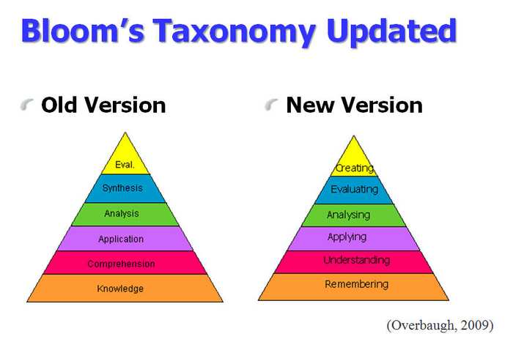
Topic 101: Cognitive Domain
- The most-used of the domains refers to knowledge structures (although sheer “knowing the facts” is its bottom level). It can be viewed as a sequence of progressive contextualization of the material.
Changes in Bloom’s Taxonomy
- There is an interchange of two top levels: Evaluation and Synthesis.
- The names of six major categories were changes from noun to verb forms.
- Comprehension and synthesis were retitles to understanding and creating respectively.
Topic 102: Explanation of Cognitive domain
Knowledge: Familiarity
Comprehension: Understanding
Application: Use of knowledge
Analysis: Differentiation into parts
Synthesis: Creation
Evaluation: Judgements

LECTURE 17
KNOWLEDGE LEVEL OF BLOOM’S TAXONOMY
Topic 103: Knowledge Level
What is Knowledge level?
- Exhibits previously learned materials by recalling the facts, terms, basic concepts and answers.
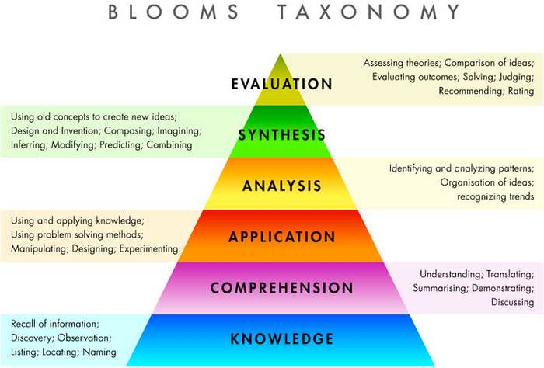
Topic 104: Knowledge Level
At Knowledge Level of Learning a student can define terms.
Related Verbs and Words
- Arrange
- Define
- Describe
- Duplicate
- Identify
- Label
- List
- Match
- Memorize
- Name
- Outline
- Recognize
- Relate
- Recall
- Repeat
- Reproduce
- State
- Who
- What
- When
Recalling and remembering previously learned information is knowledge level.
Topic 105: Knowledge Level Objectives
Knowledge refers to rote memorization of facts and information.
- Students will be able to define nouns.
- Students will be able to name the items given in the pictures.
Topic 106: Knowledge Level Questions
These questions test rote memorization of facts or information.
For example:
What is…..? Where is…? When did….?
- What is a noun?
- Define the concept of action words?

Topic 107: Same level Objectives and Questions
Example 1:
Objective: Students should be able to define noun.
Question: What is a noun?
Example 2:
Objective: Students should be able to name the places shown in the map.
Question: where is this place located?
Topic 108: Mismatch b/w Objectives and Questions
The objectives and assessment of some course do not show the same level of cognition.
Example:
Objective: students should be able to define noun.
Question: Explain the function of noun in a paragraph?
Example:
Objective: students should be able to name the places in the map.
Question: Discuss the importance of the places shown in the map?

LECTURE 18
COMPREHENSION LEVEL OF BLOOOM’S TAXONOMY
Topic 109: Comprehension Level
What is Comprehension level?
- Demonstrating understanding of facts and ideas by organizing, comparing, translating, interpreting, giving descriptions and stating main ideas.
Topic 110: Related Verbs and Words
- Demonstrate
- Interpret
- Explain
- Extend
- Illustrate
- Infer
- Outline
- Relate
- Rephrase
- Translate
- Summarize
- Show
- Classify
Grasping the meaning of information is comprehension.
Topic 111: Comprehension Level Objectives
At this level learner can restate in his own words that he has stored in memory.
- Students will be able to explain the theory.
- Students will be able to discuss the global warming.
Topic 112: Comprehension Level Questions
These questions test the understanding about of facts or information.
How is…? Why is….?
- How does global warming affect us?
- Explain the role of action words?
Topic 113: Same Level Objectives and Questions
Example 1:
Objective: students should be able to explain global warming.
Question: Discuss the concept of global warming?
Example 2:
Objective: Students should be able to paraphrase the poem.
Question:
Explain the following stanza with reference to the context?
Topic 114: Mismatch b/w Objectives and Questions
The objectives and assessment of some course do not show the same level of cognition.
Example:
Objective: Students should be able to summarize the poem.
Question: Evaluate the poem?
Example:
Objective: students should be able to interpret the story.
Question: Review the story?

LECTURE 19
APPLICATION LEVEL OF BLOOM’S TAXONOMY
Topic 115: Application Level
This level refers to applying gained knowledge to actual situations
Topic 116: Related Verbs and Words
Apply, build, construct, develop, Interview, make use of, organize, solve, utilize, model etc.
Solving problems by applying acquired knowledge, facts, techniques and rules.
Topic 117: Application Level Objectives
Knowledge and understanding are applied to solve some problem or build further knowledge.
- Students will be able to solve the mathematical problem.
- Students will be able to suggest some reforms.
Topic 118: Application Level Questions
These questions test the ability to apply your knowledge.
How will you…?
- Solve the following problem?
- How will you arrange the following words into a meaningful sentence?
Topic 119: Same Level Objectives and Questions
Example:
Objective: Students should be able to apply this formula for mathematical problem.
Question: Are these mathematical answers correct?
Example:
Objective: Students should be able to modify the given passages.
Question:
How will you change this paragraph into interrogative?

Topic 120: Mismatch b/w Objectives and Questions
The objectives and assessment of some course do not show the same level of cognition.
Example:
Objective: Students should be able to find the moral of the story.
Question: Compare the story with a plot of a novel?
Example:
Objective: Students should be able to apply their understanding to make correction.
Question: what are the positive points in the given paragraph?

LECTURE 20
ANALYSIS LEVEL OF BLOOM’S TAXONOMY
Topic 121: Analysis Level
What is analysis level?
Examining and breaking information into parts by identifying motives or causes;
Making inferences and finding evidence to support generalizations.
Blooms taxonomy
Topic 122: Related Verbs and Words
Analyze, categorize, classify, compare, contrast, discover, divide, examine, inspect, simplify, test for distinguish, distinction, theme, relationships, function, motive, inference, assumption.
Breaking down objects or ideas into simpler parts and seeing how the parts relate and are organized.
Topic 123: Analysis Level Objectives
One should be able to analyze a system and divide into its constituent parts.
- Student should be able to understand the parts of a microscope.
- Students will be able to recognize the parts of speech.
Topic 124: Analysis Level Questions
These questions test the ability to analyze an item or system on the basis of learning.
What are the parts or features of …?
- Distinguish between hard disc and removable disc?
- How will you analyze the role of light in photosynthesis?
Topic 125: Same Level Objectives and Questions
Example:
Objective:
Students should be able to divide the system into its parts.
Question:
Recognize the parts of the system and place them correctly?
Example:
Objective: Student should be able to differentiate between antonyms and synonyms.
Question:
Replace the given words by synonyms.
Topic 126: Mismatch b/w Objectives and Questions
The objectives and assessment of some course do not show the same level of cognition.
Example:
Objective:
Students should be able to infer the message carried by each paragraph.
Question:
Evaluate this paragraph?
Example:
Objective: Students should be able to contrast these two devices.
Question: Synthesize the function of two devices?

LECTURE 21
SYNTHESIS LEVEL OF BLOOM’S TAXONOMY
Topic 127: Synthesis Level
What is Synthesis Level?
The level refers to compiling information together by combining elements in a new pattern or proposing alternative solutions.
Blooms Taxonomy.
Topic 128: Related Verbs and Words
Combine, Compile, Compose, Construct, Create, design, develop, estimate, formulate, invent, originate, plan,Propose,Solution,suppose,modify,improve,adapt,minimize,maximize,delete,theorize,elaborate, improve.
Rearranging component ideas into a complete presentation.
Topic 129: Synthesis Level Objectives
Knowledge and understanding are applied to compile information to build or pattern.
- Student will be able to complete the story with the help of hints.
- Students will be able to rearrange the jumbled words to make a sentence.
Topic 130: Synthesis Level Questions
These questions test the ability to construct/ synthesize something on the basis of your learning.
What changes would you make…?
- How will you design your classroom for language learning activities?
- How will you assemble the following words into a meaningful sentence?
Topic 131: Same Level Objectives and Questions
Example:
Objective:
Student should be able to give their judgment about inactive teaching.
Question: Do you recommend interactive teaching?
Example:
Objective:
Students should be able to evaluate the novel?
Topic 132: Mismatch b/w Objectives and Questions
The objectives and assessment of some course do not show the same level of cognition.
Example:
Objective:
Student should be able to compare a story from the pictures.
Question: Evaluate the story shown in picture?
Example:
Objective:
Students should be able to construct a model for teaching.
Question:
Evaluate teaching material?

LECTURE 22
EVALUATION LEVEL OF BLOOM’S TAXONOMY
Topic 133: Evaluation Level
What is evaluation level?
This level refers to making judgments about information validity of ideas or quality of work based on a set of criteria.
Blooms Taxonomy
Topic 134: Related Verbs and Words
Awards, Criticize, decide, defend, evaluate, judge, justify, compare, mark, rate, recommend, appraise, support, prove, disprove, assess, value, estimate, etc.
Making judgments based on evidence or criteria.
Topic 135: Evaluation Level Objectives
Blooms Taxonomy
Knowledge and understanding are applied to judge and evaluate something.
- Students will be able to assess the system of taxation.
- Students will be able to give their opinion about educational reforms.
Topic 136: Evaluation Level Questions
These questions test the ability to judge something on the basis of your learning.
Can you access the value…?
- How will you justify the educational reforms?
- Do you value the changing methodologies of teaching?
Topic 137: Same Level Objectives and Questions
Example:
Objective:
Students should be able to compile the information into a report.
Question:
Write a report of your project?
Example:
Objective:
Students should be able to improve the given plan.
Question:
Formulate a new plan by mentioning the flaws of the previous one?
Topic 138: Mismatch b/w Objectives and Questions
The objectives and assessment of some course do not show the same level of cognition..
Example:
Objective:
Students should be able to give their opinion about abstract art.
Question: Define abstract art?
Example:
Objective: Students should be able to give their judgment about economic conditions prevailing today
Example:
Question: How do you comment about the social condition ' prevailing today?

LECTURE 23
ITEM ANALYSIS I
Topic 139: Item Analysis
What is Item Analysis?
Item and distracter analysis
Item analysis is a process which examines student responses to individual test items (questions) in order to assess the quality of those items and of the test as a whole.
Item Analysis deals with:
- Item Difficulty
- Item Discrimination
- Effectiveness of Distractors
Topic 140: What is Item Difficulty?
- Item difficulty is simply the percentage of students taking the test who answered the item correctly.
- The larger the percentage getting an item right, the easier the item.
- For instance, if the percentage of correct answer is 85%, it means the item is very easy.
- If the percentage is 15%, it means the item is very difficult.
- The proportion for the item is usually denoted as p and is called item difficulty (Crocker & Algina,1986)
Topic 141: Calculating Item Difficulty
P: Correct Responses/ Total Responses
P=H+L/N
H is high scorers with correct responses
L is low scorers with correct responses
N is total number of students.
For instance:
Total Responses::42
Correct
Responses:18
p=18/42: 0.42
For instance:
Total Responses: 40
Correct responses=35
p=3S/40: 0.87
High Medium Low
(Difficult) (Moderate) (Easy)
<= 30% > 30% AND < 80% >=80%
P= Correct
Responses/Total Responses
Item difficulty should be moderate.
Topic 142: High and Low Performers
When the test result is divided and arranged into two groups on the basis of total scores.
Topic 143: What is Discrimination Index?
The ability of the test to differentiate between good (High Scoring) and poor (Low Scoring) students
Topic 144: Calculating Discrimination Index
D= H-L/ N
H is high scorers with correct responses.
L is low scorers with correct responses.
N is total number of students.
For instance:
H=12
L=3
N=15
D=12-3/1S=.60
D= H-L/ N
Its value should be around .50-.75.

LECTURE 24
ITEM ANALYSIS II
Topic 145: More About Item Analysis
More about Item Analysis Distractors
Item Analysis deals with:
- Item Difficulty
- Item Discrimination
- Effectiveness of Distractors
Distractors are various alternatives chosen to be as close as possible to the right answer. In good test construction, all distractors should be feasible and reasonable and should apply directly to the steam.
Topic 146: What is Distractor Analysis?
The best distractor is one that contains the common mistakes that students will make.
In distractor analysis, however, we are no long: interested in how test takers select the correct answer, but how the distracters were able to function effectively by drawing the test takers away from the correct answer.
Topic 147: Analyzing Distractor
D= H-L/ N
H is high scorers with correct responses
L is low scorers with correct responses
N is total number of students
Each column is showing a different value as it has been calculated for each distractor separately.
Topic 148: Interpretation of the Analysis
The value .33 is acceptable because it discriminates between high and low. The value for distractor B is 0 so no discrimination between high and low groups. C has been chosen more by the weak students.

Topic 149: Putting Responses on a Sheet
By looking at the sheet, you can know about the responses to distractors.
Topic 150: Signiﬁcance of Distractor Analysis
- Distractor analysis can be a useful tool in evaluating the effectiveness of distractors. When distractors are not effective, they are virtually useless.
- Good quality distractors ensure that the outcome of the tests provides more credible and objective picture of the knowledge of the test takers.

LECTURE 25
MARKING
Topic 151: Marking and Assessment
What is Marking?
Marking is when you set a certain standard numerically about certain task. Here we are discussing the work oral or written.
To identify what is required for achievement of each of the grades being awarded .Student work is then judged to fall at a given point within the range of descriptors.
- Marks
- Grades
- Percentage
Topic 152: Clarity in Questions
Questions should be written very clearly. There should be no confusion what to be answered.
Students cannot answer correctly if they are confused about the statements of questions.
Topic 153: Clarity in Marking Scheme
Marking scheme should be clearly conveyed to students that will help them to arrange their answers as is required
For instance:
Q. What is Bloom's taxonomy? (10)
Or
a. Name three domains of Bloom's taxonomy. (1.S)
b. How does this taxonomy help in context of teaching and learning? (8.5)
Topic 154: Level of Question and Marks
For instance:
Q. What is Bloom's taxonomy? ( 10)

Or
a. Name three Domains of Bloom's taxonomy.(1.5)
b. How does this taxonomy help in context of teaching and learning? (8.5) w
Distribution of marks should be decided according to the levels of cognition. The lower the level, the lesser the marks. Similarly more marks will be allocated to higher level questions.
Topic 155: Co-ordinations
A coordination must be maintained starting from objective to teaching and then to questions of assessment.
This co-ordination must be perceived in the allocation of marks also. For instance:
1. Objective: Knowledge level
2. Teaching and assessment: Knowledge level
3. Marks: 2-3
Topic156: Sharing with Students
This co-ordination must be shared with the student.
For instance:
1. Objective: Knowledge level
2. Teaching and assessment: Knowledge level
3. Marks: 2-3

LECTURE 26
RUBRICS I
Topic 157: Rubrics
What are Rubrics?
A rubric is a scoring tool that teachers use to assess student learning after a lesson.
A rubric usually in the form of a matrix or grid; is a tool used to interpret and grade students’ work against criteria and standards. Rubrics are sometimes called "criteria sheets", “grading schemes", or "scoring guides".
Topic 158: Elements in Rubrics
A set of criteria that provides an interpretation of the stated objectives (performance, behavior, quality).
A range of different levels of performance between highest and lowest.
Descriptors that specify the performance corresponding to each level, to allow assessors to interpret which level has been met.
Topic 159: Example from IT
This should be noted that starting from the highest point, the standards set over here, gradually move towards lower standards.
Topic 160 Example from Speaking Task
Certain standards have been set and then levels of performance have been defines against these standards.
Topic 161 Objectives & Rubrics
Learning objectives --------Institutional activities-------Assessment
Objectives of a lesson or topics help in setting rubrics.
Whatever is needed as objectives, must be reflected in the grid of rubrics.

LECTURE 27
RUBRICS II
Topic 162: Signiﬁcance of Rubrics
Using a set of criteria and standards (directly tied to the stated learning objectives), educators can assess each student's performance on a wide variety of work, ranging from written essays to class projects.
A rubric makes explicit a range of assessment criteria and expected performance standards. Assessors evaluate a student's performance against all of these, rather than assigning single subjective score. :
Using a set of criteria and standards (directly tied to the stated learning objectives), Educators can assess each student.
Topic 163: More about Rubrics
Assessment rubrics can be used for assessing learning at all levels, from assignments, a course projects, larger research or design projects and learning portfolios.
Topic 164: Challenges
When learning outcomes relate to higher levels of cognition (for example, evaluating or creating).
It can be difficult to include different dimensions.
- When changing these detailed standards to grades.
- Workload for teachers.
- Students sometimes depend too much on these standards.
Topic 165: Some Requirements
Prepared and available for students well before they begin work on tasks
Discuss assessment rubrics with students in class
Students should be familiar with these standards.
Practice using rubrics in class
Frame your assessment
Feedback to students in the terms laid out in the rubric.
Involve students while forming rubrics.
Topic 166: Developing Rubrics
Develop the goals.
Select the assessment tasks.
Develop performance standards.
Differentiate performances.
Assign marks to these categories.
Topic 167: Scoring Rubrics
- Exemplary
- Good quality
- Average
- Below average

1st at the top is related to the best performance. The last shows the least level. Two in the middle is related to average. According to the subject and objectives, the remaining grid is filled.

LECTURE 28
DISPLAYING THE DATA
Topic 168: Displaying Data
Tally marks also called hash marks show numeral system. They are a form of numerical used for counting. They are most useful in counting. These are used in different areas including assessment and research. We should have a set of data which can be stored in tallies. It is represented by a small line.
Topic 169: Representation
We use these lines to store data. You can see that tallies do not carry numbers, but serve as numbers for counting etc.
Topic 170: Tables
The simplest style for displaying data is tables. There are different types of tables.
This way tables help us a lot, from simple of difficult areas.
Topic 171: Graphs
A diagram showing the relation between variable quantities, typically of two variables. each measured along one of a pair of axes at right angles.
Topic 172: Some Principles
There are certain principles of displaying data. For instance, we must keep in mind:
- A relationship tries to show a connection or correlation.
- A comparison tries to set one set of variables a part from another.
- A composition tries to collect different types of information.
- A distribution tries to lay out a collection of related or unrelated.
Topic 173: Some Recommendations
Sorting and re-grouping data.
Transforming raw data into indicators such as percentages, rates and ratios.
Presenting the data and indicators in tables, charts and texts which enable easy analysis, interpretation and use.

LECTURE 29
ITEM DEVELOPMENT
Topic 174: Item Development
The term item is used as a shorthand for questions on the test. Item development can proceed only when a clearly agreed upon set of objectives is available.
It is advised that an item should measure only a single objective.
Each objective, however, should be measured by one or several items, depending on the test specifications.
Topic 175: Item Format
The format of the item necessarily proceeds from the test blueprint. The blueprint indicates the kinds of skills and the balance of test content to be measured. The selection of item types and test format should be based on the kinds of skills to be measured and not on some personal like or dislike for a particular item format.
Topic 176: Objective Questions
- Write with clear terminology.
- Clear statement.
- Avoid confusions.
- Keep each item separate.
- If more options than one are correct, ask for the best answer.

- Complete requirement.
- Correct grammar.
- None of the above’ should not be used as options.
- Bring variety.

Topic 177: Essay Test Items
Essay items are useful when examinees have to show how they arrived at an answer.
A test of writing ability is a good example of the kind of test that should be given in an essay response format.
This type of item, however, is difficult to score reliably and can require a significant amount of time to be graded.
Grading is often affected by the verbal fluency in the answer, handwriting, presence or lack of spelling errors, grammar used and the subjective judgments of the grader.
Topic 178: Marking Scheme
Marking scheme should be clear and relevant.
For instance:
Q. What is assessment? (10)
And compare this question:
Q. a. Define assessment. (2)
b. Discuss the role of assessment in a classroom. (8)

LECTURE 30
OUTCOMES OF ASSESSMENT
Topic 179: Outcomes of Assessment
Assessment is related to the targets of learners and tests them about these targets. This way, it helps to mark the position of some learner.
Assessment approaches promote learner engagement and encourage learners to become more independent in their learning.
Topic 180: Learner’s Skills
Assessment promotes learner engagement and encourages learners to improve their skills.
Speaking, writing, listening, thinking all refer to different skills. Assessment helps learners to improve their skills.
Topic 181: Learner’s Knowledge
We enhance our knowledge with the help of assessment.
Different materials and techniques polish our capabilities.
It helps those also to improve their knowledge who considers assessment as a pressure.
Topic 182: Guiding Teaching
Assessment guides teachers as well about their teaching materials and techniques.
If learners have a picture about learning quality, teachers can also have an idea how they have performed as teachers.
Topic 183: Involving Many Parties
Assessment involves many parties directly and indirectly. For instance your teacher is a direct party. Your principal also might be taken as a direct party.
But those sitting in the finance office or publishing your question papers are the example of indirect parties.

