 | Assignment No. 2  Semester: Spring 2026  CS201P – Introduction to Programming(Practical) |  | Total Marks: 20  Due Date: 6th July, 2026
Instructions
Please read the following instructions carefully before submitting the assignment:
It should be clear that your assignment will not get any credit if:

- Assignment is submitted after the due date.
- Submitted assignment does not open or file is corrupt.
- Assignment is copied (From the internet/students).
- Assignment is submitted in any file format other than .cpp.

Recommended tool to develop Assignment
- Dev C++

Objectives:
To enable students to understand and practice the concepts of:
- Function calling
- Classes and objects
- Constructors and their types

Assignment Submission Instructions
You must submit only a .cpp file on the assignments interface of CS201P from your LMS account. Assignments submitted in any other format (image, pdf, doc, docx, etc) will be scaled with zero marks. So, check your solution file format before submission.

For any query related to the assignment, please contact CS201P@vu.edu.pk.

Assignment

Problem Statement
Imagine a student registration system for an online university. The system checks if a student can register for a specific course based on their grade level, prerequisites, and whether they have paid the course fee.
The students' details are as follows:
- Student ID (string)
- Student Name (string)
- Grade Level (integer)
  - 1 = First Year
  - 2 = Second Year
  - 3 = Third Year
  - 4 = Fourth Year
- Prerequisite Grade (integer marks out of 100)
- Fee Paid Status (boolean)
  - true = Fee Paid
  - false = Fee Not Paid

Registration Criteria:
The registration criteria for course enrollment are as follows:
- Students must be in 2nd year or higher to register.
- Prerequisite grades must be 50 or above.
- The fee must be paid.

Your Task:
You need to implement the StudentRegistration class with the following components:

1. Constructors
- Default Constructor:
  - Initializes the student's attributes with default values:
    - ID: “Your Student ID”
    - Name: "Your Name"
    - Grade Level: 0
    - Prerequisite Grade: 0
    - Fee Paid: false

- Parameterized Constructor:
Create a constructor that accepts the following values and initializes the object accordingly:
- Student ID
- Student Name
- Grade Level
- Prerequisite Grade
- Fee Paid Status
- Copy Constructor:
  - Creates a new instance of the StudentRegistration class by copying the values from an existing object. This constructor is used when creating a new object by copying another object.

2. Member Functions
- checkEligibility():
  - This function checks the eligibility of a student based on the following criteria:
    - The student must be in the 2nd year or higher.
    - The prerequisite grade must be at least 50 out of 100.
    - The fee must be paid.
  - The function should return true if all conditions are met, and false otherwise.
- displayInformation():
  - Display the following student information:
    - Student ID
    - Student Name
    - Grade Level
    - Prerequisite Grade
    - Fee Status
  - Display the fee status using the following format:
    - Fee Status: Paid
    - Fee Status: Not Paid
- displayReasons():
  - This function will be called if the student is ineligible and it should print the reasons of the ineligibility as below:
      - If the student is not in the 2nd year or higher it should print “Reason: Must be in 2nd year or higher.”
      - If the prerequisite grade is below 50 it should print “Reason: Prerequisite grade below 50.”
      - If the fee is not paid it should print “Reason: Fee not paid.”

3. Main Function
- A complete main() function code is given below in this assignment file. You need to use the same main function in your solution. You must not change, edit, or modify the main function in any way.
- Your task is to implement the StudentRegistration class so that it works correctly with the provided main function and produces the output exactly as shown in the sample output, except that the Student ID and Name displayed by the default constructor should be your own.
- The program will be evaluated using this exact main function, and any modification to it will result in zero marks.

Note:

Replace "Your Student ID" and "Your Name" in the default constructor with your own student ID and name. Failure to do so will result in deduction of marks.

If you do not use the main function provided, you will receive zero marks. Any submission not in cpp format will also result in zero marks.

Main Function:

int main() {
cout << "Default constructor called: " << endl;
StudentRegistration student1;
student1.displayInformation();
cout << endl;

cout << "Parameterised constructor called for object Ali and checking its eligibility: " << endl;
StudentRegistration student2("BC010101010", "Ali", 1, 45, true);
if (student2.checkEligibility()) {
cout << "Status: Eligible for Course Registration" << endl;
}
else {
cout << "Status: Ineligible for Course Registration" << endl;
student2.displayReasons();
}
cout << endl;

cout << "Parameterised constructor called for object Ayesha and checking its eligibility: " << endl;
StudentRegistration student3("MC123789000", "Ayesha", 2, 60, true);
if (student3.checkEligibility()) {
cout << "Status: Eligible for Course Registration" << endl;
}
else {
cout << "Status: Ineligible for Course Registration" << endl;
student3.displayReasons();
}
cout << endl;

// Testing the copy constructor
cout << "Copy constructor called: " << endl;
StudentRegistration student4 = student2;
student4.displayInformation();

return 0;
}

Output Sample:

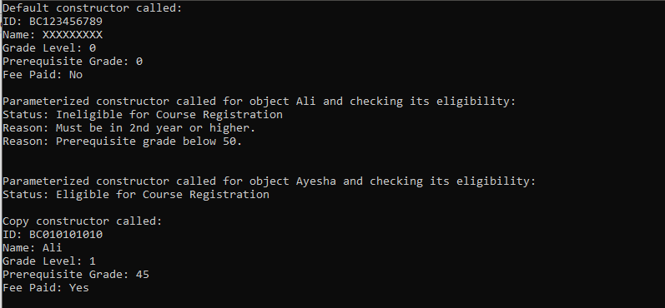

Syllabus:
The syllabus for this assignment includes all topics covered from Lab 8 to Lab 10.
Best of luck!

